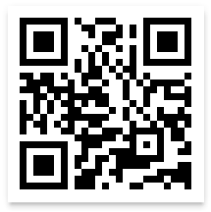

**Questions? Want to request a paper questionnaire?**

Telephone Helpline: **1-888-324-8337** (8 a.m. to 8 p.m. ET)

E-mail: [nssatsweb@mathematica-mpr.com](mailto:nssatsweb@mathematica-mpr.com)

**STATE ID:** [STATE ID]

[FAC NAME1]: [FAC NAME 2]

[LOCATION ADDRESS 1]

[LOCATION ADDRESS 2]

[CITY], [STATE] [ZIP]

**Scan the QR Code** Open the camera application on your smartphone and scan it over the QR code to get to the survey and enter your **USER ID** and **PASSWORD**.

**USER ID:**

**PASSWORD:**

**Thank you in advance for your participation!**

**2nd Option**

**Complete the 2021 N-SSATS Online!**

**1st Option**

**Access the survey at:** <https://survey.nssats.com>

**Enter User ID and Password**