January 6, 2020

Dear [R First] [R Last]:

Thank you for participating in the Medicare Current Beneficiary Survey. The Medicare program is always trying to improve! This survey is our main way to learn about how well Medicare is meeting your health care needs. The data collected allows us to understand how Medicare and other sources of coverage help you and your family manage the cost of health care. The data also tells us how well we are helping the millions of people you and other survey participants represent.
Participation in the survey is your way of telling us how we are doing! Our interviewers will be contacting you again in the winter and we look to continue our relationship with you. We sincerely thank you for your time and effort in providing us the information we need to improve. Know that as you review your health events and speak with your interviewer, you are making a meaningful difference in lives of others like you across the country.
We look forward to seeing you again soon. If you have any questions, please do not hesitate to contact NORC toll-free at 1-877-389-3429, or by email at mcbs@norc.org.

Sincerely,
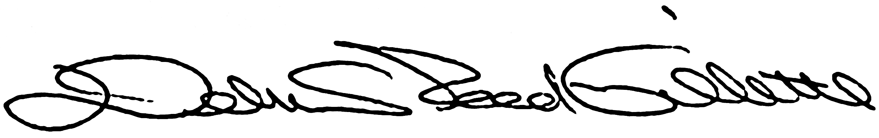
Debra Reed-Gillette

Director, Medicare Current Beneficiary Survey
Centers for Medicare and Medicaid Services

