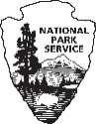
Form 10·404A (Rev. 6/2020)
0MB Control No. 1024-0022
NOTICES

PRIVACY ACT STATEMENT

Authority: 54 U.S.C. §100101, NPS Organic Act; 16 U.S.C. 1131-1136. Wilderness Act 43 U.S.C. §1701
et seq., the Federal Land Policy and Management Act; 54 U.S.C. §200301-200310, Land and Water
Conservation Fund Act as amended: 16 U.S.C. §6801-6814, the Federal Lands Recreation Enhancement
Act; 36 CFR Part 71, Recreation Fees; and, 36 CFR 1 .6. Permits.

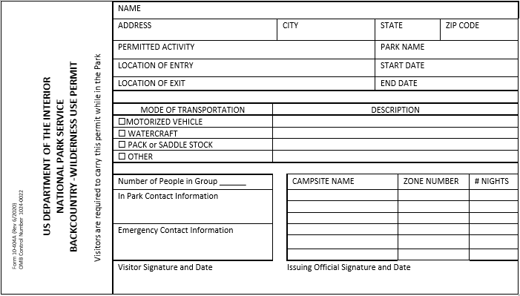
Purpose: To establish and verify an applicant’s eligibility for a permit to conduct certain activities within the National Park System and to process permits for individual members of the public and organizations interested in obtaining a permit authorizing an activity. Information collected will be used to provide the public and permittees with permit-related information, to monitor activities conducted under a permit, to analyze data and produce reports to monitor the use of park resources, to assess the impact of permitted activities on the conservation and management of protected species and their habitats, and to evaluate the effectiveness of the permit programs. The DOI and NPS may use the information to meet reporting requirements, to generate budget estimates and track performance, and to assist park staff with visitors' education, fee collection, resource management and protection, recreational use planning, law enforcement and public safety personnel for such purposes as emergency contact and search and rescue efforts; to provide permit holders and participants with information about parks and their partners; and to provide reports or
activities conducted under an issued permit.

Routine Uses: In addition to those disclosures generally permitted under 5 U.S.C.552a(b) of the Privacy Act, the National Park Service may disclose records or information to Federal, State, territorial, local, tribal, or foreign agencies to provide information needed to locate an individual or render aid In an emergency; to recover debts owed to me United States; to respond to a violation or potential violation of the law; in response to a court order and/or discovery purposes related to litigation; or other authorized routine use when the disclosure is compatible with the purpose for which the records were compiled.

Disclosure: Voluntary, however, failure to provide the requested information may impede the processing of the Backcountry/Wilderness Use Permit application for the individual member of the public or organization. Deliberately and materially making false or fraudulent statements on this form will be grounds for not granting you a Backcountry/Wilderness Use Permit.

PAPERWORK REDUCTION ACT STATEMENT

We are collecting this information subject to the Paperwork Reduction Act (44 U.S.C. 3501) and 36
CFR 1- 7, 12 and 13 which authorize the National Park Service to require applicants to fill out this form
to monitor resources and to protect visitors. This information is being collected to allow the park
management to make value judgments necessary to enhance the safely and enjoyment of both the
visitors and wildlife. Your response is required to obtain or retain a benefit however, failure to provide
the requested information may prevent or delay the processing of your request. OMB has approved
this collection and assigned OMB Control No. 1024-0022. You are not required to respond to this or
any other Federal agency-sponsored information collection unless it displays a currently valid OMB
control number.

ESTIMATED BURDEN STATEMENT

Public Reporting burden for this form is estimated to average 5 minutes per response, including the
time it takes for reviewing instructions, gathering and maintaining data, and completing and reviewing the form. Comments regarding this burden estimate or any aspect of this form should be sent to the Information Collection Clearance Officer, National Park Service, 1201 Oakridge Drive, Fort Collins, CO 80525. Please do not send your completed form to this address.

 | Please practice Leave No Trace Ethics

