Screen Shots of the National Map Corp Web Application
Logon Page for user
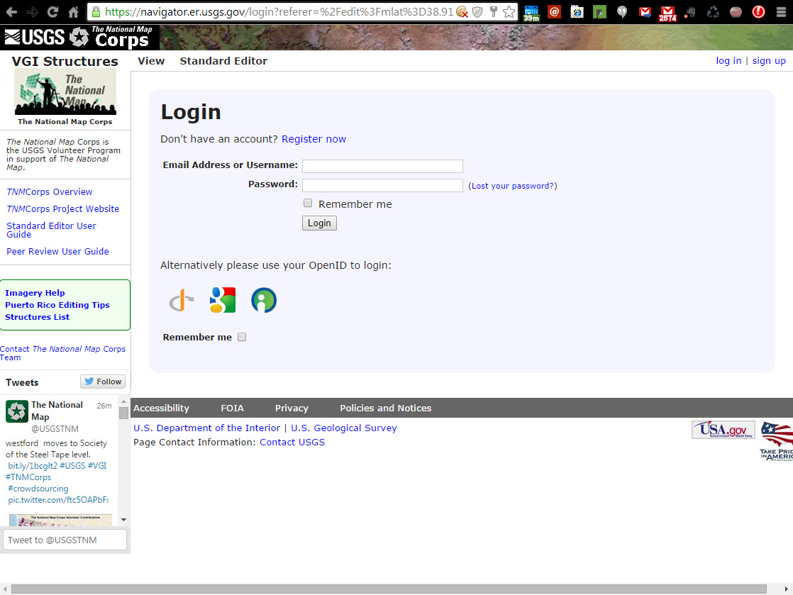

Logon Page for New User Account
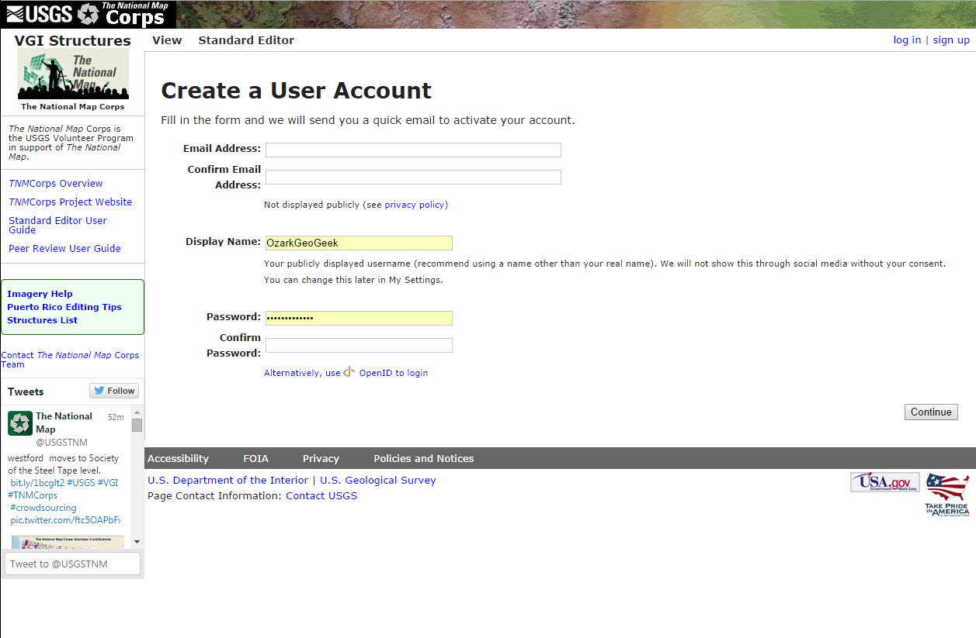

Help and Training Information for Users
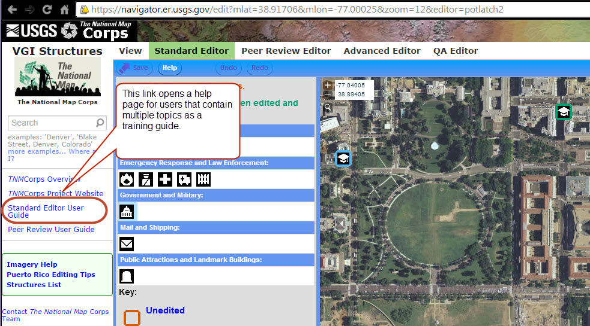

Opens this standard Windows training document
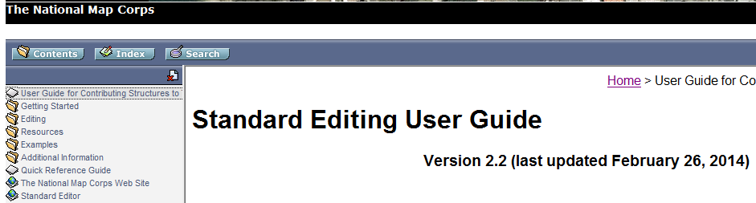

Navigation in the standard editor
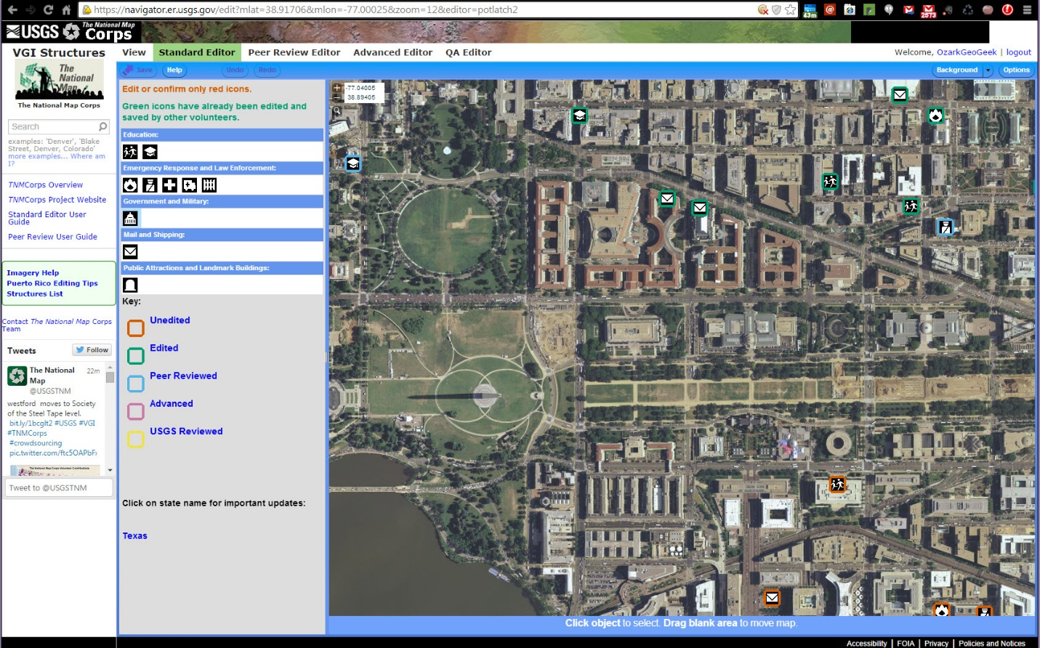

Easy Editor to place manmade structures on a map
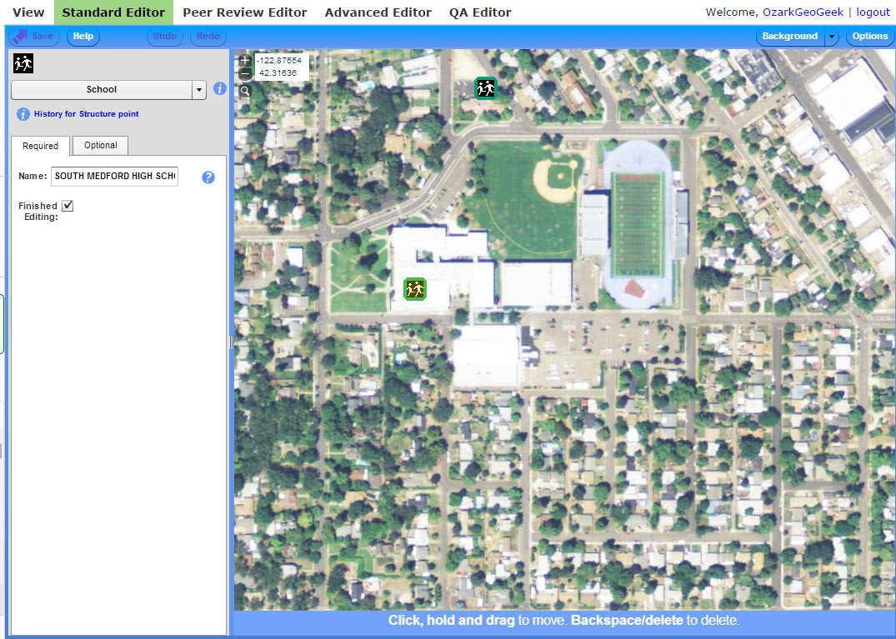

Optional input tab in the editor
