|  |
| --- |
|  |
| Housing Collection Instrument Screen Shots |
| Last Modified: April 19, 2018 |
|  |
|  |
|  |

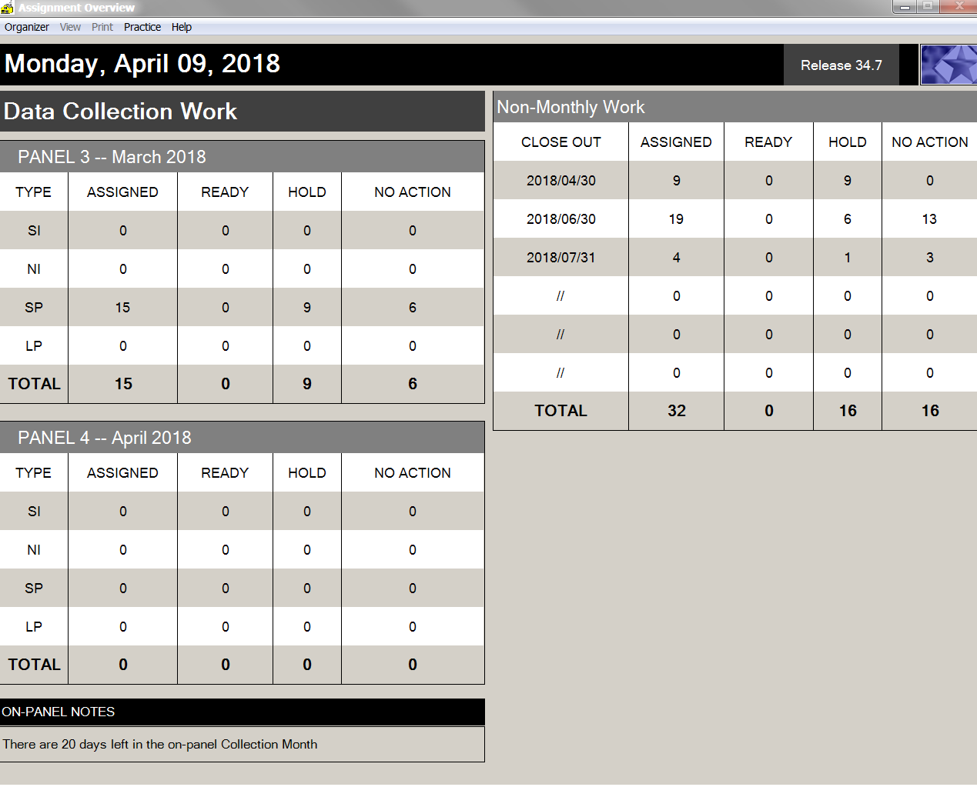

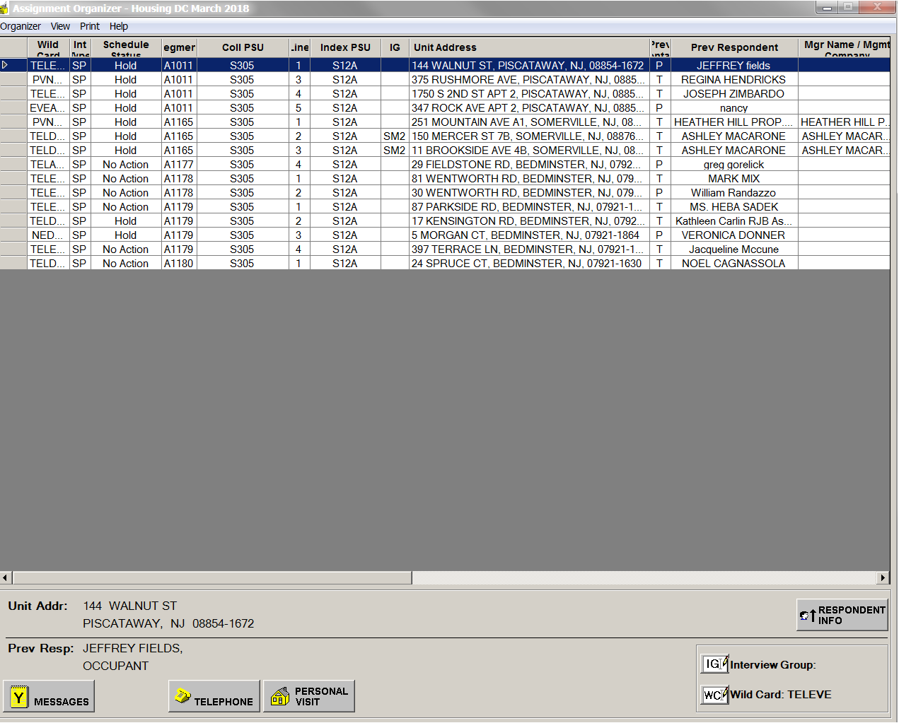

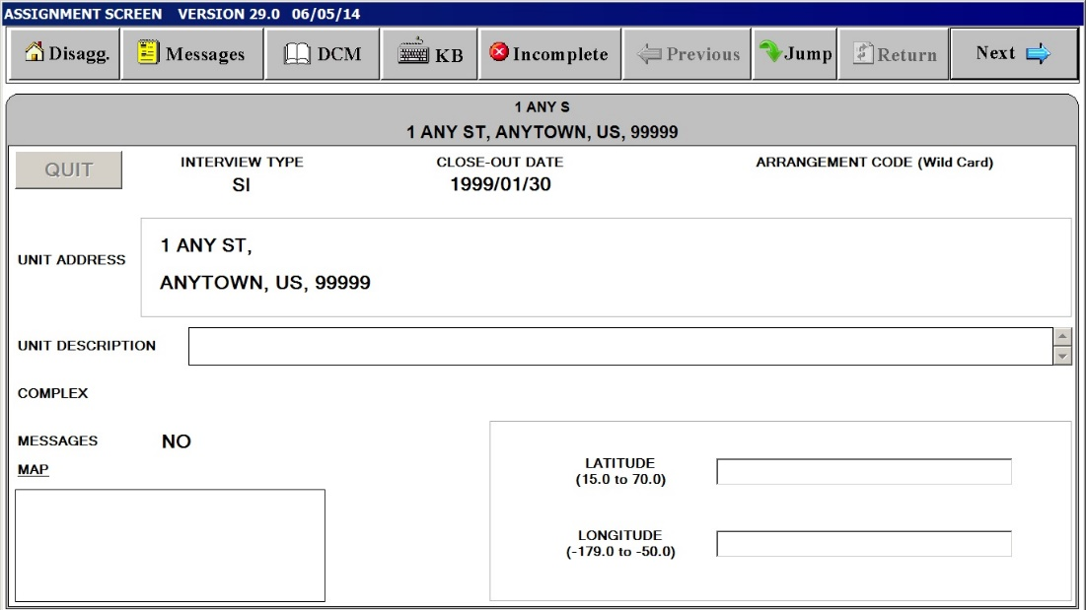

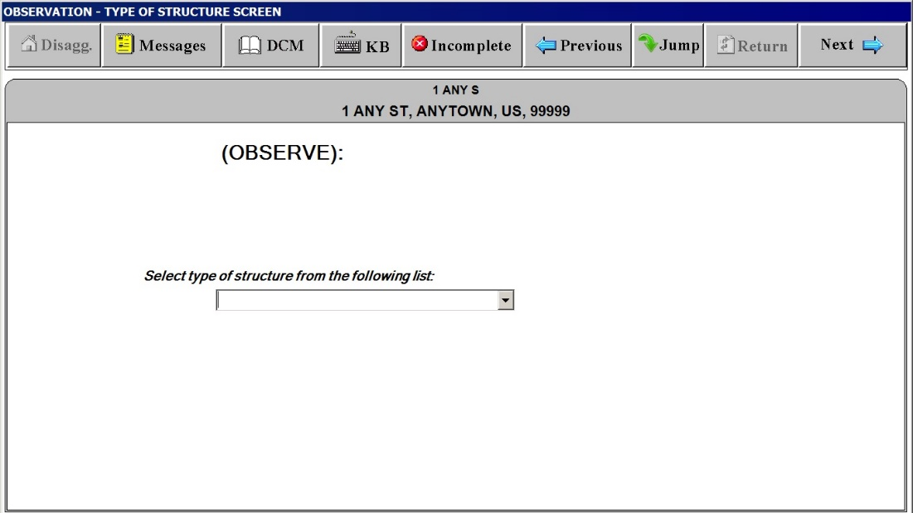

The following 2 screen shots are non-substantive changes to the housing survey questions that OMB approved in August 2017. The non-substantive changes were supposed to be updated in January 2018 but due to lack of resources the changes will not be updated until FY19.

***“Type of Structure”***

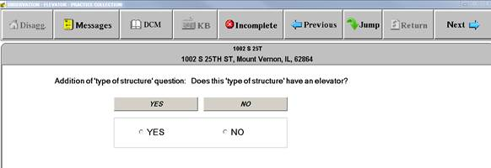

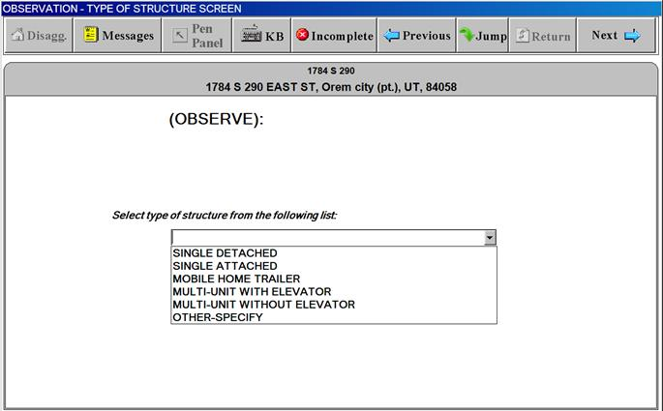

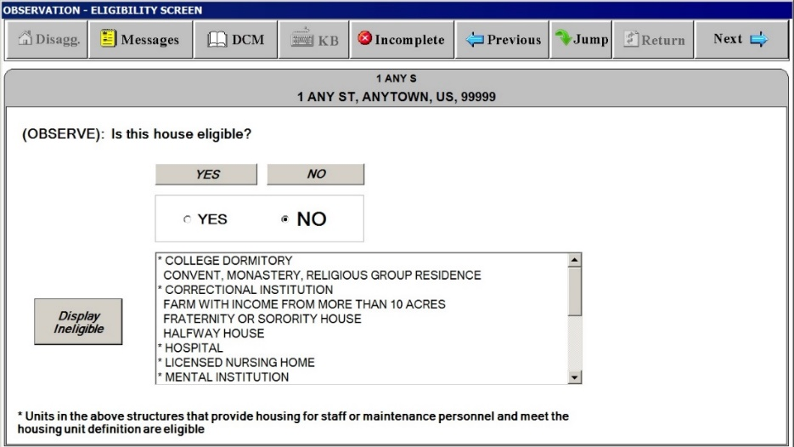

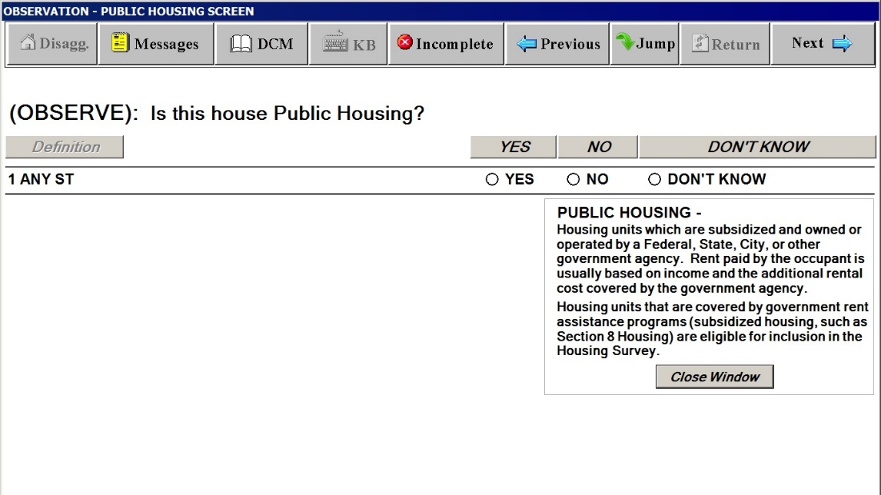

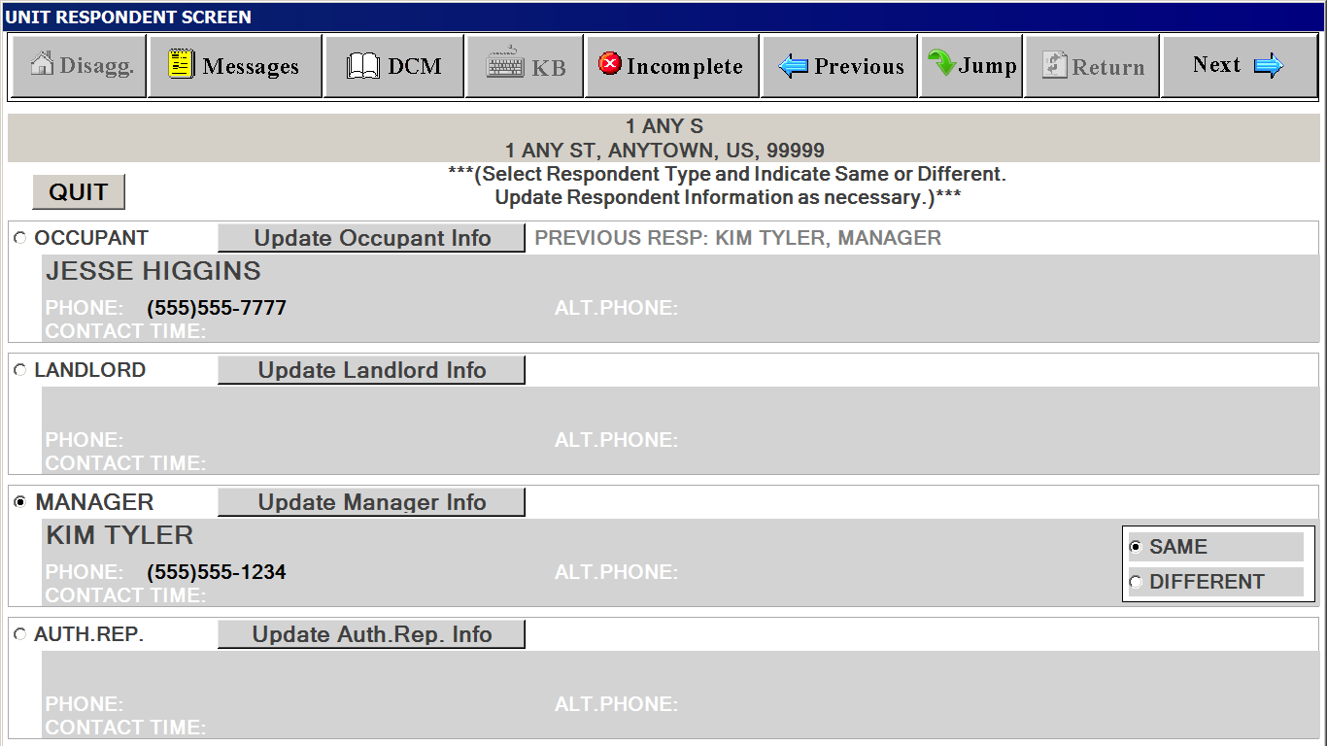

**Respondent Screen for Interview Groups**

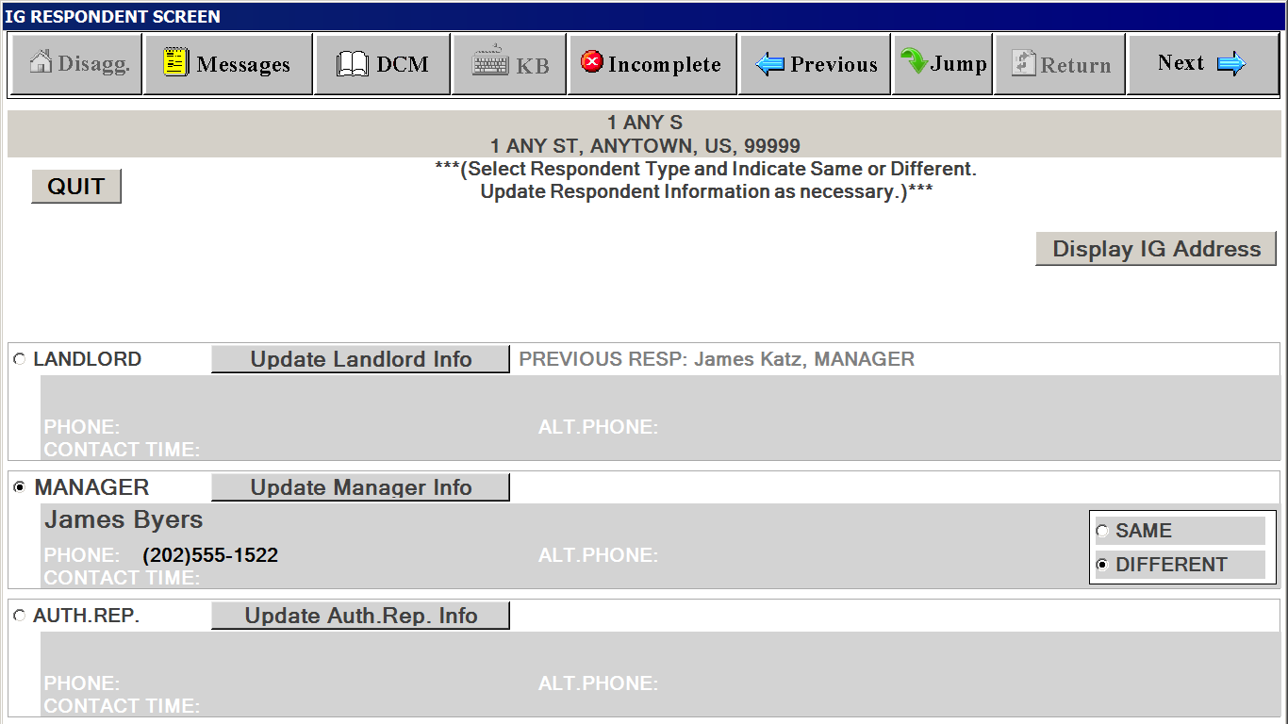

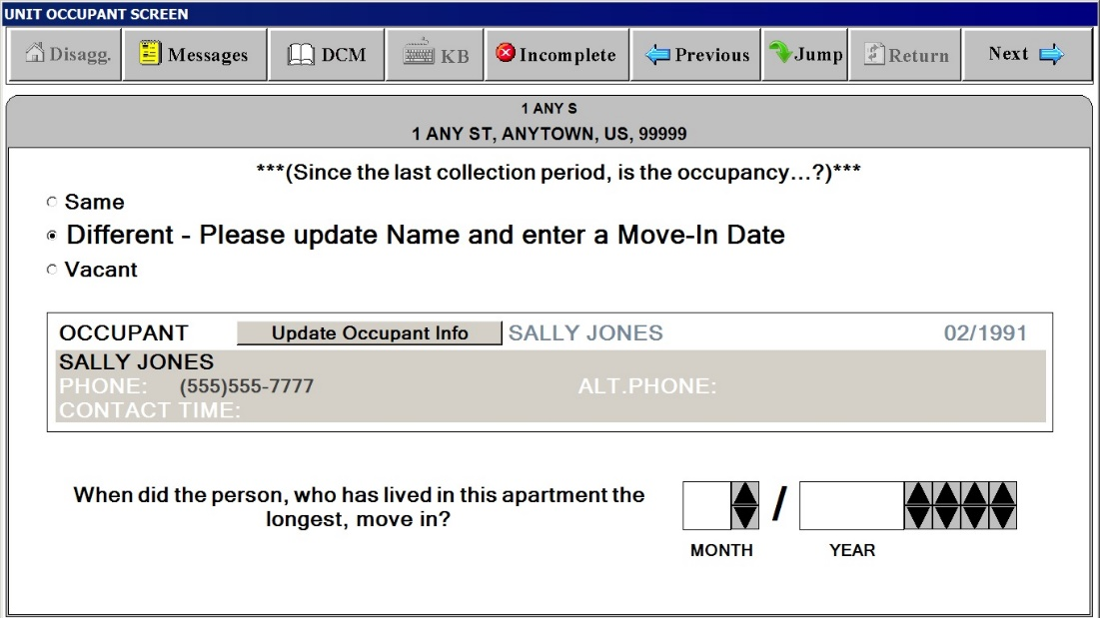

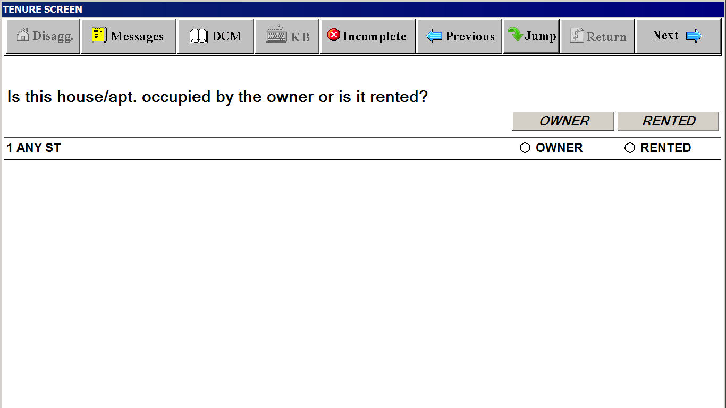

**PUBLIC HOUSING SCREEN**

**(Screen appears if data collector cannot determine if unit is public housing through observation)**

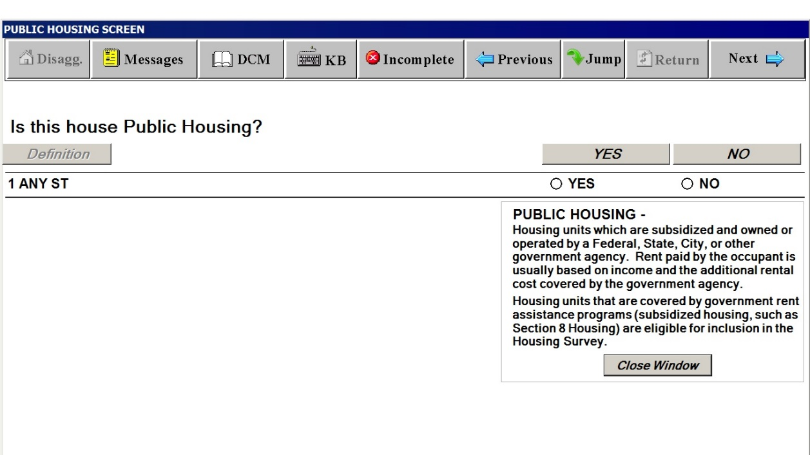

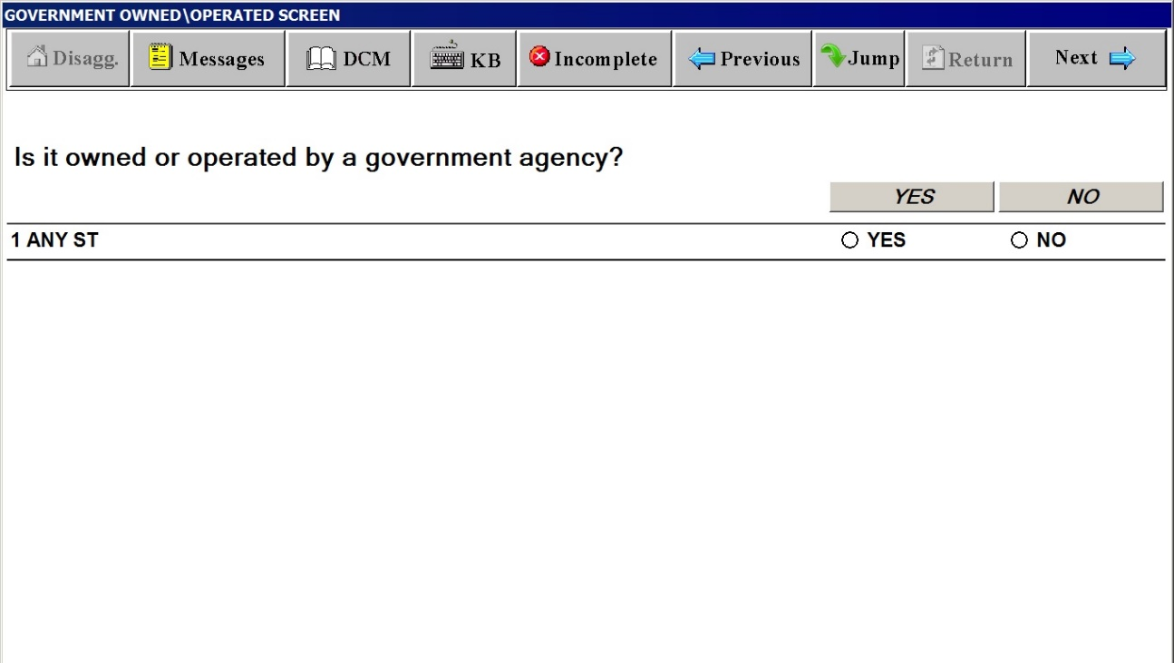

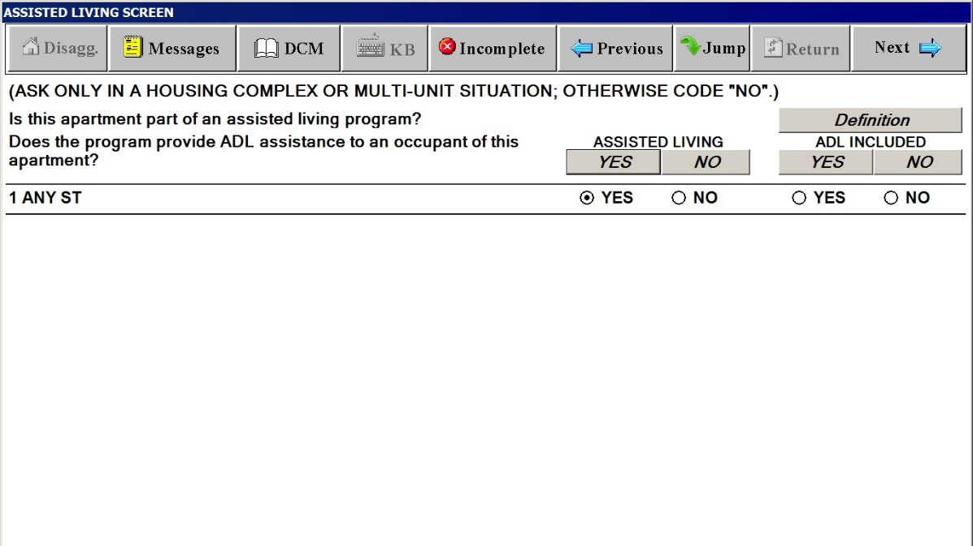

**Definitions Window for ASSISTING LIVING SCREEN**

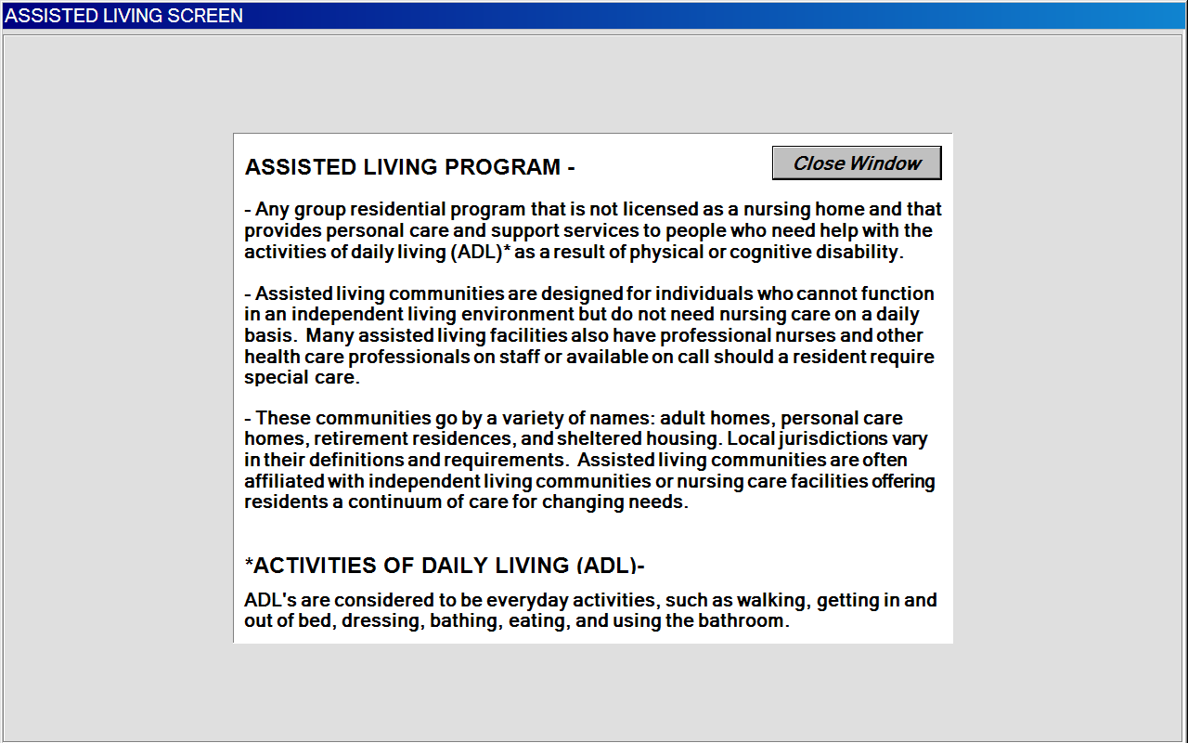

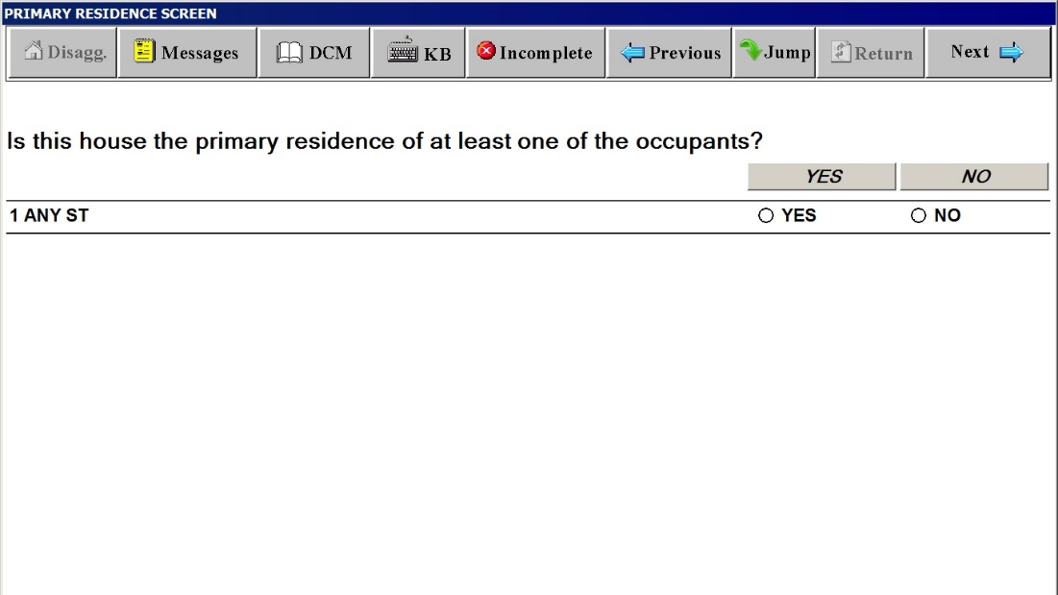

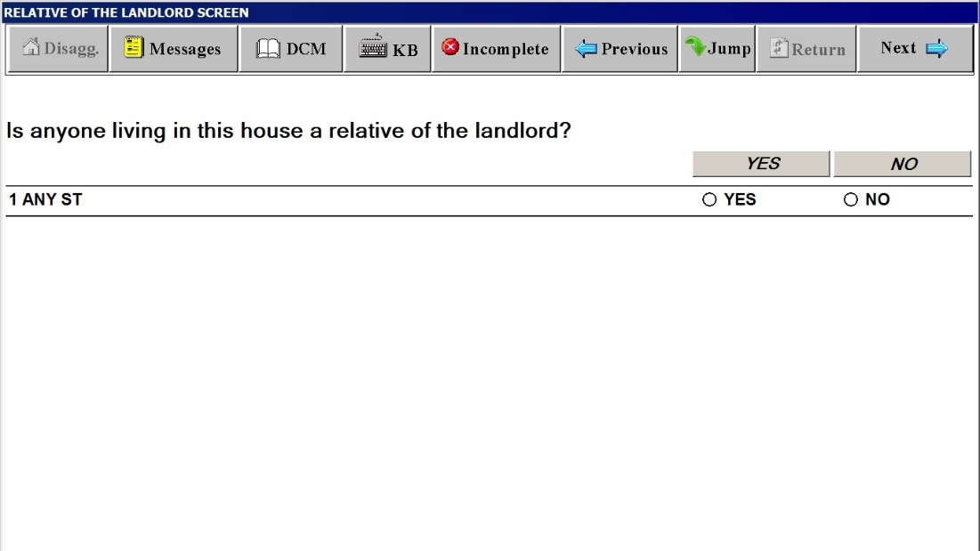

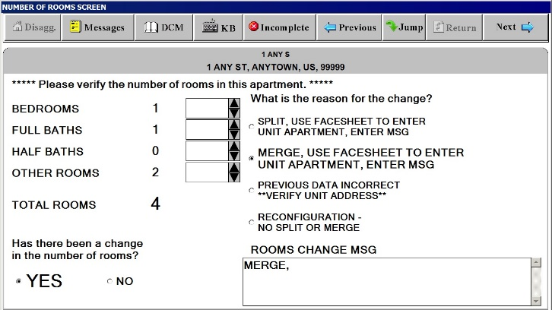

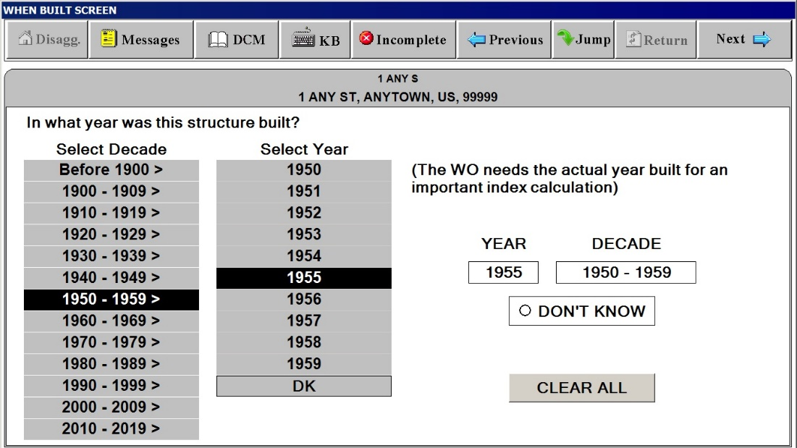

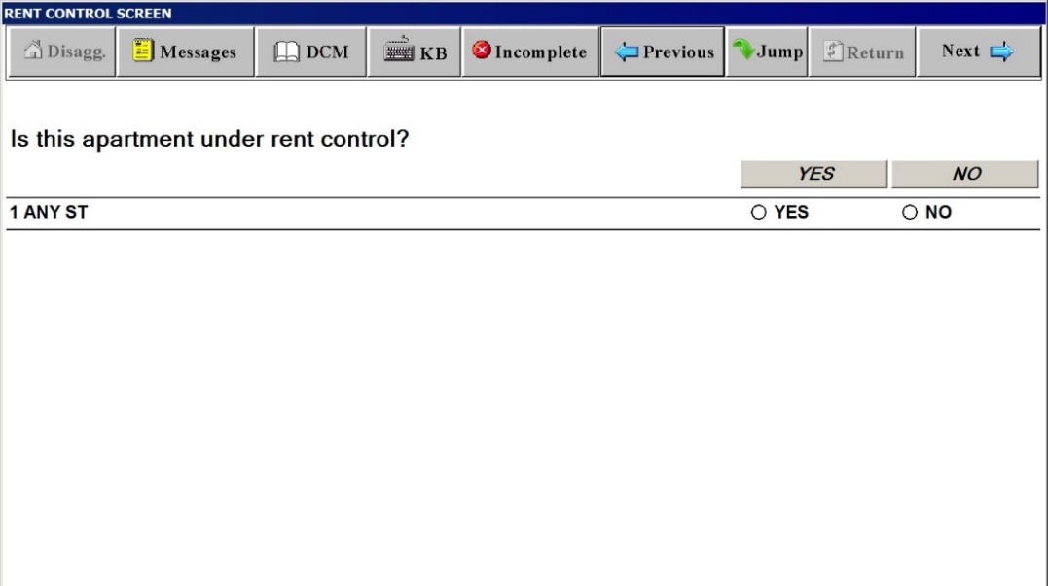

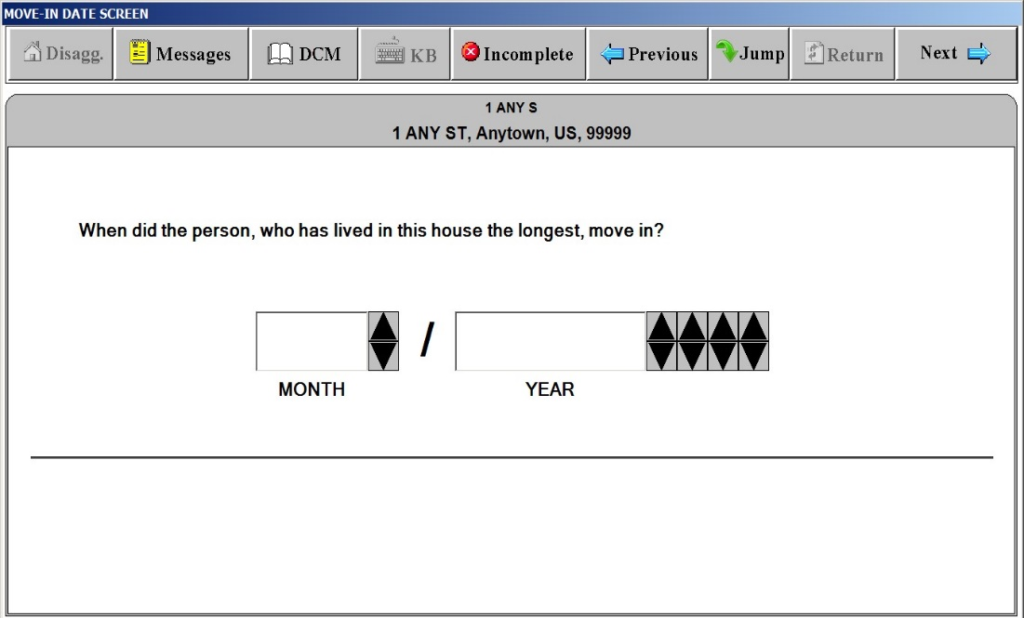

**RENT POD**

***“Respondent/Occupant” Window***

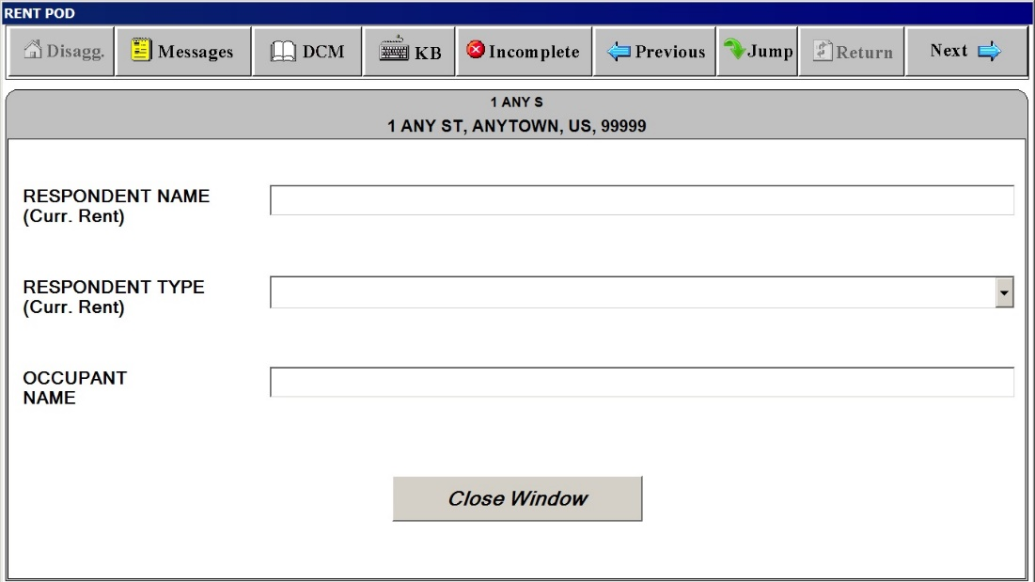

**RENT POD**

***“Rent Amount”***

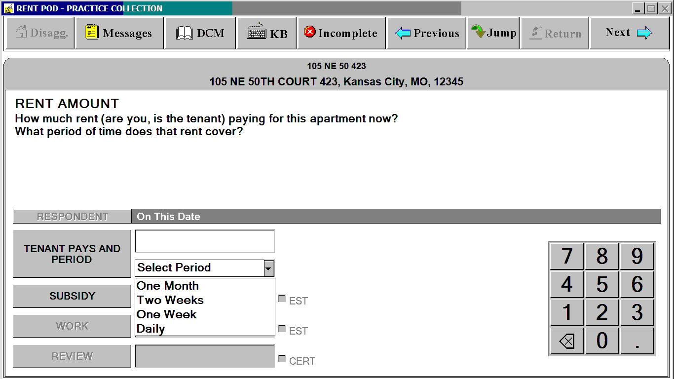

**RENT POD**

***“Subsidy”***

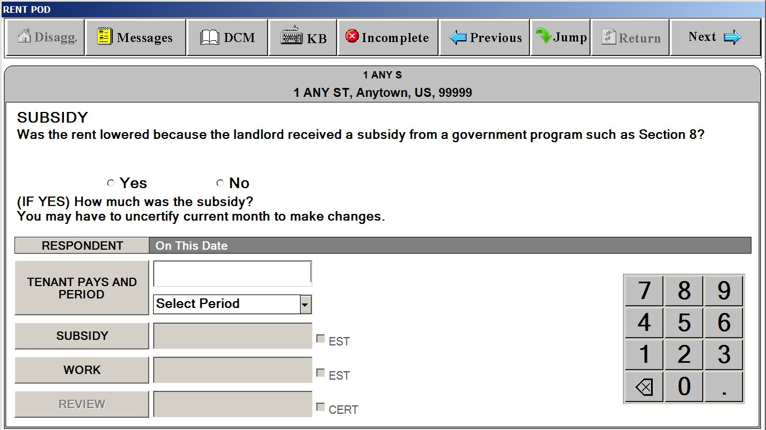

**RENT POD**

***“Work Reduction”***

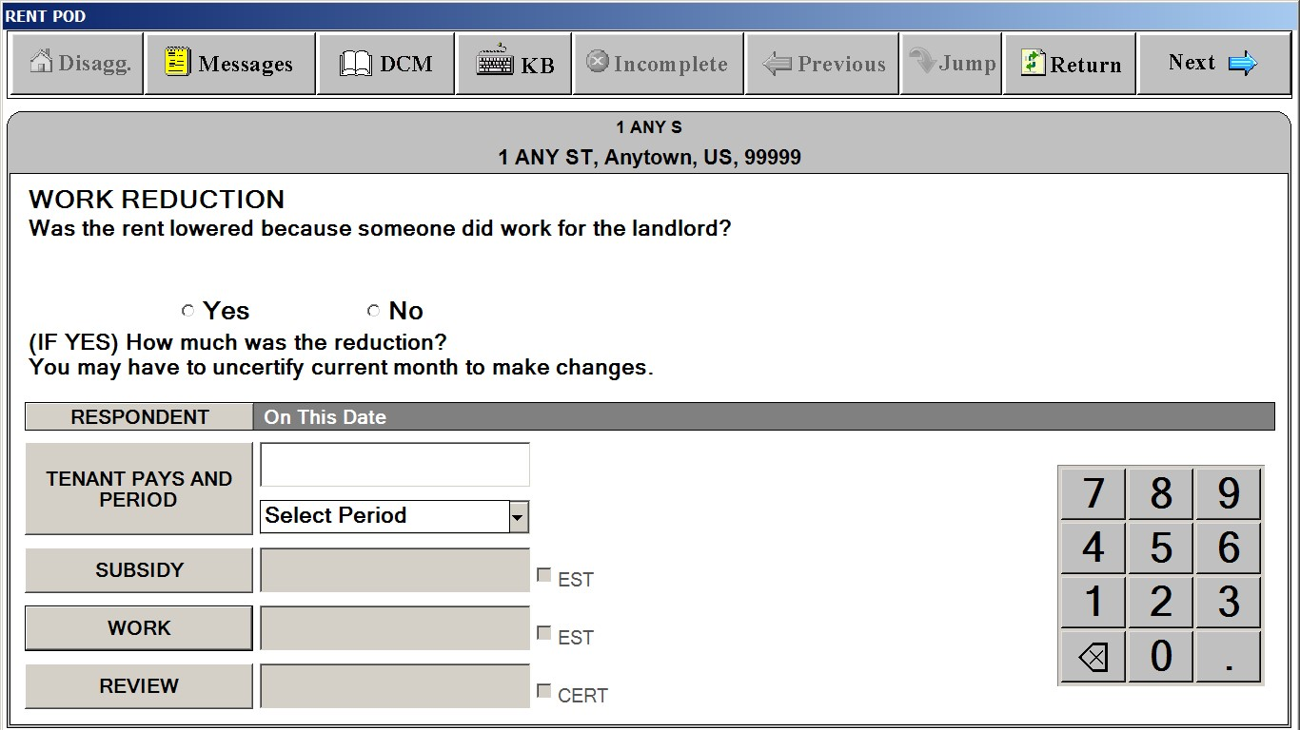

**RENT POD**

***“Review”***

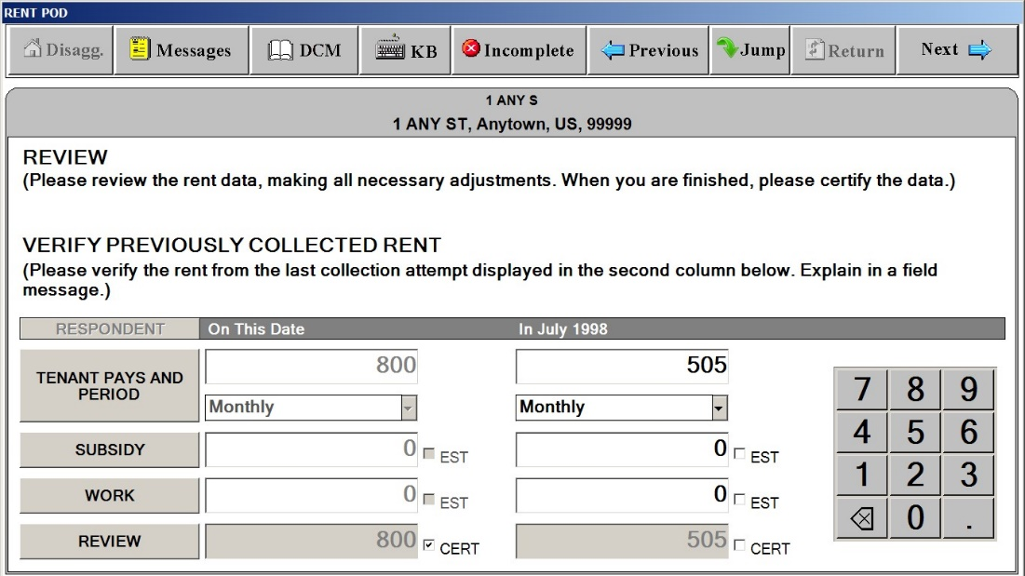

**EXTRA CHARGES SCREEN**

***“Extra Charges” Tab***

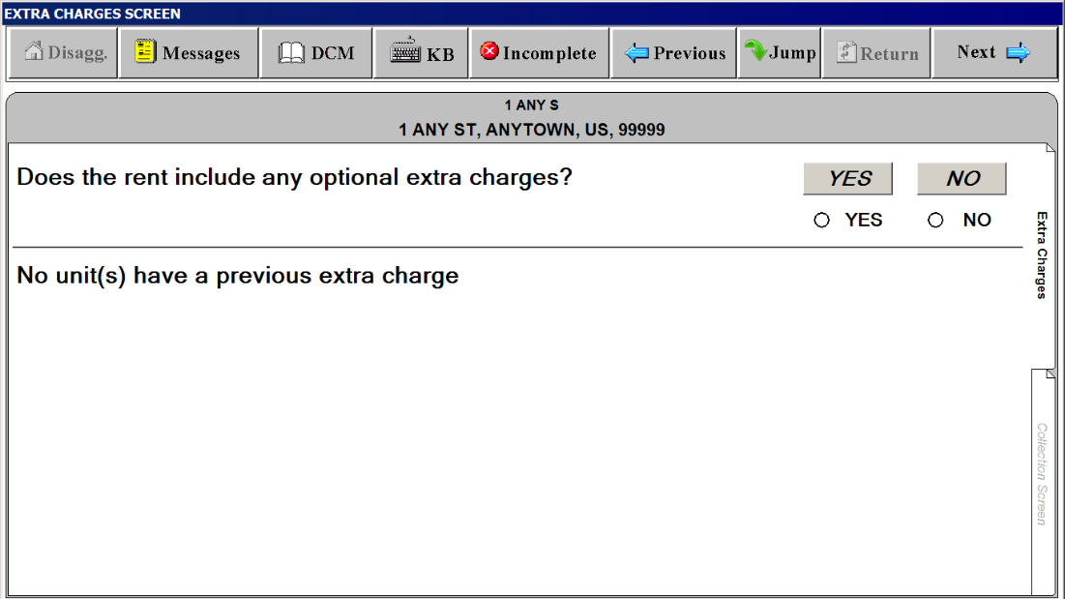

**EXTRA CHARGES SCREEN**

***“Collection Screen” Tab – SELECT EXTRA CHARGE”*** ***Window***

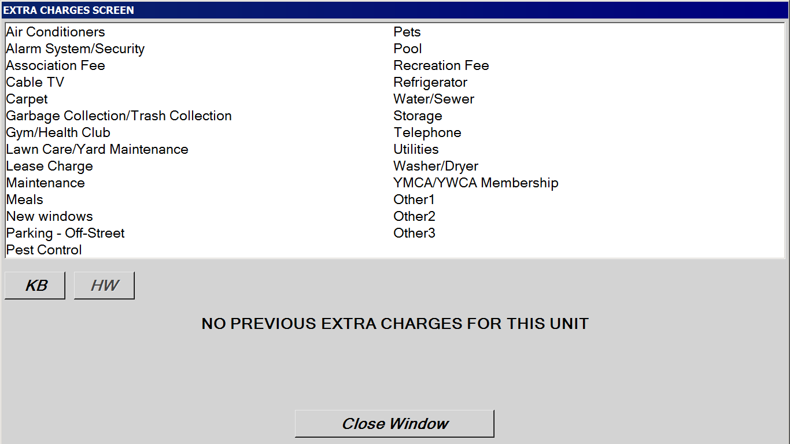

**EXTRA CHARGES SCREEN**

***“Collection Screen” Tab – Amount***

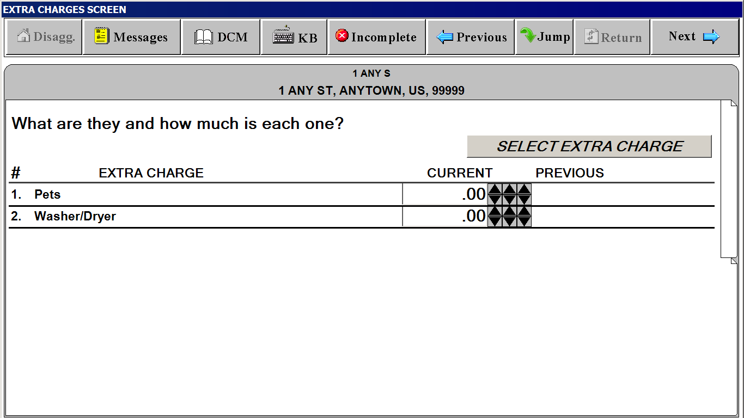

**SP CHANGES SCREEN**

**(“Last interview” date is filled in with actual month and year)**

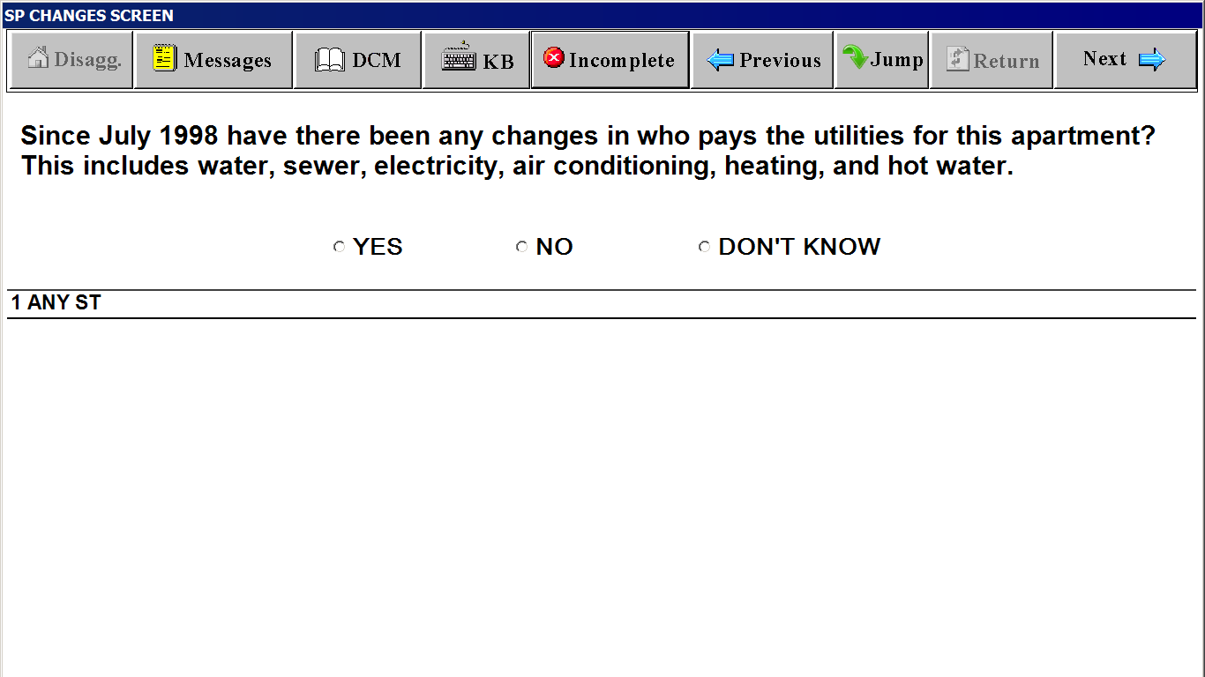

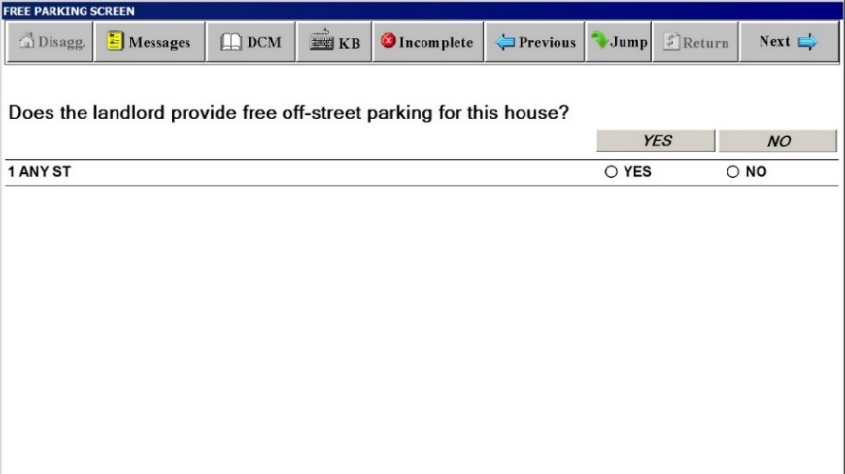

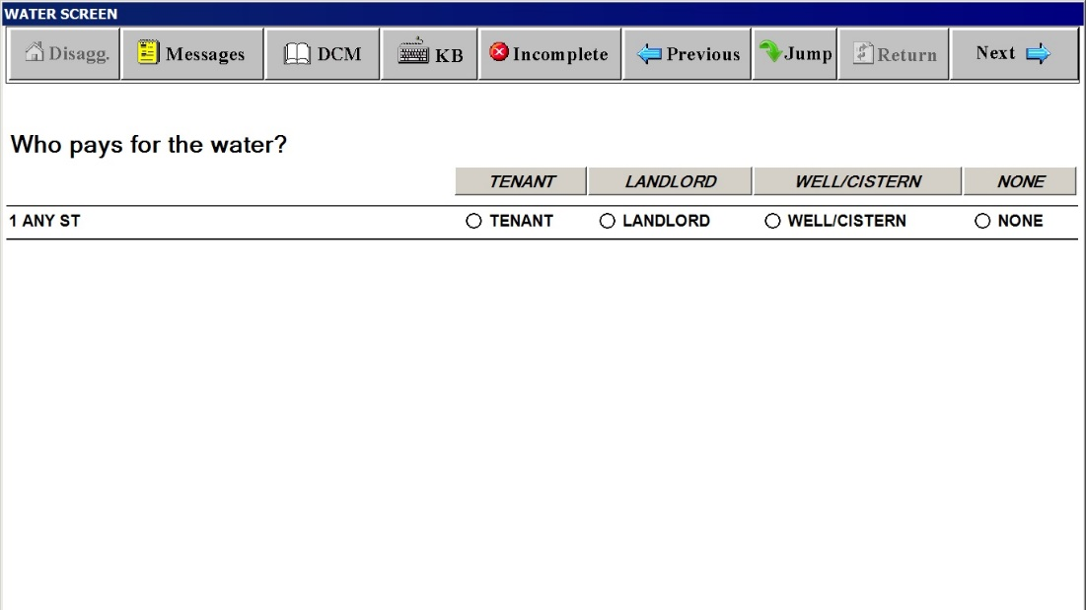

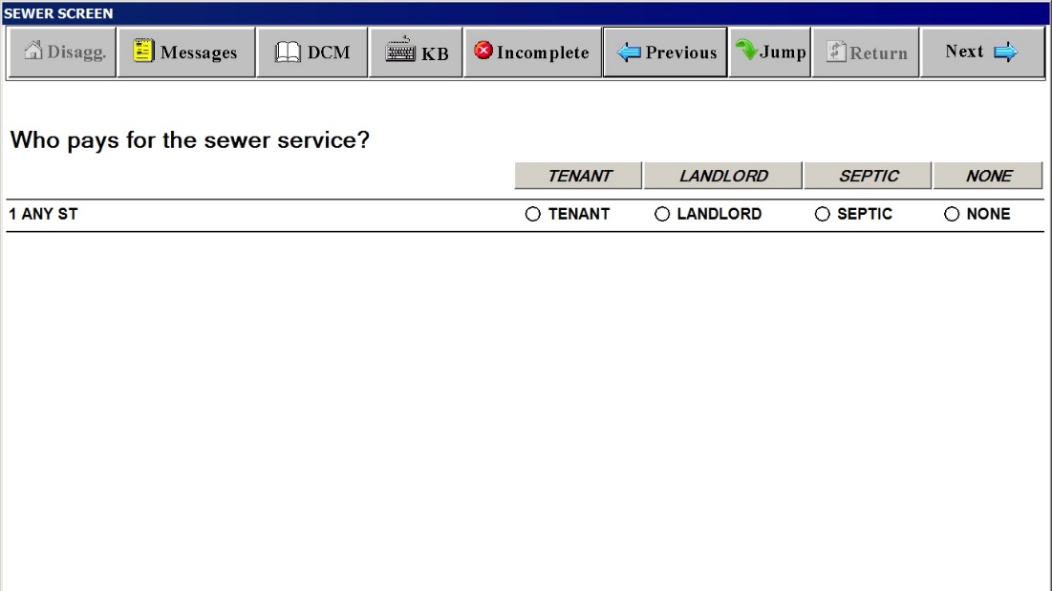

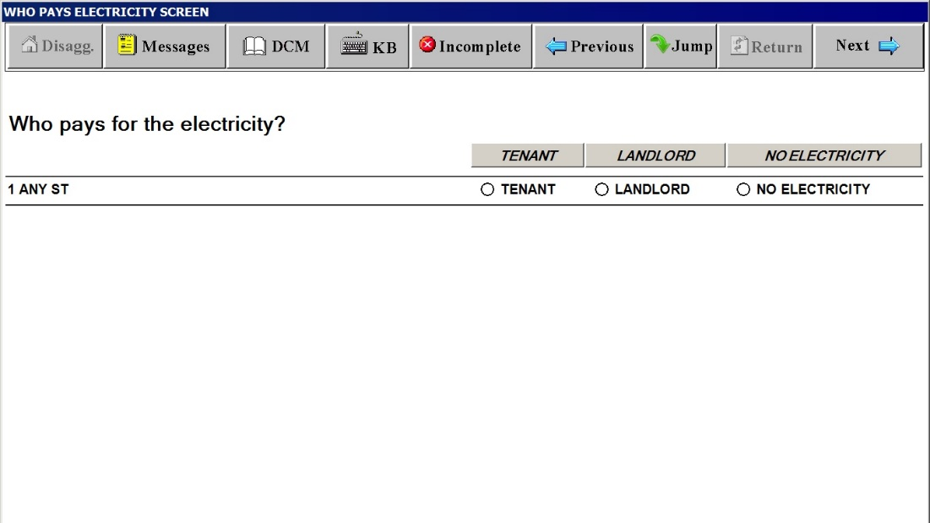

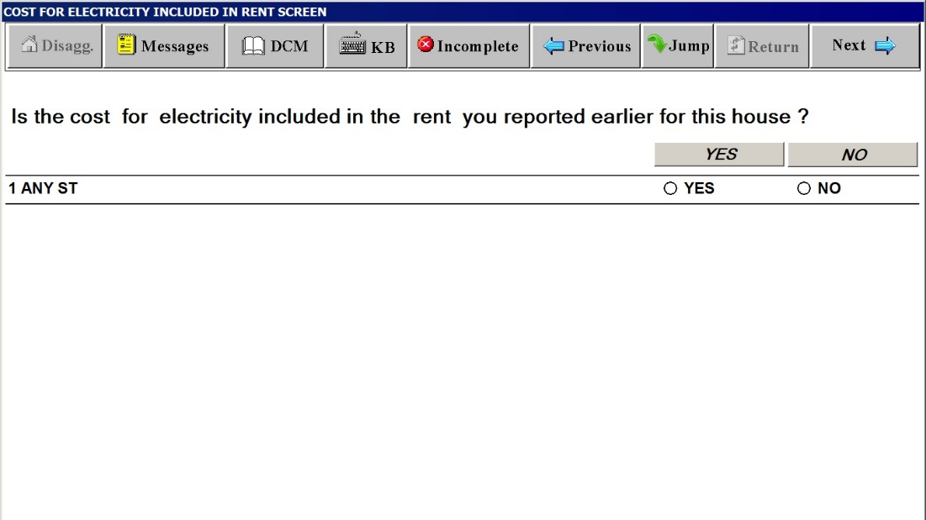

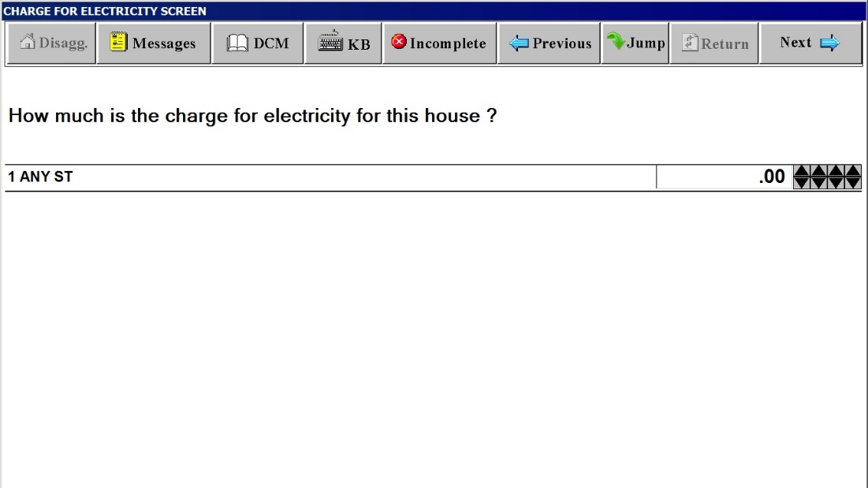

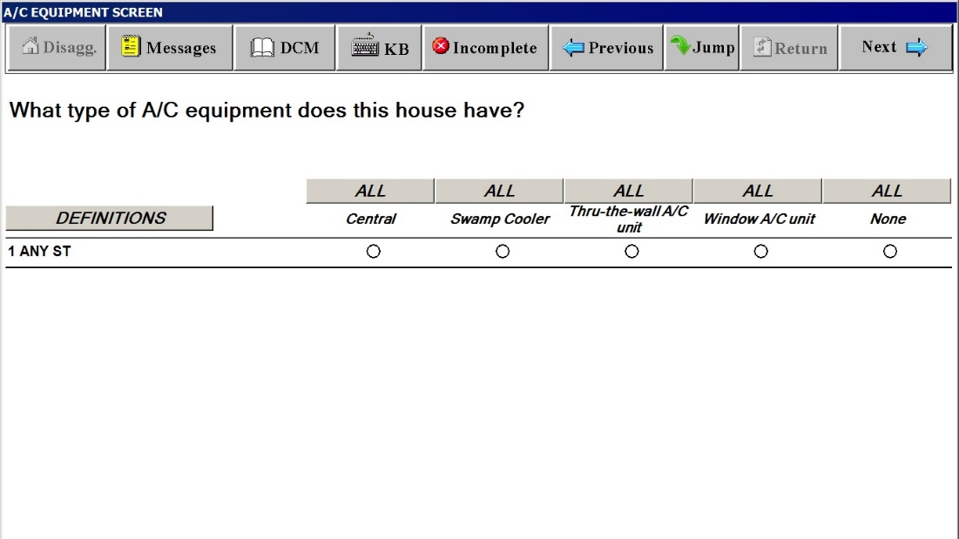

**Definitions Window for A/C EQUIPMENT SCREEN**

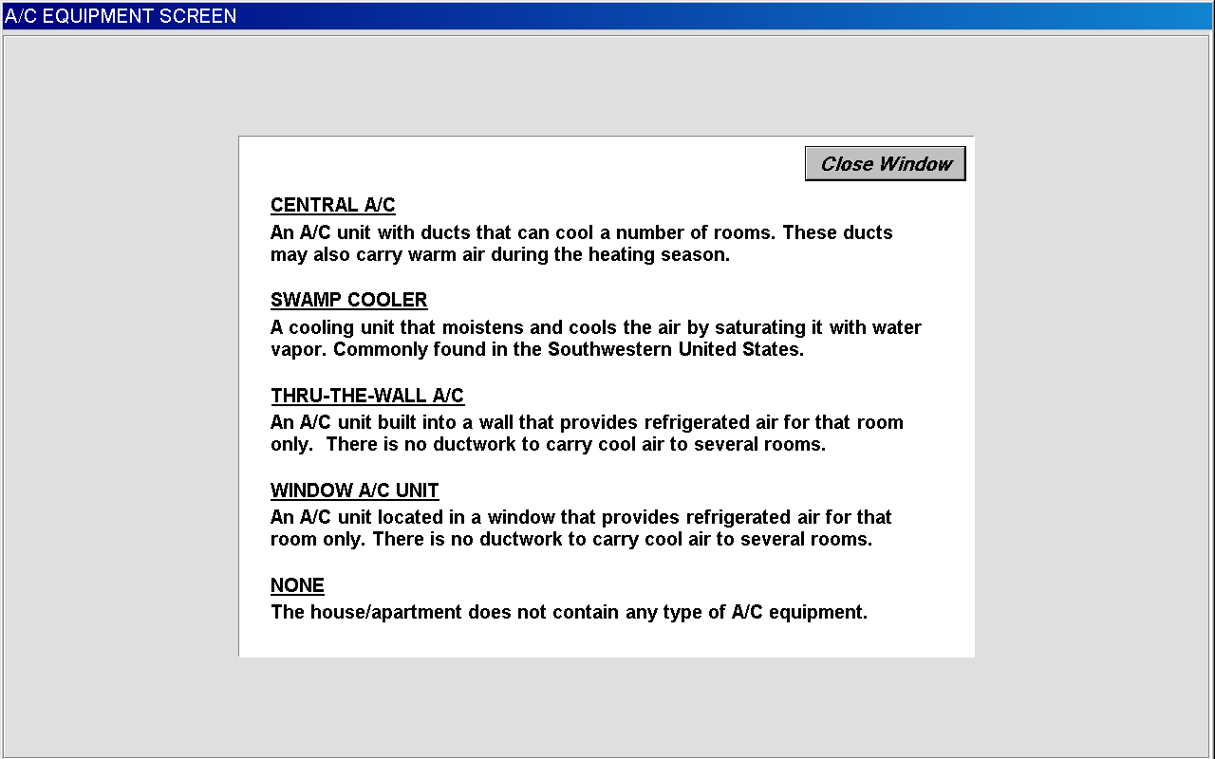

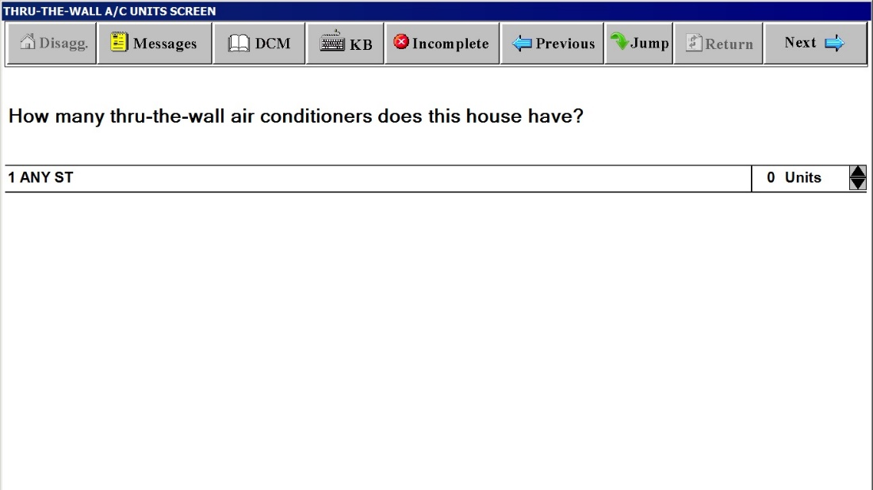

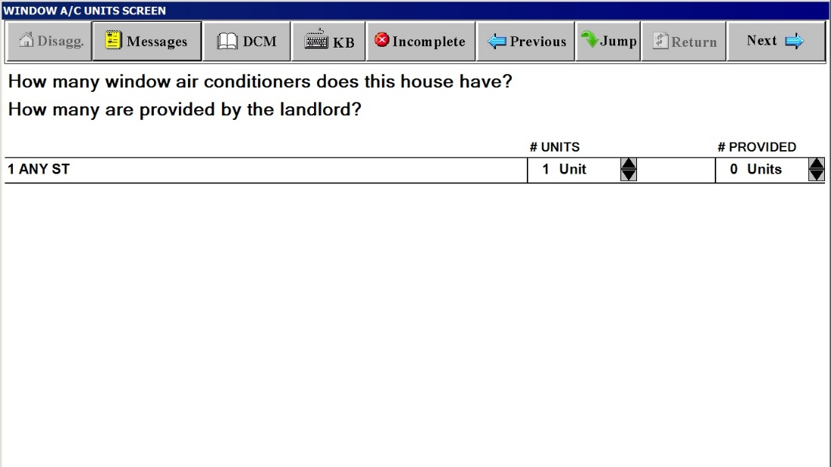

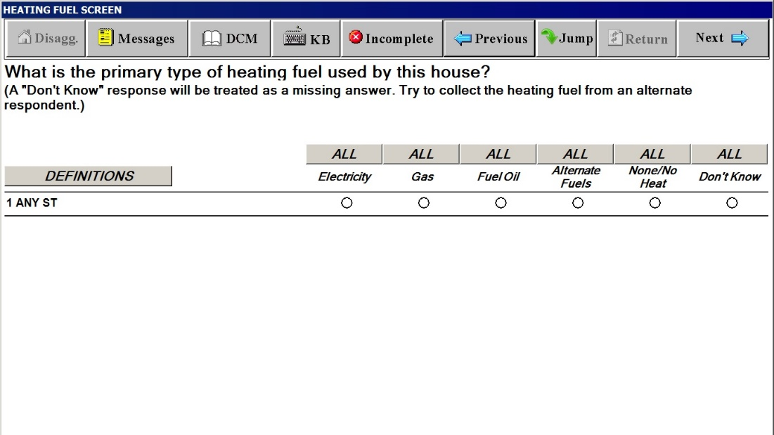

**Definitions Window for HEATING FUEL SCREEN**

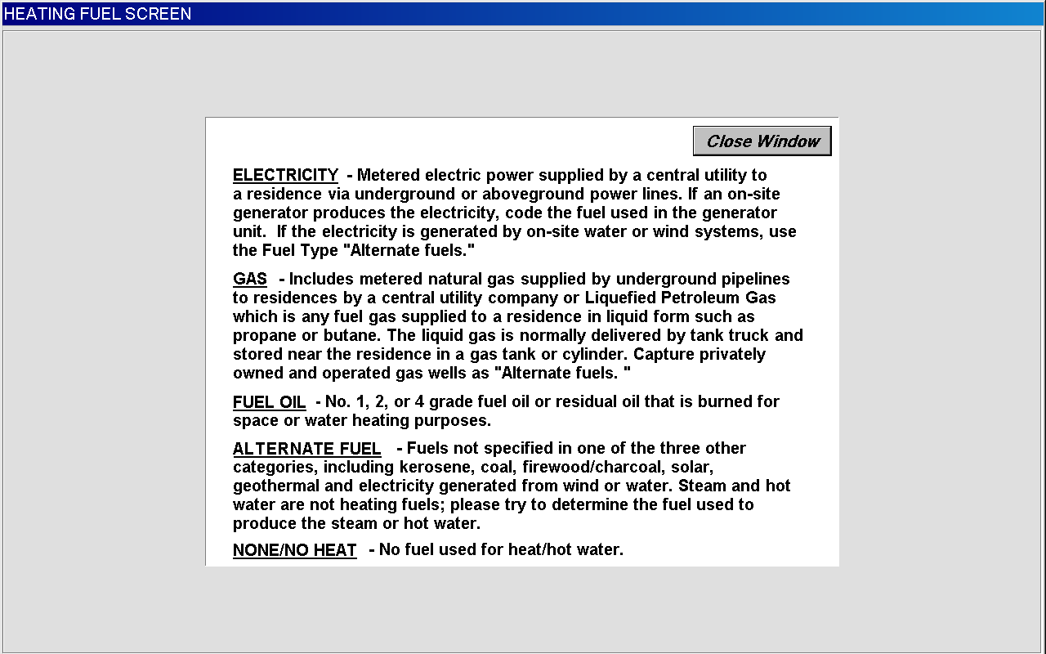

**WHO PAYS FOR HEATING FUEL SCREEN**

**(Wording substituted with selected fuel, such as “gas”, “fuel oil” or  
 “alternate fuel”)**

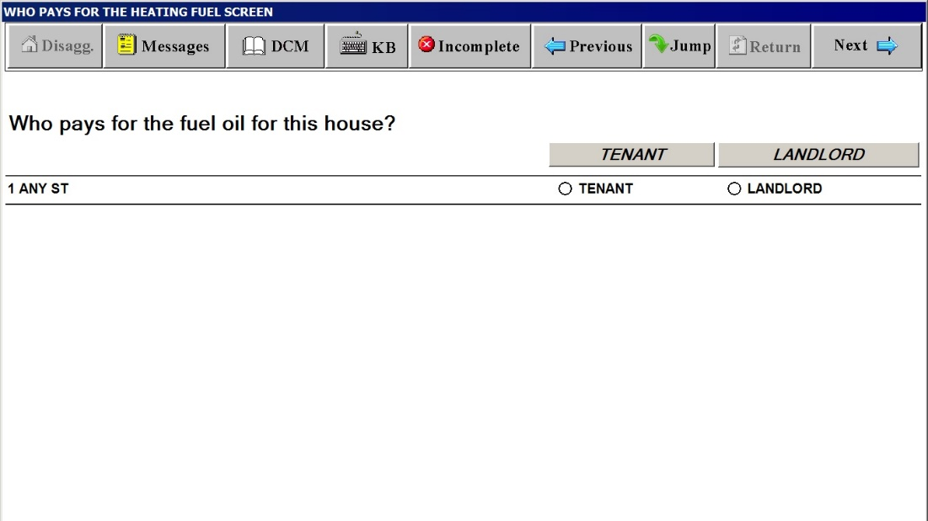

**COST FOR HEATING FUEL INCLUDED IN RENT SCREEN**

**(Wording substituted with selected fuel, such as “gas”, “fuel oil” or “alternate fuel”)**

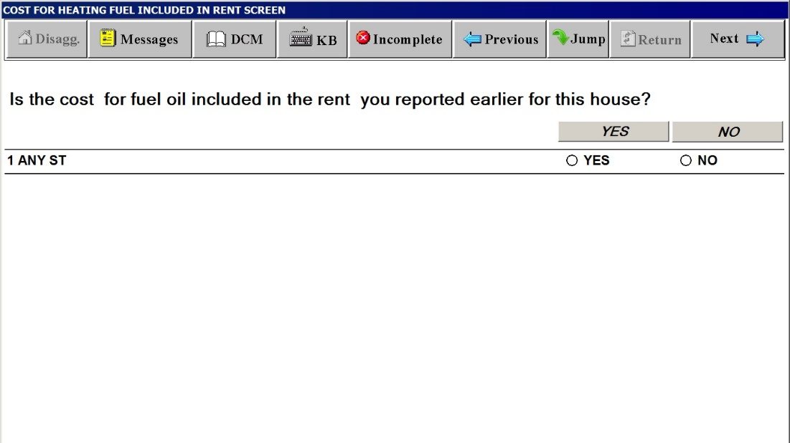

**CHARGE FOR HEATING FUEL SCREEN**

**(Wording substituted with selected fuel, such as “gas”, “fuel oil” or “alternate fuel”)**

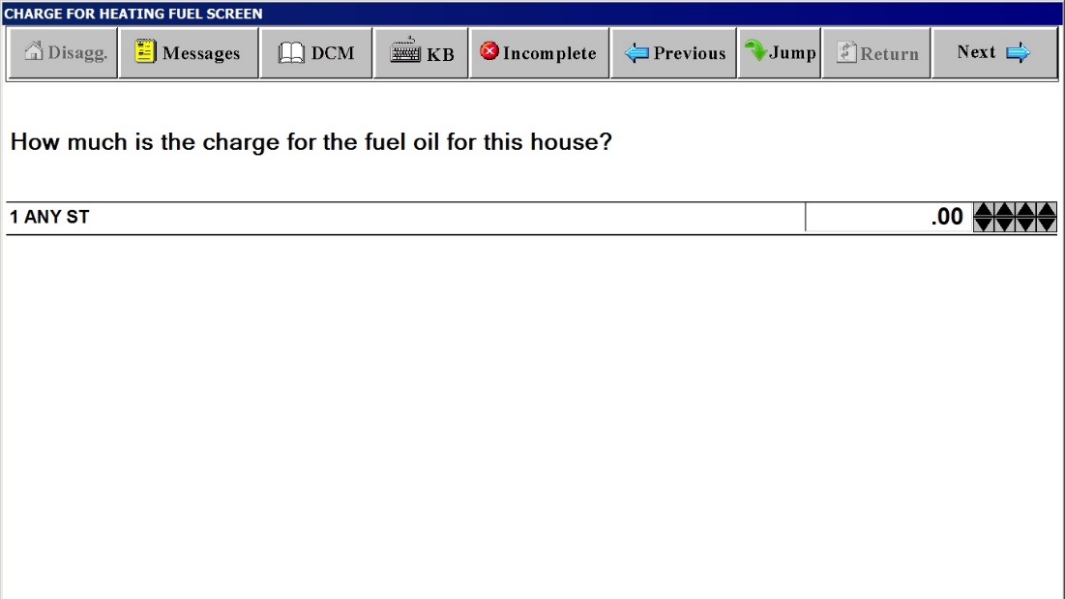

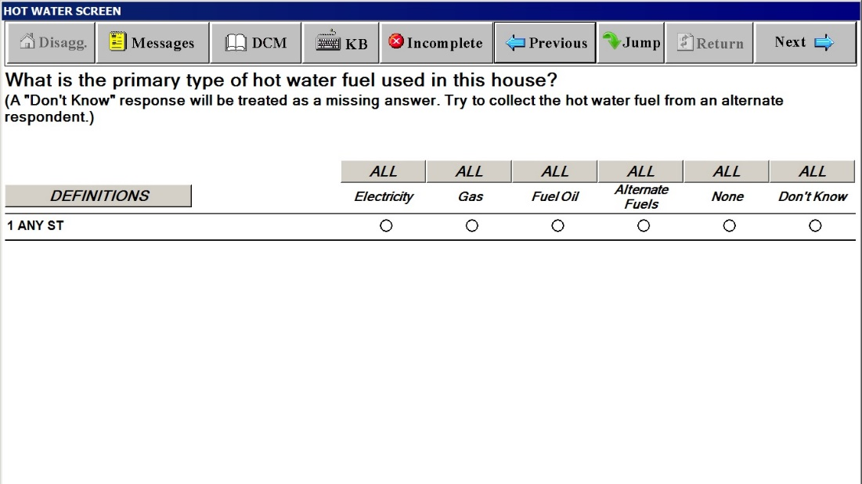

**Definitions Window for HOT WATER SCREEN**

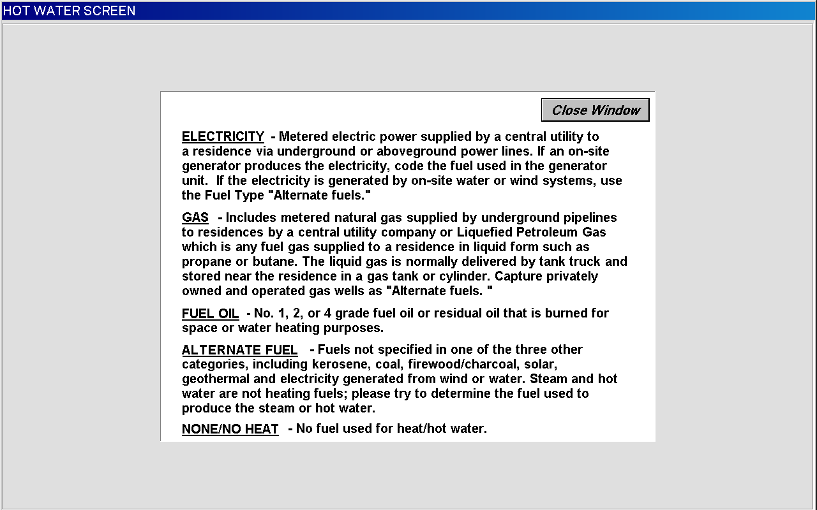

**WHO PAYS FOR THE HOT WATER FUEL SCREEN**

**(Wording substituted with selected fuel, such as “gas”, “fuel oil” or “alternate fuel”)**

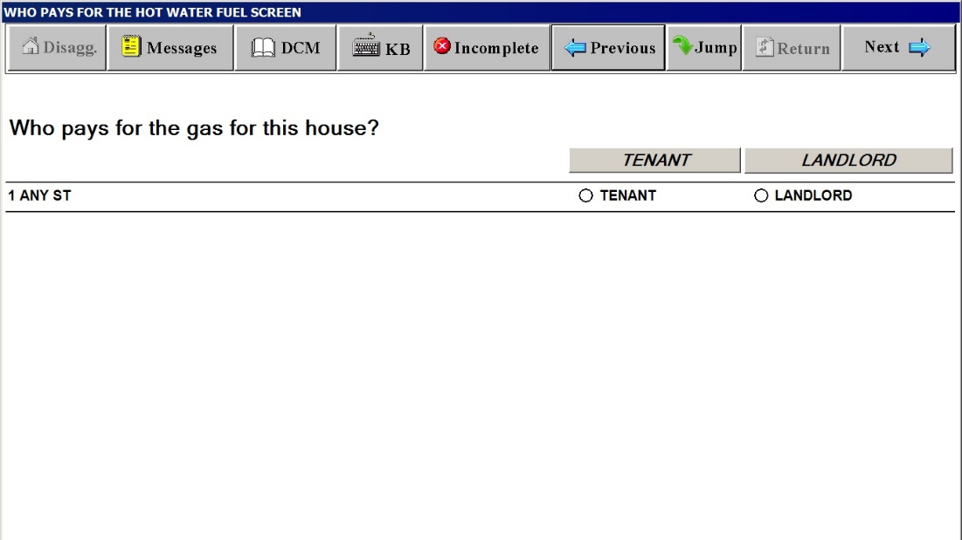

**COST FOR HOT WATER FUEL INCLUDED IN RENT SCREEN**

**(Wording substituted with selected fuel, such as “gas”, “fuel oil” or “alternate fuel”)**

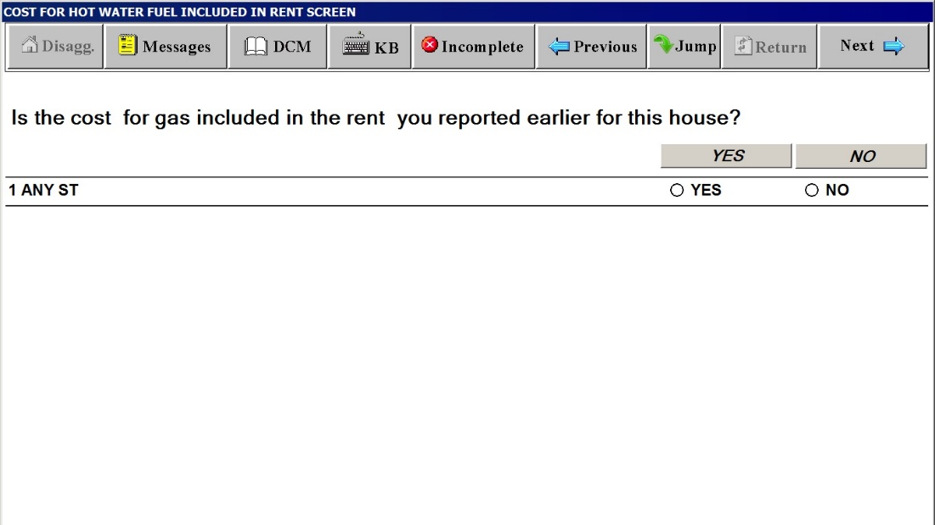

**CHARGE FOR HOT WATER FUEL SCREEN**

**(Wording substituted with selected fuel, such as “gas”, “fuel oil” or “alternate fuel”)**

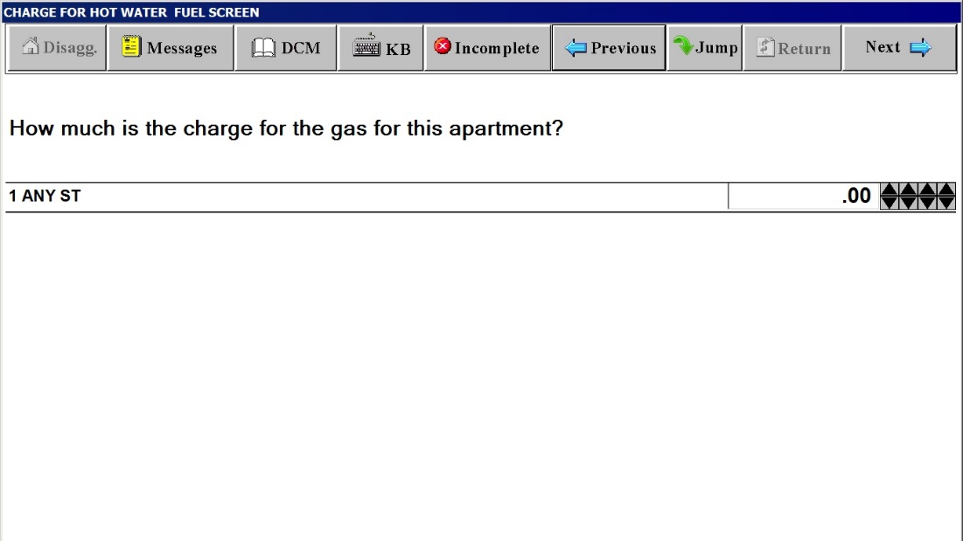

**INCOMPLETE INTERVIEW POD DURING SCOPE DETERMINATION**

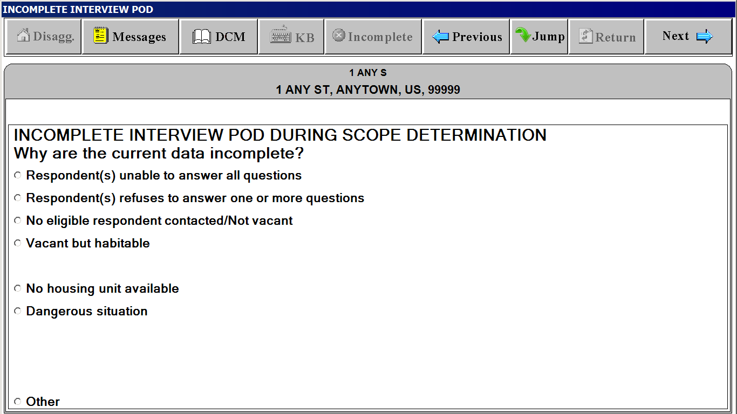

**INCOMPLETE INTERVIEW POD DURING INITIATION/PRICING**

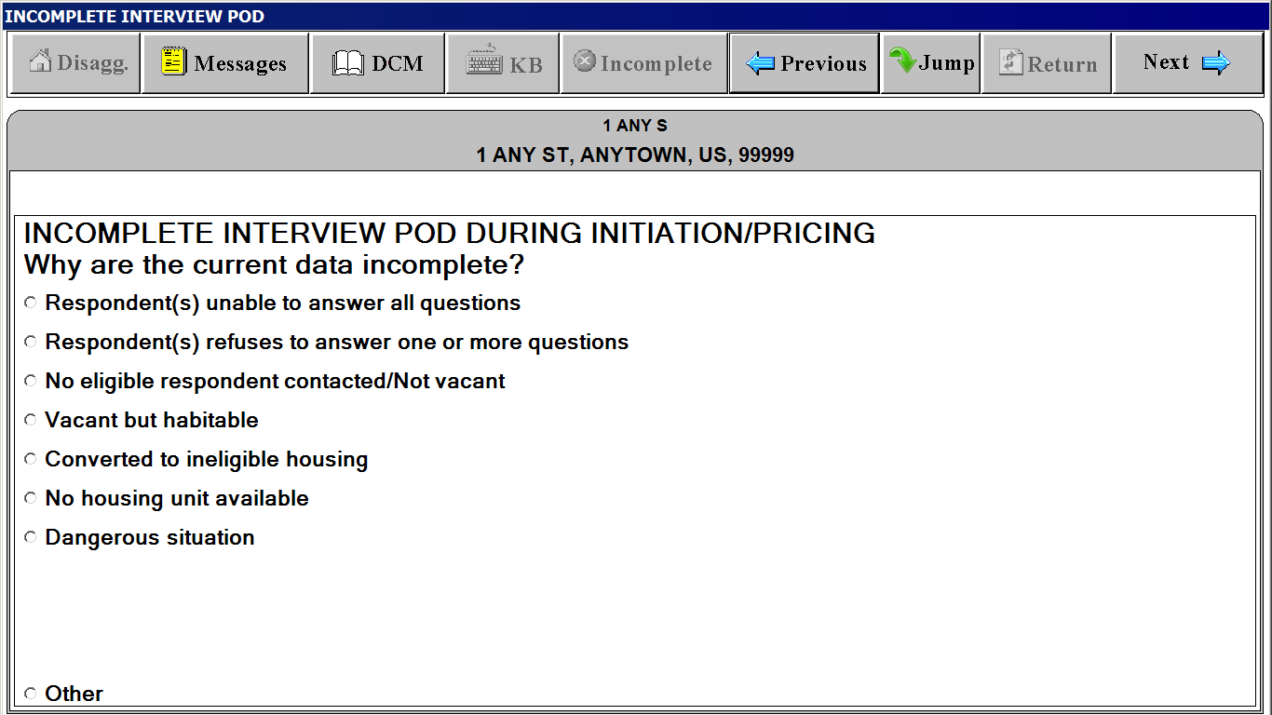

**UNIT SI FACESHEET and UNIT FACESHEET**

**(Basically have the same content but different screen titles)**

***“Unit” Tab***

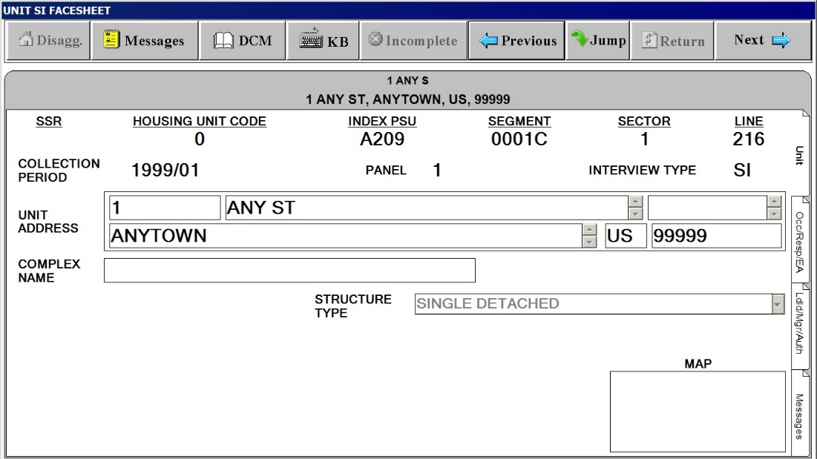

**UNIT SI FACESHEET and UNIT FACESHEET**

**(Basically have the same content but different screen titles)**

***“Occ/Resp/EA” Tab***

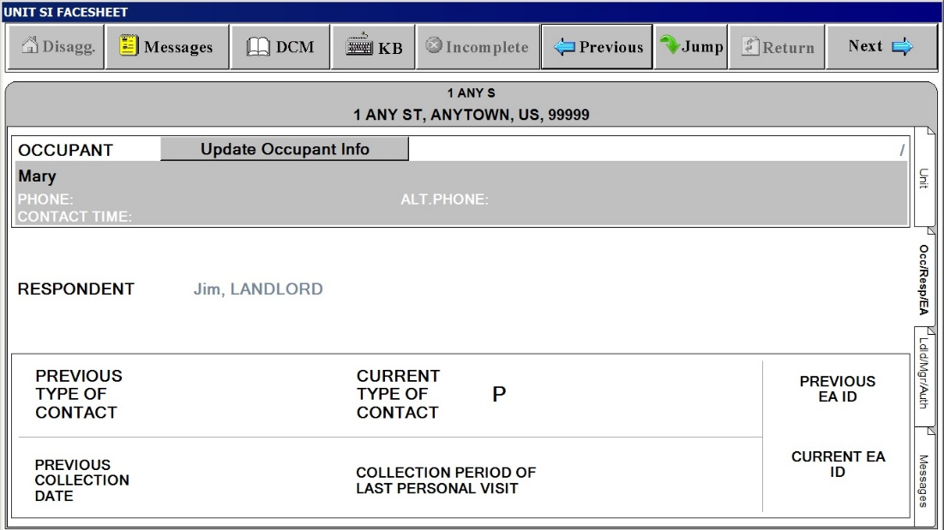

**UNIT SI FACESHEET and UNIT FACESHEET**

**(Basically have the same content but different screen titles)**

***“Ldld/Mgr/Auth.” Tab***

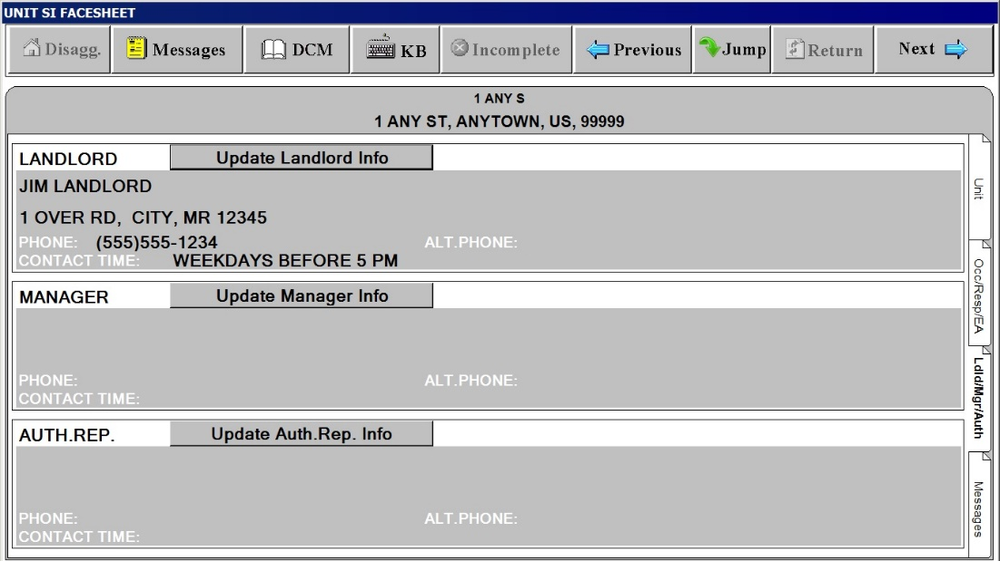

**UNIT SI FACESHEET and UNIT FACESHEET**

**(Basically have the same content but different screen titles)**

***“Messages” Tab***

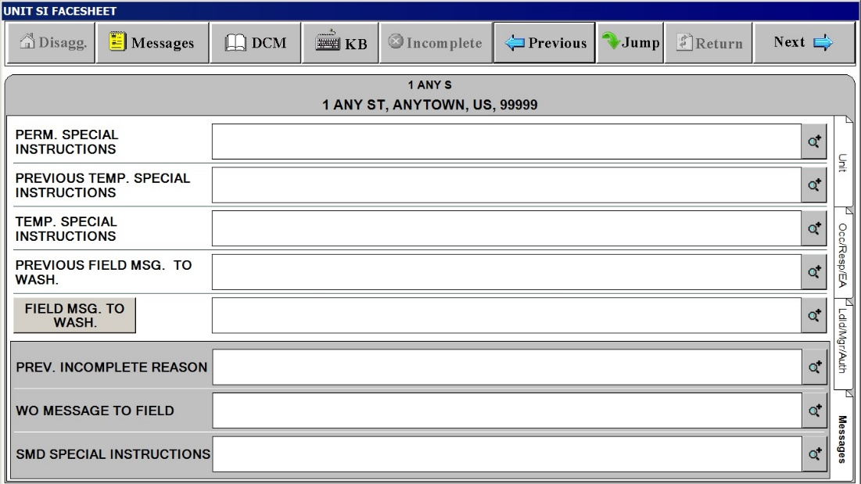**UNIT SI FACESHEET and UNIT FACESHEET**

**(Basically have the same content but different screen titles)**

***Field MSG. TO WASH. Button on the“Messages” Tab. Tap this to display standardized field message to Washington***

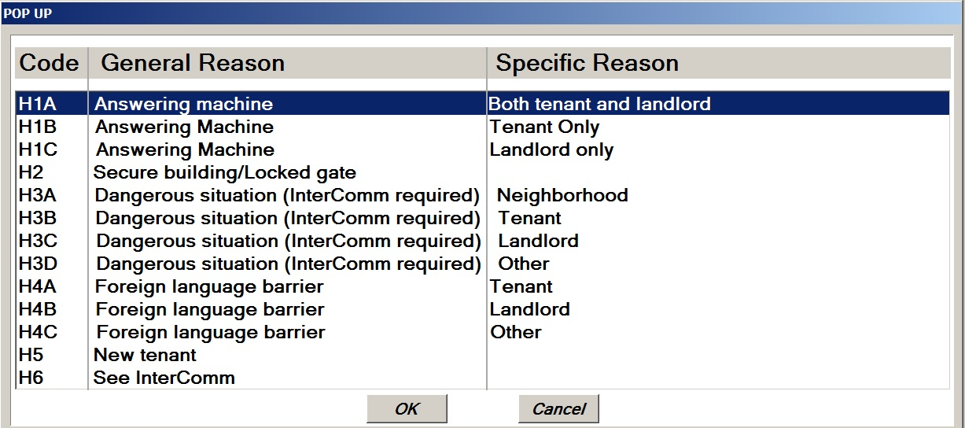

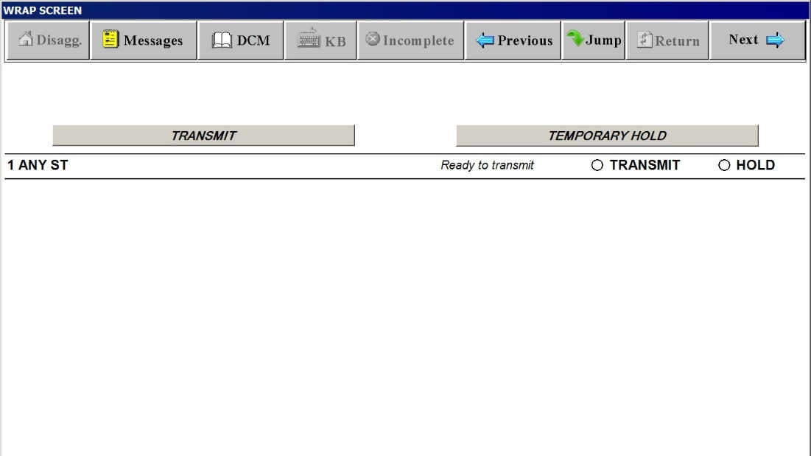

**JUMP Screen with JUMP MENU**

