Housing Collection Instrument Screen Shots
Last Modified: April 19, 2018

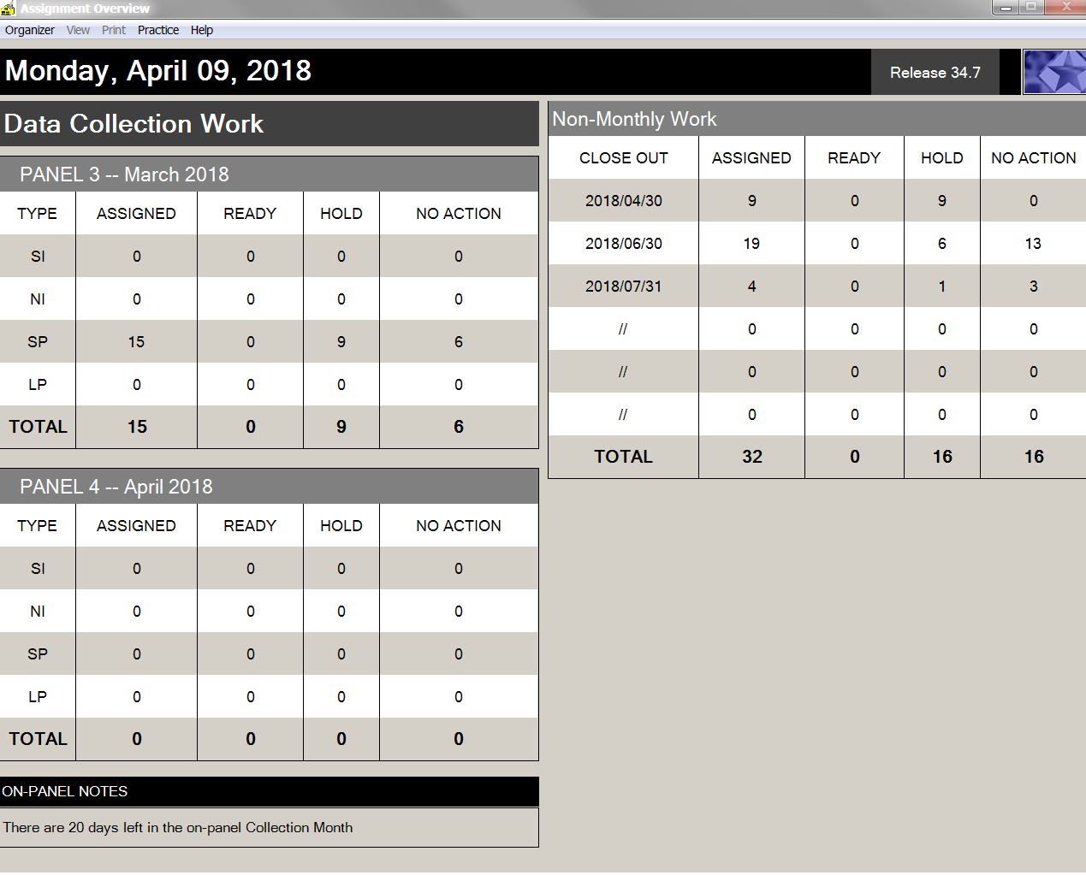

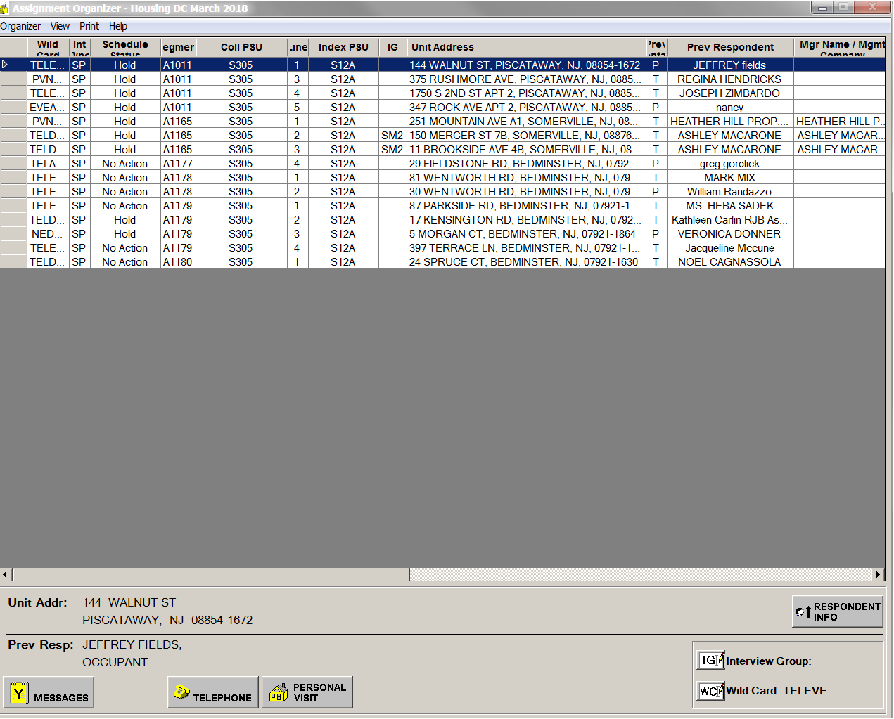

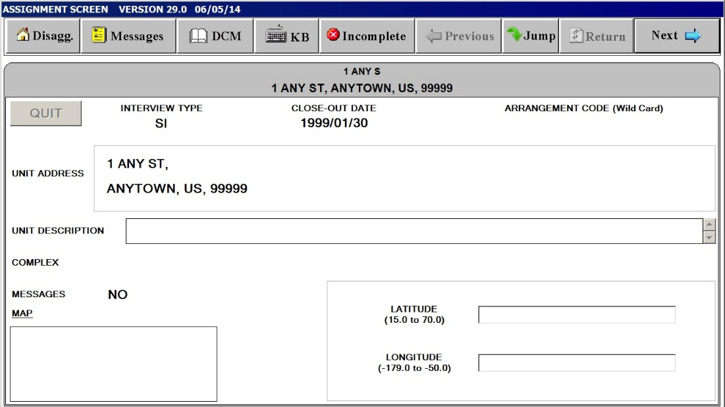
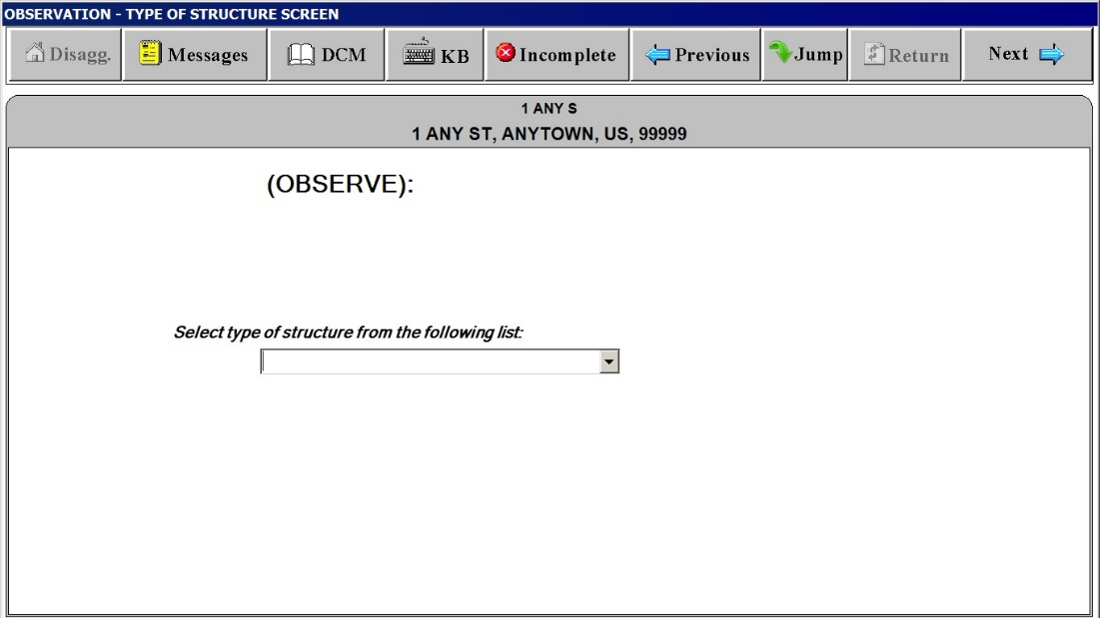

The following 2 screen shots are non-substantive changes to the housing survey questions that OMB approved in August 2017. The non-substantive changes were supposed to be updated in January 2018 but due to lack of resources the changes will not be updated until FY19.
“Type of Structure”
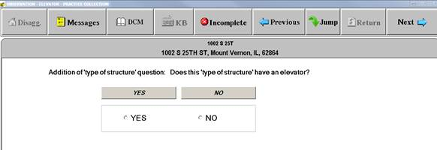
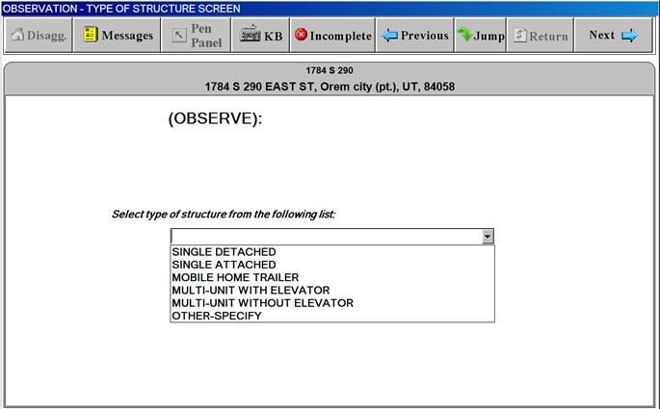

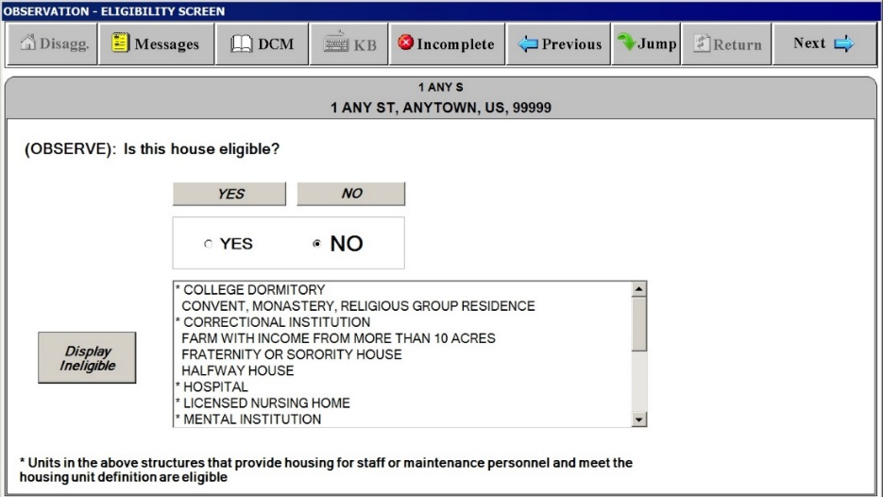

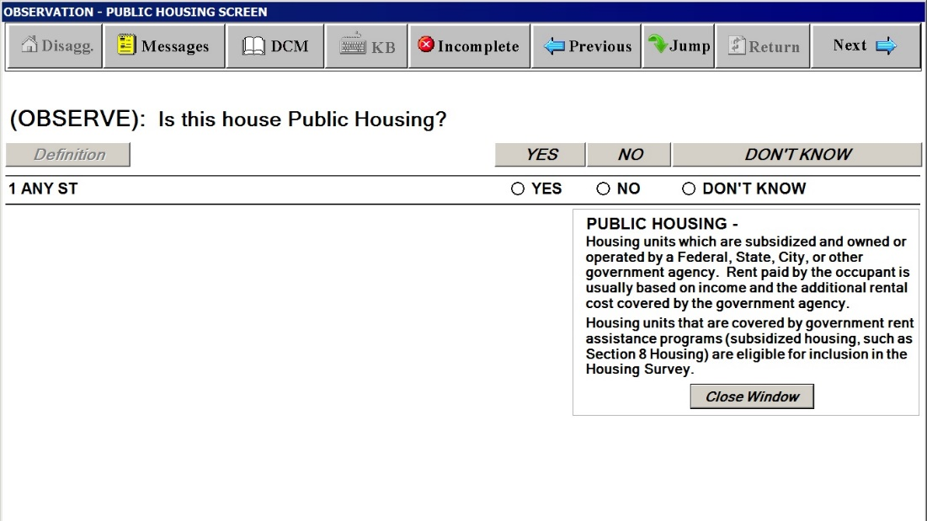

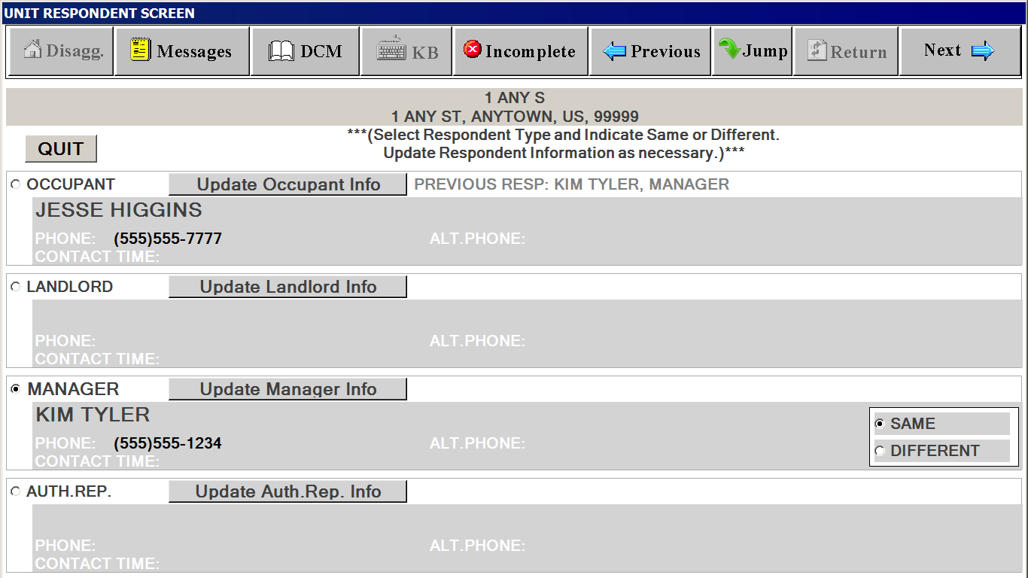

Respondent Screen for Interview Groups
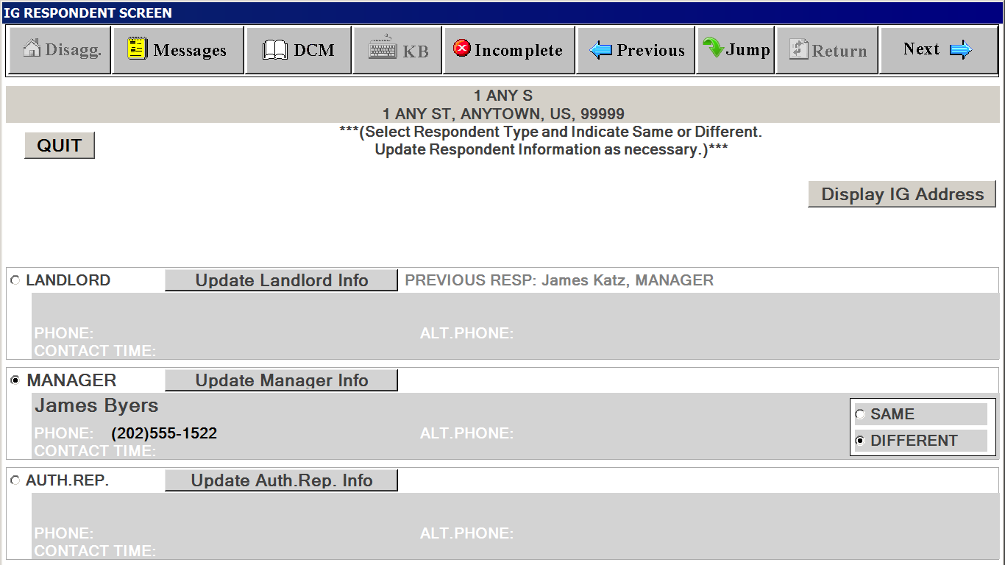

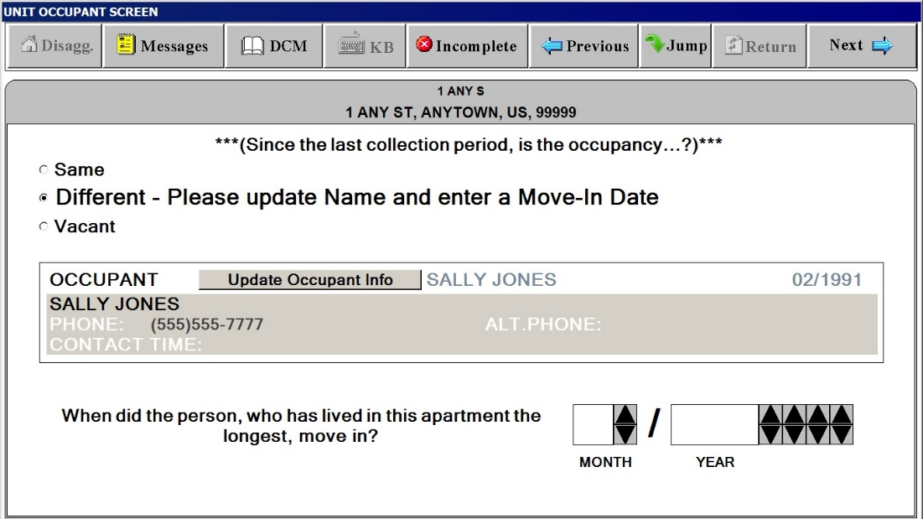

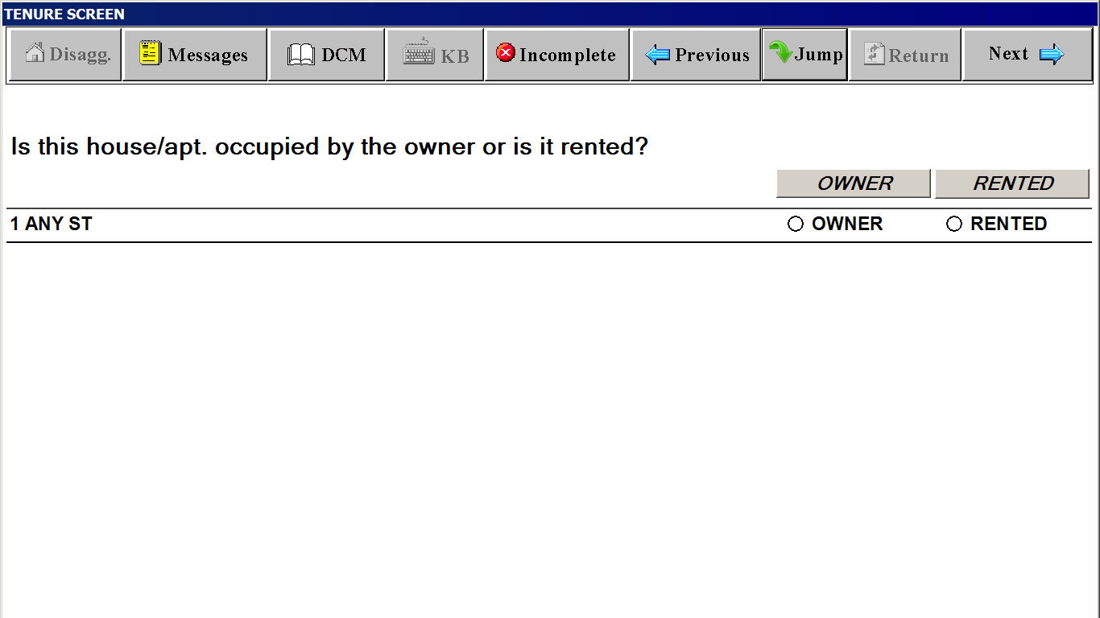

PUBLIC HOUSING SCREEN
(Screen appears if data collector cannot determine if unit is public housing through observation)
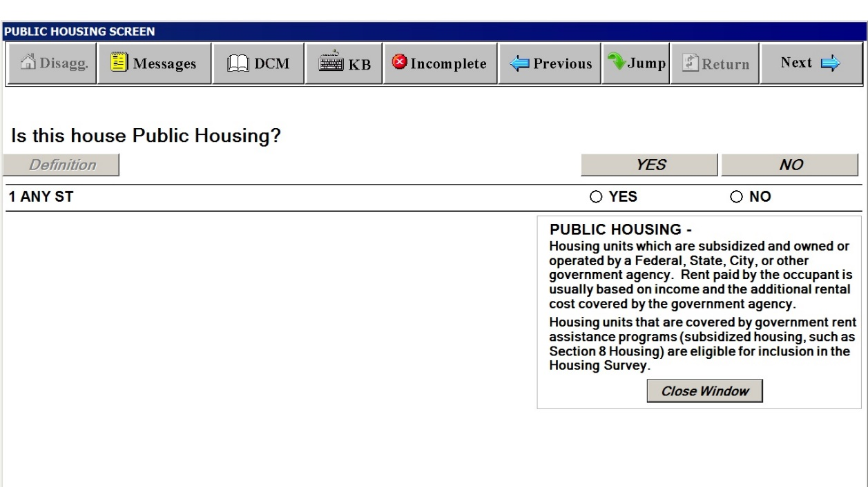

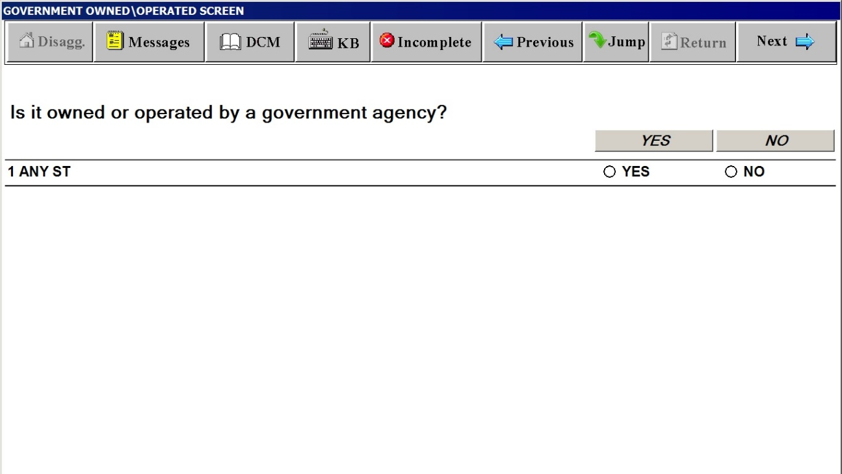

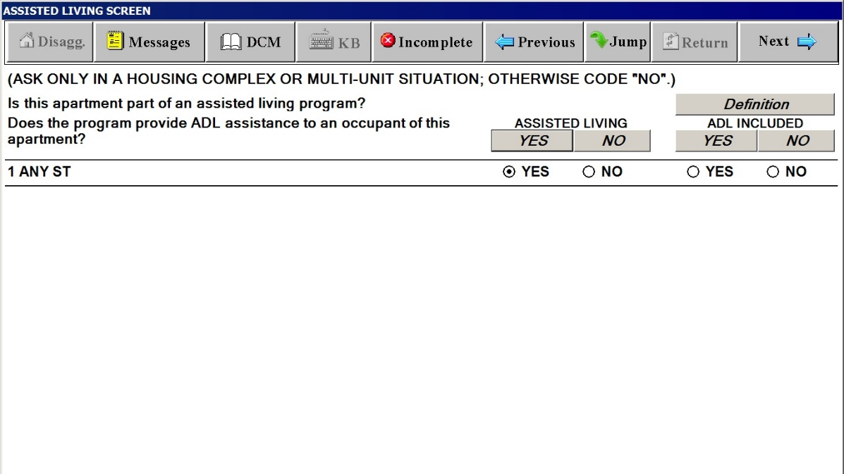

Definitions Window for ASSISTING LIVING SCREEN
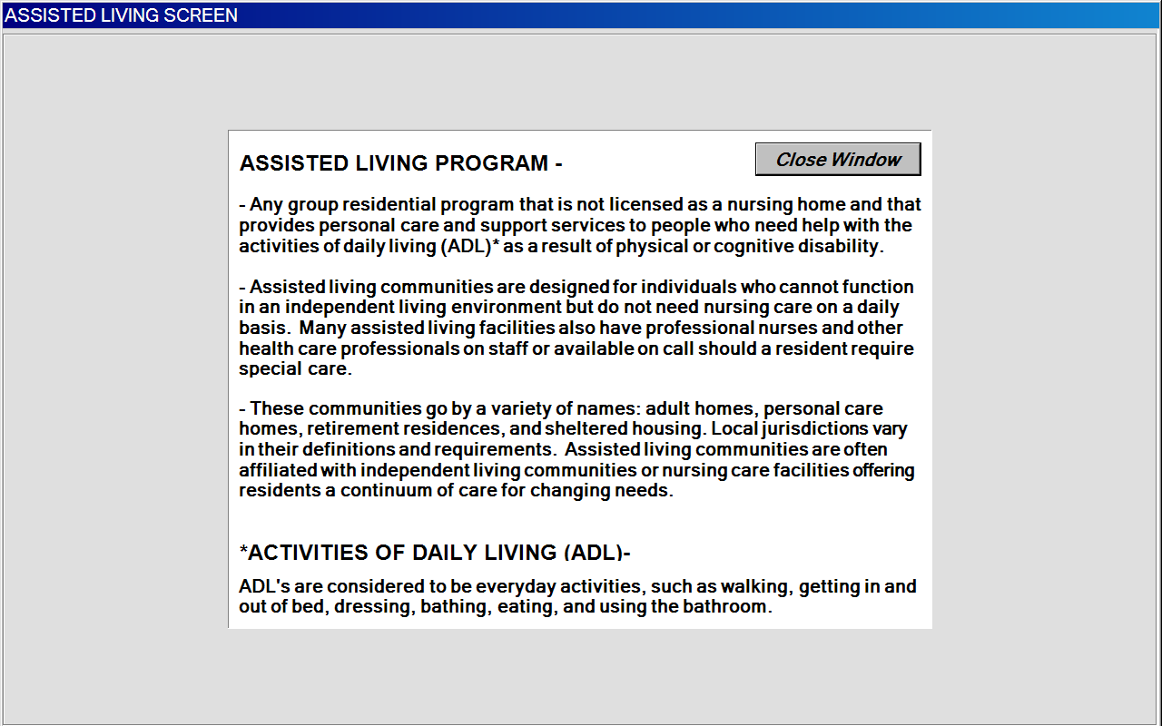

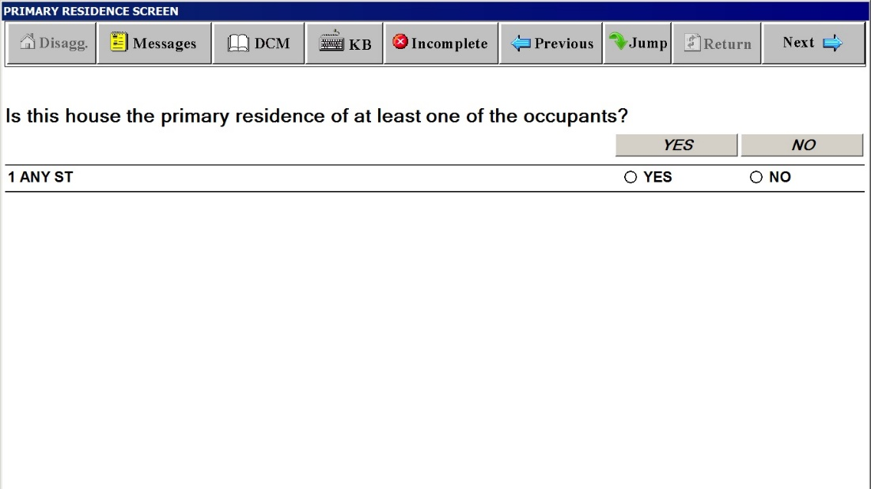

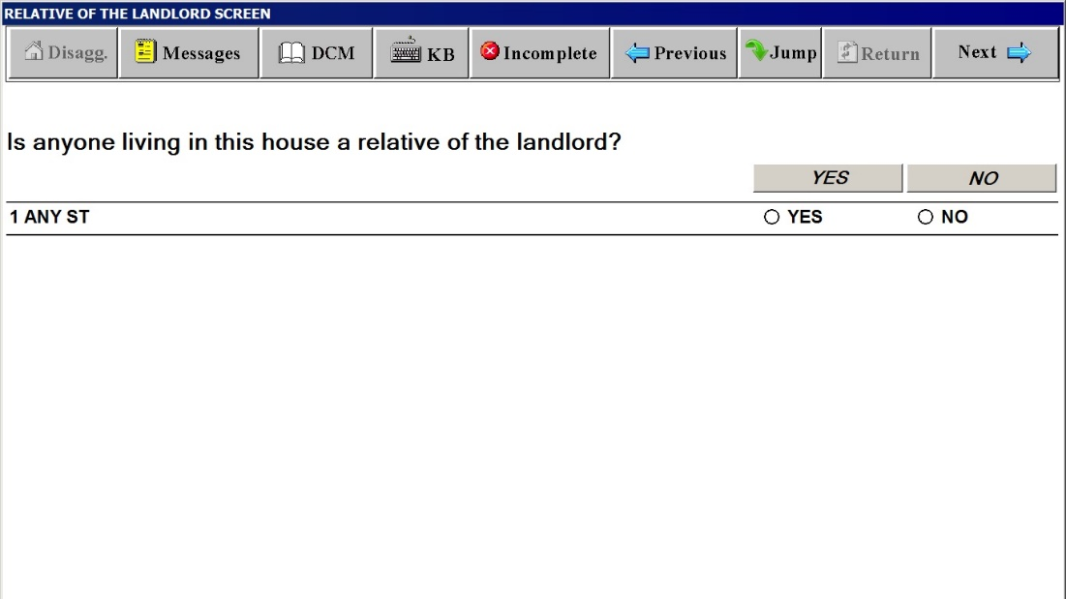

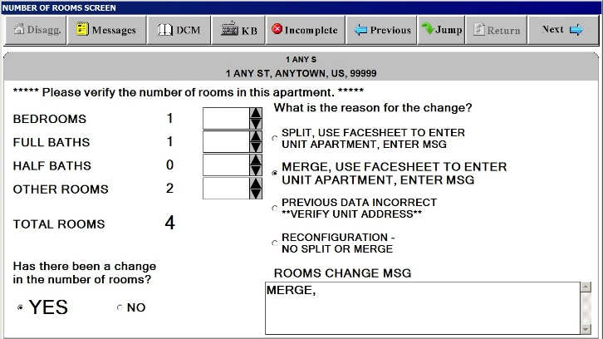

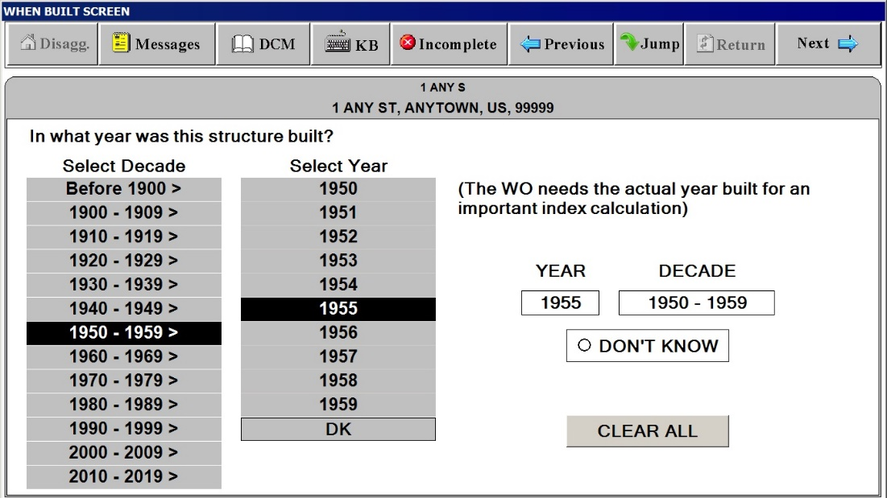

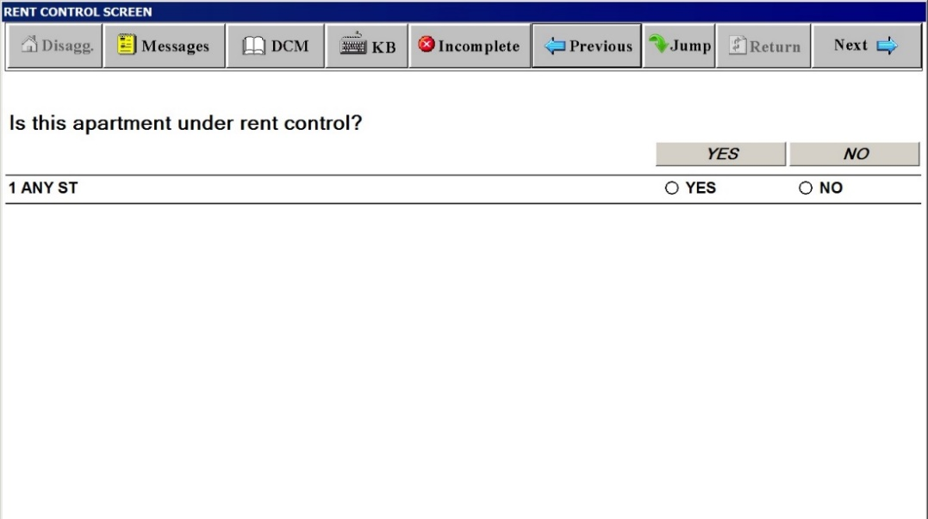

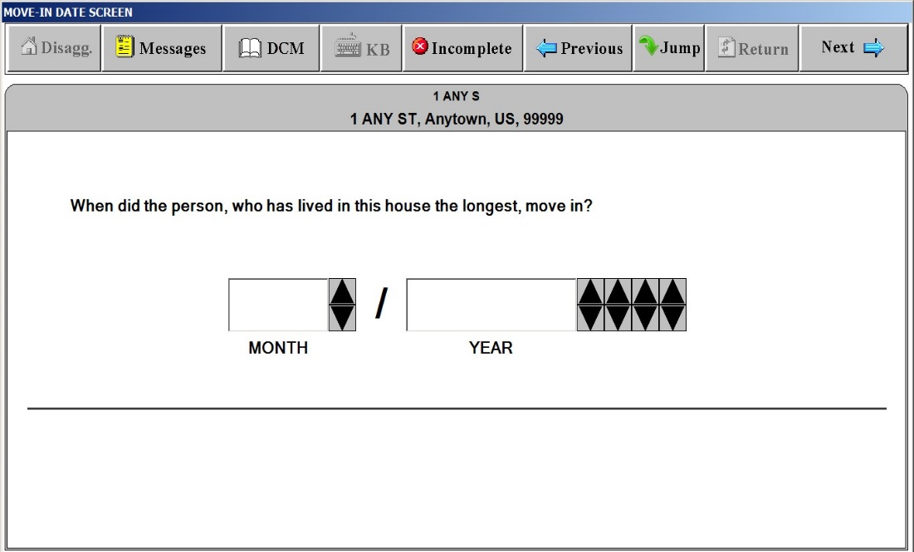

RENT POD
“Respondent/Occupant” Window
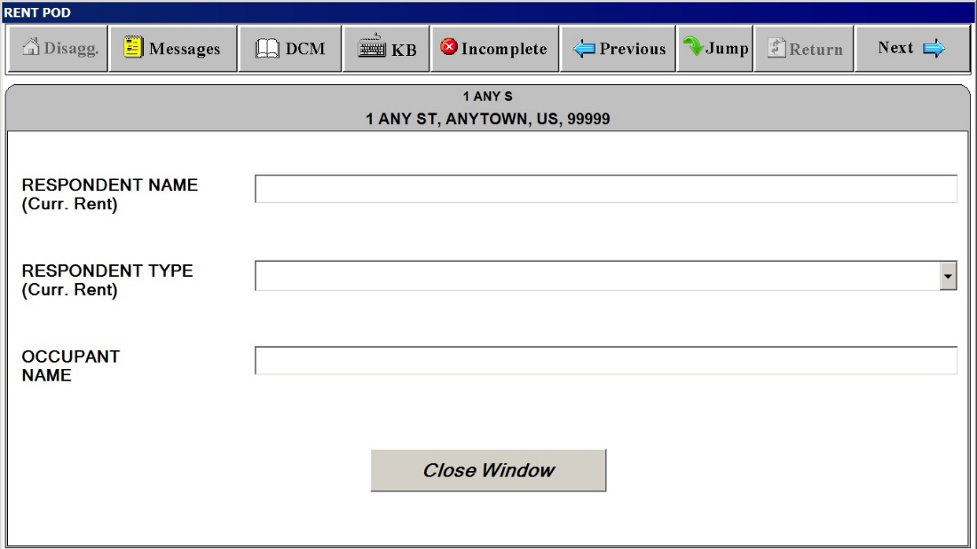

RENT POD
“Rent Amount”
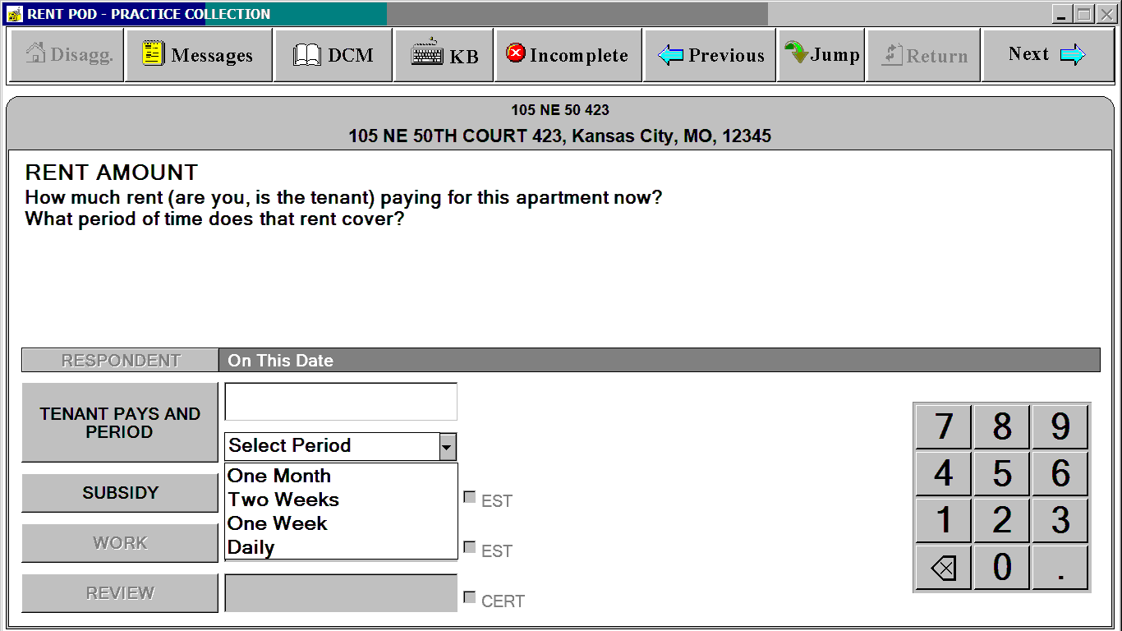
RENT POD
“Subsidy”
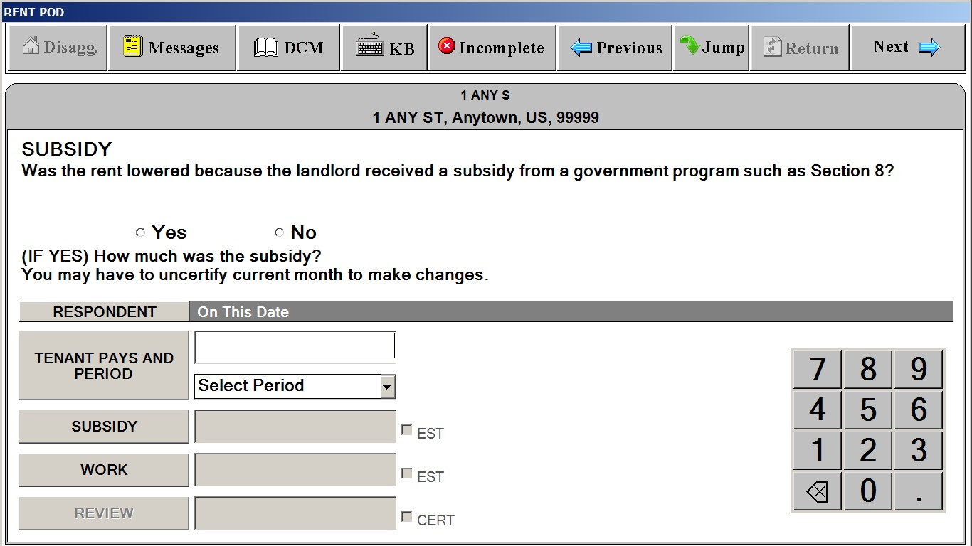
RENT POD
“Work Reduction”
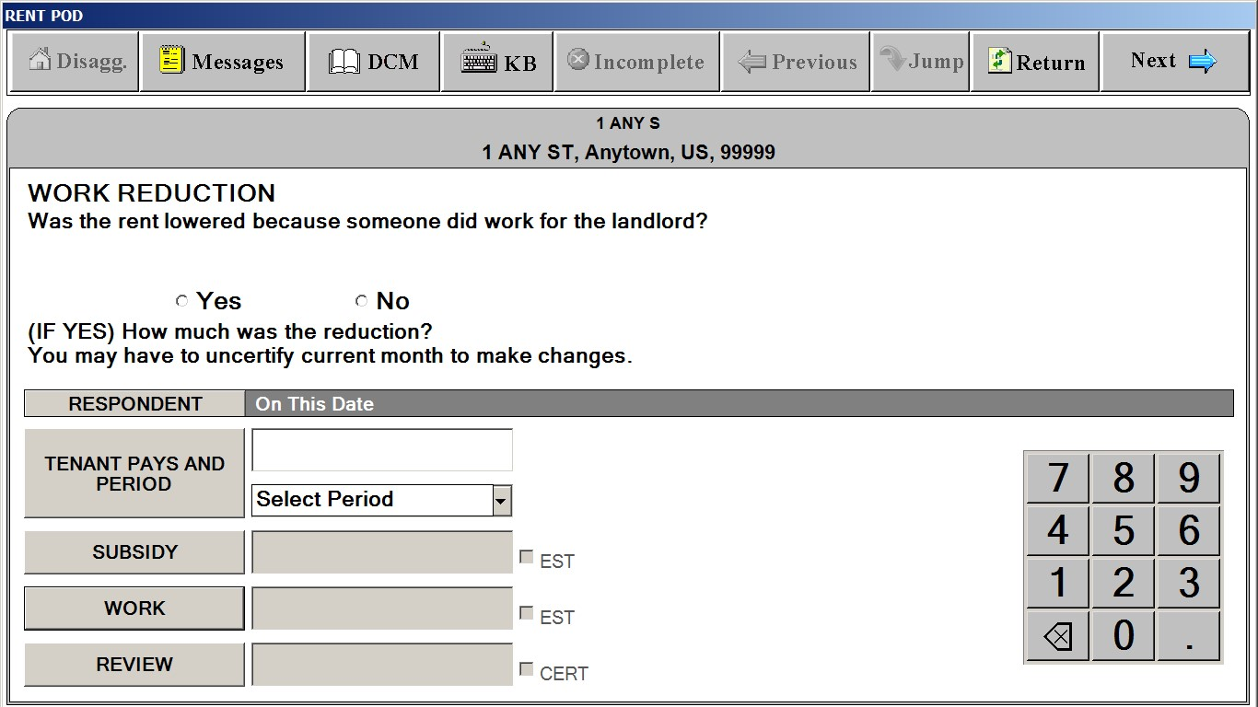
RENT POD
“Review”
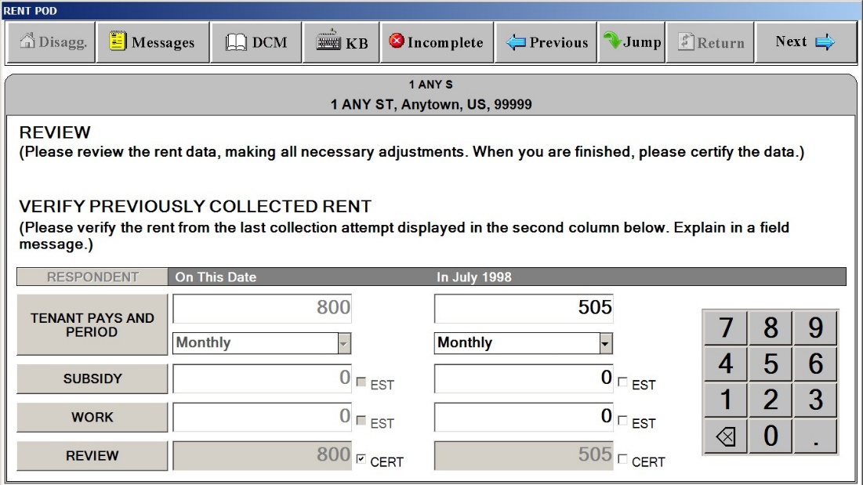
EXTRA CHARGES SCREEN
“Extra Charges” Tab
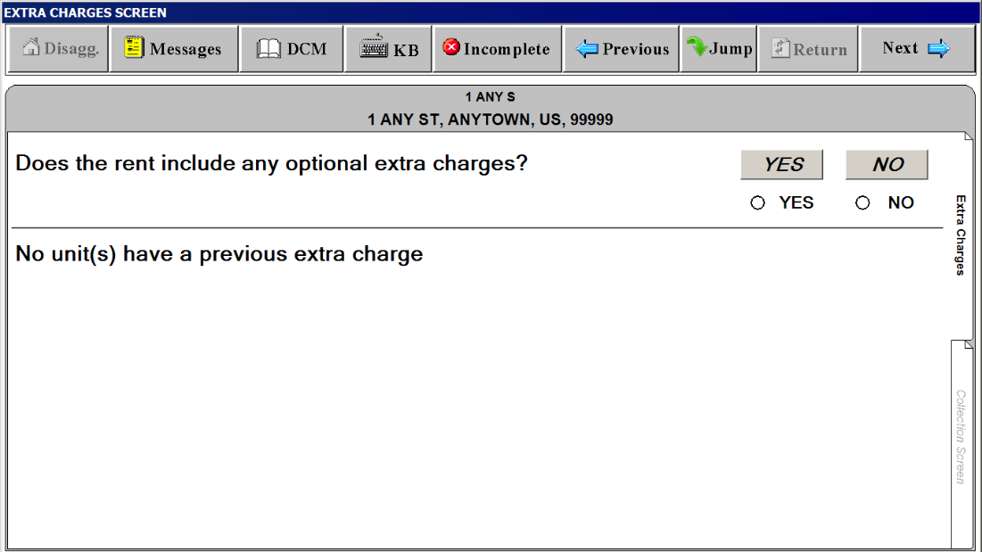
EXTRA CHARGES SCREEN
“Collection Screen” Tab – SELECT EXTRA CHARGE” Window
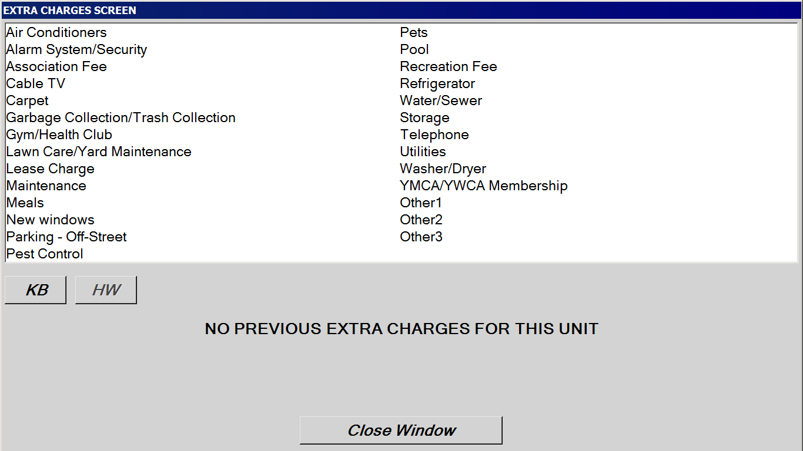
EXTRA CHARGES SCREEN
“Collection Screen” Tab – Amount
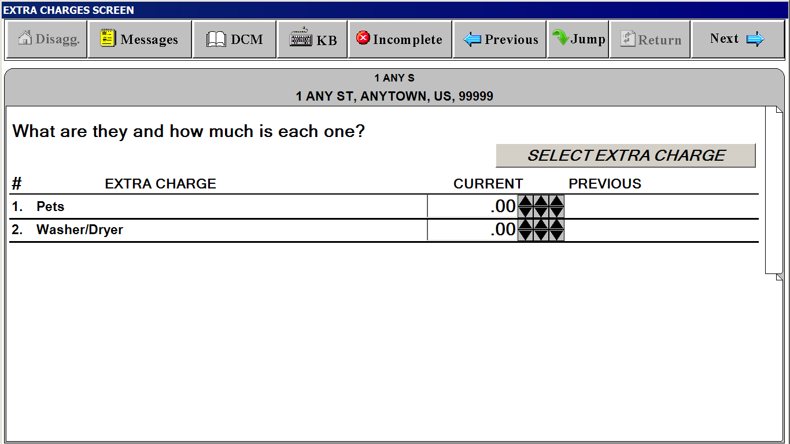

SP CHANGES SCREEN
(“Last interview” date is filled in with actual month and year)
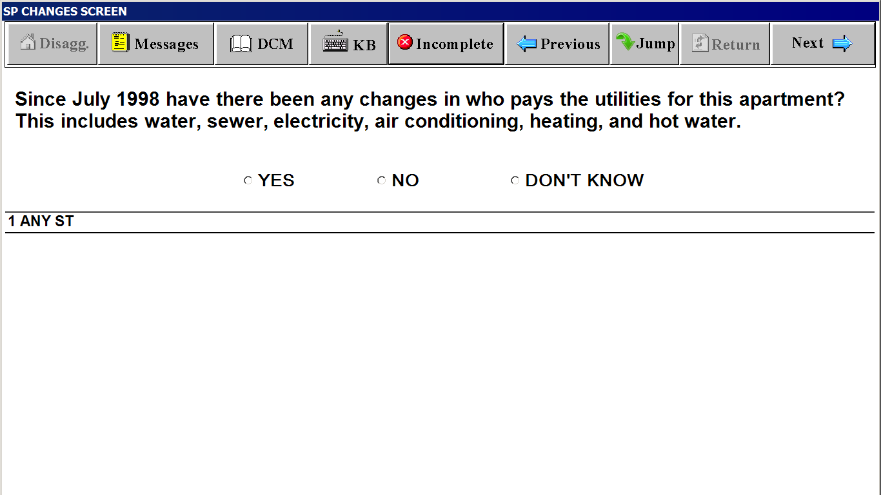

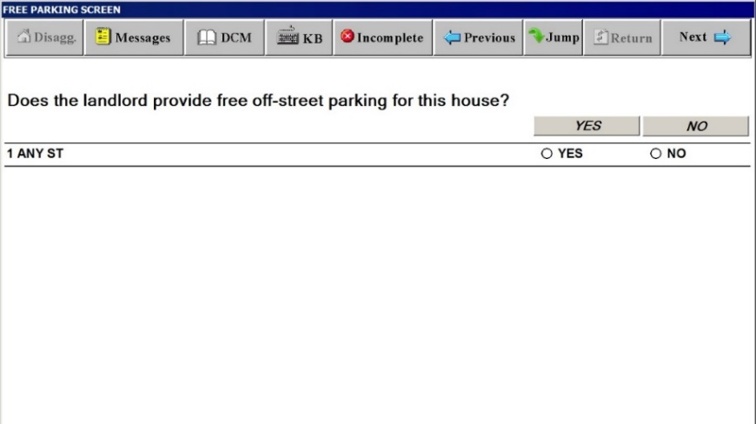

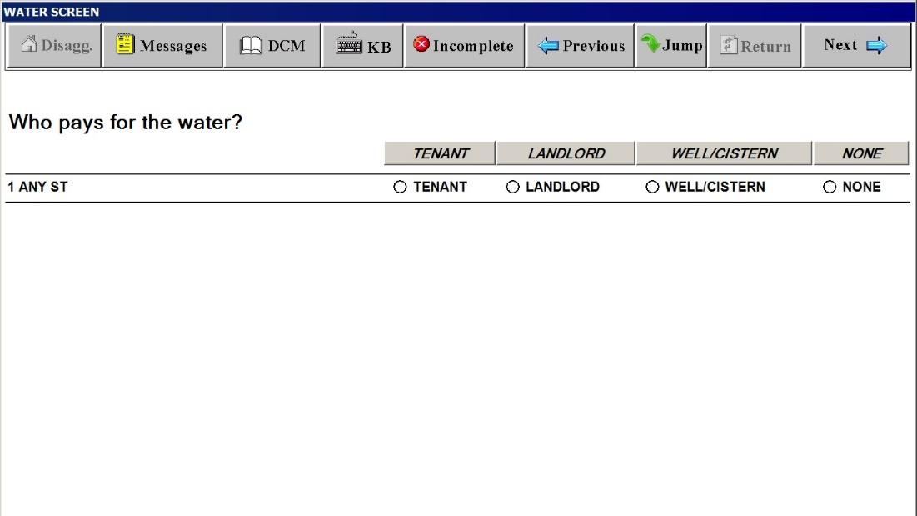

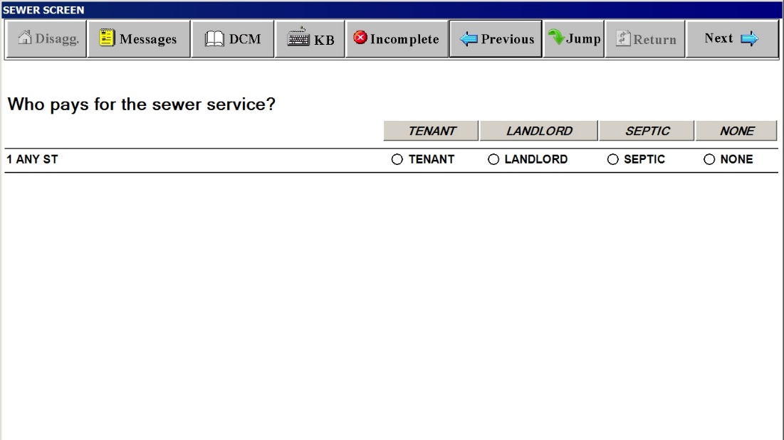

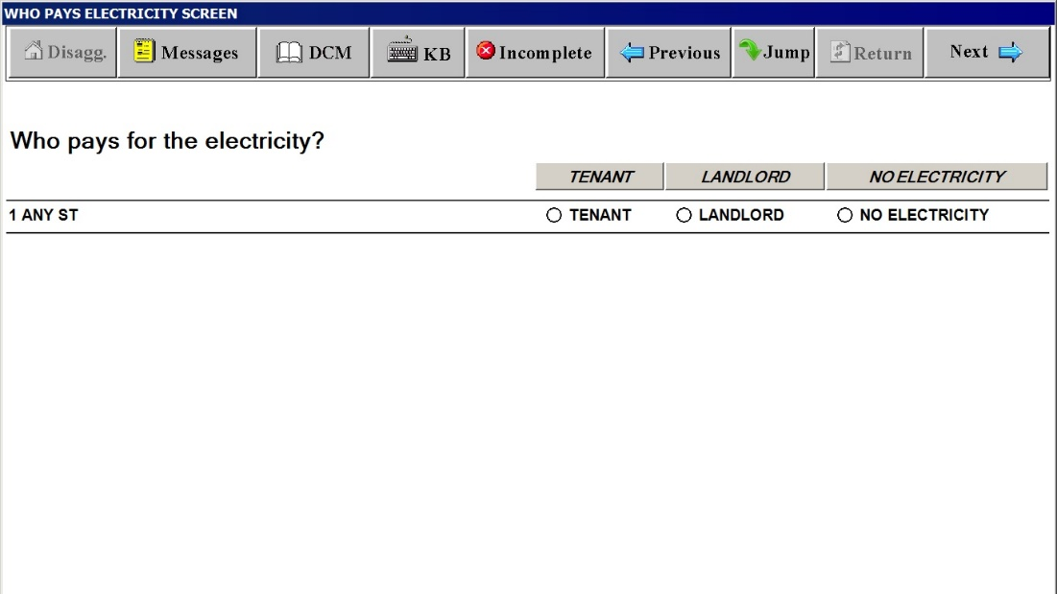

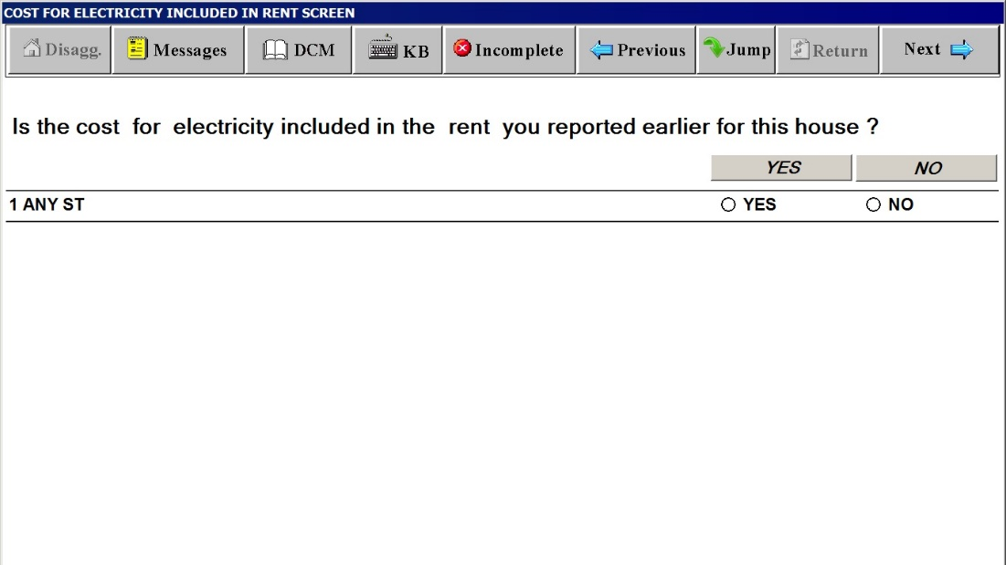

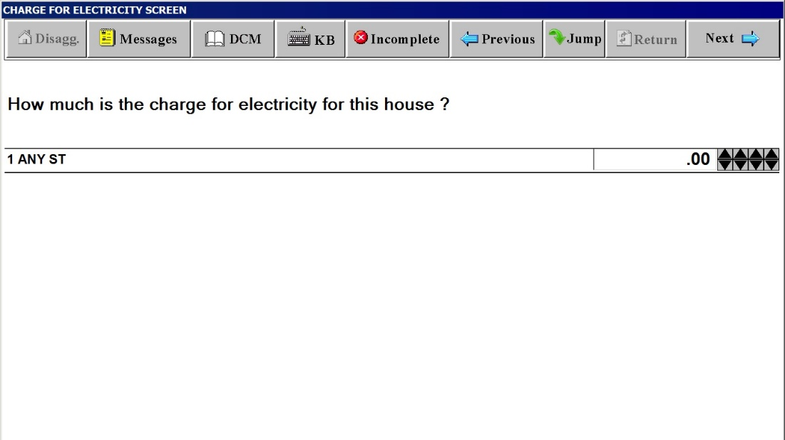

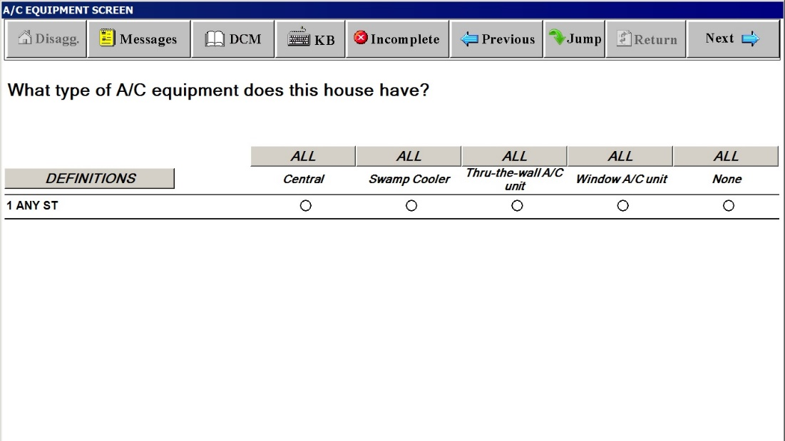
Definitions Window for A/C EQUIPMENT SCREEN
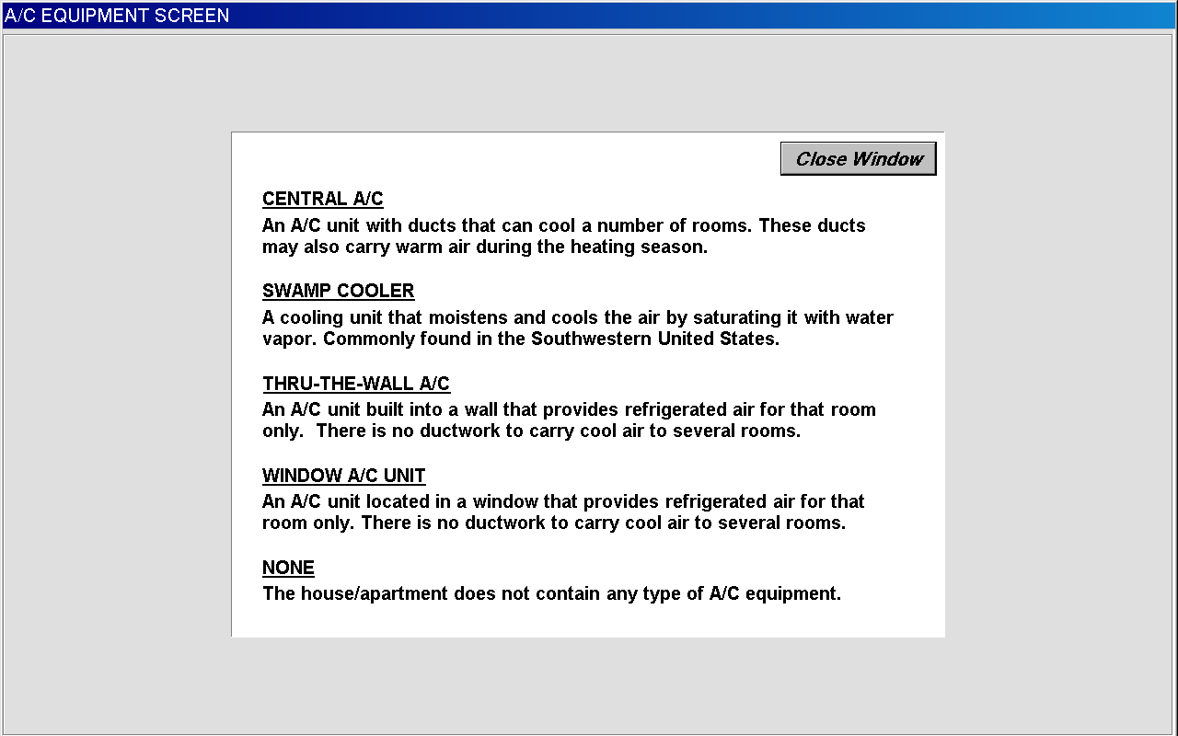

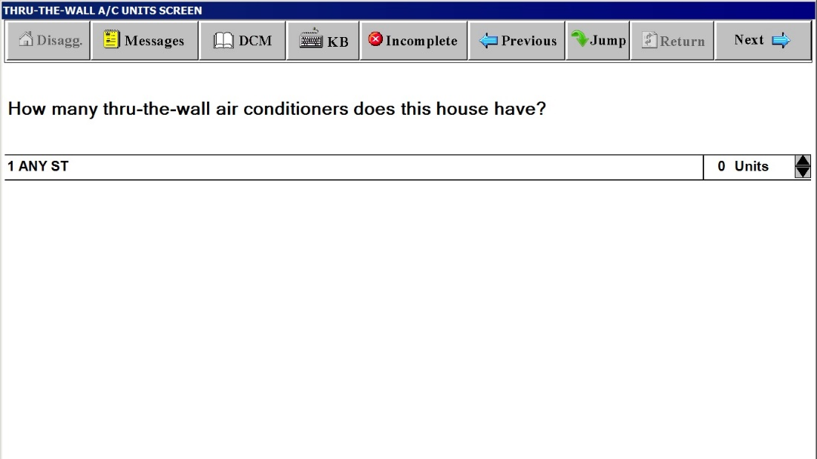

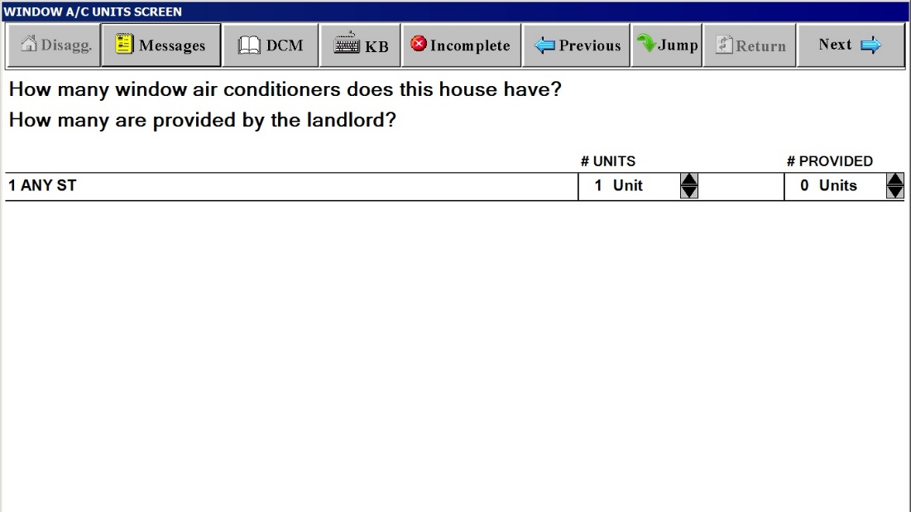

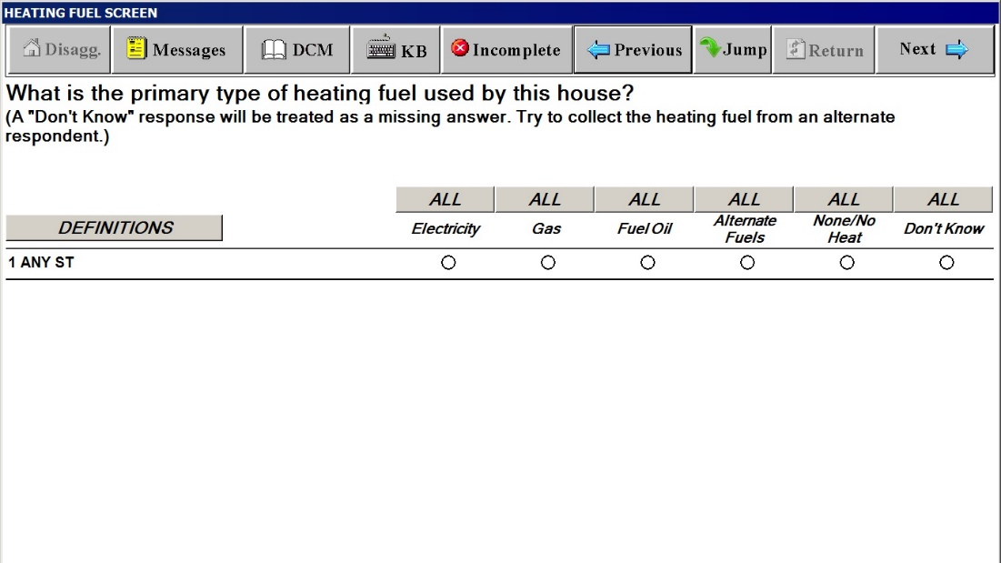
Definitions Window for HEATING FUEL SCREEN
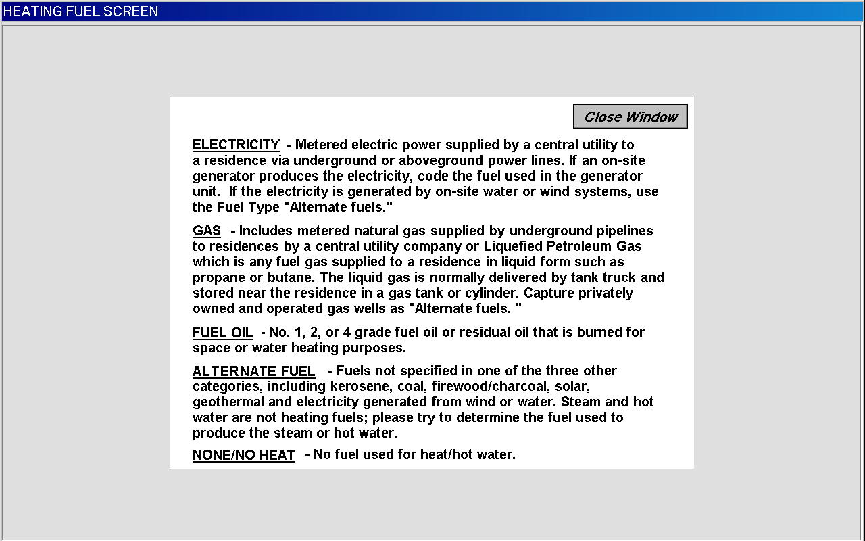
WHO PAYS FOR HEATING FUEL SCREEN
(Wording substituted with selected fuel, such as “gas”, “fuel oil” or
“alternate fuel”)
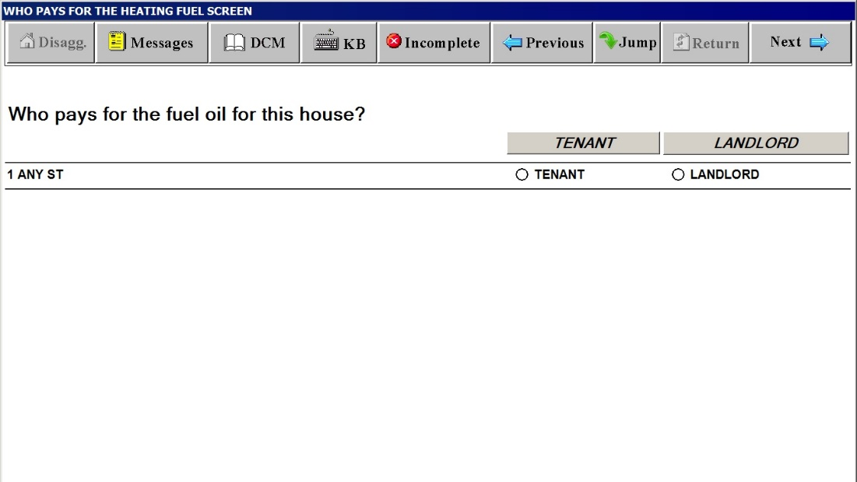
COST FOR HEATING FUEL INCLUDED IN RENT SCREEN
(Wording substituted with selected fuel, such as “gas”, “fuel oil” or “alternate fuel”)
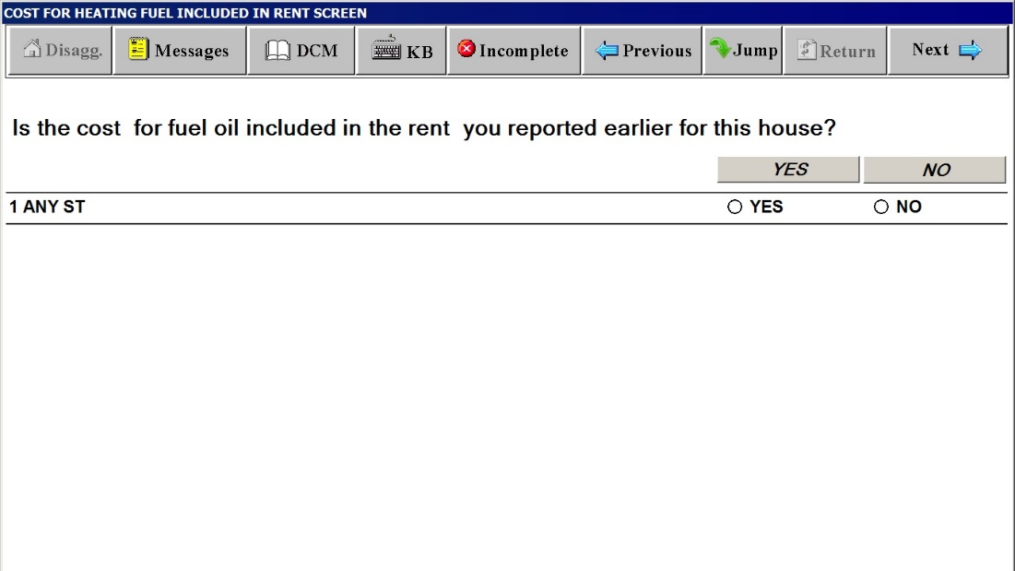
CHARGE FOR HEATING FUEL SCREEN
(Wording substituted with selected fuel, such as “gas”, “fuel oil” or “alternate fuel”)
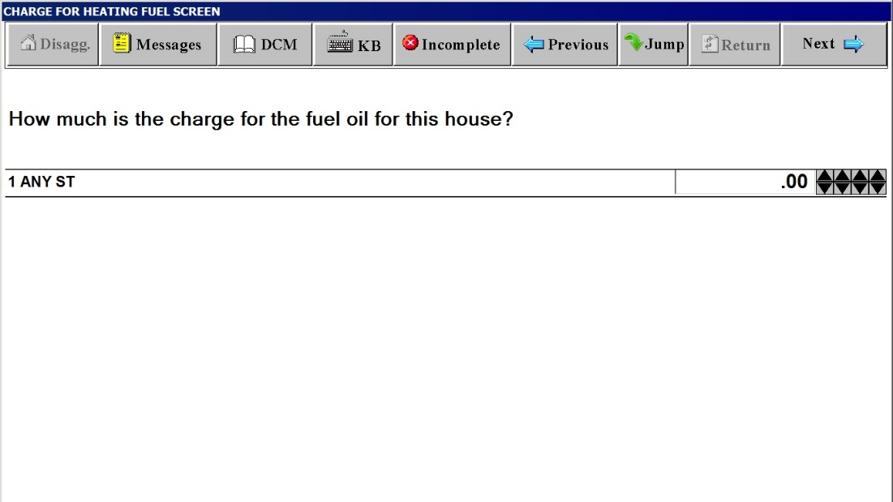

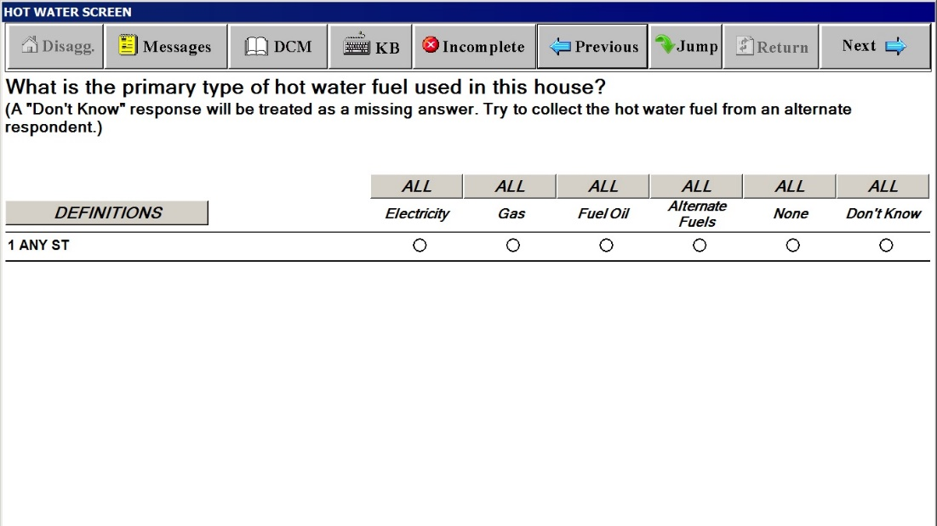
Definitions Window for HOT WATER SCREEN
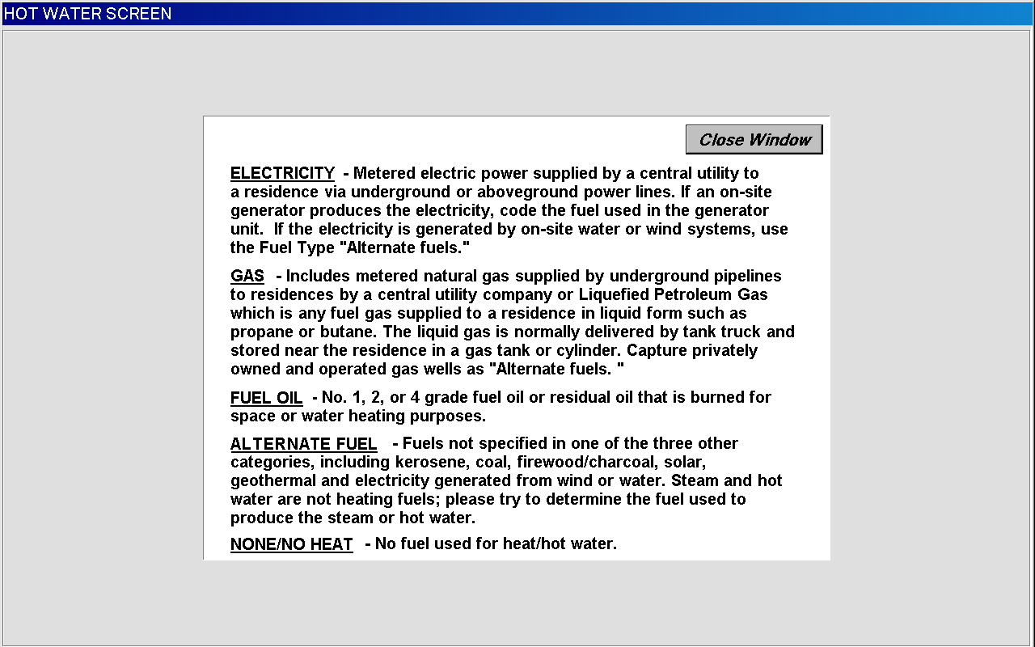
WHO PAYS FOR THE HOT WATER FUEL SCREEN
(Wording substituted with selected fuel, such as “gas”, “fuel oil” or “alternate fuel”)
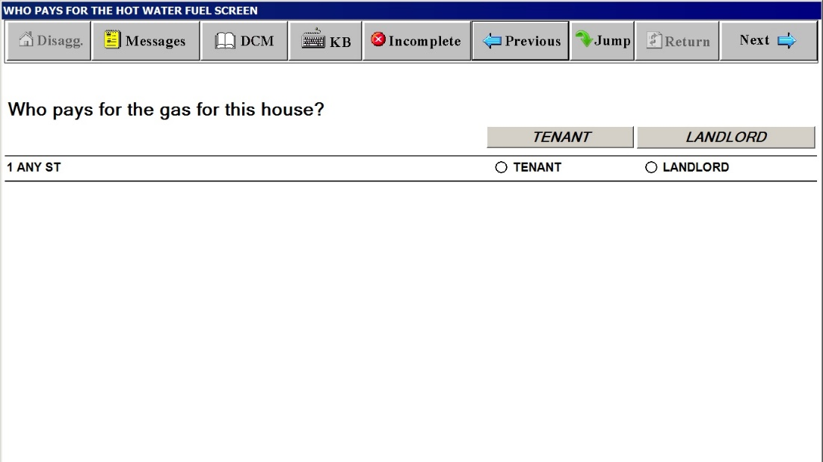
COST FOR HOT WATER FUEL INCLUDED IN RENT SCREEN
(Wording substituted with selected fuel, such as “gas”, “fuel oil” or “alternate fuel”)
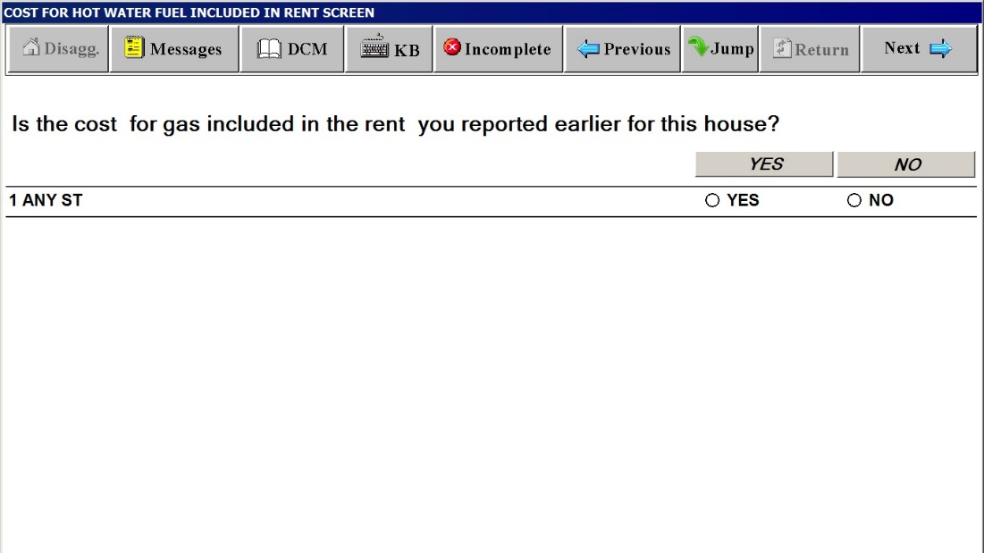
CHARGE FOR HOT WATER FUEL SCREEN
(Wording substituted with selected fuel, such as “gas”, “fuel oil” or “alternate fuel”)
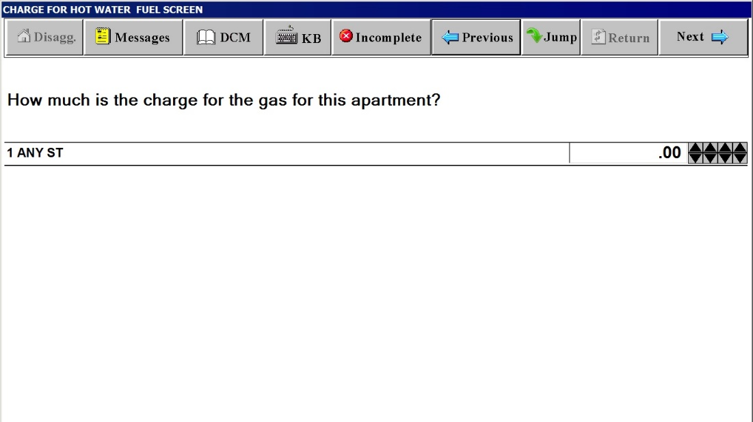
INCOMPLETE INTERVIEW POD DURING SCOPE DETERMINATION
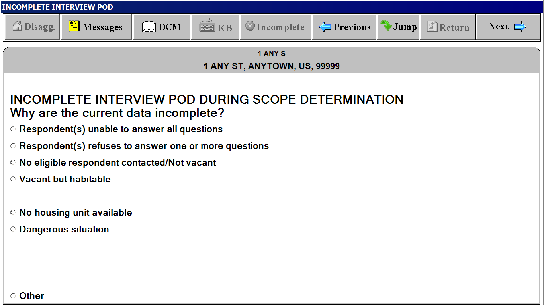
INCOMPLETE INTERVIEW POD DURING INITIATION/PRICING
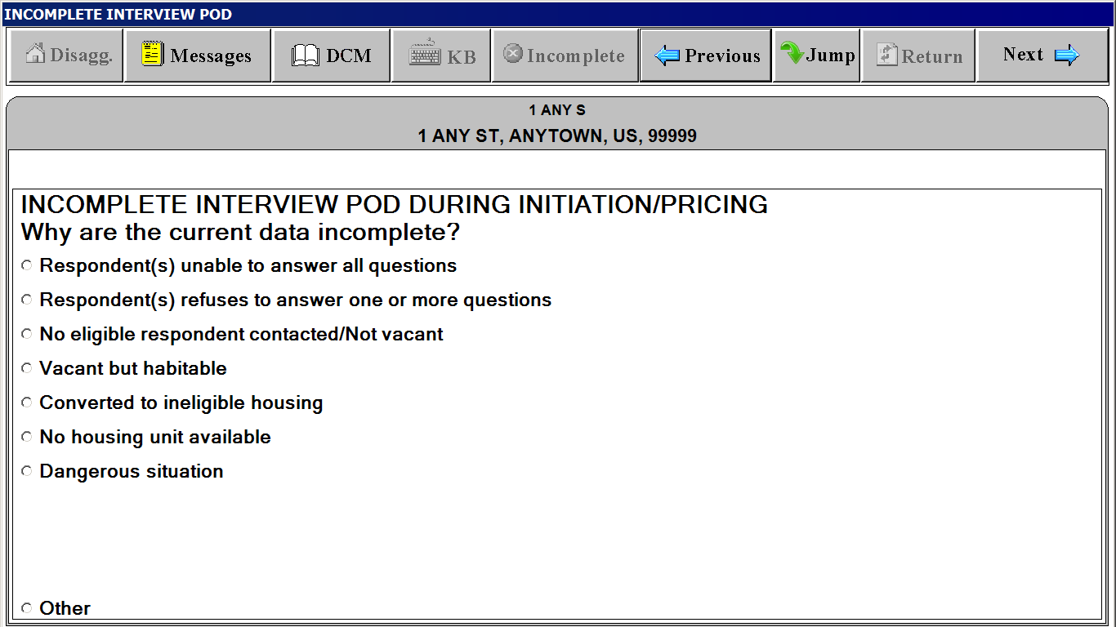
UNIT SI FACESHEET and UNIT FACESHEET
(Basically have the same content but different screen titles)
“Unit” Tab
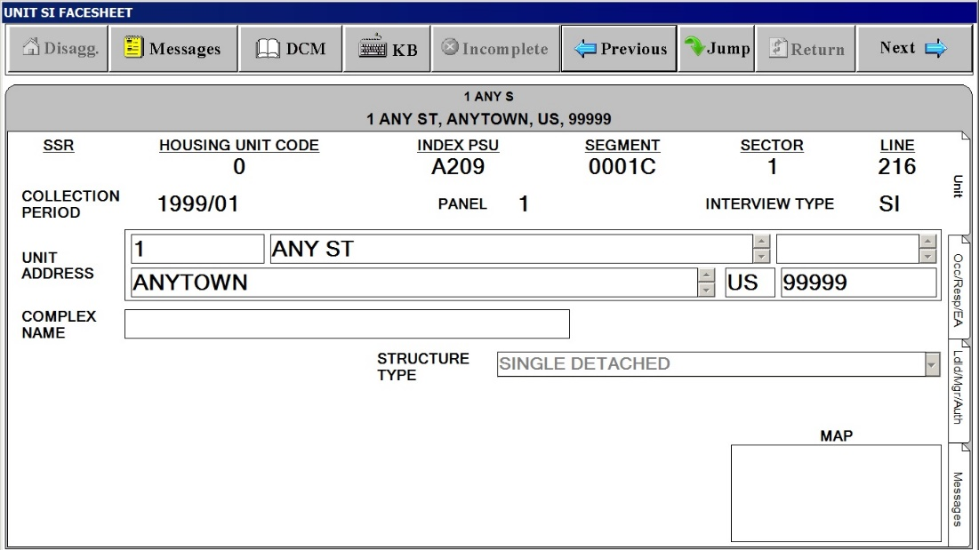
UNIT SI FACESHEET and UNIT FACESHEET
(Basically have the same content but different screen titles)
“Occ/Resp/EA” Tab
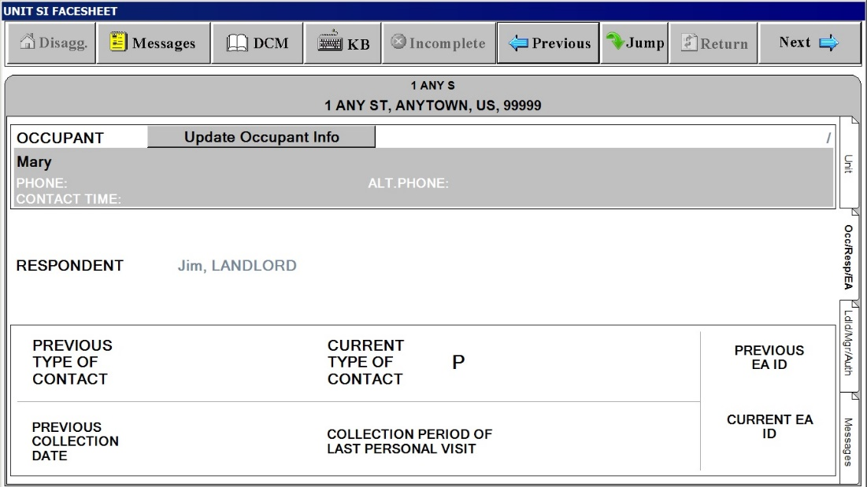
UNIT SI FACESHEET and UNIT FACESHEET
(Basically have the same content but different screen titles)
“Ldld/Mgr/Auth.” Tab
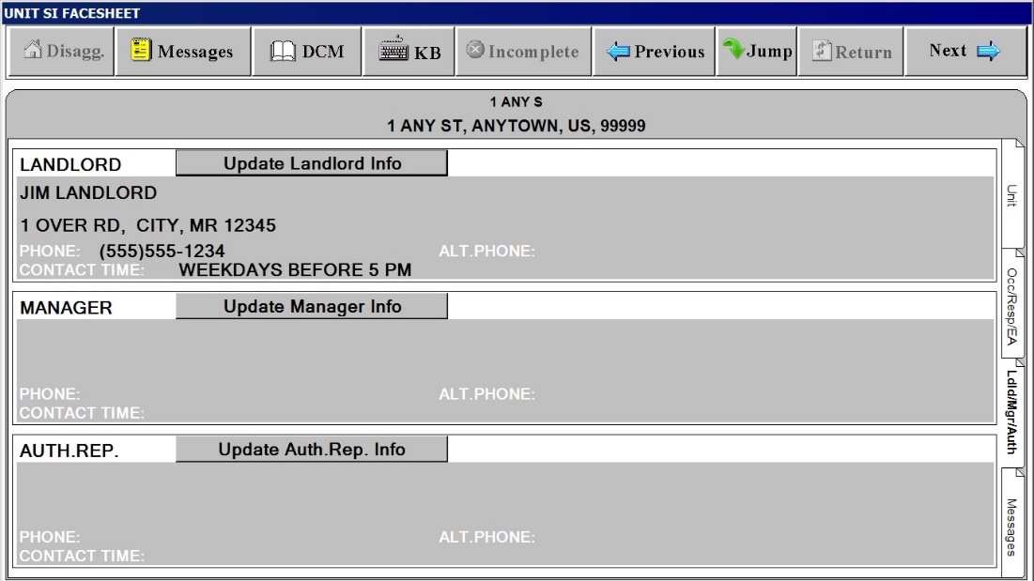
UNIT SI FACESHEET and UNIT FACESHEET
(Basically have the same content but different screen titles)
“Messages” Tab
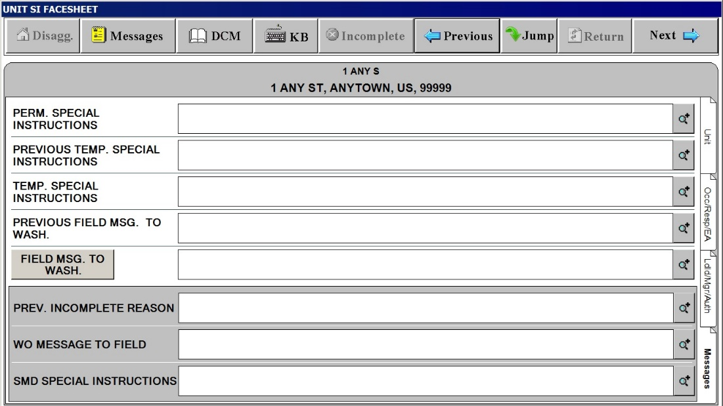
UNIT SI FACESHEET and UNIT FACESHEET
(Basically have the same content but different screen titles)
Field MSG. TO WASH. Button on the“Messages” Tab. Tap this to display standardized field message to Washington
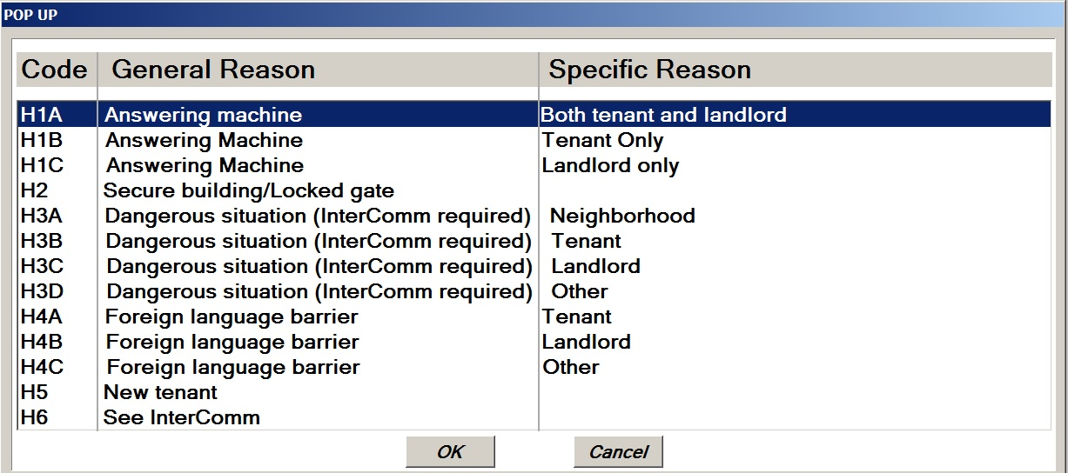

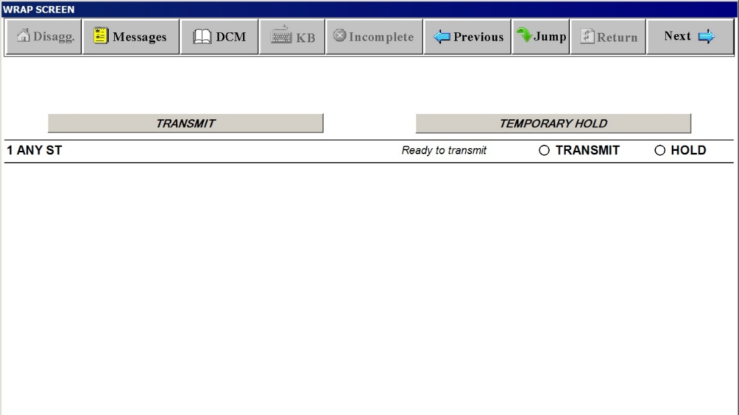
JUMP Screen with JUMP MENU
