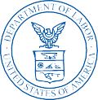
US BUREAU OF LABOR STATISTICS UNITED STATES DEPARTMENT OF LABOR
CONTRACTOR RETURN ADDRESS Bureau of Labor Statistics
CONTRACTOR RETURN ADDRESS Washington, D.C.

U.S. Business Response Survey
to the Coronavirus Pandemic

ATTENTION COMPANY NAME ADDRESS
CITY, ST ZIP

99
DATE

Dear [NAME],

Over the past few months the novel Coronavirus pandemic has affected businesses and workers across the United States and the world. The U.S. Bureau of Labor Statistics (BLS) has launched a new survey to ask U.S. businesses how they are changing the ways in which they operate due to the pandemic. We request that you answer a few brief questions about how the Coronavirus pandemic has affected your business. Your response is important to ensure that the data we produce are accurate, timely, and relevant. Don’t miss this opportunity to ensure that your business is included.
This survey can be completed online in about 5-10 minutes. Please use the Web ID and case-sensitive password provided below to log into the secure BLS website: https://idcfars.bls.gov

WEB ID: 981234567890 PASSWORD: Aa123456

The U.S. Business Response Survey to the Coronavirus Pandemic is approved with O.M.B. No. xxxx­xxxx. The information collected will be used for statistical purposes in accordance with the law. Additional information and instructions for this survey can be found at: www.bls.gov/respondents/COVID-19.htm

Please provide your response within 14 days.

Thank you for your participation in keeping us informed of your situation. We greatly value your input.

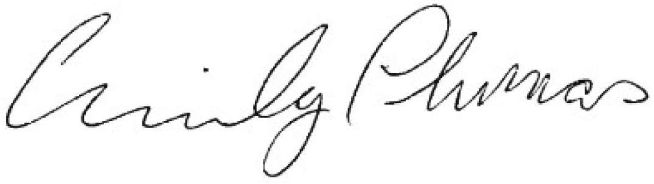
Sincerely,
Emily Thomas
U.S. Bureau of Labor Statistics
