**Justification for No Material Change**

We have a need to add country field to this form to accommodate foreign entities.

Current:

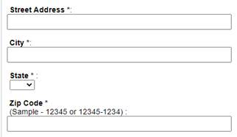

Suggested Design:

* Add Country field
* If Country = United States of America, no changes.
* If Country <> United States of America…thus a Foreign Address, then

