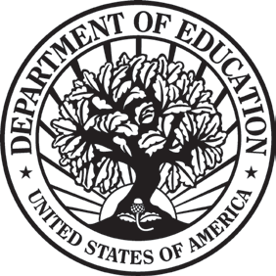
THE SECRETARY OF EDUCATION
WASHINGTON, DC 20202

April 14, 2020

Dear Governor XXXXX:

Thank you for all you are doing to lead your State through this unprecedented national emergency. You are making important decisions every day to keep your citizens safe, and you are tackling head on the challenges created by COVID-19 in your communities, workplaces, and schools. While students and educators are facing significant disruptions and obstacles, you play an influential role in ensuring learning continues for all students.

We have been working around the clock to put Coronavirus Aid, Relief, and Economic Security (CARES) Act resources in the hands of those who need them most and for whom these funds will have the greatest immediate impact. As Governor, you have the opportunity to truly rethink and transform the approach to education in your State and to empower parents, teachers, and local education leaders to ensure all students can access meaningful learning options.

To support those efforts, today the Department is making available $XX,XXX,XXX for [State], part of the nearly $3 billion allocated to the Governor’s Emergency Education Relief Fund (GEER Fund), authorized under section 18002 of the CARES Act. The allocation is set by statutory formula, based on your State’s student-aged population and poverty levels.

This extraordinarily flexible emergency block grant empowers you to decide how best to meet the current needs of students, schools (including charter schools and non-public schools), postsecondary institutions, and other education-related organizations in your State so that faculty continue to teach and students continue to learn. My Department will not micromanage how you spend these funds, but I encourage you, at a time when so many school boards, superintendents, and institutions of higher education have had to close their brick and mortar campuses for the balance of the school year, to focus these resources on ensuring that all students continue to learn most likely through some form of remote learning. They and their families are depending on your leadership to ensure that they don’t fall behind.

In an effort to get these emergency funds to you as quickly as possible, we have kept the application process simple; all that is required is the completion of a brief Certification and Agreement, which can be digitally signed and submitted in PDF to the email address GEERF@ed.gov. The Certification and Agreement, including instructions to apply, are on the Department’s website at https://oese.ed.gov/offices/education-stabilization-fund/governors-emergency-education-relief-fund/
.

We understand that you and your team might have additional questions. We will post answers to frequently asked questions about the GEER Fund on the Department’s website in the coming days.
The enclosed table shows State allocations for the GEER Fund, as well the Certification and Agreement required to process your State’s grant. Once you submit the signed PDF, we will process your Certification and Agreement and obligate your funds within 3 business days. You will be able to draw down these emergency block grant funds using the Department’s G5 system.

We will announce additional education-related resources available under the CARES Act in the very near future. We look forward to partnering with you to ensure that learning continues for all students during the COVID-19 pandemic.
Thank you for your continued leadership on behalf of America’s students. I welcome your direct outreach if you would like to discuss this further.

Sincerely,

Betsy DeVos

