Pilot study data

This appendix summarizes the four pilot studies around Atlanta, GA (ATL), Philadelphia, PA (PHL), Frankfurt, Germany (NORAH) and Cologne, Germany (STRAIN), which were used to estimate model parameters for the calculation of sample size for the field study. The number of participants and aircraft noise events during sleep are given in Table A1. The distributions of the measured maximum and 1-minute background sound pressure levels in the bedrooms in each study are given in Figure A1. Details for the fitted Model 0 coefficients for the 4 pilot studies, and their average values, are provided in Table A2 (see Section B1.3).

Table A1 Summary of pilot studies.
Pilot study | Aircraft noise events (n) | Study participants (n)
ATL | 1670 | 23
PHL | 2010 | 32
STRAIN | 17,095 | 63
NORAH | 8,695 | 162
Total | 29,470 | 280
Average | 7367 | 70

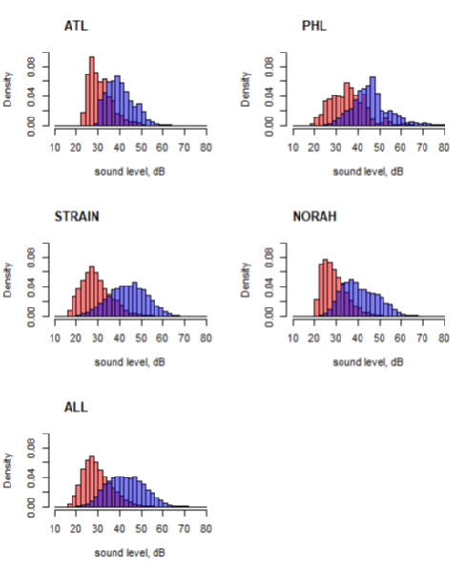
Figure A1 Histograms of background L_{Aeq,1minute} (red) and L_{AS,max} (blue) for pilot data. Sound pressure levels were measured indoors in the bedroom.

Table A2 Summary of Model 0 to fit pilot data. The last row was used to generate the true parameters in Model 2.
Pilot | β₀ (SD) | β₁ (SD) | Cov(β₀, β₁) | Var(b₀) | Var(b₁) | Cov(b₀, b₁)
ATL | -3.5244 (0.6356) | 0.0296 (0.0147) | -0.0092 | 0.7988 | 0.00018 | -0.0122
PHL | -4.2744 (0.7139) | 0.0418 (0.0150) | -0.0106 | 3.7876 | 0.00157 | -0.0764
STRAIN | -4.1686 (.3453) | 0.0403 (0.0477) | -0.0027 | 4.0348 | 0.00227 | -0.0930
NORAH | -5.0672 (0.3042) | 0.0619 (0.0071) | -0.0021 | 2.1062 | 0.00124 | -0.0478
Average | -4.2586 (0.6328) | 0.0434 (0.0134) | -0.0084 | 2.6819 | 0.00132 | -0.0573

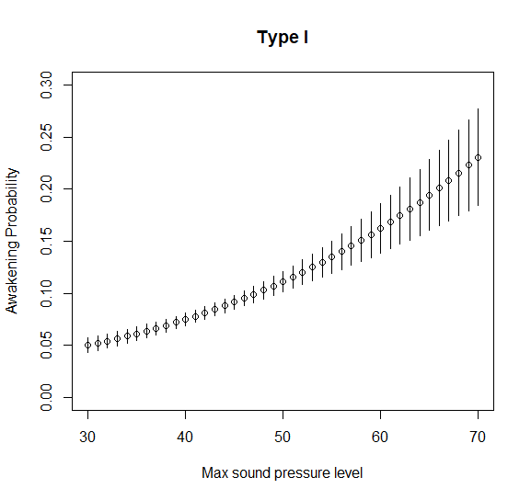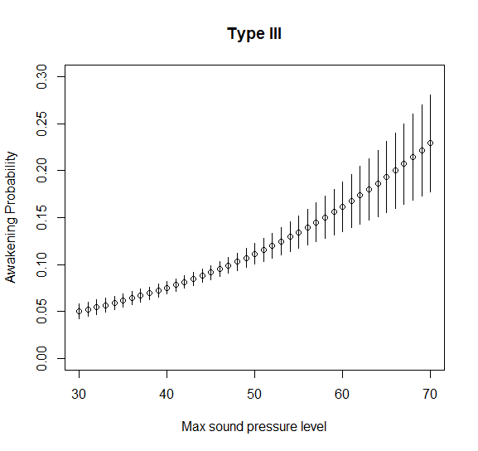
Figure A2 Empirical 95% confidence interval for P(Awake| L_{AS,max}) for the medium-high traffic scenario with type I random effects (left) and the type III random effects (right).

