National Sleep Study
Sponsored by the Federal Aviation Administration

<<city>> Resident
<<address line 1>>
<<city, state, zip>>

Dear <<city>> Resident
Your household has been selected to take part in an important study on the effect of noise in your community on sleep which is sponsored by the United States Federal Aviation Administration. We encourage 1 adult in the household to complete the attached brief survey. The information you provide will help to update transportation-related policies that affect people in neighborhoods like yours.
Your participation is voluntary. However, your participation is essential to inform us about your neighborhood. Your answers will be treated as confidential. We have enclosed $2.00 as a token of our appreciation for your participation.
In addition to the survey, we are conducting a 5 night in home study, which includes measurements of heart rate and body movement and the indoor noise levels in the bedroom at night. Participants of this additional study will receive $30.00 per night, for a total of $150.00. For information on how to participate in this optional study, please refer to the last page of the attached survey booklet.
If you have any questions about this study:
Call: 215-573-3815
Email: noise@mail.med.upenn.edu
Visit: https://www.med.upenn.edu/uep/projects_pcns.html

Thank you in advance for your participation!
Sincerely,
Basner
Mathias Basner, MD, PhD
Associate Professor, University of Pennsylvania

National Sleep Study

Below you will find photographs of the equipment we will mail you, should you choose to participate in the field study. See the last page of the enclosed survey booklet for more information.

Indoor Noise Measurements  Indoor sound recordings will be made during the sleep period. The microphone and sound recorder should be placed near the sleeping position on a dresser or nightstand. Participants will need to start and stop the sound recorder each night/morning. | 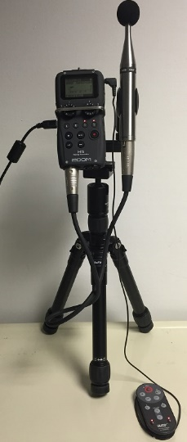
Heart Rate and Body Movement Measurements  During the night both heart rate and movement will be measured. The device used is battery operated. For measuring heart rate there are two electrodes. One electrode will go just below the right clavicle; the other electrode will go on the left side of the chest below the pectoral muscle/breast. There is a button on the device for starting and stopping the measurements each night/morning. | 