National Sleep Study

Development of postal survey instrument

# Introduction

This document provides an overview of a postal survey designed to assess respondents’ suitability for participation in a field study examining the potential effects of aircraft noise on sleep.

Section 2 provides a background of the purpose of the survey.

Section 3 provides the rationale for the inclusion of each survey item, along with the survey item itself.

Section 4 provides a full bibliography for all references given in this appendix.

# Overview of survey

## Purpose

The primary purpose of the survey is to recruit participants for a field study investigating potential effects of aircraft noise on sleep. At a minimum it should assess a respondent’s suitability for taking part in the field study, and should be structured in such a way to maximize response rates so that non-response bias is minimized.

## Choice of questions

In designing the current survey, we used items from a number of well-established surveys. In the field of sleep research, a number of surveys for measuring subjective sleep have been developed and validated. One such measure is the Pittsburgh Sleep Quality Index (PSQI), a single index used to identify poor sleepers, constructed from a series of questions (Buysse et al. 1989). The PSQI has been employed repeatedly both in the US and abroad, and correlates highly with other measures of sleep quality including clinical diagnosis of insomnia, the insomnia severity index (ISI) score, and some measures of objective sleep obtained with polysomnography and actigraphy (Mollayeva et al. 2016). In the field of noise effects research, the International Commission on the Biological Effects of Noise (ICBEN) has established standard phraseology for survey items to measure community response to noise (Fields et al. 2001). Validated surveys to measure an individual’s sensitivity to noise have also been developed and widely employed for several decades (Weinstein 1978).

## Number of questions

In a pilot study around Atlanta International Airport (ATL) we investigated the effectiveness of different postal survey methodologies, and found that short (12 question) and medium (27 question) length surveys were equally likely to be completed (Figure 1). Long surveys (58 questions) were less likely to be completed, although this was not statistically significant. However, other investigators have found that using shorter surveys can improve response rates (Nakash et al. 2006). Furthermore, longer surveys are more burdensome on the respondent, and are more expensive due to increased printing and paper costs. As such, we have endeavored to keep our planned survey as short as possible while providing all information necessary to screen respondents for suitability in the field study, and to perform non-response and non-participation analyses to account for possible biases.



Figure 1 Odds ratios and 95% confidence intervals for the effects of postal survey length on completing the survey (green), being interested in taking part in the field study (blue) and actually participating in the field study (red). Short=12 questions, Medium=27 questions, Long=58 questions. Ref=reference category. The figure shows that the likelihood of a respondent participating in the field study was almost identical for all three survey lengths, and that the likelihood of a respondent completing the survey and/or being interested in the field study was almost identical for the short and medium length surveys. The likelihood of a respondent completing the survey and/or being interested in the field study was slightly lower for long surveys than short surveys, but this difference was not statistically significant.

Including a question about interest in the sleep study, the planned postal survey includes 25 items. These 25 items will provide us with all necessary information to determine a respondent’s eligibility for the field study, perform a non-response analysis to account for possible non-response bias, and account for possible non-participation bias by analyzing differences between respondents who do and do not participate in the field study.

The total number of survey items (25 questions) is less than the number of questions in a medium-length survey (27 questions) we investigated in the earlier pilot study.[1] In this earlier pilot study, response rate to the medium length survey was not different from the shortest investigated survey (12 questions). We thus anticipate that the current survey is short enough to achieve the highest feasible response rates, which will reduce non-response bias and increase representativeness of the survey sample and participants in the field study.

# Rationale for included questions

It is important that questions are structured in a way that maximizes the likelihood that a given response actually reflects what the respondent intended. Where appropriate, consistency in response scales, and the direction of those responses, can mitigate confusion among respondents. We therefore constructed all questions so that all of the response scales are ordered so that the right-most response indicates the worst outcome, e.g. lowest sleep quality, highest noise sensitivity, highest disturbance by noise etc. Similarly, the left-most response indicates best sleep quality, lowest noise sensitivity, lowest sleep disturbance etc.

Questions can be classed into three broad categories:

1. Field study exclusion criteria
2. Demographics
3. Supplementary outcomes for non-response and non-participation analyses

The rationale for each question is outlined in the discussion of each category in the following sections.

## Field study exclusion criteria

The field study has the following exclusion criteria:

* Use of medication (either prescribed or “over-the counter”) to help with sleep three times or more per week, over the past month.
* Diagnosed by a heath professional with any sleep disorder, including but not limited to the following: sleep apnea, narcolepsy, restless leg syndrome and period limb movement syndrome.
* Diagnosed by a heath professional with cardiac arrhythmia.
* Self-reported problems or difficulties with hearing.
* Overnight shift work, defined as working for at least 4 hours between 00:00 to 06:00.
* Under 21 years of age.
* Any individuals in the household requiring care during the night.
* Body mass index (BMI) of >35 or <17 kgm-2.

Each exclusion criterion is discussed in further detail below, along with the survey item used to assess eligibility. After each question, the response(s) that would classify the respondent as ineligible for the field study are listed. These eligibility criteria will not be listed explicitly in the mailed surveys, to mitigate the possibility of misrepresentation by respondents who wish to take part in the study but would otherwise be unsuitable. Instead, the following statement on eligibility is included in the cover letter: “If you are 21 or older, do not have a sleep disorder, and have normal hearing, you may be eligible to take part in this study”.

### Sleep medication

Frequent sleep medication use could indicate that an individual has problems with their sleep, although they may not have been given a formal diagnosis by a health professional. Furthermore, an individual taking sleep medication may have a higher arousal threshold than they otherwise would, and so may not respond to noise in the same manner as a person who is not using sleep medication. The question to assess sleep medication use is given below.

|  |  |  |  |
| --- | --- | --- | --- |
| Q2. Select the response that best reflects how often you have taken medicine (prescribed or “over the counter”) to help you sleep during the **last month** or so. | | | |
| **Not during the past month**  **↓** | **Less than once a week**  **↓** | **Once or twice a week**  **↓** | **Three or more times a week**  **↓** |
| **□** | **□** | **□** | **□** |

The phrasing of the question and phrasing and direction of the response scale is identical to item 7 of the Pittsburgh Sleep Quality Index (PSQI), a validated survey used to identify poor sleepers (Buysse et al. 1989). A response of “Three or more times a week” means that the respondent is ineligible for the field study.

### Sleep disorders

It is important that field study participants’ sleep is generally good, otherwise it is problematic to determine whether any observed awakenings are a result of external nighttime noise, or are endogenous awakenings due to sleep disorders. The question to assess sleep disorders is given below.

|  |  |  |
| --- | --- | --- |
| Q8. Have you ever been diagnosed by a health professional with any of the following sleep disorders (mark all that apply)? | | |
| **□** Sleep apnea | **□** Narcolepsy | **□** Restless leg syndrome |
| **□** Periodic limb movement syndrome | **□** Insomnia | **□** None |
| **□** Other (please specify): _____________________________________________________________ | | |

Any response other than “None” or listing a disorder in the “Other (please specify)” field that is not a sleep disorder means that the respondent is ineligible for the field study.

### Hearing

An individual can develop problems with their hearing due to disease, injury or deterioration with age. A person with an impaired sense of hearing is less likely to detect nighttime aircraft noise than an individual with good hearing, and consequently could be less likely to physiologically react to a noise level that could awaken other individuals. The question used to assess hearing is given below.

|  |  |  |
| --- | --- | --- |
| Q9. Do you have any problems or difficulties with your sense of hearing? | **□** Yes | **□** No |

A response of “Yes” means that the respondent is ineligible for the field study.

### Health conditions

In the field study, physiologic awakenings will be assessed by analyzing heartbeat data from electrocardiography (ECG) measurements (Basner et al. 2008). Certain diseases can cause irregularities in the heart beat, which may limit the ability of the ECG-based algorithm to detect awakenings. We therefore include Arrhythmia/Irregular heartbeat in the following question on diagnoses of certain conditions.

|  |  |  |
| --- | --- | --- |
| Q10. Have you ever been diagnosed by a health professional with any of the following conditions (mark all that apply)? | | |
| **□** Hypertension/High blood pressure | **□** Arrhythmia/Irregular heartbeat | **□** Heart disease |
| **□** Diabetes | **□** Cancer | **□** None |

A response of “Arrhythmia/Irregular heartbeat” means that the respondent is ineligible for the field study.

### Shift work

There are two reasons why individuals who work overnight shifts would not be eligible for the field study. Firstly, if they are working during the night, they are not at home sleeping, and thus are not exposed to nighttime aircraft noise. Instead they would sleep during the daytime, when aircraft traffic patterns are different and background noise levels are typically higher. Secondly, an individual that works overnight shifts may suffer from sleep disorders including insomnia (Drake et al. 2004), which could result in sleep disturbances that are non-specific to noise exposures. The question used to assess overnight shift work is given below, and for clarification includes a definition of exactly how we define overnight shift work.

|  |  |  |
| --- | --- | --- |
| Q14. If currently employed, does your job require overnight shift work?  (Overnight shift work refers to work for at least 4 hours  between 00:00 midnight to 06:00 am in the morning) | **□** Yes | **□** No |

A response of “Yes” means that the respondent is ineligible for the field study. The hours that can constitute overnight shift work are variable, and different studies have used different definitions of “night shift” (Vyas et al. 2012). The definition used in our question means we would classify all 8-hour shift patterns from 20:00-04:00 to 02:00-10:00 as overnight shift work. Any respondent working during these times would have at most only a 3-hour non-work window overlapping with our definition of “Night” (23:00-07:00) used in the calculation of nighttime sound pressure levels from aircraft, and thus would have insufficient time in which to sleep for a long enough duration to obtain required data.

### Care giving at night

In some households there are residents who may need to care for others during the night, such as young children or family members with infirmity or certain disabilities. If these care givers frequently have their sleep disrupted due to providing this care, they may spend less time asleep at times when they could potentially be exposed to nocturnal aircraft noise. Furthermore, these frequent disruptions of sleep may make it difficult to determine whether any observed effects of aircraft noise on sleep are specific to the noise. The question used to assess care giving during the night is given below.

|  |  |  |
| --- | --- | --- |
| Q19. Is there someone living in your home that  frequently requires your care during the night? | **□** Yes | **□** No |

A response of “Yes” means that the respondent is ineligible for the field study.

### Body mass index (BMI)

The World Health Organization defines body mass index (BMI) >35 kgm-2 as Obesity Class II (“severely obese”) and BMI <17 kgm-2 as moderately underweight (Barba et al. 2004). Obesity is one of the strongest risk factors for developing obstructive sleep apnea (OSA) (Schwartz et al. 2008), and OSA in turn can cause sleep disruption, including awakenings. Being underweight may be associated with sleep deficiency and poor quality of sleep (Krueger and Friedman 2009; Yen et al. 2018). The sleep of underweight or severely overweight individuals in the field study could be disrupted by endogenous, non-noise specific factors, and therefore such people would not be suitable.

The BMI of an individual is calculated as by their weight in kilograms (kg) divided by the square of their height in meters (m), and has the units kgm-2. BMI can be calculated using imperial measurement units with an imperial to metric conversion factor of 703, i.e. BMI=703 × (weight in lbs) / (height in inches)2. We therefore included two questions to determine height and weight, given below.

|  |  |
| --- | --- |
| Q22. What is your height? | _____________feet ____________inches |
| Q23. What is your weight? | _____________________lbs |

Responses of height and weight that translate to a BMI of less than 17 kgm-2 or more than 35 kgm-2 mean that the respondent is ineligible for the field study

## Demographics

In order for the results of the field study to be generalizable beyond the study population, it is necessary that the participants are representative of the area from which they are recruited. Demographic information for a geographic area determined via the decennial US Census (United States Census Bureau 2010), most recently in 2010, and the American Community Survey (ACS) (United States Census Bureau 2019a), which is sent annually to a small percentage of the population on a rotating basis throughout the decade. These demographic data are available from American Fact Finder (United States Census Bureau 2019b). Our survey therefore includes a number of items that allow us to compare our survey respondents and field study participants to the population from which they were sampled. This allows a non-response analysis to account for possible non-response bias. The specific survey items are discussed in more detail below.

### Employment status

Employment status constitutes an important sociodemographic characteristic of respondents. Furthermore, employed respondents may spend large portions of the day outside of their homes, for which noise exposure is predicted. We therefore differentiate between “working mostly from home” and “working mostly away from home”. The employment status question is given below:

|  |
| --- |
| Q11. What is your current employment status? |
| **□** Employed (working mostly from home) |
| **□** Employed (working mostly away from home) |
| **□** Unemployed/searching for a job |
| **□** Student |
| **□** Retired  **□** Homemaker  **□** Other |

### Education

The phrasing of the education question exactly matches the wording of the ACS. The ACS lists 14 possible responses, from “No schooling completed” to “Doctorate degree”. To lower the burden on respondents of our survey, we listed five possible responses, based on responses in the ACS, that capture different levels of completed education. The education question is given below.

|  |
| --- |
| Q12. What is the highest degree or level of school you have completed? |
| **□** Less than high school |
| **□** High school graduate, including equivalency |
| **□** Some college credit, no degree |
| **□** Bachelor’s degree |
| **□** Graduate or professional degree |

### Household income

Annual household income data are determined via the ACS for each geographic region, and are provided in 10 income categories, from “Less than $10,000” to “$200,000 or more”. The 2013-2017 ACS 5-year estimates for the percentage of the national population are given in Figure 2.

Figure 2 Estimates for the percentage of the population throughout the US in the different annual household income categories used in the ACS.

It is evident from Figure 2 that less of the national population fall into the lowest and highest income categories than in the middle categories. Using a reduced number of response categories could lower the burden on our survey respondents. Response rates can be influenced by socioeconomic deprivation level (Howcutt et al. 2018), so it is important to preserve the stratification among the lowest income categories. We therefore collapsed only the highest two ACS responses into a single category ($150,000 or more). The resulting percentages of the national population in the resulting nine categories is given in Figure 3.

Figure 3 Estimates for the percentage of the population throughout the US in the collapsed annual household income categories

The question to assess household income is given below.

|  |
| --- |
| Q13. What was your total household income last year? |
| **□** Less than $10,000 |
| **□** $10,000 to $14,999 |
| **□** $15,000 to $24,999 |
| **□** $25,000 to $34,999 |
| **□** $35,000 to $49,999 |
| **□** $50,000 to $74,999 |
| **□** $75,000 to $99,999 |
| **□** $100,000 to $149,999 |
| **□** $150,000 or more |
| **□** Prefer not to answer |

### Ethnicity

The question regarding ethnicity uses the exact wording used in the ACS and the 2010 US Census, and follows standards given in OMB directive 15 on reporting ethnicity. For this question, which regards Hispanic, Latino or Spanish origin, we included only “Yes” or “No” as possible responses. This question is given below.

|  |  |  |
| --- | --- | --- |
| Q15. What is your Ethnicity? | **□** Hispanic or Latino | **□** Not Hispanic or Latino |

In addition to “No”, the ACS and 2010 census gives several possibilities when answering “Yes”, namely “Mexican, Mexican American or Chicano”, “Puerto Rican”, “Cuban” and “Another Hispanic, Latino or Spanish origin”. We chose to collapse all “Yes” responses to reduce the length of the survey and lower the burden on the respondent, but while still preserving the ability to make a comparison with geographical demographic data.

### Race

The question on race uses the exact wording used in the ACS and the 2010 US Census, and follows standards given in OMB directive 15 on reporting race, and is given below.

|  |  |
| --- | --- |
| Q16. What is your race? Mark all that apply. | |
| **□** American Indian or Alaska Native | **□** Asian |
| **□** Black or African American | **□** Native Hawaiian or Other Pacific Islander |
| **□** White | **□** Prefer not to answer |
| **□** Other (please specify): ____________________________________________________________ | |

Whereas the ACS and US census lists “Asian Indian”, “Chinese”, “Filipino”, “Japanese”, “Korean”, “Vietnamese” and “Other Asian” as possible responses, we have collapsed these into a single response, “Asian”. Whereas the US census lists “Native Hawaiian”, “Guamanian or Chamorro”, “Samoan” and “Other Pacific Islander” as possible responses, we have collapsed these into a single response, “Native Hawaiian or other Pacific Islander”. The other responses are identical to those in the US census and the ACS, and we have furthermore given the option of “Prefer not to answer” which is not given in the ACS or 2010 US census. By collapsing certain responses we reduce the length of the survey and lower the burden on the respondent, while still preserving the ability to make a comparison with geographical demographic data.

### People in household

The question on the number of people in the household, which is information available from census data, is given below.

|  |  |
| --- | --- |
| Q18. How many people (including yourself) reside in this household? | __________________ |

### Sex and age

As in the ACS and US census, we ask for “sex” rather than “gender”. The questions for sex and age are given below.

|  |  |  |  |  |
| --- | --- | --- | --- | --- |
| Q20. What is your sex: | **□** Male | **□** Female | Q21. What is your age: | ____________ (years) |

## Supplementary outcomes for non-response and non-participation analyses

When recruiting individuals to participate in research, an individual’s interest in the outcome of the research can influence how likely they are to participate (Newington and Metcalfe 2014). An individual who finds the research question interesting is more likely to participate than one who does not. In order for our research conclusions to be valid, the study group should be representative of the population from which they were recruited, i.e. representative of populations living around airports in the U.S. A number of questions are therefore included in the survey that will provide useful information that can be used to determine whether individuals who were interested in, eligible for, and subsequently completed the field study are representative of individuals who completed the survey but were not interested in and/or eligible for the field study. Each of these questions is addressed in point below.

### Sleep quality

In a pilot study around Atlanta International Airport, we found that people with better self-reported sleep quality were more likely to be enrolled as participants in the field study than those with lower self-reported sleep quality (Fisher’s exact test of independence: p=0.023;Figure 4).

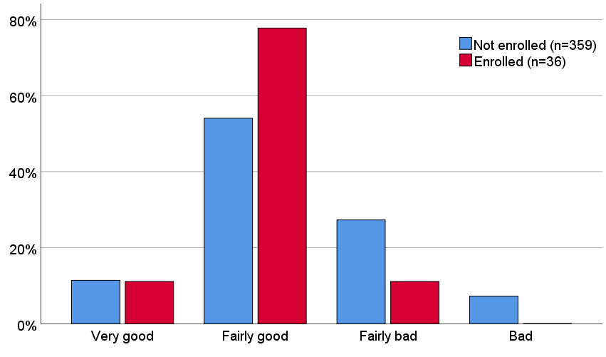

Figure 4 Distribution of proportions of responses for overall sleep quality during the last month, stratified by individuals enrolled (red) and not enrolled (blue) into a pilot field study.

Conceivably, a person with good sleep quality may perceive taking part in the field study as less burdensome than a person with poor sleep quality. Conversely, in a national sleep study with a more nationally representative population, there may also be persons with bad sleep quality living near an airport who may be interested in the research question on potential effects of aircraft noise on sleep, and who are therefore more likely to enroll as field study participants. Finally, our sleep disorder eligibility criterion may bias our sample to subjects with better sleep quality. We therefore included a question on sleep quality, given below.

|  |  |  |  |  |
| --- | --- | --- | --- | --- |
| Q1. During the **last month** or so, how would you rate your sleep quality overall? | | | | |
| **Very good**  **↓** | **Fairly good**  **↓** | **Neither good**  **nor bad**  **↓** | **Fairly bad**  **↓** | **Very bad**  **↓** |
| **□** | **□** | **□** | **□** | **□** |

The phrasing of the sleep quality question and response scale is based on item 6 of the Pittsburgh Sleep Quality Index (PSQI), a validated survey used to identify poor sleepers (Buysse et al. 1989), with the following changes:

* A fifth response, “Neither good nor bad”, was added to the center of the response scale. This was to allow survey respondents to give a more accurate rating or their sleep quality, and to make the response scale have a consistent number of responses with other items in our survey, i.e. five responses.
* The PSQI question phrasing “past month” was changed to “last month or so” in our question, to match the phrasing recommended by the International Commission on the Biological Effects of Noise (ICBEN) for questions on annoyance and sleep disturbance questions (Fields et al. 2001), which are used elsewhere in the survey (Q4 and Q5).

Apart from the above exceptions, the wording of the question and responses was identical to the PSQI phrasing. The direction of the response scale is the same as the PSQI scale, with “Very good” sleep quality on the left and “Very bad” sleep quality on the right.

### Noise sensitivity

An individual’s perceived noise sensitivity can affect their self-reported and physiologic response to noise, with noise sensitive individuals finding noises more threatening and adapting to noise more slowly than less sensitive people (Stansfeld 1992). Although of only borderline statistical significance (Fisher’s exact test of independence: p=0.065), results from our pilot study suggested that noise sensitive individuals were generally less likely to enroll in the field study than their non-sensitive counterparts (Figure 5).

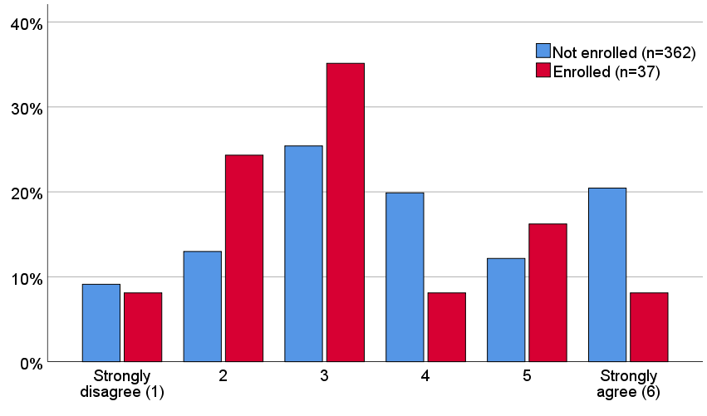

Figure 5 Distribution of proportions of responses to the question “I am sensitive to noise”, stratified by individuals enrolled (red) and not enrolled (blue) into a pilot field study

The noise sensitivity question is based on a single item from the Weinstein noise sensitivity questionnaire, a validated questionnaire with 21 items used to measure self-assessed noise sensitivity (Weinstein 1978). We have used a 5 point response scale, rather than the 6 point response scale from the original Weinstein questionnaire item, to be consistent with other response scales throughout our survey. The noise sensitivity question is given below.

|  |  |  |  |  |
| --- | --- | --- | --- | --- |
| Q3. How strongly do you agree or disagree with the statement “I am sensitive to noise”? | | | | |
| **Strongly disagree**  **1**  **↓** | **2**  **↓** | **3**  **↓** | **4**  **↓** | **Strongly agree**  **5**  **↓** |
| **□** | **□** | **□** | **□** | **□** |

### Annoyance and sleep disturbance by aircraft noise

If an individual is annoyed or sleep disturbed by noise, they may be interested in our research question, and may be more likely to participate in the field study than those who are not annoyed or sleep disturbed. We therefore include questions on annoyance and sleep disturbance.

The question on annoyance by aircraft noise, follows the exact question wording and response scale recommended by the International Commission on the Biological Effects of Noise (ICBEN) (Fields et al. 2001). To be consistent with other response scales in the survey, we inverted the response scale relative to the ICBEN recommendation, such that the “worst” response was furthest to the right. However, a recent analysis found that the direction of this response scale did not affect annoyance scores (Brink et al. 2016). This annoyance question is given below.

|  |  |  |  |  |
| --- | --- | --- | --- | --- |
| Q4. Thinking about the **last 12 months** or so, when you are here at home, how much does noise from aircraft bother, disturb or annoy you? | | | | |
| **Not at all**  **↓** | **Slightly**  **↓** | **Moderately**  **↓** | **Very**  **↓** | **Extremely**  **↓** |
| **□** | **□** | **□** | **□** | **□** |

There are as of yet no standardized phrasings specifically for questions relating to effects of noise on sleep. Therefore the question on sleep disturbance by aircraft noise uses the same wording and response scale as the ICBEN recommendation, but replaces “bother, disturb or annoy you” with “disturb your sleep”. In this way, the wording matches as closely as possible to the standardized and validated annoyance question, but specifically pertains to sleep disturbance. The sleep disturbance question is given below.

|  |  |  |  |  |
| --- | --- | --- | --- | --- |
| Q5. Thinking about the **last 12 months** or so, when you are here at home, how much does noise from aircraft disturb your sleep? | | | | |
| **Not at all**  **↓** | **Slightly**  **↓** | **Moderately**  **↓** | **Very**  **↓** | **Extremely**  **↓** |
| **□** | **□** | **□** | **□** | **□** |

### Neighborhood

We included a single question on satisfaction with the neighborhood, given below.

|  |  |  |  |  |
| --- | --- | --- | --- | --- |
| Q6. Now considering how you feel about everything in your neighborhood, how would you rate your neighborhood as a place to live on a scale from 1 to 5 where 1 is best and 5 is worst? | | | | |
| **Best**  **1**  **↓** | **2**  **↓** | **3**  **↓** | **4**  **↓** | **Worst**  **5**  **↓** |
| **□** | **□** | **□** | **□** | **□** |

This question uses the exact wording of item 2 on the Survey of Community Attitudes from the Airport Cooperative Research Program (ACRP) 02-35 project (National Academies of Sciences 2014), with the following exceptions:

* A 5-point response scale has been used, rather than the 11 point scale used in the recent U.S. Civil Aircraft Noise Annoyance Survey, to be consistent with other items in the current survey
* The response scale has been inverted relative to the recent U.S. Civil Aircraft Noise Annoyance Survey, so that the right-most response indicates the “worst” response, consistent with the other items in the current survey.

### Health

In a pilot study around Atlanta International Airport, we found that people with better self-reported general health were more likely to be enrolled as participants in the field study than those with lower self-reported general health (Fisher’s exact test of independence: p=0.0004, Figure 6). Conceivably, a person in better health may perceive taking part in the field study as less burdensome than a person with poorer health.

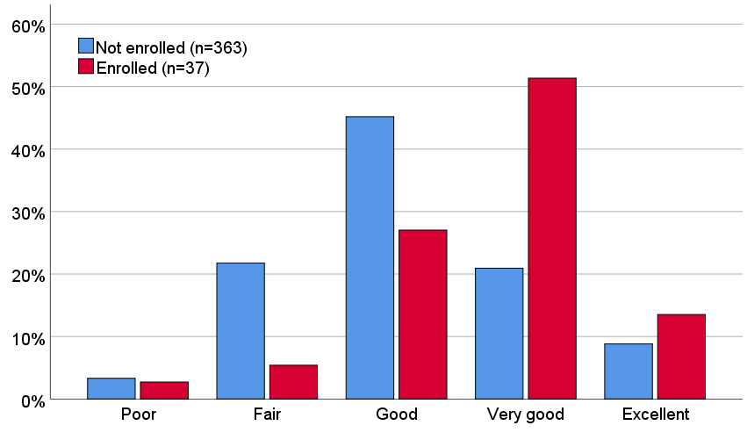

Figure 6 Distribution of proportions of responses for self-rated general health, stratified by individuals enrolled (red) and not enrolled (blue) into a pilot field study.

The general health question is given below, with “Excellent” on the left and “Poor” on the right so that the direction is consistent with other items in the survey.

|  |  |  |  |  |
| --- | --- | --- | --- | --- |
| Q7. In general, would you say your health is…? | | | | |
| **Excellent**  **↓** | **Very good**  **↓** | **Good**  **↓** | **Fair**  **↓** | **Poor**  **↓** |
| **□** | **□** | **□** | **□** | **□** |

### Duration of residence

Over time, an individual may acclimatize (habituate) to nighttime noise to a certain degree, although this habituation may not be complete. Furthermore, before habituation occurs, there may be a period of sensitization to noise among newer residents, whose cardiovascular response to noise during sleep may be stronger than among people who are not exposed to the noise at home (Tassi et al. 2010).

Apart from habituation and sensitization, there is also the possibility that individuals who are vulnerable to sleep disturbance by aircraft noise move to quieter areas after a few years. Conversely, populations who have lived close to airports for a long period may represent resilient sleepers. We therefore included a question on duration of residence, given below.

|  |
| --- |
| Q17. How long have you lived at your current residence? |
| **□** Less than 1 year |
| **□** 1 year or more but less than 5 years |
| **□** 5 to 10 years |
| **□** More than 10 years |

### Other comments

Giving respondents the open-ended option to provide additional comments may increase response rates (McColl et al. 2002). Such a question can also provide useful qualitative data not captured by the quantitative responses elsewhere in the survey. We therefore included an open-ended comments option, given below.

|  |  |
| --- | --- |
| Q24. Any other comments? | ________________________________________________________ |
| ___________________________________________________________________________________ | |
| ___________________________________________________________________________________ | |

## Interest in the field study

In addition to the questions in the survey proper, there was a question in the cover letter where respondents would indicate their interest in taking part in the sleep study, written “I am interested in taking part in the in-home sleep study and give my permission to the study team to contact me either by phone or email”. If a respondent is interested, they provide their name, email address and telephone number(s) so that the research group can contact them to provide more information on the study, obtain informed consent, and subsequently enroll the participant into the field study.

# References

Barba C, Cavalli-Sforza T, Cutter J, Darnton-Hill I, Deurenberg P, Deurenberg-Yap M, et al. 2004. Appropriate body-mass index for asian populations and its implications for policy and intervention strategies. Lancet 363:157-163.

Basner M, Müller U, Elmenhorst EM, Kluge G, Griefahn B. 2008. Aircraft noise effects on sleep: A systematic comparison of eeg awakenings and automatically detected cardiac activations. Physiol Meas 29:1089-1103.

Brink M, Schreckenberg D, Vienneau D, Cajochen C, Wunderli JM, Probst-Hensch N, et al. 2016. Effects of scale, question location, order of response alternatives, and season on self-reported noise annoyance using icben scales: A field experiment. Int J Env Res Pub He 13.

Buysse DJ, Reynolds CF, 3rd, Monk TH, Berman SR, Kupfer DJ. 1989. The pittsburgh sleep quality index: A new instrument for psychiatric practice and research. Psychiatry Res 28:193-213.

Drake CL, Roehrs T, Richardson G, Walsh JK, Roth T. 2004. Shift work sleep disorder: Prevalence and consequences beyond that of symptomatic day workers. Sleep 27:1453-1462.

Fields JM, De Jong RG, Gjestland T, Flindell IH, Job RFS, Kurra S, et al. 2001. Standardized general-purpose noise reaction questions for community noise surveys: Research and a recommendation. Journal of Sound and Vibration 242:641-679.

Howcutt SJ, Barnett AL, Barbosa-Boucas S, Smith LA. 2018. Patterns of response by sociodemographic characteristics and recruitment methods for women in uk population surveys and cohort studies. Women Health 58:365-386.

Krueger PM, Friedman EM. 2009. Sleep duration in the united states: A cross-sectional population-based study. American Journal of Epidemiology 169:1052-1063.

McColl E, Jacoby A, Thomas L, Soutter J, Bamford C, Steen N, et al. 2002. Design and use of surveys: A review of best practice applicable to surveys of health service staff and patients. Health Technology Assessment 5.

Mollayeva T, Thurairajah P, Burton K, Mollayeva S, Shapiro CM, Colantonio A. 2016. The pittsburgh sleep quality index as a screening tool for sleep dysfunction in clinical and non-clinical samples: A systematic review and meta-analysis. Sleep medicine reviews 25:52-73.

Nakash RA, Hutton JL, Jorstad-Stein EC, Gates S, Lamb SE. 2006. Maximising response to postal surveys--a systematic review of randomised trials in health research. Bmc Med Res Methodol 6:5.

National Academies of Sciences E, and Medicine,. 2014. Research methods for understanding aircraft noise annoyances and sleep disturbance. Washington, D. C.:The National Academies Press.

Newington L, Metcalfe A. 2014. Factors influencing recruitment to research: Qualitative study of the experiences and perceptions of research teams. Bmc Med Res Methodol 14.

Schwartz AR, Patil SP, Laffan AM, Polotsky V, Schneider H, Smith PL. 2008. Obesity and obstructive sleep apnea: Pathogenic mechanisms and therapeutic approaches. Proc Am Thorac Soc 5:185-192.

Stansfeld SA. 1992. Noise, noise sensitivity and psychological studies. In: Psychol med, monograph suppl 22. Cambridge:Cambridge U. P.

Tassi P, Rohmer O, Schimchowitsch S, Eschenlauer A, Bonnefond A, Margiocchi F, et al. 2010. Living alongside railway tracks: Long-term effects of nocturnal noise on sleep and cardiovascular reactivity as a function of age. Environ Int 36:683-689.

United States Census Bureau. 2010. 2010 dicennial census of population and housing. Available: https://www.census.gov/programs-surveys/decennial-census/decade.2010.html [accessed July 2019].

United States Census Bureau. 2019a. American community survey (acs). Available: https://www.census.gov/programs-surveys/acs [accessed July 2019].

United States Census Bureau. 2019b. American factfinder. Available: https://factfinder.census.gov/ [accessed March 2019].

Vyas MV, Garg AX, Iansavichus AV, Costella J, Donner A, Laugsand LE, et al. 2012. Shift work and vascular events: Systematic review and meta-analysis. BMJ : British Medical Journal 345:e4800.

Weinstein ND. 1978. Individual differences in reactions to noise: A longitudinal study in a college dormitory. J Appl Psychol 63:458-466.

Yen Y, Shi YM, Soeung B, Seng R, Dy C, Suy R, et al. 2018. The associated risk factors for underweight and overweight high school students in cambodia. Diabetes Metab Synd 12:737-742.

1. This medium length survey included nine questions that are not included in the current survey draft. These were six questions on strategies used to cope with noise when sleeping (wearing earplugs or headphones, turning on the television, turning on music, closing windows, using a sound machine, turning on a fan), and three questions on sleep disturbance by noise from road traffic, trains and neighbors. The current survey includes six questions that were not included in the medium-length survey in the pilot study. These questions are annoyance by aircraft noise (Q4), neighborhood satisfaction (Q6), education (Q11), household income (Q12), number of people in the household (Q17) and other comments (Q23). As outlined in the rationale for including these questions, their addition will allow analysis of non-response to the survey, and analysis of non-participation in the field study. Both analyses are needed to draw conclusions as to the generalizability of the results to a wider population.