NMLS ID of Third Party Originator
Property Address (including name of subdivision, lot & block no. & zip code)
Borrower’s Name and Present Address (include zip code)
Type or Print all entries clearly
Name and Address of Sponsor Name and Address of Agent

Mortgagee ID Sponsor ID Agent ID
Mortgagee Name, Address (include zip code and Telephone Number)
HUD: 2502-0059 (exp. Xx/xx/xxxx
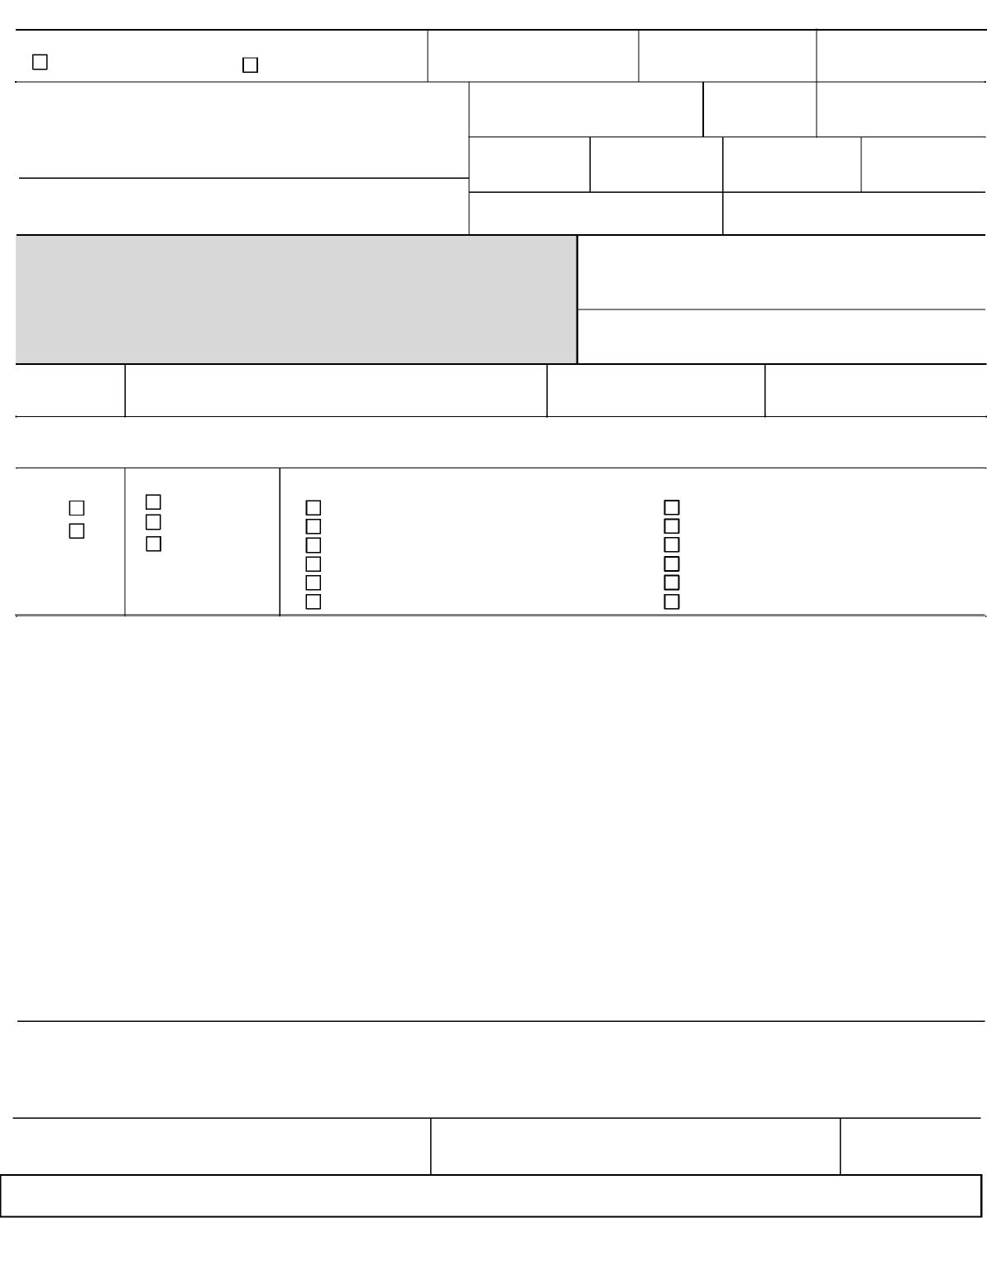
HUD Addendum to Uniform Residential Loan Application OMB Approval No.

Mortgagee Case No.
FHA Case No. (include any suffix)
Part I - Identifying Information
HUD/FHA Application for Insurance
under the National Housing Act
.

Sponsored Originations

Name of Third Party Originator

.

.

page 1 Form HUD-92900-A (08/01/2016)
VA Form 26-1802a (06/2016)

%

:

Part II Borrower Consent for Social Security Administration to Verify Social Security Number
I authorize the Social Security Administration (SSA) to verify my Social Security Number (SSN) to the Mortgagee and HUD/FHA. I authorize SSA to provide explanatory information to HUD/FHA in the event of a discrepancy. This consent is valid for 180 days from the date signed, unless indicated otherwise by the individual(s) named in this loan application.
Signature(s) of Borrower(s) Read consent carefully. Review accuracy of Social Security Number(s) provided on this application.  Borrower’s Name: | CoBorrower’s Name: -  Date of Birth:  Social Security Number:
Date of Birth:
Social Security Number:

Signature: Date Signed:
Signature: Date Signed:

Part III Borrower Notices, Information, and Acknowledgment
Public Reporting Burden
Public reporting burden for this collection of information is estimated to average 10 minutes per response, including the time for reviewing instructions, searching existing data sources, gathering and maintaining the data needed, and completing and reviewing the collection of information. This agency may not conduct or sponsor, and a person is not required to respond to, a collection of information unless that collection displays a valid OMB control number, which can be located on the OMB Internet page at http://www.reginfo.gov/public/do/PRAMain.
Privacy Act Information
The information requested on the Uniform Residential Loan Application and this Addendum is authorized by the National Housing Act of 1934, 12 U.S.C. § 1701, et seq. The Debt Collection Act of 1982, Pub. L. 97 and local agencies when relevant to civil, criminal, or regulatory investigations and prosecutions. It will not otherwise be disclosed or released outside of HUD except as required and permitted by law. The information will be used to determine whether you qualify as a mortgagor. Failure to provide any of the requested information, including SSN, may result in disapproval of your loan application. This is notice to you as required by the Right to Financial Privacy Act of 1978 that HUD/FHA has a right of access to financial records held by financial institutions in connection with the consideration or administration of assistance to you. Financial records involving your transaction will be available to HUD/FHA without further notice or authorization but will not be disclosed or released by the institution to another Government Agency or Department without your consent except as required or permitted by law. State365, and HUD’s Housing and Community Development Act of 1987, 42 U.S.C. § 3543, require persons applying for a federally insured loan to furnish their SSN. You must provide all the requested information, including your SSN. HUD may conduct a computer match to verify the information you provide. HUD may disclose certain information to Federal, -
WARNING: This warning applies to all certifications made in this document.

Anyone who knowingly submits a false claim, or makes false statements is subject to criminal and civil penalties, including confinement for up to 5 years, fines, and civil penalties. 18 U.S.C. §§ 287, 1001 and 31 U.S.C. § 3729
Borrower Name_________________________FHA Case Number _____________

Caution: Delinquencies, Defaults, Foreclosures and Abuses
Delinquencies, defaults, these actions may be used to recover any debts owed when it is determined to be in the interest of the Mortgagee or Federal Government, or both. All ofand (9) Report any resulting written off debt of yours to the Internal Revenue Service as your taxable income. ; (8) Refer your debt to the Internal Revenue Service for offset against any amount owed to you as an income tax refund; (7) If you are a current or retired Federal employee, take action to offset your salary, or civil service retirement benefits; (6) Refer your account to the Department of Justice (DOJ) for litigation in the courts; and seek judgment against you for any deficiency, (5) Refer your account to a private attorney, collection agency or mortgage servicing agency to collect the amount due, foreclose the mortgage, sell the property; (4) Offset amounts owed to you under other Federal programs; (3) Assess charges to cover additional administrative costs incurred by the Federal Government to service your account; (2) Assess additional interest and penalty charges for the period of time that payment is not made; are authorized to take any and all of the following actions in the event loan payments become delinquent on the mortgage loan described in the attached application: (1) Report your name and account information to a credit bureauas well as the Federal Government, its agencies, agents and assigns , and abuses of mortgage loans involving programs of the Federal Government can be costly and detrimental to your credit, now and in the future. The Mortgagee in this transaction, its agents and assignsforeclosures
As a mortgage loan borrower, you will be legally obligated to make the mortgage payments called for by your mortgage loan contract. The fact that you dispose of your property after the loan has been made will not relieve you of liability for making these payments. Payment of the loan in full is ordinarily the way liability on a mortgage note is ended. Some home buyers have the mistaken impression that if they sell their homes when they move to another locality, or dispose of it for any other reasons, they are no longer liable for the mortgage payments and that liability for these payments is solely that of the new owners. Even through the new owners may agree in writing to assume liability for your mortgage payments, this assumption agreement will not relieve you from liability to the holder of the note which you signed when you obtained the loan to buy the property. Unless you are able to sell the property to a buyer who is acceptable to HUD/FHA who will assume the payment of your obligation to the lender, you will not be relieved from liability to repay any claim which HUD/FHA may be required to pay your lender on account of default in your loan payments. The amount of any such claim payment may be a debt owed by you to the Federal Government and subject to established collection procedures.

Fair Housing Act
I and anyone acting on my behalf are, and will remain, in compliance with the Fair Housing Act, 42 U.S.C. § 3604, et seq., with respect to the dwelling or property covered by the loan and in the provision of services or facilities in connection therewith. I recognize that any restrictive covenant on this property related to race, color, religion, sex, disability, familial status, or national origin is unlawful under the Fair Housing Act and unenforceable. I further recognize that in addition to administrative action by HUD, a civil action may be brought by the DOJ in any appropriate U.S. court against any person responsible for a violation of the applicable law.

Certification and Acknowledgment
All information in this application is given for the purpose of obtaining a loan to be insured under the National Housing Act and the information in the Uniform Residential Loan Application and this Addendum is true and complete to the best of my knowledge and belief. Verification may be obtained from any source named herein. I have read and understand the foregoing concerning my liability on the loan and Part III, Borrower Notices, Informationand Acknowledgment.,
Signature(s) of Borrower(s) – Do not sign unless this application is fully completed. Read the certifications carefully and review accuracy of this application.
Signature(s) of Borrower(s) Date Signed Signature(s) of Co - Borrower(s) Date Signed
/ / / /

Borrower Name_________ FHA Case No.___________
Part IV. Direct Endorsement Approval for a HUDvFHA-Insured Mortgage

- Underwriting the Borrower
Date Mortgage Approved: ______________________________ Date Approval Expires: ______________________
For mortgages rated as an “accept” or “approve” by FHA's TOTAL Mortgage Scorecard:
- The information submitted to TOTAL was documented in accordance with Single Family Housing Policy Handbook 4000.1 (SF Handbook) and accurately represents the final information obtained by the mortgagee; and
- This mortgage complies with SF Handbook 4000.1 Section II.A.4.e Final Underwriting Decision (TOTAL) to the extent that no defect exists in connection with the underwriting of this mortgage such that it should not have been approved in accordance with FHA requirements.

I certify that the statements above are materially correct, with the understanding that, in the event HUD elects to pursue a claim arising out of or relating to any inaccuracy of this certification, HUD will interpret the severity of such inaccuracy in a manner that is consistent with the HUD Defect Taxonomy in effect as of the date this mortgage is endorsed for insurance.

Mortgagee Representative Signature: ___________________________________
Printed Name:______________________________________________________
Title:______________________________________________________________

- - - - - - - - - - OR - - - - - - - - - - - - -

For mortgages rated as a “refer” by FHA's TOTAL Mortgage Scorecard, or manually underwritten by a Direct Endorsement underwriter:
- I have personally reviewed and underwritten the borrower’s credit application;
- The information used to underwrite the borrower was documented in accordance with Single Family Housing Policy Handbook 4000.1 (SF Handbook) and accurately represents the final information obtained by the mortgagee; and
- This mortgage complies with SF Handbook 4000.1 Section II.A.5.d Final Underwriting Decision (Manual) to the extent that no defect exists in connection with the underwriting of this mortgage such that it should not have been approved in accordance with FHA requirements.

I certify that the statements above are materially correct, with the understanding that in the event HUD elects to pursue a claim arising out of or relating to any inaccuracy of this certification, HUD will interpret the severity of such inaccuracy in a manner that is consistent with the HUD Defect Taxonomy in effect as of the date this mortgage is endorsed for insurance.
Direct Endorsement Underwriter Signature: __________________________ DE’s ID Number: _____________________

B. Underwriting the Property

For all mortgages where FHA requires an appraisal, I have personally reviewed and underwritten the appraisal according to FHA requirements. I certify that the statements above are materially correct, with the understanding that in the event HUD elects to pursue a claim arising out of or relating to any inaccuracy of this certification, HUD will interpret the severity of such inaccuracy in a manner that is consistent with the HUD Defect Taxonomy in effect as of the date this mortgage is endorsed for insurance.
Direct Endorsement Underwriter Signature: __________________________ DE’s ID Number: _____________________

Borrower Name: FHA Case No.:

Mortgagee's Certification:

- I have personally reviewed the mortgage documents and the application for insurance endorsement; and
- This mortgage complies with SF Handbook 4000.1 Section II.A.7 Post-Closing and Endorsement to the extent that no defect exists that would have changed the decision to endorse or submit the mortgage for insurance.
I certify that the statements above are materially correct, with the understanding that in the event HUD elects to pursue a claim arising out of or relating to any inaccuracy of this certification, HUD will interpret the severity of such inaccuracy in a manner that is consistent with the HUD Defect Taxonomy in effect as of the date this mortgage is endorsed for insurance.

VA Form 26-1802a (06/2016)
Mortgagee

Name of Mortgagee’s Representative

Title of Mortgagee’s Representative

Signature of the Mortgagee’s Representative Date

