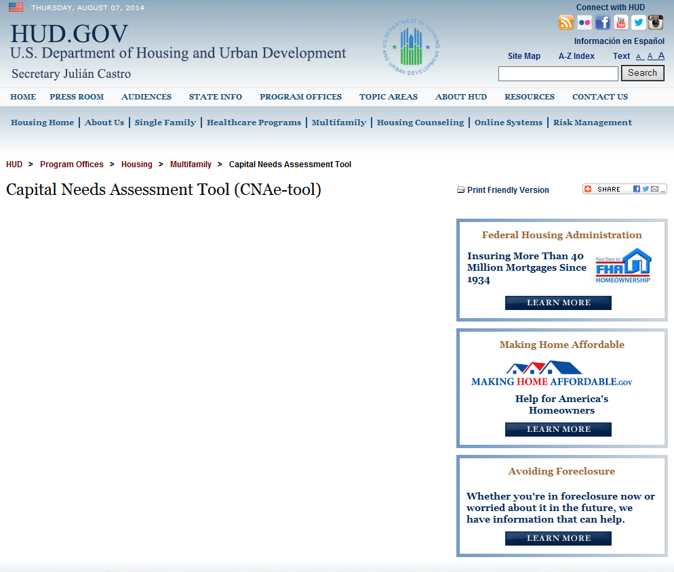

The CNA e Tool will conform to all requirements of the Paperwork Reduction Act (PRA) and as a paperless, automated process for business partner preparation and submission and agency review of capital needs assessments, time savings, improved accuracy and more efficient work processes are anticipated. See further PRA disclosures here: (link to .pdf PRA statement)
HUD Logo Handshake emblem USDA-RD logo
The CNA e Tool is a coordinated assembly of several automated ‘tools’ and electronic templates developed by HUD and USDA Rural Development to establish an aligned data standard and analytical framework for preparing capital needs assessments (CNAs) A CNA is a due diligence report commonly used in the multifamily industry to examine current physical conditions at properties, specify repairs/replacements needed Immediately and to budget for long-term capital repair and replacement needs during the life of an asset. Several of the tools are freely available to the public and may be used to prepare a CNA for any multifamily property no matter whether a HUD or USDA financing or activity is contemplated. These include the following:
The Assessment Tool (a downloadable MS Excel spreadsheet) (download button)
Instructions for Use of Assessment Tool (url & pdf)
CNA Validation Portal (url)
CNA Training Resources (url)
Other tools are available only to credentialed users (HUD or USDA approved lenders, or Agency staff). These are:
CNA Submission Portal (url)
CNA Agency Reviewer Tool (url)
Agency Review Tool User Manual (url & pdf)
RELEVANT AGENCY GUIDANCE
What’ HOT?

Locate announcements, new release info etc here at upper right of page.
HUD: ML 2014-xx
MAP Guide Chapter 5
MAP Guide Appendix 5G
USDA: xyxyxyxyxyxyxyxy
Xyxyxyxyxyxyxyx

