**Virtual NSF Grants Conference Survey (**[**hyperlink**](https://na.eventscloud.com/esurvey/index.php?surveyid=87283)**)**

NSF is proposing that our upcoming in-person Grants Conference move to a virtual format. We are proposing to hold the conference over eight days, with two to three sessions each day. To enhance the attendee experience, we would appreciate your taking a few minutes to answer the following questions. A federal agency may not conduct or sponsor a collection of information unless it displays a currently valid OMB control number; the number for this is 3145-0215.

Please review the draft schedule for a Virtual NSF Grants Conference.

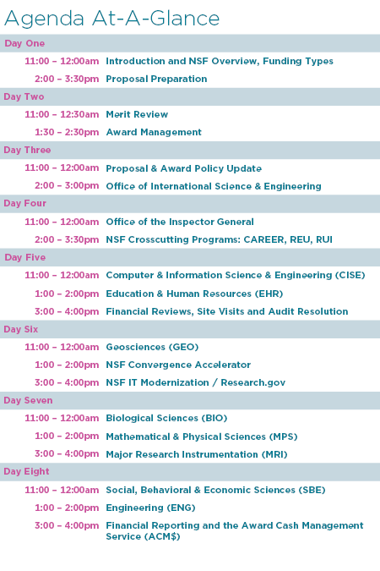

1. If NSF moves forward with this proposed schedule, how likely are you to attend the Virtual NSF Grants Conference?
   1. Very likely
   2. Somewhat likely
   3. Not likely
2. Is there an alternative schedule format that you would prefer?
   1. No
   2. Yes, the conference should be condensed so that multiple sessions take place over fewer than eight days
   3. Yes, the conference should be expanded to take place over more than eight days
   4. Yes, I would prefer an alternative schedule
      1. Please explain
3. Which plenary session topics would you most like to see covered? Please select all that apply.
   1. Introduction, NSF Overview and Funding Types

This session will cover NSF’s purpose, mandate, structure and budget highlights, as well as the various mechanisms NSF uses to fund proposals.

* 1. Proposal Preparation

Learn how to prepare a proposal and what constitutes a proposal of high quality.

* 1. Merit Review

Learn how the merit review system at NSF works, as well as types of reviews. Presenters will also cover the role of the NSF Program Officer, timing of proposal submissions, reviewer selection, release of reviewer comments and conflict of interest issues.

* 1. Award Management

This session will address post-award requirements and conditions and will outline the responsibility of those involved in the award process.

* 1. Proposal & Award Policy Update

This session will provide an update to NSF policies and procedures that affect proposal preparation, merit review and award management.

* 1. Office of International Science & Engineering

Presenters will discuss the role of the office in coordinating activities, as well as how to incorporate international components in NSF proposals.

* 1. Office of the Inspector General

Presenters will discuss the roles and responsibilities of the office. Issues arising from current audits and investigations will be covered.

1. Which breakout session topics would you most like to see covered? Please select all that apply. [For a description of each of these sessions, click here]
   1. Financial Reviews, Site Visits and Audit Resolution
   2. NSF Crosscutting Programs: NSF CAREER Program
   3. NSF Crosscutting Programs: REU, RUI and RET Programs
   4. Promoting and Protecting the U.S. Science and Engineering Enterprise
   5. NSF Convergence Accelerator
   6. NSF IT Modernization / Research.gov
   7. Sexual Harassment Term and Condition for NSF Awards
   8. Major Research Instrumentation (MRI)
   9. Financial Reporting and the Award Cash Management Service (ACM$)
2. Please add any additional topics you would like to see covered.
3. Have you used Zoom webinar or Zoom meetings before?
   1. Yes
   2. No
4. What is your comfort level using Zoom?
   1. Very comfortable
   2. Somewhat comfortable
   3. Not comfortable
5. When do you plan to attend in-person events again? Please consider the following scenarios. (each option will have a Likely, Somewhat Likely, or Not Likely option to choose from.)
   1. I will attend events when a vaccine or effective treatment for the coronavirus has been developed
   2. I will attend events when COVID-19 testing and contact tracing are widely available
   3. I will attend events when the number of COVID-19 cases remain low for an extended period of time
   4. I will only attend events when national and/or local authorities determine it is safe to hold them
   5. I may feel comfortable attending local events soon, as long as social distancing measures are strictly implemented
   6. I may feel comfortable attending non-local events soon, as long as social distancing measures are strictly implemented