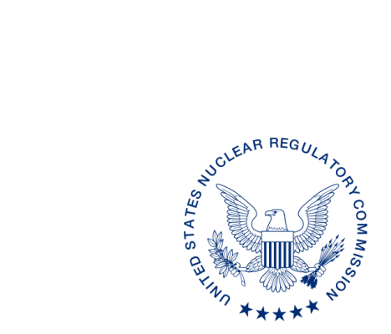
UNITED STATES
NUCLEAR REGULATORY COMMISSION
WASHINGTON, D.C. 20555-0001

ALL AGREEMENT STATES, NRC NMSS, NRC REGIONS I, III and IV

OPPORTUNITY TO COMMENT ON STATE AGREEMENT (SA) PROCEDURE SA-116, PERIODIC MEETINGS BETWEEN IMPEP REVIEWS (STC-20-0XX)

Purpose: To provide the National Materials Program (NMP) an opportunity to comment on the revised SA-116, Periodic Meetings Between IMPEP Reviews.

Background: Periodic Meetings serve as the platform for information exchange between IMPEP reviews. These meetings are not evaluations but an opportunity to help the Agreement States and the NRC maintain awareness of the others’ respective radiation control programs between Integrated Materials Performance Evaluation Program (IMPEP) reviews and to plan for future IMPEP reviews.

Discussion: This letter notifies the NMP community that NMSS procedure SA-116 has been revised to allow Agreement State and the NRC staff in the NMP community to provide comments based on their review of the procedure.
The procedure was revised to clarify and enhance roles and responsibilities of the different participants, includes information regarding the details of the one NRC periodic meeting, and timing of the periodic meeting summary.
The comment period which was developed following consultation with the Organization of Agreement States, ends 60 days from the date of this letter. Please provide comments to me or the individual listed below.
If you have any questions regarding this correspondence, please contact me at (301) 415-3340, or the individual named below:

POINT OF CONTACT: Lizette Roldan-Otero, Ph.D. E-MAIL: lizette.roldan@nrc.gov
TELEPHONE: (817) 200-1596

Kevin Williams, Director
Division of Materials Safety, Security, State
and Tribal Programs
Office of Nuclear Material Safety
and Safeguard

^{[1]} This information request has been approved by OMB 3150-0029 expiration 7/31/2023. Comments regarding this collection may be submitted to the FOIA, Library and Information Collections Branch, U.S. Nuclear Regulatory Commission, Washington, DC 20555-0001, or by e-mail to infocollects.resource@nrc.gov, and to the Desk Officer, Office of Information and Regulatory Affairs, NEOB-10202 (3150-0029), Office of Management and Budget, Washington, DC 20503. If a means used to impose an information collection does not display a currently valid OMB control number, the NRC may not conduct or sponsor, and a person is not required to respond to, the information collection.

