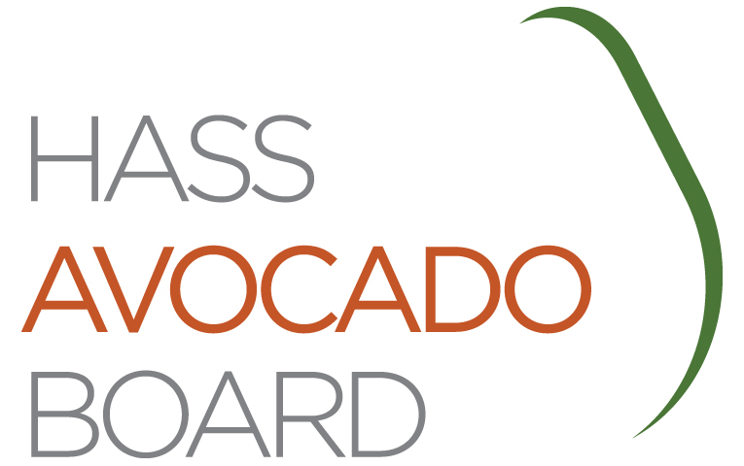

ANNOUNCEMENT OF OPEN SEATS ON THE HASS AVOCADO BOARD

HASS AVOCADO IMPORTER MEMBERS & ALTERNATES

The Hass Avocado Board (HAB) announces the availability of X open importer seats on the Board, X member seats and X alternate member seats. Persons appointed to fill these seats will serve on the Board from November 1, 20XX, to October 31, 20XX.

Importers who are interested in serving as a member or alternate member of HAB must complete and return the form provided below. Completed forms may be faxed, emailed, or mailed, but must be received at the HAB office no later than MONTH XX, 20XX. Importers that would like to nominate another importer, shall have the nominee complete this form and attach a nomination cover letter.

Qualification Requirements:

To be eligible to serve on the Board as an importer member or alternate, importers must be in accordance with:

- Section 1219.30(a) of the Hass Avocado Promotion, Research, and Information Order (Order) requires every board member and alternate to be domiciled in the United States. Domiciled means a place where a person has their true, fixed, and permanent home, and to which whenever they are absent, they have the intention of returning. A person may have more than one residence but only one domicile. Black’s Law Dictionary (5th Edition). No single document, fact or circumstance, is conclusive in determining United States domicile, and if a nominee, member, or alternate is uncertain of his or her domicile status, he or she should consult his or her attorney.

- Section 1219.30(d) of the Order, defines an “Importer” as a “person who is involved in, as a substantial activity, the importation of Hass avocados for sale or marketing in the United States (either directly or as an agent, broker, or consignee of any person that produces Hass avocados outside of the United States for sale in the United States), who is subject to assessments under the Order, and who is listed by U.S. Customs as the importer of record for such Hass avocados. A substantial activity means that the volume of a person's Hass avocado imports must exceed the volume of the person’s production or handling of domestic Hass avocados. In addition, the term “person” (as defined in §1219.19 of the Order) means any individual, group of individuals, firm, partnership, corporation, joint stock company, association, cooperative, or any other legal entity.

Following receipt of nominee names, HAB will engage an independent Certified Public Accounting firm to conduct a nomination process to arrive at two names for each open seat. The names of those receiving the highest number of votes for the available seats will be submitted to the U.S. Secretary of Agriculture (Secretary). The Secretary will make the final decision on who will be appointed to fill the open seats. For information, call HAB at xxx-xxx-xxxx.

If you are an importer and would like to be considered as a nominee for the importer member and/or alternate seat, complete and sign below and return this form to the Hass Avocado Board.

By my signature I hereby certify that I meet the qualification requirements to serve as an importer on the Hass Avocado Board.

Name (print) _______________________________ Signature _______________________
Company Name ____________________________________________________________
Address ___________________________City________________State____Zip__________
Telephone Number _________________________Fax Number_______________________
Email Address _____________________________________________________________

Must be received in HAB office no later than MONTH XX, 20XX

Return via Fax to: Hass Avocado Board, XXX-XXX-XXXX
Scan and email to:
Or mail to: HAB Board Open Seats, Street Address
City, State, Zip

……………………..

According to the Paperwork Reduction Act of 1995, an agency may not conduct or sponsor, and a person is not required to respond to a collection of information unless it displays a valid OMB control number. The valid OMB control number for this information collection is 0581-0093. The time required to complete this information collection is estimated to average
15 minutes per response, including the time for reviewing instructions, searching existing data sources, gathering and maintaining the data needed, and completing and reviewing the collection of information.

In accordance with Federal civil rights law and U.S. Department of Agriculture (USDA) civil rights regulations and policies, the USDA, its Agencies, offices, and employees, and institutions participating in or administering USDA programs are prohibited from discriminating based on race, color, national origin, religion, sex, gender identity (including gender expression), sexual orientation, disability, age, marital status, family/parental status, income derived from a public assistance program, political beliefs, or reprisal or retaliation for prior civil rights activity, in any program or activity conducted or funded by USDA (not all bases apply to all programs). Remedies and complaint filing deadlines vary by program or incident.

Persons with disabilities who require alternative means of communication for program information (e.g., Braille, large print, audiotape, American Sign Language, etc.) should contact the responsible Agency or USDA’s TARGET Center at (202) 720-2600 (voice and TTY) or contact USDA through the Federal Relay Service at (800) 877-8339. Additionally, program information may be made available in languages other than English.

To file a program discrimination complaint, complete the USDA Program Discrimination Complaint Form, AD-3027, found online at http://www.ascr.usda.gov/complaint_filing_cust.html and at any USDA office or write a letter addressed to USDA and provide in the letter all of the information requested in the form. To request a copy of the complaint form, call (866) 632-9992. Submit your completed form or letter to USDA by: 1) mail: U.S. Department of Agriculture Office of the Assistant Secretary for Civil Rights, 1400 Independence Avenue, SW., Washington, D.C. 20250-9410; 2) fax: (202) 690-7442; or 3) email: program.intake@usda.gov.

USDA is an equal opportunity provider, employer, and lender.

