B: Small Business Pulse Survey Data Visualization Mockup

Data will be represented in a user-friendly graphical format and available at https://www.census.gov/businesspulsedata as a featured experimental data product.

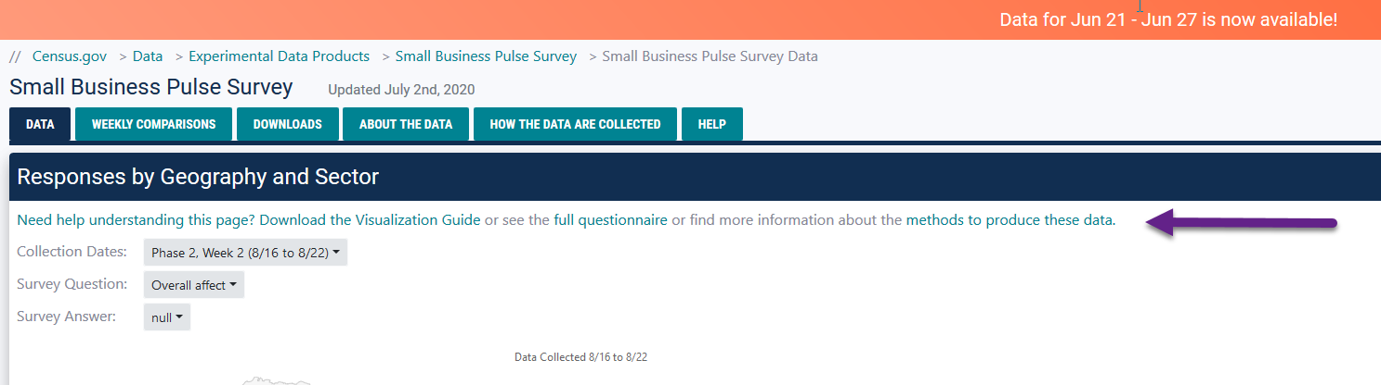

Updated: Overall Impact to Overall Affect

The text ‘see the full questionnaire or find more information about the methods to produce these data’ will be added above the visuals on the data tab and the weekly comparison tab. Note, the screenshots below have the previous shorter language as we are working to implement this on the other pages, but the image above shows what they will look like.

‘Methods to Produce the Data’ will link to About the Data tab

About the Data – top part of the page

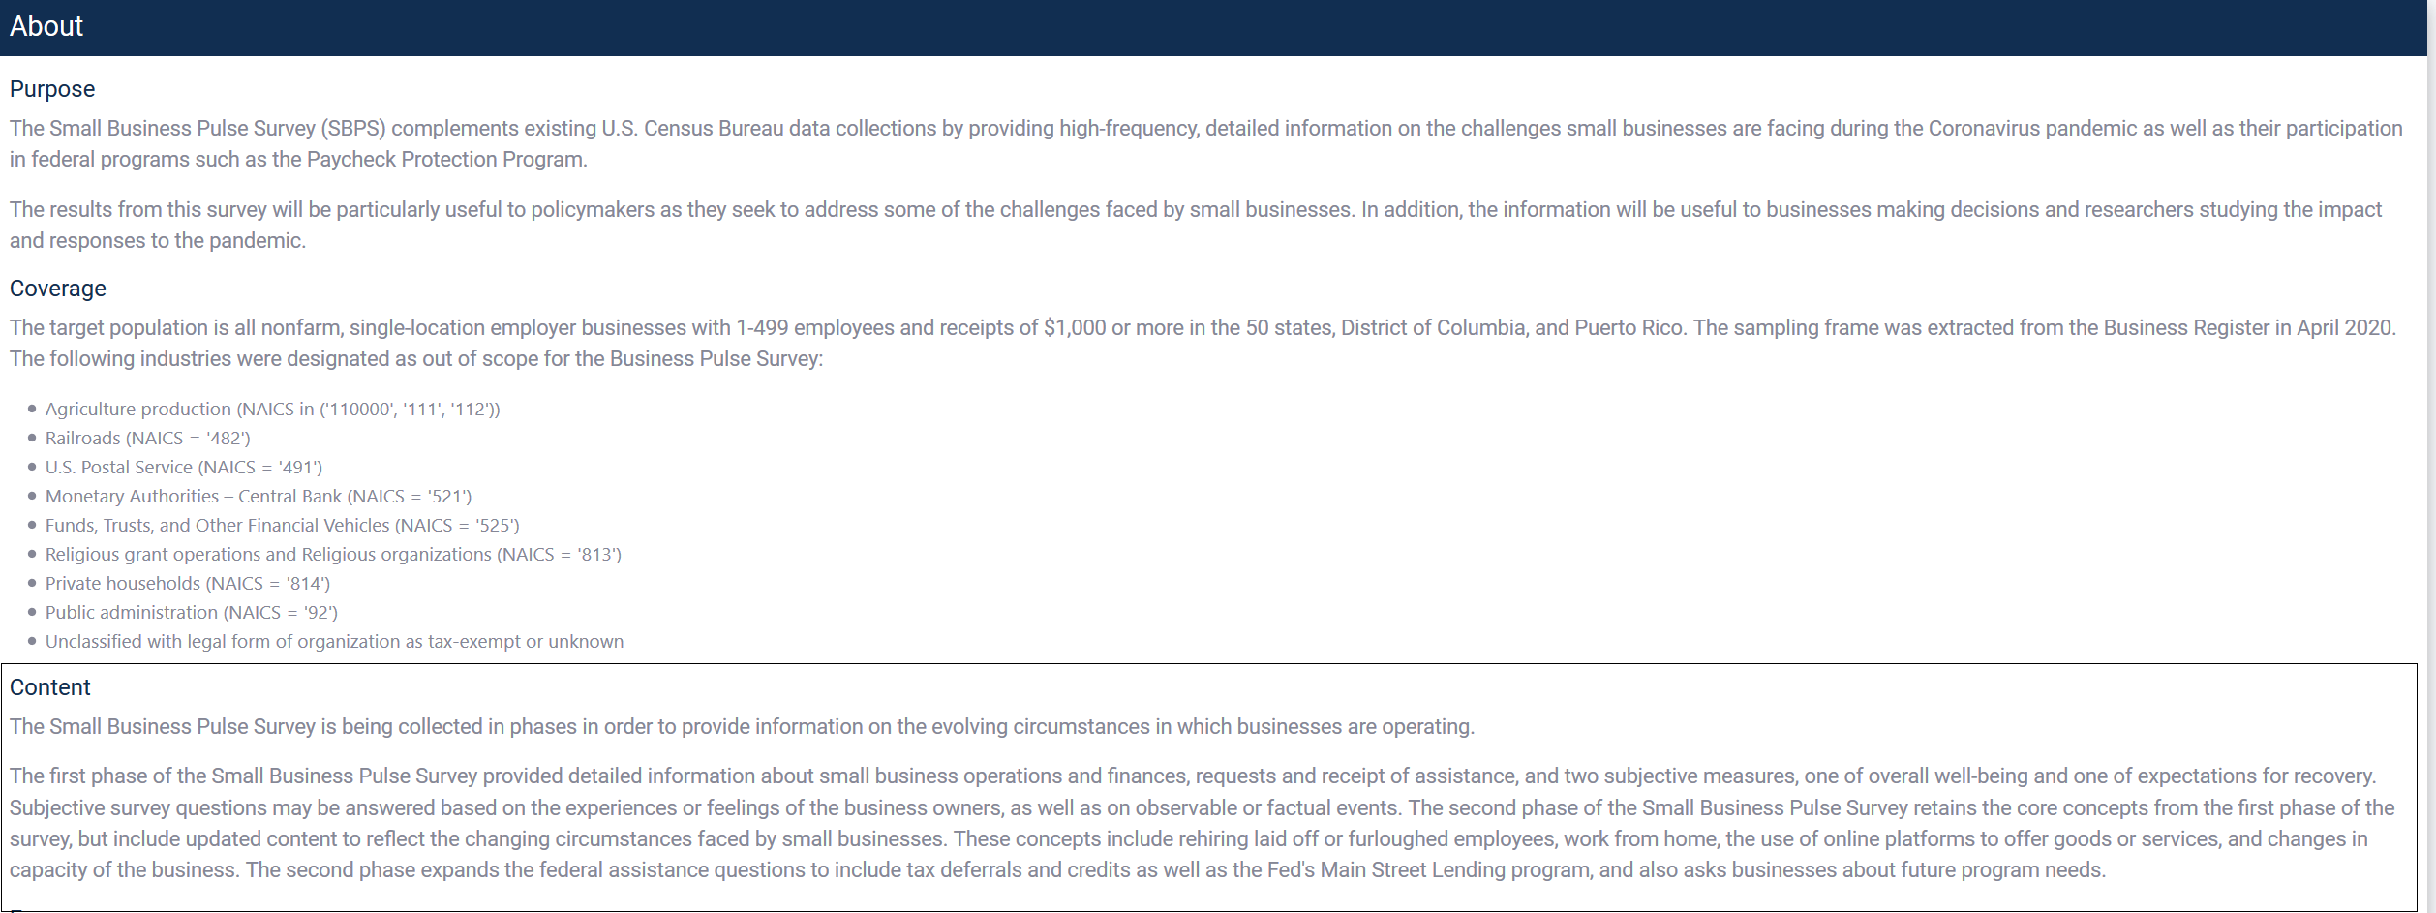
Subjective comments were incorporated into the Content section of the about the data.

Home: Geographical and Bar Chart

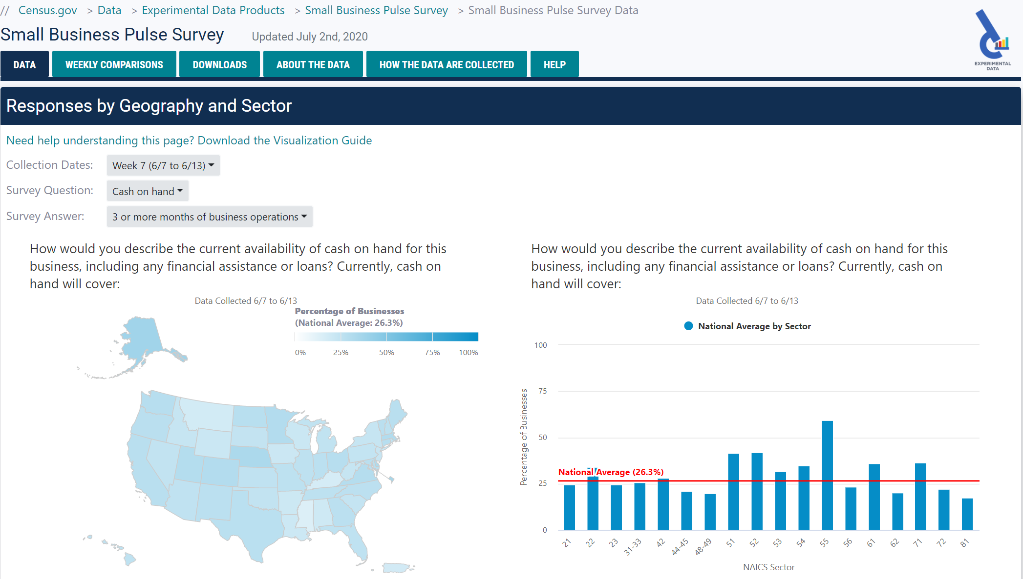

Home: Survey Response Detail

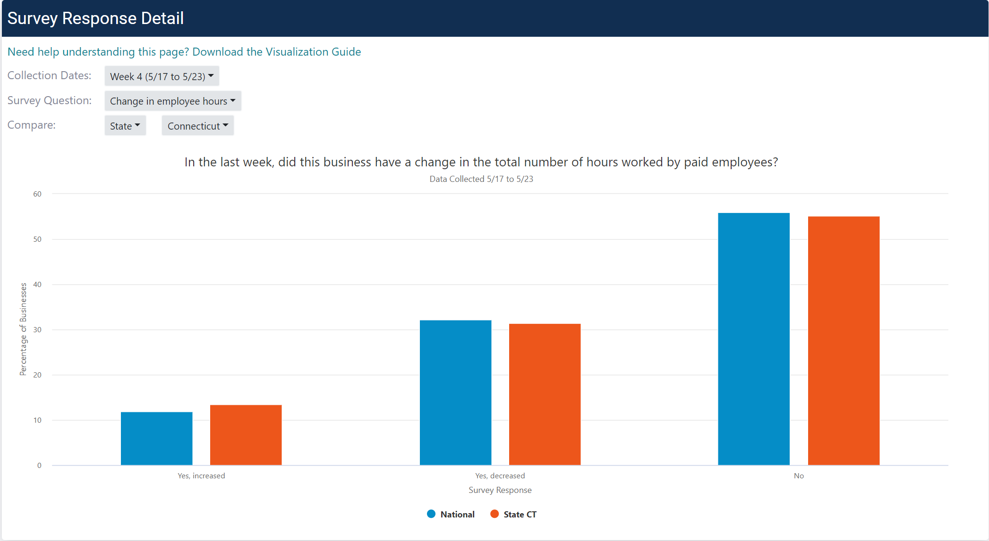

Home: Multiple Response Comparisons

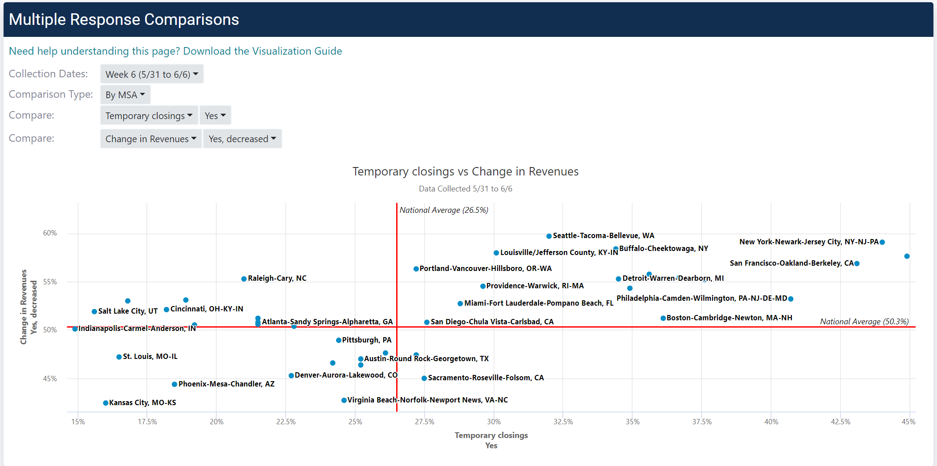

Weekly Comparisons tab: Survey Responses Weekly Comparison

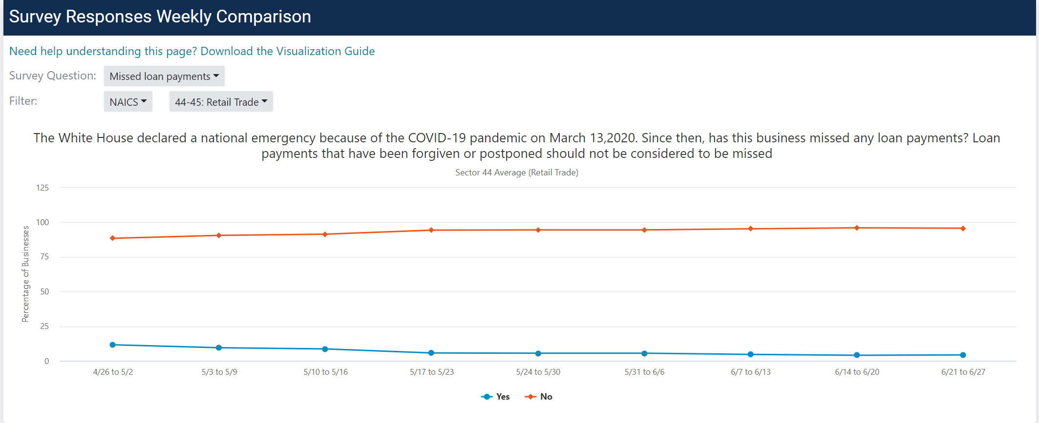

Downloads tab: Downloads and Documentation

