Prescriber Survey to Assess Boxed Warnings Perceptions
Survey Questionnaire: Vulvar and Vaginal Atrophy
(Questions used for pre-testing condition are included at the end)

Introductory Script:
Thank you for your participation in this survey. The first few questions will focus on the condition of vulvar and vaginal atrophy in menopause, which you may also know as postmenopausal atrophic vaginitis.
//PROGRAMMING NOTES: Display each question on its own separate screen. Do not allow participants to go back on any screen. Include soft prompts for all items. //

Question Type: Single Punch

Question 1
How experienced are you with treating vulvar and vaginal atrophy?

Variable Label: Q1 Familiarity with treating VVA

Value | Value Label
1 | Not at all experienced
2 | Slightly experienced
3 | Somewhat experienced
4 | Experienced
5 | Very experienced
--99 | Refused

Question Type: Single Punch

Question 2
How many patients do you typically see for treatment of vulvar and vaginal atrophy?

Variable Label: Q2 Number of patients typically seen

Value | Value Label
1 | One to two patients each week, or fewer
2 | Several patients a week
3 | Several patients a day
--98 | Unsure/Don’t know
--99 | Refused

Question Type: Single Punch

Question 3
In general, how bothersome are symptoms of vulvar and vaginal atrophy for most of your patients who have the condition?

Variable Label: Q3 Bothersomeness of symptoms

Value | Value Label
1 | Not at all bothersome
2 | Slightly bothersome
3 | Somewhat bothersome
4 | Bothersome
5 | Very bothersome
--98 | Unsure/Don’t know
--99 | Refused

Question Type: Single Punch

Question 4A
Which of the following is true of your prescribing vaginal inserts (e.g., Vagifem, Imvexxy) for the treatment of vulvar and vaginal atrophy?

Variable Label: Q4A Experience prescribing vaginal inserts

Value | Value Label
1 | I have written new prescriptions for this product
2 | I have only prescribed a refill for this product
3 | I have never prescribed this product
-98 | Unsure/don’t know
-99 | Refused

// PROGRAMMING NOTE: SKIP 4B if 4A = 2, 3, 4, or -98//

Question Type: Single Punch

Question 4B
On average, how often do you prescribe vaginal inserts (e.g., Vagifem, Imvexxy) for the treatment of vulvar and vaginal atrophy?

Variable Label: Q4B Frequency of prescribing vaginal inserts

Value | Value Label
1 | I prescribe this product one or more times a week
2 | I prescribe this product a few times a month
3 | I prescribe this product a few times a year
-98 | Unsure/Don’t know
-99 | Refused
Question Type: Multi Punch

Question 5
Which of the following other treatments would you recommended or prescribe in a typical month? (Select all that apply.)

Value | Value Label | Variable Label
1 | Over-the-counter products (e.g., personal lubricant) | Q5_1 Typical treatment: OTC products
2 | Vaginal estrogen rings (e.g., Estring, Femring) | Q5_2 Typical treatment: Estrogen rings
3 | Vaginal estrogen creams (e.g., Premarin, Estrace) | Q5_3 Typical treatment: Estrogen creams
4 | Topical estrogen gels (e.g., Estrogel, Divigel) | Q5_4 Typical treatment: Estrogen gels
5 | Oral estrogens (e.g., Premarin) | Q5_5 Typical treatment: Oral estrogens
6 | Estrogen transdermal patches (e.g., Alora, Estraderm) | Q5_6 Typical treatment: Estrogen patch
7 | Other prescription product that does not contain estrogen | Q5_7 Typical treatment: Other prescription product w/o estrogen
8 | Other (specify) | Q5_8 Typical treatment: Other

Value | Value Label
1 | Selected
0 | Not selected

For the next few questions, we would like you to consider your patients who are postmenopausal women with vulvo-vaginal atrophy and are complaining of symptoms such as vaginal itching and discomfort or pain during intercourse. They have previously tried over-the-counter ointments with little success.
// PROGRAMMING NOTE: [SHOW SCENARIO AT THE TOP OF THE SCREEN FOR QUESTION 6]//

Question Type: Single Punch

Question 6
How likely are you to discuss vaginal inserts, such as Vagifem or Imvexxy, as a potential option for these patients?

Variable Label: Q6 Likelihood of discussing inserts

Value | Value Label
1 | Very unlikely
2 | Unlikely
3 | Somewhat likely
4 | Likely
5 | Very likely
-99 | Refused
Question Type: Single Punch

Question 7
Which of the following statements describe your assessment of the safety of vaginal inserts used to treat vulvar and vaginal atrophy?

Variable Label: Q7 Risk assessment of vaginal inserts

Value | Value Label
1 | Risks are minimal for almost all patients
2 | Risks are minimal for most patients, but are significant for some patients
3 | Risks are significant for most patients
4 | I am not familiar enough with vaginal inserts to make an assessment
-99 | Refused

Question Type: Single Punch

Question 8A
Which statement best describes your assessment of the safety of vaginal inserts compared to oral estrogen products?

Variable Label: Q8A Assessment of inserts vs. oral estrogen

Value | Value Label
1 | Vaginal inserts are safer than oral estrogen products
2 | Vaginal inserts are less safe than oral estrogen products
3 | Vaginal inserts are no more and no less safe than oral estrogen products
4 | The safety of vaginal inserts versus oral estrogen products has not been established
5 | I am not familiar enough with vaginal inserts to make an assessment
-99 | Refused

Question Type: Single Punch

Question 8B
Which statement best describes your assessment of the safety of vaginal inserts compared to transdermal estrogen products?

Variable Label: Q8B Assessment of inserts vs. transdermal estrogen

Value | Value Label
1 | Vaginal inserts are safer than transdermal estrogen products
2 | Vaginal inserts are less safe than transdermal estrogen products
3 | Vaginal inserts are no more and no less safe than transdermal estrogen products
4 | The safety of vaginal inserts versus transdermal estrogen products has not been established
5 | I am not familiar enough with vaginal inserts to make an assessment
-99 | Refused

Question Type: Single Punch

Question 8C
Which statement best describes your general perspective on the benefits versus risks of vaginal inserts for patients with vulvar and vaginal atrophy.

Variable Label: Q8C Benefits/risks of inserts

Value | Value Label
1 | The benefits of vaginal inserts outweigh the risks for most patients
2 | The benefits of vaginal inserts outweigh the risks for some, but not most, patients
3 | The benefits of vaginal inserts outweigh the risks for very few patients
4 | I am not familiar enough with vaginal inserts to make an assessment
-99 | Refused

Question Type: Multi Punch

Question 9
Which of the following factors play the most important role when deciding whether or not to prescribe vaginal inserts to a patient with vulvar and vaginal atrophy? Please choose the three factors that you consider to be most important. [//Multi-punch//]

//PROGRAMMING NOTE: ALLOW PARTICIPANTS TO SELECT UP TO THREE ANSWERS//

[RANDOM ORDER EXCEPT FOR OTHER]

Variable Name | Variable Text | Variable Label
Q9_1 | Considerations of this patient’s ability to use the product as prescribed | Q9_1 Factor: Patient ability to use
Q9_2 | This patient’s understanding of and comfort with the risks of this medication | Q9_2 Factor: Understanding and comfort with risks
Q9_3 | This patient’s previous experience with treatments (over-the-counter and prescription) | Q9_3 Factor: Patient’s previous experience
Q9_4 | This patient’s medical and health context (e.g., medical history, comorbidities, family history) | Q9_4 Factor: Medical and health context
Q9_5 | Considerations of this patient’s access to the product (e.g., cost, insurance) | Q9_5 Factor: Patient access
Q9_6 | Extent, duration, and severity of this patient’s symptoms | Q9_6 Factor: Symptoms
Q9_7 | Patient’s preference for a mode of administration | Q9_7 Factor: Patient preference for administration
Q9_8 | Potential duration of treatment use/course | Q9_8 Factor: Duration
Q9_9 | Other (please specify) | Q9_9 Factor: Other

Value | Value Label
1 | Selected
0 | Not selected
Question Type: Multi Punch
Question 10
What are the top three comments or questions you have you heard from patients about using vaginal inserts to treat vulvar and vaginal atrophy? (Select up to three.) [//Multi-punch//]

//PROGRAMMING NOTE: ALLOW PARTICIPANTS TO SELECT UP TO THREE ANSWERS//

[RANDOM ORDER, EXCEPT FOR OTHER]

Variable Name | Variable Text | Variable Label
Q10_1 | Pros about vaginal inserts’ application method | Q10_1 Pros application method
Q10_2 | Hearing positive things about how well vaginal inserts work | Q10_2 Heard positive things
Q10_3 | Whether vaginal inserts may be safer than other estrogen treatments | Q10_3 Inserts safer than other estrogen
Q10_4 | A desire to try something new | Q10_4 Try something new
Q10_5 | Cons about vaginal inserts’ application method | Q10_5 Cons application method
Q10_6 | Concerns about insurance coverage or cost | Q10_6 Insurance coverage/cost
Q10_7 | Hearing negative things about how well vaginal inserts work | Q10_7 Hearing negative things
Q10_8 | Concerns about using an estrogen treatment | Q10_8 General concerns re: estrogen
Q10_9 | Other (specify) | Q10_9 Other

Value | Value Label
1 | Selected
0 | Not selected

Question Type: Multi Punch
Question 11
What are the top three topics that you prioritize when talking to your patients about vaginal inserts as a treatment option?

//PROGRAMMING NOTE: ALLOW PARTICIPANT TO SELECT UP TO THREE ANSWERS//

[RANDOM ORDER EXCEPT FOR LAST OPTION] [//Multi-punch//]

Variable Name | Variable Text | Variable Label
Q11_1 | How the product works | Q11_1 Talking top 3: How product works
Q11_2 | Expected benefits of the product | Q11_2 Talking top 3: Expected benefits
Q11_3 | Common side effects of the product | Q11_3 Talking top 3: Common side effects
Q11_4 | Rare but serious side effects of the product | Q11_4 Talking top 3: Rare serious effects
Q11_5 | Patient’s medical history (e.g., personal history or family history, possible co-morbidities) | Q11_5 Talking top 3: Medical history
Q11_6 | The importance of using the product as directed | Q11_6 Talking top 3: Importance of use as directed
Q11_7 | Other (Specify) | Q11_7 Talking top 3: Other

Value | Value Label
1 | Selected
0 | Not selected

//PROGRAMMING NOTE: If Q11D selected, display Q11_RISKS. OTHERWISE, PROCEED TO Q12 //

Question Type: Open End Essay

Question 11_RISKS
You said that you discuss rare but serious side effects of the product. What potential side effects do you discuss?
Variable Label: Q11_RISKS Side effects discussed

Question Type: Multi Punch

Question 12
How do you most commonly monitor your patients for potential safety risks and side effects after prescribing vaginal inserts for vulvar and vaginal atrophy? Select all that apply. [//Multi-punch//]
Variable Name | Value | Variable Label
Q12_1 | I schedule routine follow-up appointments with patients. | Q12_1 Monitor: Follow-up appointment
Q12_2 | I instruct patients to get bloodwork before follow-up appointment. | Q12_2: Monitor: Bloodwork
Q12_3 | I instruct patients to call and schedule an appointment if they experience side effects. | Q12_3 Monitor: Appointment if side effects
Q12_4 | I leave it to the patient to follow up if they feel a need to. | Q12_4 Monitor: Leave up to patient
Q12_5 | A follow-up appointment is not necessary. | Q12_5 Monitor: Follow-up not necessary
Q12_6 | Other (specify) | Q12_6 Monitor: Other

Value | Value Label
1 | Selected
0 | Not selected

Question Type: Grid

Question 13
How often do you look for information about vaginal inserts or other products from the following sources:

[RANDOM ORDER]

Variable Name | Variable Text | Variable Label
Q13_ 1 | Medical journals | Q13_1 Info: Medical journals
Q13_2 | Medical websites or software (e.g. UpToDate, Epocrates, Medscape) | Q13_2 Info: Medical websites or software
Q13_3 | Drug company/pharmaceutical representatives or their website | Q13_3 Info: Drug company rep or website
Q13_4 | Go online/use a search engine (e.g., Google) | Q13_4 Info: Online search
Q13_5 | Professional medical societies (e.g., publications, guidelines) | Q13_5 Info: Professional medical societies
Q13_6 | Conferences | Q13_6 Info: Conferences
Q13_7 | Discussion with colleagues (e.g., in person, email) | Q13_7 Info: Discussion w/ colleagues
Q13_8 | FDA website or other FDA sources of information (e.g., email, alerts) | Q13_8 Info: FDA
Q13_9 | Other government agencies (e.g., NIH, CDC) | Q13_9 Info: Other government agencies

Value | Value Label
1 | Never
2 | Rarely
3 | Sometimes
4 | Often

//[SHOW QUESTION AT THE TOP OF THE SCREEN FOR QUESTION 14]//

The next question refers to boxed warnings on the product labeling for Vagifem, a vaginal tablet, and other estrogen products.

Question Type: Multi-Punch

Question 14
In your opinion, what is the primary role of a boxed warning? Choose up to three options.

//Random Order, except last three
//PROGRAMMING NOTE: ALLOW PARTICIPANT TO UP TO SELECT THREE ANSWERS//

Variable Name | Variable Text | Variable Label
Q14_1 | To highlight the most serious potential risks of the product | Q14_1 BW Primary Role: Highlight most serious risks
Q14_2 | To provide information that should be factored into a decision to prescribe the product | Q14_2 BW Primary Role: Provide prescribing information
Q14_3 | To provide an overview of the safety profile of the product | Q14_3 BW Primary Role: Provide safety profile overview
Q14_4 | To disclose clinical trial and other product safety testing information | Q14_4 BW Primary Role: Clinical trial and safety testing
Q14_5 | To provide information that prescribers should be communicating to patients | Q14_5 BW Primary Role: Info to communicate to patients
Q14_6 | To provide information on how to safely use the product | Q14_6 BW Primary Role: Info on how to safely use product
Q14_7 | I do not see a role for them | Q14_7 BW Primary Role: No role for BW
Q14_8 | Other (specify) | Q14_8 BW Primary Role: Other
Q14_9 | Unsure/Don’t know | Q14_9 BW Primary Role: Unsure/Don’t know

Value | Value Label
1 | Included
0 | Not included

//PROGRAMMING NOTE: SHOW PARAGRAPH ON ITS OWN PAGE//
The next set of questions will ask you more specifically about the boxed warning and prescribing information for Vagifem to treat vulvar and vaginal atrophy. This boxed warning appears on all prescription estrogen products.

//PROGRAMMING NOTE: “NEXT” BUTTON TO PROCEED TO Q15//

Question Type: Single Punch
Question 15
How would you rate your familiarity with the boxed warning information for Vagifem and other estrogen products?

Variable Label: Q15 Familiarity with BW information for Vagifem and other estrogen products

Value | Value Label
1 | Not at all familiar
2 | Slightly familiar
3 | Somewhat familiar
4 | Familiar
5 | Very familiar
-99 | Refused

Question Type: Multi Punch
Question 16
Which of the following risks do you recall being included in the boxed warning for vaginal inserts? Select all that apply.

[RANDOM ORDER EXCEPT FOR LAST TWO OPTIONS] [//Multi-punch//]

Variable Name | Variable Text | Variable Label
Q16_1 | Endometrial cancer | Q16_1 Risks: Endometrial cancer
Q16_2 | Endometrial hyperplasia | Q16_2 Risks: Endometrial hyperplasia
Q16_3 | Dementia | Q16_3 Risks: Dementia
Q16_4 | Stroke | Q16_4 Risks: Stroke
Q16_5 | Deep vein thrombosis (DVT) | Q16_5 Risks: Deep vein thrombosis
Q16_6 | Breast cancer | Q16_6 Risks: Breast cancer
Q16_7 | Gallbladder disease | Q16_7 Risks: Gallbladder disease
Q16_8 | Hypercalcemia | Q16_8 Risks: Hypercalcemia
Q16_9 | Visual abnormalities | Q16_9 Risks: Visual abnormalities
Q16_10 | Elevated blood pressure | Q16_10 Risks: Elevated blood pressure
Q16_11 | None of the above | Q16_11 Risks: None of the above
Q16_12 | Other (specify) | Q16_12 Risks: Other

Value | Value Label
1 | Included
2 | Not included
3 | Don’t know

//PROGRAMMING NOTE: SHOW PARAGRAPH ON ITS OWN PAGE, THEN CLICK NEXT TO VIEW BOXED WARNING//
We would like to show you some of the boxed warning information for Vagifem, which is available in the FDA-approved prescribing information. This boxed warning information appears on the labeling for all estrogen products. Please take a few moments to review this information.
//PROGRAMMING NOTE: SHOW THE BOXED WARNING ON ITS OWN PAGE//

[View boxed warning information]
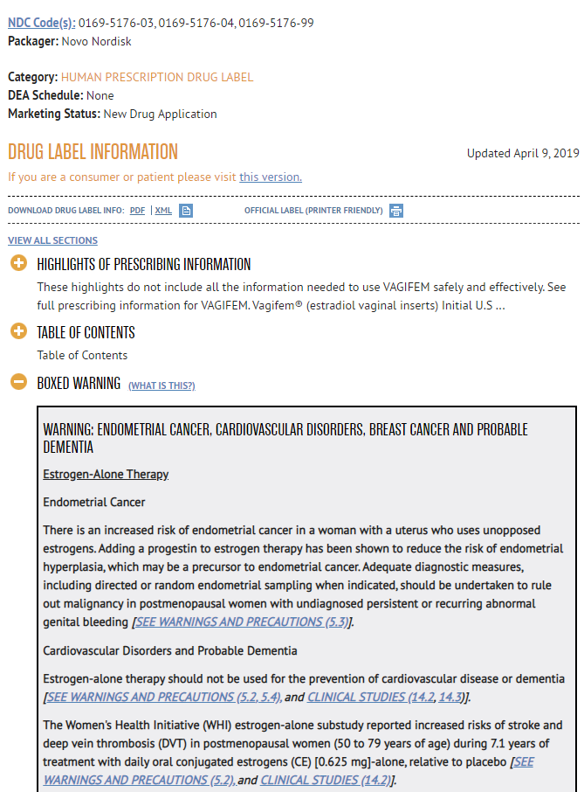
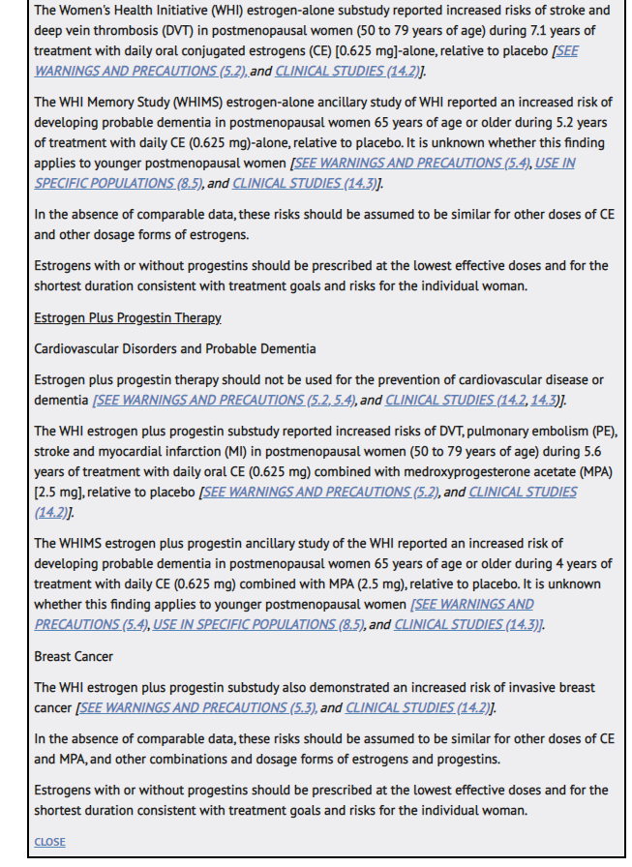
//PROGRAMMING NOTE: HAVE A “NEXT” BUTTON AT THE BOTTOM OF THE BOXED WARNING PAGE TO PROCEED TO QUESTION 17//
Question Type: Single Punch

Question 17
How useful is the information in the boxed warning for Vagifem?

Variable Label: Q17 Usefulness of BW for Vagifem

Value | Value Label
1 | Not at all useful
2 | Slightly useful
3 | Somewhat useful
4 | Useful
5 | Very useful
-99 | Refused

Question Type: Single Punch

Question 18
What is your assessment of the way the risks of Vagifem are framed in the boxed warning?

Variable Label: Q18 Assessment of risk framing in Vagifem BW

Value | Value Label
1 | Strongly understates risk
2 | Somewhat understates risk
3 | Provides appropriate assessment of risk
4 | Somewhat overstates risk
5 | Strongly overstates risk
6 | Other (specify)
-99 | Refused

Question Type: Single Punch

Question 19
Which statement best reflects your opinion on the relative benefits versus risks of vaginal inserts for patients with vulvar and vaginal atrophy.

Variable Label: Q19 Assessment of benefits versus risks Post-BW

Value | Value Label
1 | The benefits of vaginal inserts outweigh the risks for most patients
2 | The benefits of vaginal inserts outweigh the risks for some, but not most, patients
3 | The benefits of vaginal inserts outweigh the risks for very few patients
4 | I am not familiar enough with vaginal inserts to make an assessment
-99 | Refused

Question Type: Multi Punch
Question 20
What would improve the boxed warning for Vagifem, in your opinion? (Select all that apply.) [//Multi-punch//]

Variable Name | Variable Text | Variable Label
Q20_1 | Nothing, the warning is fine the way it is | Q20_1 Improve BW: Nothing
Q20_2 | Better evidence to support risk information | Q20_2 Improve BW: Better risk info evidence
Q20_3 | Decrease the amount of information given/fewer words | Q20_3 Improve BW: Decrease amount of info/shorten
Q20_4 | Simpler language | Q20_4 Improve BW: Simpler language
Q20_5 | Formatting improvements (e.g., use of boldface) | Q20_5 Improve BW: Formatting
Q20_6 | Increase the amount of information (e.g., statistics, more details) | Q20_6 Improve BW: Increase amount of info
Q20_7 | Other (Specify) | Q20_7 Improve BW: Other (specify)
Q20_8 | Unsure/Don’t know | Q20_8 Improve BW: Unsure/Don’t know

Value | Value Label
1 | Included
2 | Not included

Question Type: Open-End Essay

Question 21
Please provide any specific feedback on the boxed warning information for Vagifem.

Variable Label: Q21 Specific feedback on Vagifem BW information

//PROGRAMMING NOTE: SHOW SENTENCE ON ITS OWN PAGE, THEN CLICK NEXT TO VIEW Q22//
Please now consider boxed warnings in general, not only the one you saw for Vagifem.

Question Type: Grid
Question 22
To what degree do you agree or disagree with the following statements about boxed warnings in general (in other words, across all classes of prescription drugs)?

[RANDOM ORDER for 1-6]

Variable Name | Variable Text | Variable Label
Q22_1 | Boxed warnings are very common on the products that I prescribe | Q22_1 Agree/Disagree: BW are very common on products I prescribe
Q22_2 | Boxed warnings do not generally factor heavily into my decisions on whether to prescribe a product | Q22_2 Agree/Disagree: BW do not generally factor heavily
Q22_3 | I think carefully before prescribing a product with a boxed warning if other treatments are available | Q22_3 Agree/Disagree: I think carefully before prescribing BW product if others available
Q22_4 | I counsel my patients differently when prescribing a product with a boxed warning | Q22_4 Agree/Disagree: Counsel patients differently with BW
Q22_5 | My patients rarely know whether a product would have a boxed warning or not | Q22_5 Agree/Disagree: Patients rarely know if product has BW
Q22_6 | My patients are worried or scared when they see boxed warnings | Q22_6 Agree/Disagree: Patients worried/scared when they see BW
Q22_7 | Other (specify) | Q22_7

Value | Value Label
1 | Strongly disagree
2 | Disagree
3 | Neither agree nor disagree
4 | Agree
5 | Strongly agree
-98 | Unsure/Don’t know

Question Type: Single Punch

Question 23
How favorable is your opinion of boxed warnings in general (across all classes of prescription drugs)?

Variable Label: Q23 General favorability of BW

Value | Value Label
1 | Very unfavorable
2 | Somewhat unfavorable
3 | Neither unfavorable nor favorable
4 | Somewhat favorable
5 | Very favorable
-98 | Unsure/Don’t know
-99 | Refused

Question Type: Open End Essay
Question 24
In general, what suggestions do you have on how to better use boxed warnings as a tool to highlight important safety information?

Variable Label: Q24 Suggestions for better using BW to highlight safety info

//DISPLAY TEXT//
We would like your feedback on the survey that you completed. This will help FDA improve the survey for future use with healthcare providers.
Question Type: Single Punch
Question P1
Were you able to complete the survey in one session?
Variable Label: P1 One session completion
Value | Value Label
1 | Yes
0 | No

Question Type: Open End Essay
Question P2
Did you rely on other sources (e.g., Google, colleagues, etc.) to answer questions you found difficult to answer? If yes, please explain.

Variable Label: P2 Other sources

Question Type: Open End Essay
Question P3
Were there any questions you had difficulty answering? If yes, please explain.

Variable Label: P3 Difficulty answering question

Question Type: Open End Essay
Question P4
What other suggestions of feedback about this survey would you like to share?

Variable Label: P4 Other feedback

Thank you for taking this survey. Your time is greatly appreciated.

NIH NLM (2019). LABEL: VAGIFEM- estradiol insert. https://dailymed.nlm.nih.gov/dailymed/drugInfo.cfm?setid=e5ad3cf6-dd96-4e64-af21-c1eee38d0b88

