APPENDIX C1
SCREENER

TITLE OF INFORMATION COLLECTION: Creative Concept Testing Designed to Prevent Youth ENDS Use in General and Hip-Hop Audiences

Overview:
Recruitment will be conducted by telephone by recruiters from YPulse. Individuals from a diverse range of racial/ethnic groups and socioeconomic backgrounds are eligible to participate. Recruitment will continue until a representative sample of the required number of participants for each group is obtained. YPulse will draw from its own existing database of individuals interested in research participation using a participant database, which generates call lists of individuals who have voluntarily signed up to participate in research. YPulse has demonstrated capability in recruiting individuals from diverse demographic backgrounds. Time necessary to complete this survey is an average of five minutes per response for PARENTS and an average of eight minutes per response for YOUTH.

Before recruiting commences, all recruiters will attend training to ensure the screening procedures are administered consistently.

Justification for Screener Questions

Item(s) | Rationale/Justification
 | Questions for Parent
1-4 | Assess if there is a youth in the home between ages of 12 and17 (and will not turn 18 by the time the study takes place) and if legal guardian gives permission for the youth to participate in the study
 | Termination Point for if there is not a youth in the home within the appropriate age ranges
5 | Assess if youth will be comfortable discussing the project in English
 | Termination Point if discomfort with English language
6 | Income level of household
7-8 | Verify race/ethnicity
9 | Relationship with tobacco company, market research company, ad agency, media, or health care
 | Termination Point for individuals who work for a tobacco company or have friends or family who work for a tobacco company
10 | Ask if legal guardian gives permission for the youth to participate in the study
 | Termination Point if parent/guardian does not wish their child to participate
 | Questions for Youth
11 | Ask if youth has engaged in a discussion group, survey, or interview about tobacco in the last 6 months
 | Termination Point for youth who have engaged in a discussion group, survey, or interview about tobacco within the last 6 months
12a-c  13a-c  14a-b  15a-c | Verify e-cigarette and cigarette use status. Identify youth who are at risk and experimenters. Exclude youth who are closed to using e-cigarettes as well as established e-cigarette or cigarette users.
 | Termination Point for youth who do not meet criteria in 12b-c, 13a-c, and 14b
16 | Youth willing to be audio recorded during interview as part of this study
17 | Youth willing to participate in the study
 | Termination Point for eligible youth who are not willing to comply with 16 or 17
18 | Collect name, phone number, email address, and home address (for scheduling purposes only; this information will be deleted on a weekly basis)
19 | Unique identification number created at this point.  In locations where we will not hold focus groups with specific peer crowds, peer crowd will not be used as a screen-in criterion, therefore we will collect this data at the end of focus groups using secure iPads that prompt participants to log into I-Base using their unique identifier ensuring that we can also have this demographic information for the youth who participate in those groups.
20 | In locations where we will hold groups with youth who are part of the Hip-hop peer crowd, youth will be given the I-Base survey during screening to assess their peer crowd affiliation for group assignment In locations where we will not hold focus groups with specific Hip-hop peer crowds, we will collect I-Base survey data during groups so that we can also have this demographic information for participating youth.  I-Base will be administered via unique URL links tied to the youth’s unique identifier and no PII will be shared through the I-Base survey. After the participant completes the I-Base, Rescue will analyze the results and will send an encrypted file using a secure FTP connection containing the I-Base scores to Ypulse, stating whether the participant qualifies for a Hip-Hop group or not.
21 | Hip-Hop peer crowd youth identified at this point

INTRODUCTION:

Hello, my name is ___________, and I am calling on behalf of YPulse, a professional marketing research company. We are currently inviting people to participate in a focus group. We’re hoping there may be someone in your household who may qualify. Please be assured that this research does not involve sales of any kind, we are just interested in your opinions. The focus group will be held on ________ and will last approximately 95 minutes. Those who participate will receive a $25 prepaid debit card as a thank you for their time. A parent or guardian of a participant will also receive a $25 prepaid debit card as a thank you for their time. May I please ask you a few questions to see if someone in your household qualifies for this study?

SECTION 1: READ TO PARENT

1. Do you have any children currently living in the household?
1. Yes
2. No TERMINATE

2. Please tell me the gender, age, and grade level of the children living in the home.

CHILD 1: (GENDER) _____ (AGE)_____ (GRADE) ____
CHILD 2: (GENDER) _____ (AGE)_____ (GRADE) ____
CHILD 3: (GENDER) _____ (AGE)_____ (GRADE) ____
CHILD 4: (GENDER) _____ (AGE)_____ (GRADE) ____

2a. If child is 17. Will your child turn 18 by X date: TERMINATE if child will turn 18 before the focus group will take place.

IF NO CHILDREN BETWEEN 12 AND 17 IN HOUSEHOLD – THANK AND TERMINATE

RESPONDENTS MUST BE BETWEEN THE AGES OF 12 AND 17
GROUPS TO BE SEPARATED BY AGE & SELF-REPORTED TOBACCO USE

3. Are you the parent or legal guardian of the children living in the household?
1. Yes GO TO SECTION 2
2. No

4. Can I speak to the parent or legal guardian of the children?
1. Yes
2. No IF NOT HOME, FIND OUT WHEN THEY WILL BE HOME AND CALL BACK.

READ TO PARENT: Thanks for the information. Your children may be eligible to participate in our focus groups. The focus group is a research study to understand what youth think about different kinds of message to stop and reduce youth e-cigarette use. As I mentioned before, the focus group will be held on _____ and will last approximately 95 minutes. Those who participate will receive a $25 gift card as a thank you for their time and their parent or guardian will also receive a $25 gift card.

THERE WOULD BE NO ATTEMPT TO SELL YOU OR YOUR CHILD ANYTHING AS ALL OF THE INFORMATION GATHERED IN THE FOCUS GROUP WILL BE USED FOR RESEARCH PURPOSES ONLY AND KEPT PRIVATE TO THE EXTENT ALLOWABLE BY LAW.

Let me ask you a few more questions please.

SECTION 2:

READ TO PARENT AND ASK THEM TO ANSWER THE FOLLOWING QUESTIONS ON BEHALF OF THEIR CHILD

5. Will your child be comfortable discussing this project in English?

Yes CONTINUE
No TERMINATE

6. We are hoping to speak to people from households who represent various income levels. Which best describes your total annual household income?

Less than $30,000 CONTINUE
$30,000 - $54,999 CONTINUE
$55,000 - $74,999 CONTINUE
$75,000 - $99,999 CONTINUE
$100,000 or more CONTINUE
Don’t Know/Prefer Not to Answer CONTINUE

We are hoping to speak to people from households that represent various races and/or ethnicities.

7. Would you consider your child Hispanic or Latino?

Yes CONTINUE
No CONTINUE

8. What race or races best describes your child? (You can choose one answer or more than one answer)

American Indian or Alaska Native ₁ CONTINUE
Asian ₂ CONTINUE
Black or African American ₃ CONTINUE
Native Hawaiian or Other Pacific Islander ₄ CONTINUE
White ₅ CONTINUE

9. Do you, your child, or any member of your immediate family or a close friend work for...? (Select all that apply)

- A market research company
- A tobacco company (manufacturer or importer of tobacco products) TERMINATE
- An advertising agency or public relations firm
- The media (TV/radio/newspapers/magazines)
- A health care professional (doctor, nurse, pharmacist, dietitian, etc.)
- None of these

10. If your son/daughter qualifies, do you give permission for him/her to take part in the focus group?

- Yes
- No TERMINATE

TO PARENT/GUARDIAN:

I would now like to speak with your son/daughter to ask him/her a few questions about teens’ opinions on smoking. May I please speak with him/her now? IF NOT HOME, FIND OUT WHEN THEY WILL BE HOME AND CALL BACK.

TO YOUTH:

ONCE RESPONDENT IS ON THE PHONE READ:

Hello, my name is ___________, and I am calling on behalf of YPulse, a professional marketing research company. I just spoke with your mom/dad/guardian and she/he said it would be okay if I ask you a few questions to see if you qualify to take part in a focus group, which is a gathering of other kids your age to talk and share opinions on important topics. We’re hoping that you may qualify. Please be assured that this research does not involve sales of any kind, we are just interested in your opinions. The focus group will be held on _____ and will last approximately 95 minutes. Those who participate will receive a $25 Visa prepaid debit card as a thank you for their time. May I please ask you a few questions?

11. Have you ever received money or gift cards from a company for sharing your opinions about tobacco in a discussion group, interview, or survey?
- Yes, within the past six months TERMINATE
- Yes, more than six months ago
- No
- I’m not sure

E-CIGARETTE EXPERIMENTER QUESTIONS:

Switching gears now, I’d like to ask you a few questions about vaping, or using an e-cigarette; sometimes these products are also called vapes, vape pens, hookah pens, personal vaporizers and mods, e-cigars, pipes, or e-hookahs. I will be calling the products e-cigarettes from now on. I will also use the term “vaping” to describe using these products. Please know that when I ask about “vaping” I am referring to using vapes or vaping only, not smoking traditional cigarettes or any other substance.

12a. Have you ever tried an e-cigarette, such as a JUUL, even one or two puffs?

Yes CONTINUE
No SKIP TO Q13 FOR E-CIGARETTE SUSCEPTIBILITY/AT-RISK QUESTIONS

12b. For this question, do not tell me your answer, just tell me the letter that corresponds to each answer I read or say stop when I say your answer. About how many times have you used an e-cigarette in your entire life? Your best guess is fine. Please just say a number and do not mention the word e-cigarette.

1 | A | CONTINUE TO Q12C
2 to 5 | B
6 to 15 | C
16 to 25 | D
26 to 49 | E
50 to 99 | F | TERMINATE
100 or more | G | TERMINATE

12c. For this question, do not tell me your answer, just tell me the letter that corresponds to each answer I read or say stop when I say your answer. During the past 30 days, on how many days did you use an e-cigarette?

0 days | A | [QUALIFY FOR E-CIGARETTE EXPERIMENTER GROUP, BUT FIRST SKIP TO Q14 TO SCREEN FOR DUAL EXPERIMENTER GROUP]
1 or 2 days | B
3 to 5 days | C
6 to 9 days | D
10 to 16 days | E
16 to 20 days | F
21 to 29 days | G | TERMINATE
All 30 days | H | TERMINATE

E-CIGARETTE SUSCEPTIBILITY QUESTIONS:
For all these questions, do not tell me your answer – just tell me the letter that corresponds to each answer I read or say stop when I say your answer.

13a. Do you think you will try an e-cigarette soon?
Definitely yes | 4
Probably yes | 3
Probably not | 2
Definitely not | 1

13b. Do you think you will try an e-cigarette at any time in the next year?
Definitely yes | 4
Probably yes | 3
Probably not | 2
Definitely not | 1

13c. If one of your best friends were to offer you an e-cigarette, would you try it?
Definitely yes | 4
Probably yes | 3
Probably not | 2
Definitely not | 1

[IF Q13a and Q13b and Q13c = 1, EXCLUDE FROM SUSCEPTIBLE/AT-RISK E-CIGARETTE GROUP AND TERMINATE]
[ALL ELSE QUALIFY FOR AT-RISK E-CIGARETTE GROUP, CONTINUE TO Q15 TO SCREEN FOR CIGARETTE SUSCEPTIBILITY QUOTA

CIGARETTE EXPERIMENTER QUESTIONS:

Switching gears, I’d like to ask you about smoking traditional cigarettes, like the kind that are lit and smoked. Again, do not tell me your answer, just tell me the number that corresponds to the answers I read.

14a. Have you ever tried a cigarette, even one or two puffs? Please just say yes or no, you don’t have to mention the word cigarette.

Yes CONTINUE to 14b
No QUALIFY FOR ENDS EXPERIMENTER GROUP, CONTINUE TO Q15 TO SCREEN FOR PETE/NIKKI QUOTA

14b. About how many cigarettes have you smoked in your entire life? Your best guess is fine. Please just tell me the letter that corresponds to each answer I read or say stop when I say your answer. Don’t mention the word cigarette.

1 or more puffs but never a whole cigarette | A | [Responses A - E QUALIFY AS CIGARETTE EXPERIMENTER, THUS QUALIFY FOR DUAL USE GROUP]
1 cigarette | B
2 to 5 cigarettes | C
6 to 15 cigarettes (about ½ a pack total) | D
16 to 25 cigarettes (about 1 pack total) | E
26 to 99 (more than 1 pack but less than 5 packs) | F | TERMINATE
100 or more cigarettes (5 or more packs) | H | TERMINATE

CIGARETTE SUSCEPTIBILITY/AT RISK QUESTIONS (PETE/NIKKI QUOTA):

Now let’s switch gears and talk about traditional cigarettes, the kind that are lit and smoked. I’m going to ask you some questions about smoking traditional cigarettes. Remember, respond using the number that corresponds to the right answer for you.

15a. Do you think that you will try a cigarette soon?
Definitely yes | 4
Probably yes | 3
Probably not | 2
Definitely not | 1

15b. Do you think you will smoke a cigarette in the next year?
Definitely yes | 4
Probably yes | 3
Probably not | 2
Definitely not | 1

15c. If one of your best friends were to offer you a cigarette, would you smoke it?
Definitely yes | 4
Probably yes | 3
Probably not | 2
Definitely not | 1

[FOR PARTICIPANTS IN NEW YORK CITY AND CINCINNATI, CONTINUE TO INVITATION]

[FOR PARTICIPANTS IN LOS ANGELES AND ATLANTA, CONTINUE TO TYPING TOOL]

INVITATION [NYC / CIN]:

Thank you for your responses! We would like to invite you to participate in this study.

FOCUS GROUP:

The face-to-face focus group is where you will be joined by a group of people your age. The focus group would be taking place at _________________ in the evening. The group will last approximately 95 minutes or a little more than 1.5 hours. We are inviting only a small number of individuals to be a part of this research project, so your opinions and participation are very important to us. You will receive a $25 gift card for your participation. Your parent or guardian will also receive a $25 gift card.

16. We would like to audio record the focus groups. Would you be willing to be audio recorded during the focus group as part of this study?

1. Yes CONTINUE
2. No TERMINATE

17. Do you consent to taking part in the focus group at ___________ (INSERT FACILITY LOCATION)?

1. Yes CONTINUE
2. No TERMINATE

RECRUITER: PLEASE ENSURE RESPONDENT LIVES WITHIN 45 MINUTES OF THE FACILITY.

We will call you to tell you the date and time of the focus groups. It will be on one of these days in the afternoon or evening: (INSERT DATES). Because we are only inviting a limited number of people to take part in this study, it is vital that everyone participates. However, if for any reason you are unable to participate in this study or have any further questions about this study, please call _____________.

18. Because we need to call you back with the focus group date and time, please confirm your contact details. [Refer to Screener Contact Sheet]

19. Unique identification number ID: [ ]

TYPING TOOL/I-BASE [LA / ATL]:

Thank you for your responses! We have one more task for you to complete on your mobile phone or computer to see if you qualify for the study. Can you confirm your email address so you can take a 1- to 2-minute-long survey online after we end this call?

Great. After you complete the survey, we will call you back to let you know if you qualify. If you do qualify, the face-to-face focus group is where you will be joined by a group of people your age. The group will last approximately 95 minutes or a little more than 1.5 hours and it will be necessary for you to stay the entire time. It will be on one of these days in the afternoon or evening: (INSERT DATES). We will invite only a small number of individuals to be a part of this research project, so your opinions and participation are very important to us. You will receive a $25 gift card for your participation. Your parent or guardian will also receive a $25 gift card.

16. We would like to audio record the focus groups. If you qualify, would you be willing to be audio recorded during the focus group as part of this study.
1. Yes CONTINUE
2. No TERMINATE

17. If you qualify, do you consent to taking part in the focus group at ___________ (INSERT FACILITY LOCATION)?
1. Yes CONTINUE
2. No TERMINATE

RECRUITER: PLEASE ENSURE RESPONDENT LIVES WITHIN 45 MINUTES OF THE FACILITY.

18. Because we need to call you back with the focus group date and time, please confirm your contact details. [Refer to screener contact sheet]

19. Unique identification number ID: [ ]

20. Great. Please check your email and follow the link that was sent to you from the address [ ]. If you qualify, we will call you to confirm your participation and schedule you for your group within 24 hours of when you take this online survey. Because we are only inviting a limited number of people to take part in this study, it is vital that everyone we invite participates. However, if for any reason you are unable to participate in this study or have any further questions about this study, please call _____________.

--------------------I-BASE Peer Crowd Identification Questionnaire: ----------------

* In locations where we will hold groups with youth who are part of the Hip-hop peer crowd, youth will be given the I-Base survey during screening to assess their peer crowd affiliation for group assignment In locations where we will not hold focus groups with specific Hip-hop peer crowds, we will collect I-Base survey data during groups so that we can also have this demographic information for participating youth.

Rank the 3 people that would BEST FIT in your main group of friends by clicking on the pictures. The first picture you select by clicking on it will be the best fit overall.

Rank the 3 people that would LEAST FIT in your main group of friends by clicking on the pictures. The first picture you select by clicking on it will be the least fit overall.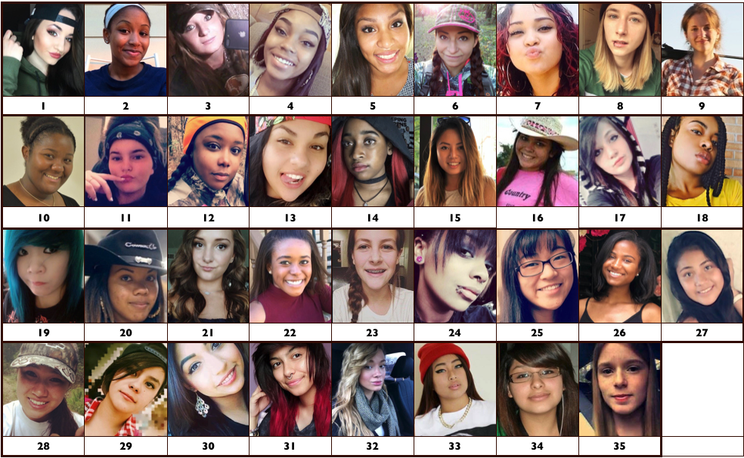

Rank the 3 people that would BEST FIT in your main group of friends by clicking on the pictures. The first picture you select by clicking on it will be the best fit overall.
Rank the 3 people that would LEAST FIT in your main group of friends by clicking on the pictures. The first picture you select by clicking on it will be the least fit overall.
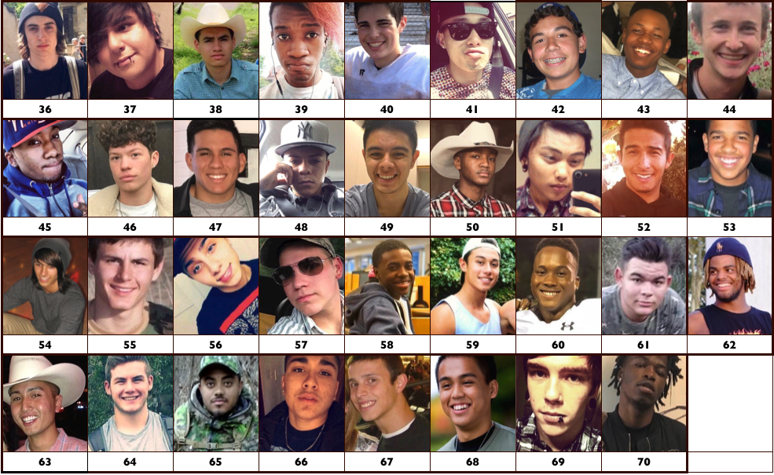

Paperwork Reduction Act Statement: The public reporting burden for this information collection has been estimated to average five minutes per response for PARENTS and eight minutes per response for YOUTH to complete the survey (the time estimated to read and complete). Send comments regarding this burden estimate or any other aspects of this information collection, including suggestions for reducing burden, to PRAStaff@fda.hhs.gov

