**Qualitative Research to Design Advertising to Encourage Quitting Among Adult Cigarette Smokers (SGM Population)**

**STIMULI**





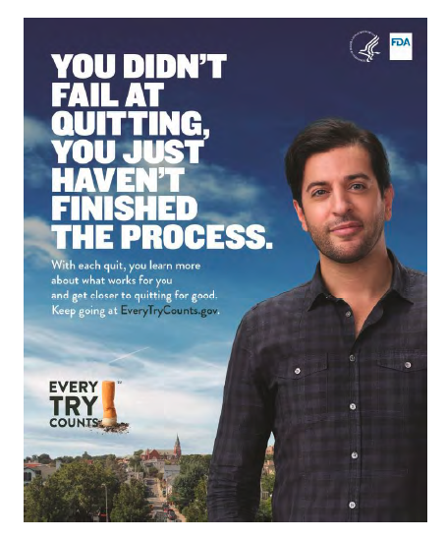

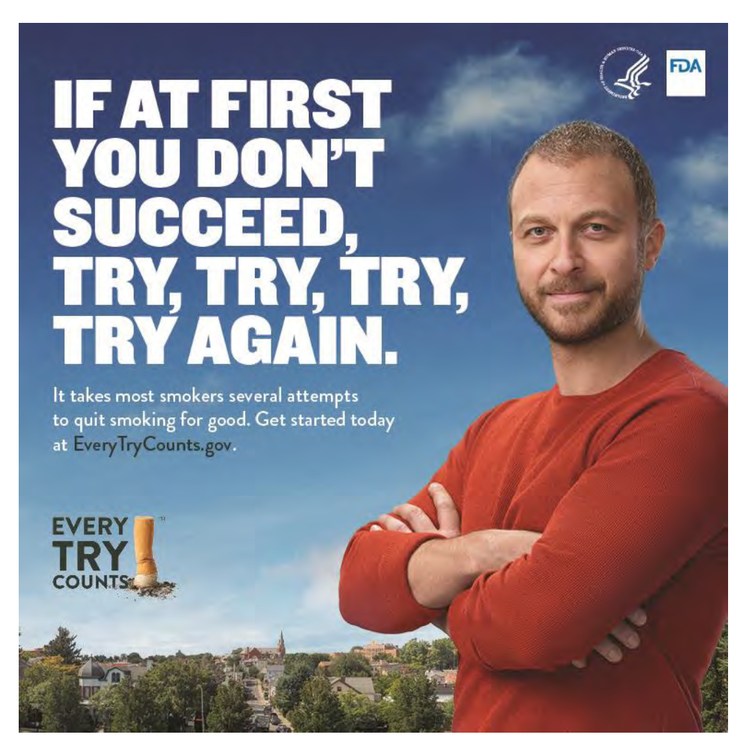

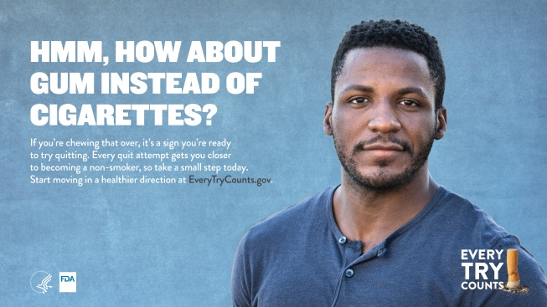

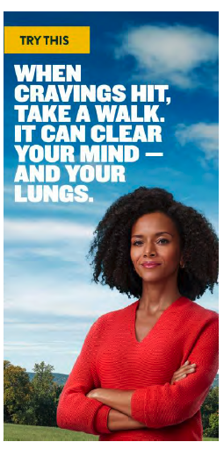

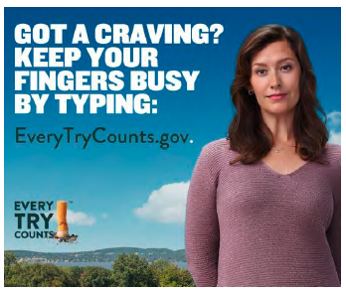

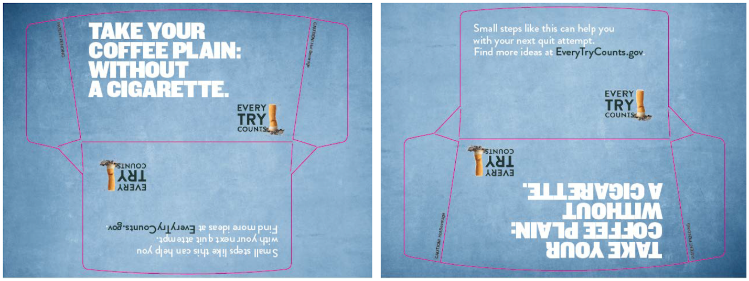

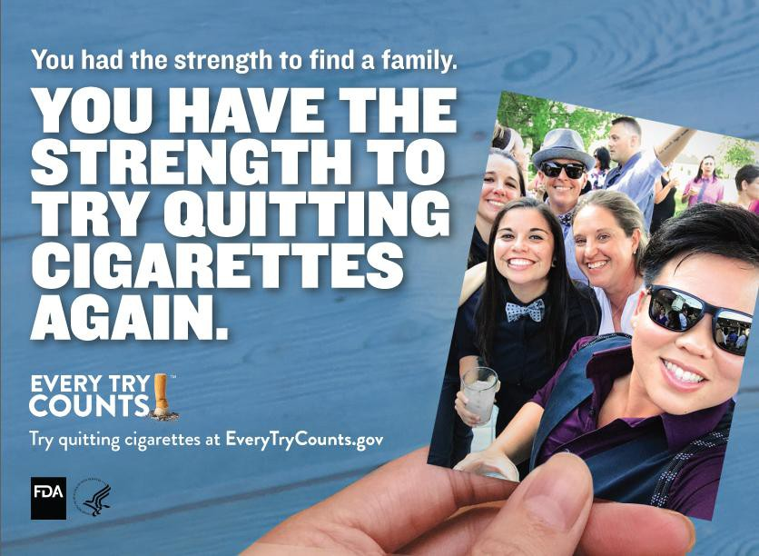



**Headline**: This Isn’t Just a Celebration of Us.

This is Our Reason to Try Quitting Cigarettes Again.

**Body Copy**: The power of our community is that we never give up. Try quitting cigarettes again at EveryTryCounts.Gov

**Headline**: She Isn’t Just Your #1.

She’s Your #1 Reason to Try Quitting Cigarettes Again.

**Body Copy**: Having a great reason can be just the motivation you need to try again. Learn how at EveryTryCounts.Gov

**Headline**: This isn’t just a new love.

This is your inspiration to try quitting cigarettes again.

**Body Copy**: A new partner, a new job — there are lots of reasons to try quitting again. Find yours at EveryTryCounts.gov

**Headline**: OUR FUTURE IS WORTH TRYING TO QUIT CIGARETTES FOR.

**Body Copy**: For the extra years you’ll have together

and for the memories you’ll get to share, it’s worth trying again. Get help quitting cigarettes at EveryTryCounts.Gov

**Headline**: THESE MOMENTS ARE WORTH TRYING TO QUIT CIGARETTES FOR.

**Body Copy**: Trying to quit is hard, but moments like this are a good reason to try again. .

Get help quitting cigarettes at EveryTryCounts.gov

**Headline**: WE ARE WORTH TRYING TO QUIT CIGARETTES FOR.

**Body Copy**: Our community never gives up, and neither will you. Your next try starts at EveryTryCounts.Gov

**Headline**: You had the strength to find a family. Your family is one reason to try quitting cigarettes again.

**Body Copy**: Try quitting cigarettes at EveryTryCounts.gov

**Headline**: YOU’VE HAD THE STRENGTH TO HOLD HIS HAND FOR 20 YEARS.

For the more years you’ll have holding his hand, it’s worth trying to quit cigarettes again.

**Body Copy**: Plan your next quit at EveryTryCounts.gov

**Headline**: You had the strength to live your truth. For the extra years you’ll be living your truth it’s worth it to try quitting cigarettes again.

**Body Copy**: Plan your next quit at EveryTryCounts.gov

**Headline**: MY FIRST TRY I LEARNED THAT QUITTING CIGARETTES TAKES PRACTICE.

**Body Copy**: Everything worth it in life takes practice. Quitting cigarettes is one of those things that takes practice. Try again at EveryTryCounts.gov

**Headline**: MY FIFTH TRY QUITTING CIGARETTES,

I LEARNED I NEED MY FAMILY.

**Body Copy**: Quitting isn’t easy, but encouragement from the ones you love might make it easier. Try again at EveryTryCounts.gov

**Headline**: MY SEVENTH TRY QUITTING CIGARETTES, I LEARNED TO CHOOSE A START DATE THAT MATTERS.

**Body Copy**: Whether it’s your anniversary or another special day, planning your quit date can help with your next try. Try again at EveryTryCounts.gov

**Headline**: MY LAST TRY QUITTING CIGARETTES

I ~~FAILED~~ PRACTICED

**Body Copy**: “Every try toward quitting cigarettes is practice. Each try, I learned new ways to overcome some of my triggers. I didn’t fail, I learned.” - Soni, 33

Get support at EveryTry Count.Gov

**Headline**: MY LAST TRY QUITTING CIGARETTES

I ~~FAILED~~ LEARNED

**Body Copy**: “I learned it helps to put a photo of my reason to quit in the places I am tempted the most. Each try I’m learning more.” - Joanie, 49

Get support at EveryTry Count.Gov

**Headline**: MY LAST TRY QUITTING CIGARETTES

I ~~FAILED~~ LEARNED ABOUT MYSELF

**Body Copy**: “Every try I write down what works and doesn’t.

Each try I’m learning more about myself.” - Dylan, 35

Get support at EveryTry Count.Gov

**Headline**: AFTER SEVEN DAYS, CIGARETTE CRAVINGS BEGIN TO DISAPPEAR.

**Body Copy**: Try again, one day at a time, at EveryTryCounts.gov

**Headline**: THERE ARE A LOT OF REASONS TO TRY QUITTING CIGS AGAIN

**Body Copy**: Find your reason and get support at EveryTryCounts.gov

**Headline**: Any time is a good time to try quitting cigarettes again.

**Body Copy**: Plan your perfect quit date at EveryTryCounts.gov

**Headline**: TRY A CIGARETTE-FREE COFFEE BREAK.

**Body Copy**: A latte and good conversation can be just what you need to get through a craving. Find more ways to try at EveryTryCounts.gov

**Headline**: TRY SWAPPING YOUR SMOKING TIME FOR QUALITY TIME.

**Body Copy**: Special moments with your partner can help take your mind off cigarettes and reduce stress. Get more help quitting at EveryTryCounts.gov

**Headine**: TRY UNINVITING CIGARETTES TO BRUNCH.

**Body Copy**: Making one meal smoke-free might make your next smoke-free meal easier. Find more ways to try at EveryTryCounts.gov