Form Approved OMB No. 0920-XXXX
Exp. Date xx/xx/20xx
Attachment J - Instrument G
Practice Roadmap
This practice roadmap is 10.4-mile long with 12 intersections. The road segments, length of each segment, speed constrain for each road segment, route direction (turn decision), light logic, and estimated travel time (travel duration) for each road segment are outlined in the table below the roadmap.
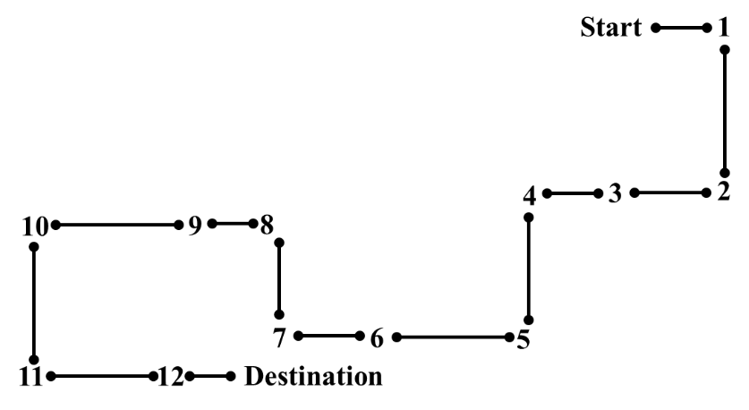
Steps | Road Segment | Length  (miles) | Speed | Turn decision | Light logic | Travel duration (minutes)
1 | Start to 1 | 0.4 | 30 | Right | Green | 1.00
2 | 1 to 2 | 0.6 | 45 | Right | Green | 1.60
3 | 2 to 3 | 0.5 | 30 | Straight | Green TSL 1.73* | 1.40
4 | 3 to 4 | 1.1 | 30 | Left | Green | 1.00
5 | 4 to 5 | 1 | 45 | Right | Green | 1.33
6 | 5 to 6 | 1.2 | 45 | Straight | Green | 1.47
7 | 6 to 7 | 1.1 | 30 | Right | Green | 1.20
8 | 7 to 8 | 0.7 | 45 | Left | Green TSL 1.73* | 0.93
9 | 8 to 9 | 0.5 | 30 | Straight | Red – 30 sec | 0.80
10 | 9 to 10 | 0.7 | 30 | Left | Green TSL 1.73* | 2.40
11 | 10 to 11 | 1 | 45 | Left | Green | 1.47
12 | 11 to 12 | 1.2 | 45 | Straight | Green TSL 1.73* | 1.33
13 | 12 to destination | 0.4
 | Total | 10.4 |  |  |  | 15.9
*TSL (time to stop line): At two left-turn and two straight intersections, drivers’ decision making will be assessed using different “time to stop line (TSL) values”, i.e., when a vehicle reaches a specific location as they approach the intersection, a computer program will trigger the change of green light to yellow light, based on the velocity of the vehicle. Three TSL values are used in this study. In this driving practice, the TSL value is set for 1.73 seconds only. Drivers will encounter 7 green lights, 4 yellow lights, and 1 red light at intersections.

Public reporting burden of this collection of information is estimated to average 48 minutes per response, including the time for reviewing instructions, searching existing data sources, gathering and maintaining the data needed, and completing and reviewing the collection of information. An agency may not conduct or sponsor, and a person is not required to respond to a collection of information unless it displays a currently valid OMB control number. Send comments regarding this burden estimate or any other aspect of this collection of information, including suggestions for reducing this burden to CDC/ATSDR Information Collection Review Office, 1600 Clifton Road NE, MS D-74, Atlanta, Georgia 30333; ATTN: PRA (0920-XXXX).

