Attachment E-3
Resident and Participant NCHS Data Briefs

(We are providing screenshots of the first pages of the 2016 data briefs. We plan to use these.)

Accessed at: https://www.cdc.gov/nchs/data/databriefs/db299.pdf

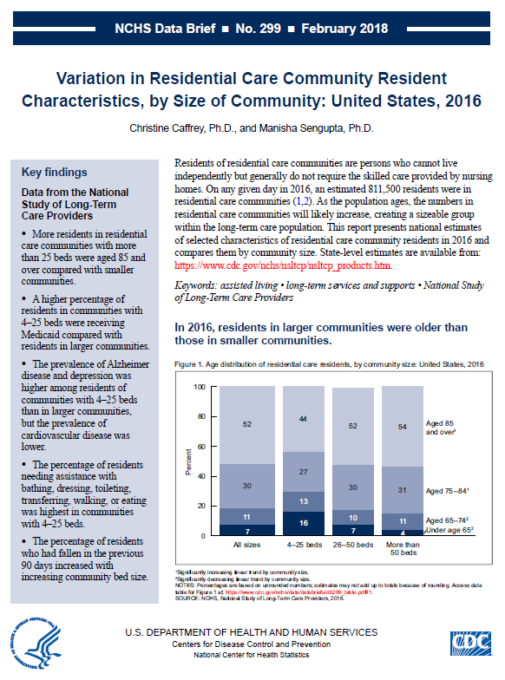

Accessed at https://www.cdc.gov/nchs/data/databriefs/db296.pdf

