Attachment 98

MEDICAL EXPENDITURE PANEL SURVEY

MEDICAL PROVIDER COMPONENT

DATA FORM

FOR

PHARMACIES

for

REFERENCE YEAR 2017

OMB

DCS: READ THIS ALOUD ONLY IF REQUESTED BY RESPONDENT.

PRESS NEXT TO CONTINUE IN THIS EVENT FORM

PRESS BREAKOFF TO DISCONTINUE

(Public reporting burden for this collection of information is estimated to average 3 minutes per response, the estimated time required to complete the survey. An agency may not conduct or sponsor, and a person is not required to respond to, a collection of information unless it displays a currently valid OMB control number. Send comments regarding this burden estimate or any other aspect of this collection of information, including suggestions for reducing this burden, to: AHRQ Reports Clearance Officer Attention: PRA, Paperwork Reduction Project (0935-0118) AHRQ, 5600 Fishers Lane, Rockville, MD 20857.)

Q1. Date Filled OMB Statement link

MONTH DAY YEAR

Q2. Prescription information will be identified using: 1 = NDC
2 = Drug Name, Strength/Unit, and Dosage Form
NOTE: TRY TO OBTAIN NDC. USE DRUG NAME
ONLY IF NDC NOT AVAILABLE.

Q2a. NDC

ENTER 11-DIGIT NDC WITHOUT DASHES OR SPACES.
NDC IS UNKNOWN OR REFUSED, RETURN TO PREVIOUS SCREEN AND SELECT DRUG NAME OPTION

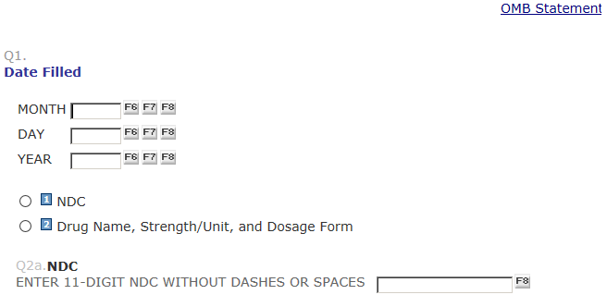

NDC ROUTE
IF Q2 = 1 (NDC COLLECTED)

The NDC you specified:
NDC: [FILL NDC]
DESCRIPTION: [SMZ/TMP DS TAB 800-160]

DCS: Please confirm that the drug names matches what is in the record (if specified in the record). If it does not, please click on Previous and correct the NDC number entered.

Q3a. Quantity:

Q4. How many days were supplied?

IF PRESCRIPTION WAS TO BE USED “AS NEEDED” ENTER 999

Q5. Patient Payment: $

Q5a. Were there any 3rd party payers? $

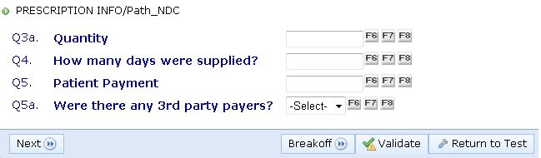

DRUG NAME ROUTE
IF Q2 = 3 (DRUG NAME COLLECTED)

Q2b. Drug Name:

Q2b_1
Compound drug?
Durable Medical Equipment
IF DURABLE MEDICAL EQUIPMENT GO TO Q3a***
MJ?
IF MJ GO TO Q3a***

Q2c. Strength

Q2d. Unit:

Q2c1. Strength 2:

Q2d2. Unit 2:

Q2e. Dosage Form:

Q3a. Quantity:

Q3b Unit:

Q4. How many days were supplied?

IF PRESCRIPTION WAS TO BE USED “AS NEEDED” ENTER 999

Q5. Patient Payment: $

Q5a. Were there any 3rd party payers? $

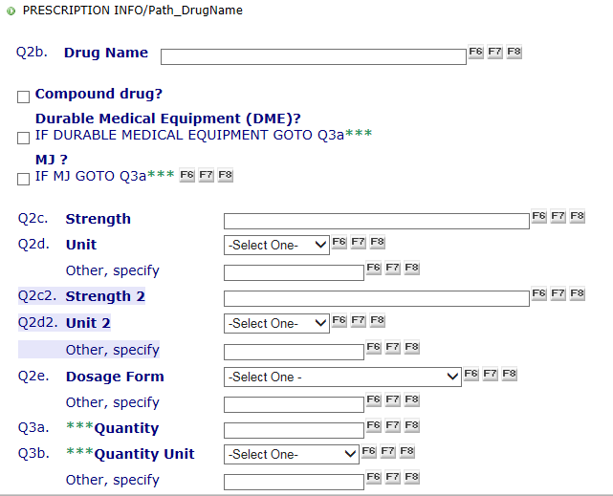
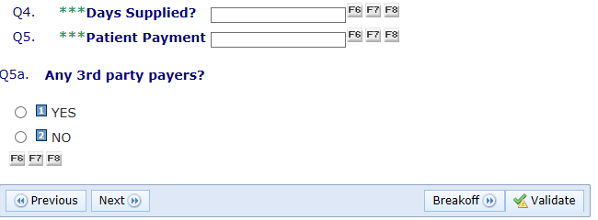

FINAL SCREEN

Q6. Type of 3rd Party Payer
Other Specify Source

Q7. 3rd Party Payment $

NOTE: IF PATIENT PAYMENT WAS $1 OR LESS,
EXPECT THE 3rd PARTY PAYER TO BE A
PUBLIC PROGRAM, E.G., MEDICAID OR
OTHER STATE/LOCAL GOVT, ETC.

Any more 3rd Party Payers?
- YES
- NO

FINISH SCREEN
PRESS VALIDATE TO COMPLETE THIS EVENT FORM.

