Addendum to the Supporting Statement for Form SSA-5072
Request for Medical Treatment in an SSA Facility:
Self-Administered or Staff-Administered
OMB No. 0960-0772

Minor Revisions to the Collection Instrument

SSA is making the following revisions to the SSA-5072:

- Change #1: We are revising the language in Section 3, Medical Office Authorization from “to be completed by Medical Officer in SSA Medical Office” to “to be completed by SSA Medical Office” to expand who may approve SSA-5072 requests.

Justification #1: The change permits Medical Office Registered Nurses to review and approve SSA-5072 requests for accuracy, completeness and safe practice in the occupational health setting. This change facilitates the efficiency of processing SSA-5072 requests and ensures the written order and signature meet Nurse Practice Act requirements.

- Change #2: We are making the following minor SSA-5072 format changes:
  - form name location moved from bottom left to top left
  - “Discontinue Prior Editions” added and
  - Form changed to electronically fillable and printable.

Justification #2: Needed format changes made to update form and meet current agency formatting requirements.

- Change #3: We are revising the Privacy Act Statement on this form.

Justification #3: SSA’s Office of the General Counsel is conducting a systematic review of SSA’s Privacy Act Statements on agency forms. As a result, SSA is updating the Privacy Act Statement on the form.

- Change #4: We are revising the PRA statement on this form.

Justification #4: We are revising the PRA statement to reflect our current boilerplate language. The current language, which dates back to the last reprint of the form, is now outdated.

We will implement these revisions upon OMB’s approval.

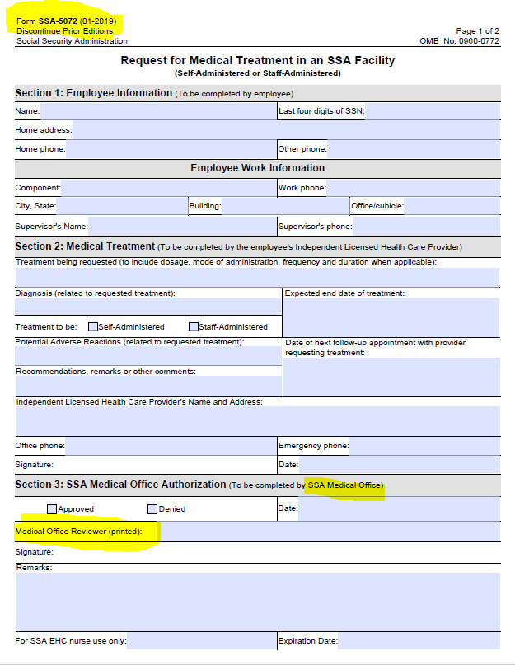
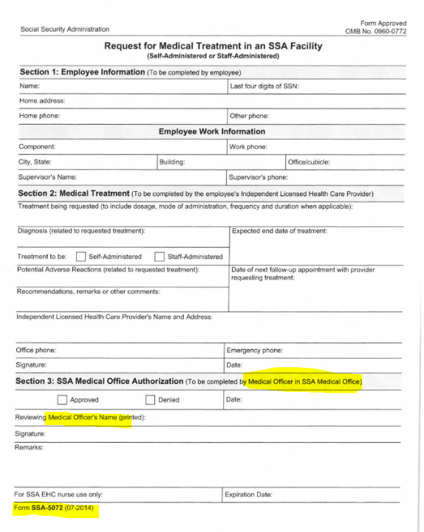
previous version 2019 revision

