OMB Control Number: 0970-0401 Expiration Date: 5/31/2021

THE PAPERWORK REDUCTION ACT OF 1995 (Pub. L. 104‐13) Public reporting burden for this collection of information is estimated to average approximately 5 minutes per response, including the time for reviewing instructions, gathering and maintaining the data needed, and reviewing the collection of information. An agency may not conduct or sponsor, and a person is not required to respond to, a collection of information unless it displays a currently valid OMB control number.

ECLKC Treejack Study Survey

Welcome
Welcome to this Treejack study, and thank you for agreeing to participate!
The activity should at the most take 15 minutes to complete.
Your response will help us to organize the content on the ECLKC website. Find out how on the next page...

Instructions
Here's how it works:
- You will be asked to find specific resources and presented with a menu.
- Click through the menu until you arrive at a menu item that you think helps you complete the task.
- If you take a wrong turn, you can go back by clicking one of the menu items above.
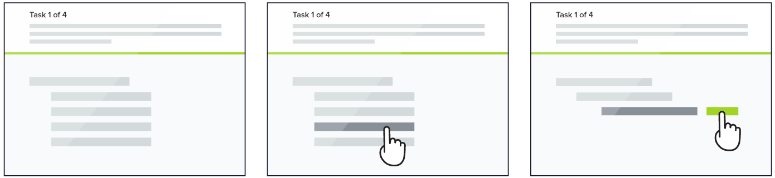
This is not a test of your ability, there are no right or wrong answers.
That's it, let's get started!

Tree Testing Survey Questions

- Where can I find information about breastfeeding that I can give to parents in my program?
- You are looking for information on stages of prenatal development - where would you find this information?
- You are looking for information about enrollment for pregnant women in Early Head Start - where would you find this information?
- You are looking for information on healthy eating habits during pregnancy - where would you find this information?
- You are looking for resources to give expectant fathers - where would you find this information?
- Overall, how difficult or easy was it to locate what you needed in this menu?
- What, if anything, would you change about the menu you just tested? Please explain your answer.

Thanks
All done, awesome! Thanks again for your participation. Your feedback is incredibly useful in helping to determine how our content should be organized, so we can make our website easier to use.
You may now close this window or navigate to another web page

REFERENCE: ECKLC Navigation Tree
ABOUT
About Us
Office of Child Care
Office of Head Start
Training & Technical Assistance Centers
Upcoming Events
Job Center
Programs
Child Care
Head Start Programs
Head Start State Collaboration
TOPICS
Cross-Cutting Approaches
Culture and Language
Data & Ongoing Monitoring
Professional Development
School Readiness
State Systems
Federal Administration Procedures
Designation Renewal System
Federal Monitoring
Grant Application
Education & Child Development
Child Screening & Assessment
Children with Disabilities
Curriculum
Learning Environments
Teaching Practices
Transitions
Family & Community
Community Engagement
Family Engagement
Family Support & Well-being
Local Early Childhood Partnerships
Parenting
Health
Health Services Management
Mental Health
Nutrition
Oral Health
Physical Health
Safety Practices
Program Management
Eligibility (ERSEA)
Facilities
Fiscal Management
Human Resources
Organizational Leadership
Program Planning
Transportation
POLICY
Head Start Policy and Regulations
Head Start Act
Head Start Program Performance Standards
Fiscal Regulations
Program Instructions
Information Memoranda
Presenting the Head Start Program Performance Standards
Child Care Policy and Regulations
Federal CCDF Regulations
State Licensing

