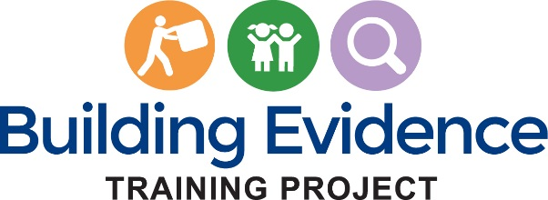

instructor experience survey

Thank you for completing this course evaluation. The information you provide will be used to help us improve the course.
________________________________________________________
THE PAPERWORK REDUCTION ACT OF 1995 (Pub. L. 104-13)
Public reporting burden for this collection of information is estimated to average .17 hours per response, including the time for reviewing instructions, gathering and maintaining the data needed, and reviewing the collection of information.
An agency may not conduct or sponsor, and a person is not required to respond to, a collection of information unless it displays a currently valid OMB control number.
__________________________________________________________________________________
Instructions:
Please respond to each question. For those questions which do not apply, please select “Not Applicable.”
- Prior to this course, had you used an online learning management system (LMS), e.g., Blackboard, Moodle, Desire2Learn, or Sakai, to teach a course?

☐ Yes
☐ No

- If yes, please select the course formats you have taught. (Choose all that apply):

☐ Primarily in-person with at least the syllabus or some work online
☐ Primarily in-person with significant work online e.g., discussion forums and quizzes
☐ Balanced between in-person and online
☐ Primarily or fully online (This includes courses that may meet only once or twice in-person for introductions or tests.)
- How did you teach the Evidence Building Strategies in Child Welfare curriculum?

☐ Roughly split between in-person and online.
☐ Primarily or fully online.
- Over what period of time did you assign students to complete the curriculum?
______________________________________________________________

Please indicate your level of agreement with the following statements:

Technical
 | Strongly Agree | Agree | Disagree | Strongly Disagree | Not Applicable
- This course does not require the instructor to have specialized technical computer skills.
- Using this course material was a manageable experience.

Difficulty
 | Strongly Agree | Agree | Disagree | Strongly Disagree | Not Applicable
- I was very knowledgeable about the content of this course before teaching it.
- I needed to learn the content of this course by reviewing course materials to teach it effectively.
- The difficulty of the course content was appropriate for my students.

Learning Platform
 | Strongly Agree | Agree | Disagree | Strongly Disagree | Not Applicable
- The course’s learning management system/website was easy to understand and navigate.
- The Instructor’s Manual was a helpful tool.
- The course’s learning management system/website functioned properly.
- I had difficulty logging into or using the web-based learning platform/website.
- The course’s web-based learning platform/website helped me interact with my students.
- The course’s web-based learning platform/website provided useful reports on students’ progress.

- The setup of this course lends itself to hybrid methods of instruction (online and in person)
- The media and other components of the course are accessible (i.e., can be used by learners with diverse needs). For example, captions are available for videos and transcripts are available to audio clips.

Learning/Impact
 | Strongly Agree | Agree | Disagree | Strongly Disagree | Not Applicable
- The course units represented a logical progression.
- The course’s subject matter is important for my students to learn.
- This course’s subject matter will help my students in their work or their future careers.

- Please identify what you consider to be the strengths of the course. Please provide as much detail as possible.

- Please identify area(s) where you think the course could be improved. Please provide as much detail as possible and include suggestions for improvement.

- Overall, how satisfied were you with this course?

☐ Very Satisfied ☐ Satisfied ☐ Dissatisfied ☐ Very Dissatisfied

- Would you use this course material again?

☐ Yes ☐ No

If yes, what parts? If no, why not?

- Please share any other feedback you’d like to provide about the course.

