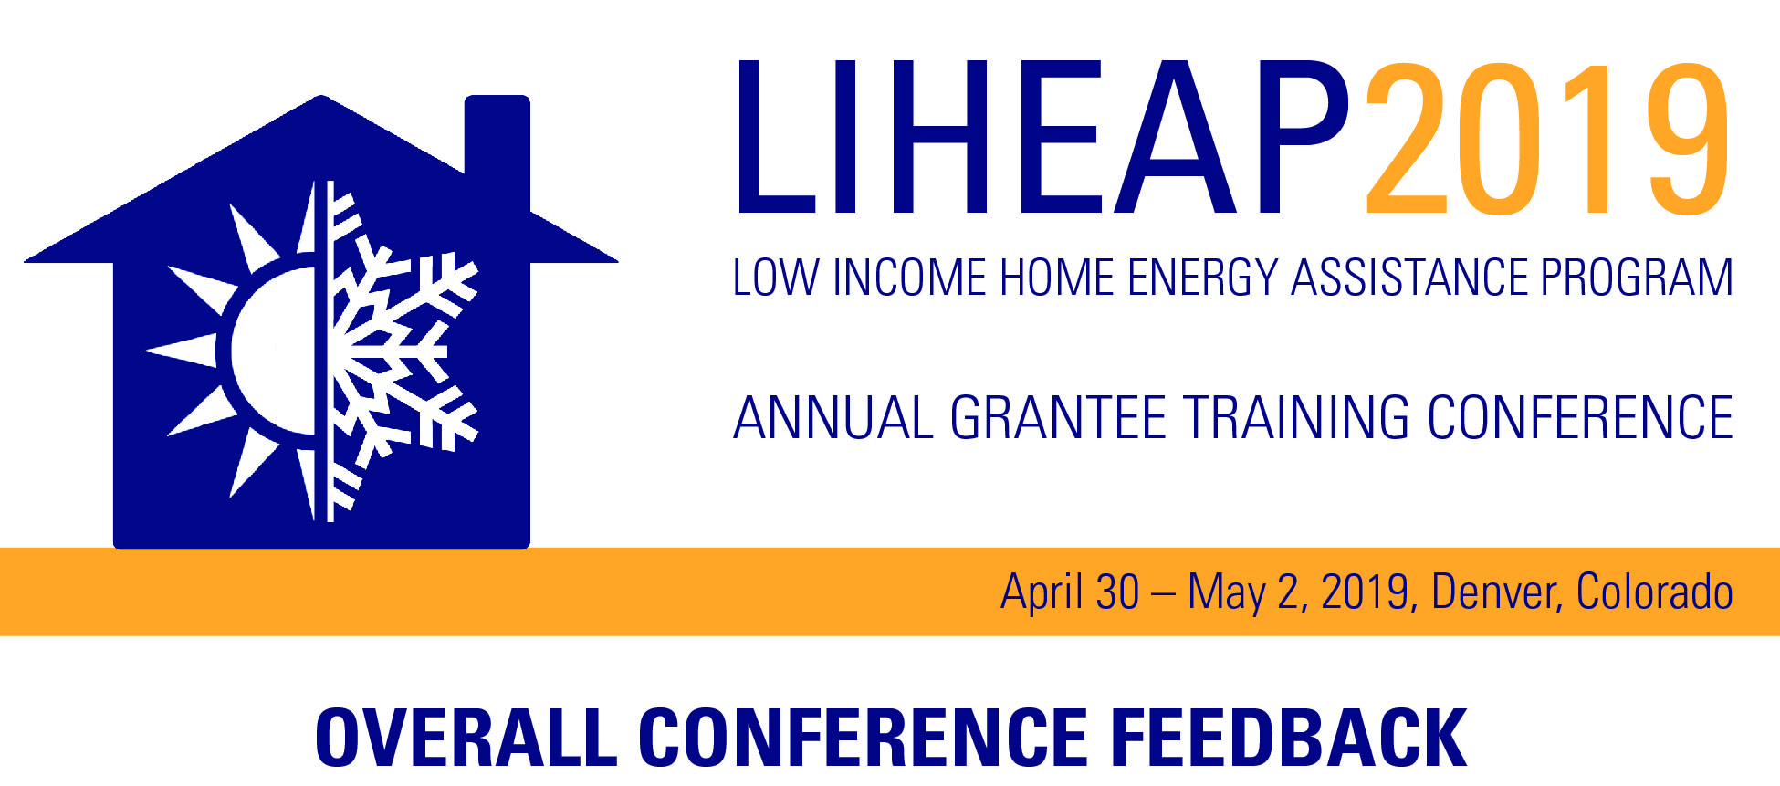
Completion of this form is voluntary and data collected from it will be kept private. The purpose of this data collection is to assist the Administration for Children and Families in improving its training opportunities for LIHEAP grantees. The anticipated time to complete this form is less than 1 minute.

Please rate the overall meeting from 1 to 4 (4 is the highest) on the following items:
 | Excellent | Very Good | Fair | Poor | Unsure
Opening Plenary Session | 4 ☐ | 3 ☐ | 2 ☐ | 1 ☐ | ☐
Networking Activity: Riddle Me This | 4 ☐ | 3 ☐ | 2 ☐ | 1 ☐ | ☐
Closing Plenary Session | 4 ☐ | 3 ☐ | 2 ☐ | 1 ☐ | ☐
Your ability to clearly see the visual materials | 4 ☐ | 3 ☐ | 2 ☐ | 1 ☐ | ☐
Your ability to hear all the presentations and questions? | 4 ☐ | 3 ☐ | 2 ☐ | 1 ☐ | ☐
Comfort of the room temperature?
General Session | 4 ☐ | 3 ☐ | 2 ☐ | 1 ☐ | ☐
State Track | 4 ☐ | 3 ☐ | 2 ☐ | 1 ☐ | ☐
Tribal Track | 4 ☐ | 3 ☐ | 2 ☐ | 1 ☐ | ☐
Comfort of seating arrangements
General Session | 4 ☐ | 3 ☐ | 2 ☐ | 1 ☐ | ☐
State Track | 4 ☐ | 3 ☐ | 2 ☐ | 1 ☐ | ☐
Tribal Track | 4 ☐ | 3 ☐ | 2 ☐ | 1 ☐ | ☐
Overall Meeting | 4 ☐ | 3 ☐ | 2 ☐ | 1 ☐ | ☐
Additional Comments:

THE PAPERWORK REDUCTION ACT OF 1995 (Pub. L. 104-13) Public reporting burden for this collection of information is estimated to average 1 minute per response, including the time for reviewing instructions, gathering and maintaining the data needed, and reviewing the collection of information. An agency may not conduct or sponsor, and a person is not required to respond to, a collection of information unless it displays a currently valid OMB control number. The control number for this project is 0970-0401. The control number expires on 5/31/2021.

