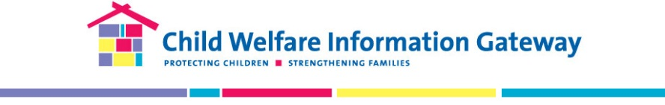
The Grantee Connection Survey
The Grantee Connection is a quarterly subscription featuring the latest materials, resources, lessons learned, and updates from Children's Bureau discretionary grantees. We are conducting this brief, voluntary survey to gather your feedback on how we can enhance and improve future issues.
- Which of the following best describes your professional background? (Select all that apply)
- Prevention/family support
- Child protective services
- Foster care services
- Adoption services
- Youth services
- Juvenile justice
- Health/mental health
- Substance use
- Legal/courts
- Research/evaluation
- Early childhood (0–5yrs)
- Education (K–12)
- Higher education
- Training
- Other (Please describe): ___________
- Which of the following best describes your workplace? (Select one)
- Local or county child welfare agency
- State child welfare agency
- Tribal child welfare agency/organization
- Federal agency
- Community-based/faith-based organization
- National organization (e.g., nonprofit, advocacy)
- Training and technical assistance service provider
- Educational institution (early education, K–12, college, university)
- Other (Please describe): ________________________________

- Which of the following best describes your position? (Select one)
- Frontline worker (e.g., caseworker, direct service worker)
- Supervisor/manager
- Director/administrator
- Training specialist
- Evaluator/researcher
- Other (Please describe): _______________________________
- Do you have experience working on a Children's Bureau discretionary grant? (Check one)
- Yes, as a current grantee
- Yes, as a former grantee
- No, but interested in being a future grantee
- No experience

- How did you first find out about The Grantee Connection? (Check one)
- Email/social media post from Child Welfare Information Gateway
- Federal Project Officer/Children's Bureau staff
- Colleague or friend
- Referred by other organization (Please describe): ____________
- Other (Please describe): ____________
- What topic(s) are you most interested in reading about in The Grantee Connection? (Check all that apply and briefly describe your topical interests)
- Prevention (Please describe): ________________
- Substance use (Please describe): ________________
- Foster care (Please describe): ________________
- Kinship care/guardianship (Please describe): ________________
- Adoption (Please describe): ________________
- Tribal child welfare (Please describe): ________________
- Legal/courts (Please describe): ________________
- Mental health (Please describe): ________________
- Other (Please describe): ________________
- What type(s) of information are you most interested in receiving in The Grantee Connection? (Check all that apply)
- Discretionary grant opportunities/awards
- Grantee summaries and lessons learned
- Tools and resources developed by grantees (e.g., assessment tools)
- Grantee project updates and information
- Grantee final reports/evaluation reports
- Other types of information/resources (Please describe): ________________

- Which of the following best describes why you subscribe to The Grantee Connection?
- I am interested in finding information to help inform/support my work
- I am interested in information about what discretionary grantees are learning in the field
- I am interested in a specific grant topic (Please describe):
- I am looking for information to help me apply for current or future discretionary grant funding opportunities
- Other (Please describe):
- Overall, how satisfied are you with The Grantee Connection?
- Very satisfied (Please describe): ________________
- Somewhat satisfied (Please describe): ________________
- Neither satisfied nor dissatisfied (Please describe): ________________
- Somewhat dissatisfied (Please describe): ________________
- Very dissatisfied (Please describe): ________________

- What suggestions do you have for improving The Grantee Connection?
Thank you for your participation!
If you are interested in learning more about grant opportunities from the Children's Bureau or other program offices under the Administration for Children and Families, please visit Funding Opportunity Announcements.

