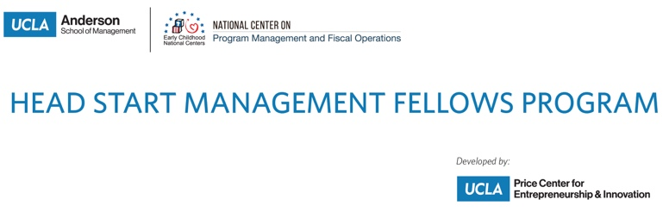
OMB Control Number: 0970-0401
Expiration Date: 5/31/2021

Head Start Management Fellows Program

End-of-Session Feedback Survey (for 2020 cohort)

Thank you for participating in the Head Start Management Fellows (HSMF) Program, conducted by the UCLA Anderson School of Management. To help ensure the quality of our services, we ask that you complete the following feedback survey about this HSMF Program session. This brief survey is voluntary and all feedback will be kept private. To further protect your privacy, please refrain from including personally identifiable information in open-ended responses.

PAPERWORK REDUCTION ACT OF 1995 (Pub. L. 104-13) STATEMENT OF PUBLIC BURDEN: Through this information collection, we are gathering feedback to improve service delivery. Public reporting burden for this collection of information is estimated to average 3 minutes per respondent, including the time for reviewing instructions, gathering and maintaining the data needed, and reviewing the collection of information. This is a voluntary collection of information. An agency may not conduct or sponsor, and a person is not required to respond to, a collection of information subject to the requirements of the Paperwork Reduction Act of 1995, unless it displays a currently valid OMB control number. If you have any comments on this collection of information, please contact Jesse Escobar at the Office of Head Start at Jesse.Escobar@acf.hhs.gov.

Individual Session Evaluation

Q1. Please select your level of agreement with the following statements about the session’s presenters and materials.
 | Strongly agree | Agree | Disagree | Strongly disagree | Don't know / NA
The presenter(s) were knowledgeable in the content area(s).
The presenter(s) were responsive to participants’ questions.
The presenter(s) were effective in engaging participants.
I found the presentation materials easy to read and understand.
The resources provided during the training were relevant and useful for my work.
The presenter(s) conveyed important constructs effectively.
Q2. Please select your level of agreement with the following statements about the session:
 | Strongly agree | Agree | Disagree | Strongly disagree | Don't know / NA
The session deepened my knowledge of the topics presented.
The content of the session was relevant to my work.
The session provided me with knowledge of available resources.
I learned something during this session that I plan to use in my work.
I plan to share the information received during the session with others.

Q3. Please let us know whether you found the content presented in this session to be too simple, too advanced, or just about right.
- Far too advanced
- A bit too advanced
- About right
- A bit too simple
- Far too simple

Q4. Before this session, my knowledge of the content/topics addressed can be best described as…
- No knowledge
- Minimal knowledge
- Moderate knowledge
- A high level of knowledge

Q5. After this session, my knowledge of the content/topics addressed can be best described as…
- No knowledge
- Minimal knowledge
- Moderate knowledge
- A high level of knowledge

Q6. I was satisfied with the overall quality of this session.
- Strongly agree
- Agree
- Disagree
- Strongly disagree

