Outcome Attainment Scale

This survey gathers information about the achievement of the intended outcomes for activities on the state’s TA plan. Your feedback on progress made is important for improving our TA services. The survey should be completed collaboratively by the state team members who participated in the PDG B-5 TA. Your team’s responses will be kept private. Only aggregate information will be shared. Please submit only one set of ratings from your team. This survey should take you about 5 minutes to complete.

**Scale Description**

As a team decide on the extent of progress toward each intended outcome using the following 4-point scale.

* ***Outcome fully achieved***: As currently written, all parts of the intended outcome have been achieved.
* ***Intended outcome in progress*:** Progress has moved past the initial stages of identifying, organizing, or planning for the intended outcome. Action is underway on all or parts of the intended outcome.
* ***Initial progress made*:** Progress is underway, but the team is still in the process of identifying, organizing, or planning for the intended outcome. Initial progress might include planning activities such as holding a planning meeting, identifying procedures used in other states, or engaging stakeholders.
* ***No or minimal work done on the intended outcome***: Minimal work may have occurred, such as scheduling or holding call(s) to discuss this intended outcome, but no progress has been made toward the outcome.

1. Record the roles of the individuals completing this scale: [add rows after 1a, 1b, 1c, etc.]

1a. _____________________________________________

1b. _____________________________________________

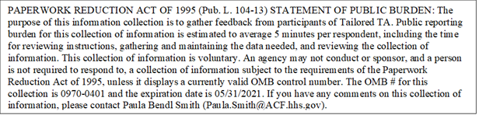1c…1o.

1. Rate the extent of progress made on the following intended outcome(s):

2a. [Intended Outcome #1]

* Outcome fully achieved
* Intended outcome in progress
* Initial progress made on intended outcome
* No or minimal work done on intended outcome

2b. Was this intended outcome revised during the course of the work?

* Yes
* No

2c. Please describe the factors that contributed to the rating for this outcome (e.g., important state context, facilitators and/or barriers):

_____________________________________________________________________

(Repeat for additional intended outcomes)

Thank you for your time!

Electronic copy survey closing message: Thank you for your time! Please submit your responses to the PDG B-5 TA Center evaluation team at [Sara.Thayer@sri.com](mailto:Sara.Thayer@sri.com)