Tailored TA Survey
Your thoughts and suggestions are important for improving the PDG B-5 TA Center services. Your individual responses will be kept private. Only aggregate information will be shared. This survey should take you about 5 minutes to complete. Thank you for taking the time to complete this feedback form!
- In the last four months, how often and how much did you participate in the PDG B-5 TA calls with your state?
- I was very involved (e.g., attended most or all calls)
- I was somewhat involved (e.g., attended more than half of the calls)
- I was minimally involved (e.g. attended fewer than half of the calls)
- I did not participate [Skip to end]

- What is your role in your state’s PDG B-5 grant?
_____________________________________________________________________

- Rate the quality of the information (and resources, if applicable) provided to your state.
- Excellent
- Good
- Poor
- Very poor

- Rate the relevance of the information (and resources, if applicable) provided to your state.
- Very relevant
- Relevant
- Not relevant
- Not relevant at all

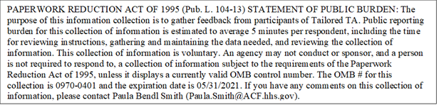

- Rate the usefulness of the information (and resources, if applicable) provided to your state.
- Very useful
- Useful
- Not useful
- Not at all useful

- Indicate whether you agree or disagree with the following statements.
6a. The TA provider(s) supported my active participation in TA for my state.
- Strongly agree
- Agree
- Disagree
- Strongly disagree

6b. The TA provider(s) was/were readily available to address my state’s TA needs.
- Strongly agree
- Agree
- Disagree
- Strongly disagree

6c. The TA provider(s) communicated openly, regularly, and consistently.
- Strongly agree
- Agree
- Disagree
- Strongly disagree

6d. Information sharing and discussions were free from bias and inclusive of diverse and historically underrepresented groups.
- Strongly agree
- Agree
- Disagree
- Strongly disagree

We appreciate any additional comments or suggestions for improvement. If you do not want to provide additional feedback, click “Next” and submit your responses.

- Are there any aspects of the TA that were particularly useful? If so, please describe.
_________________________________________________________________
- Are there any aspects of the TA that can be improved? If so, please describe.
_________________________________________________________________
- Do you have any additional comments or suggestions?
_______________________________________________________________

