Supporting Statement for OMB Clearance Request

Appendix J: 72-Month Survey Flyer

Pathways for Advancing Careers and Education (PACE) – Follow-up Data Collection

OMB No. 0970-0397

April 2017

Submitted by:
Nicole Constance
Office of Planning, Research
and Evaluation
Administration for Children
and Families
U.S. Department of Health and Human Services

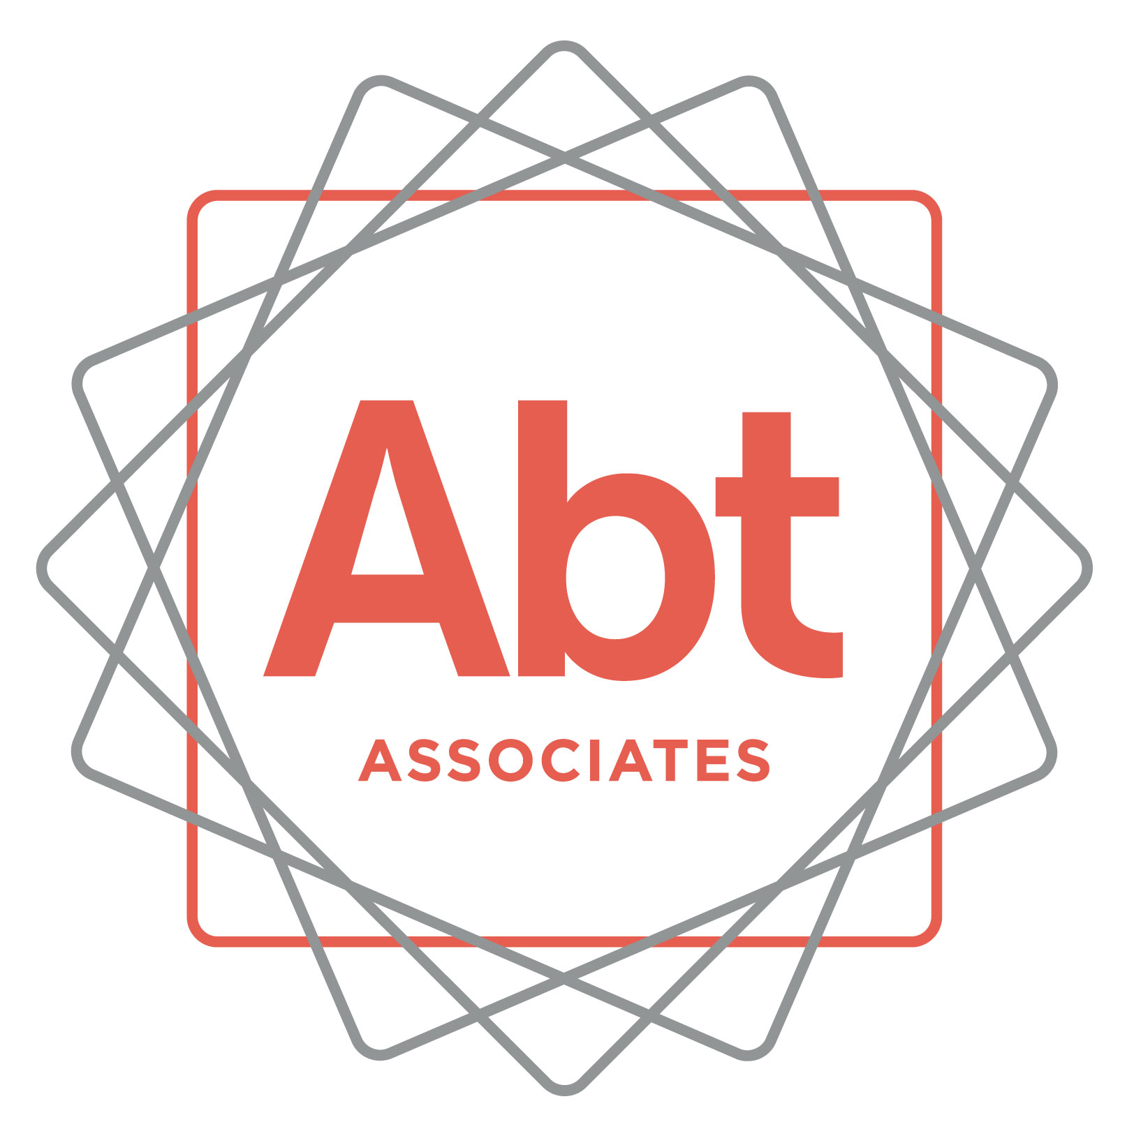
We have been trying to reach you! We’re following up about the Pathways for Advancing Careers and Education (PACE) study (previously known as the Innovative Strategies for Increasing Self-Sufficiency study). You agreed to participate in this study about 72 months ago. This is a very important research study funded by the Administration for Children and Families (ACF). ACF is part of the U.S. Department of Health and Human Services. The PACE study will help ACF improve future education and employment programs.
Upon completion of the survey, you will receive a token of appreciation valued at $45.
To schedule your interview or to get more information about the study,
please call ___________________________
at ___________________________
You may also call my supervisor _____________] at 1-866-491-0770 (toll free).
Thank you and we look forward to speaking with you soon!
ABTID_____________________________________
Please mention this number when you call

