**Ethylene Oxide Standard Appendix D PRA Public Burden Statement**

**§ 1910.1047 Ethylene Oxide.**

Appendix D to § 1910.1047—Nonmandatory Medical Disease Questionnaire

**PAPERWORK REDUCTION ACT STATEMENT**

Under the formaldehyde standard, this nonmandatory medical disease questionnaire may be administered to employees who are included in their employer’s medical surveillance program. (29 CFR 1910.1048(l)(1)). Under the Paperwork Reduction Act, a Federal agency generally cannot conduct or sponsor, and the public is generally not required to respond to, an information collection, unless it is approved by OMB and displays a valid OMB Control Number. Use of this questionnaire is optional. The questionnaire assists both physicians and employers to ensure that the physician obtains compliant employee medical documentation. OSHA estimates employer burden for the completion of this collection of information is 60 minutes (1 hour). This estimate includes the time for reviewing instructions, searching existing data sources, gathering and maintaining the data needed, and, completing and reviewing the collection of information. The time estimate includes employer time for compliance with the underlying information collection requirements in 29 CFR 1910.1048(l), including employee time for completion of the questionnaire and medical examination and providing information to the physician. Send comments regarding this burden estimate or any other aspect of this collection of information, including suggestions for reducing this burden to [OSHAPRA@dol.gov](mailto:OSHAPRA@dol.gov) or to OSHA’s Directorate of Standards and Guidance, Department of Labor, Room N-3718, 200 Constitution Ave., NW, Washington, DC 20210; Attn: Paperwork Reduction Act Comment; 1218-0145. (This address is for comments regarding this form only; **DO NOT SEND ANY COMPLETED SAMPLE FORM TO THIS OFFICE**.)

*OMB Approval# 1218-0145; Expires: 00-00-0000*

§1910.1048—Nonmandatory Medical Disease Questionnaire

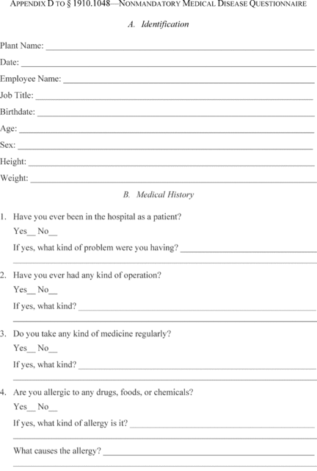

[View or download PDF](https://www.ecfr.gov/graphics/pdfs/er14my19.056.pdf)

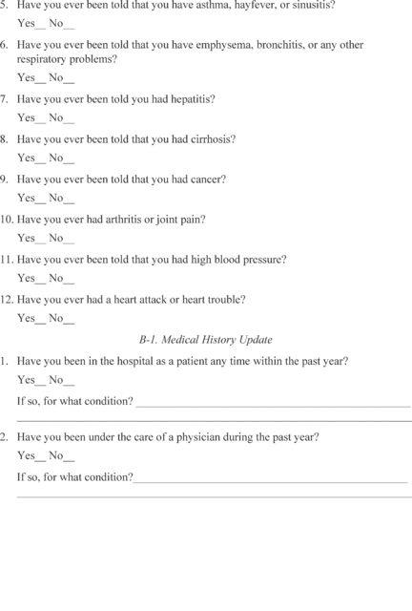

[View or download PDF](https://www.ecfr.gov/graphics/pdfs/er14my19.057.pdf)

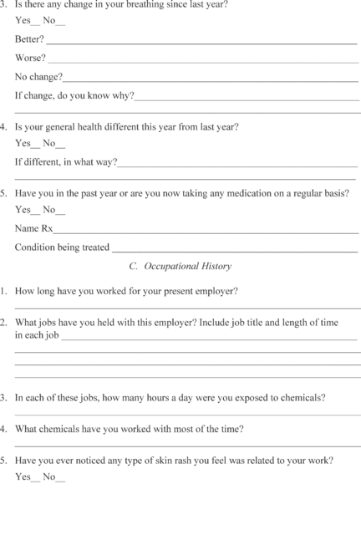

[View or download PDF](https://www.ecfr.gov/graphics/pdfs/er14my19.058.pdf)

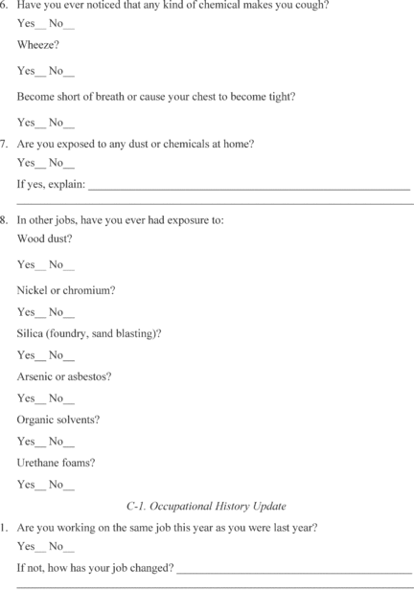

[View or download PDF](https://www.ecfr.gov/graphics/pdfs/er14my19.059.pdf)

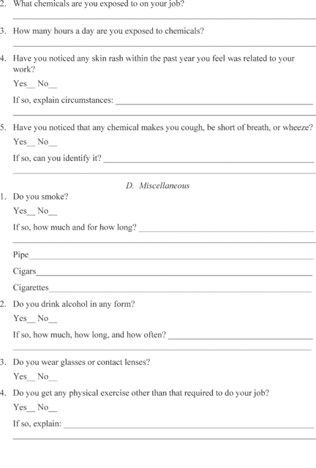

[View or download PDF](https://www.ecfr.gov/graphics/pdfs/er14my19.060.pdf)

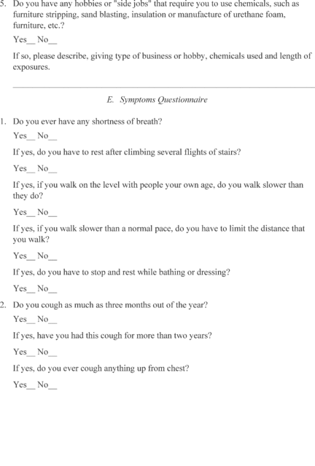

[View or download PDF](https://www.ecfr.gov/graphics/pdfs/er14my19.061.pdf)

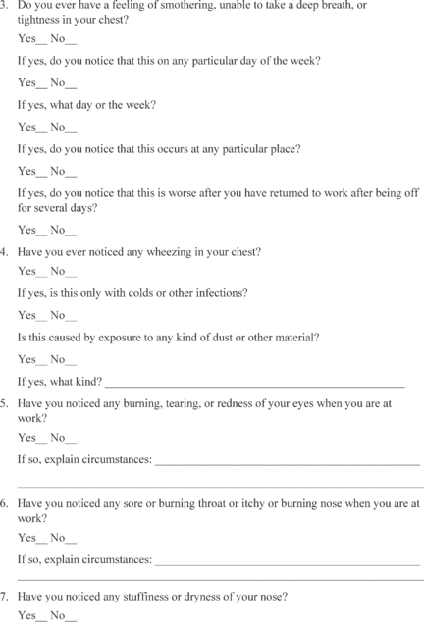

[View or download PDF](https://www.ecfr.gov/graphics/pdfs/er14my19.062.pdf)

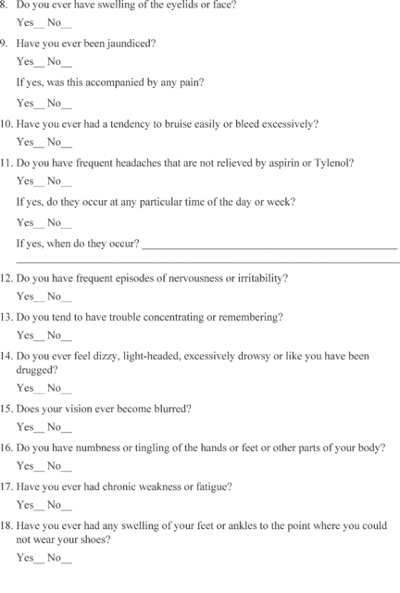

[View or download PDF](https://www.ecfr.gov/graphics/pdfs/er14my19.063.pdf)

