Your Loans & Their Impact

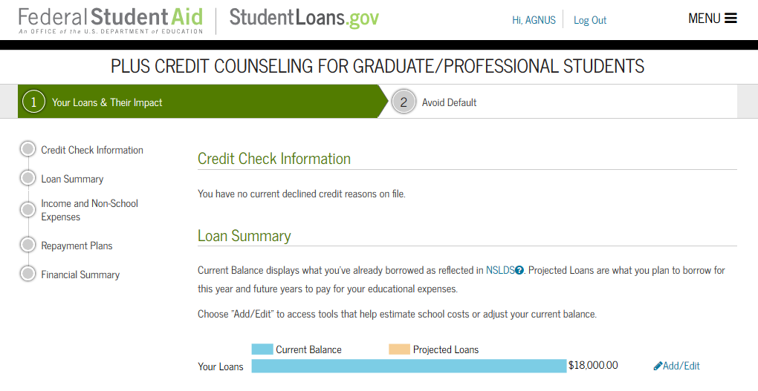

English Text
PLUS CREDIT COUNSELING FOR GRADUATE/PROFESSIONAL STUDENTS
Credit Check Information
Loan Summary
Income and Non-School Expenses
Repayment Plans
Financial Summary
Credit Check Information
[Does not display unless user has a declined credit reason]
[If a borrower has a declined credit reason, the following text is displayed]
Based on the information we received from {0}, we were unable to approve your request for a Direct PLUS Loan for the following reason(s):
You may still be eligible to receive a Direct PLUS Loan. In order to become eligible you must take one of the following actions:
- Obtain an endorser [tooltip] and complete PLUS Credit Counseling
or
- Document extenuating circumstances to the satisfaction of the U.S. Department of Education and complete PLUS Credit Counseling.
Loan Summary
Current Balance displays what you've already borrowed as reflected in NSLDS [tooltip]. Projected Loans are what you plan to borrow for this year and future years to pay for your educational expenses.
Tooltip:
The central database for student aid. NSLDS receives data from schools, guaranty agencies, and other Department of Education databases.

Choose "Add/Edit" to access tools that help estimate school costs or adjust your current balance.
Current Balance
Projected Loans
Your Loans
Add/Edit

Add Loan – Add Specific Loan Amount

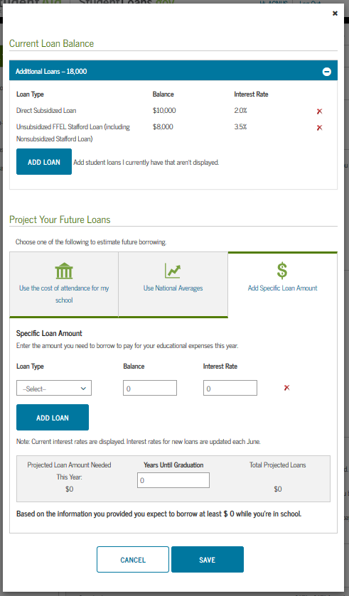

English Text
Current Loan Balance
Loan Type
Balance
Interest Rate
ADD LOAN
Add student loans I currently have that aren't displayed.
Project Your Future Loans
Choose one of the following to estimate future borrowing.
Add Specific Loan Amount
Specific Loan Amount
Enter the amount you need to borrow to pay for your educational expenses this year.
Loan Type
Balance
Interest Rate
ADD LOAN
Note: Current interest rates are displayed. Interest rates for new loans are updated each June.
Projected Loan Amount Needed This Year:
Years Until Graduation
Total Projected Loans
Based on the information you provided you expect to borrow at least
while you're in school.
CANCEL
SAVE

Add Loan – Use the cost of attendance for my school

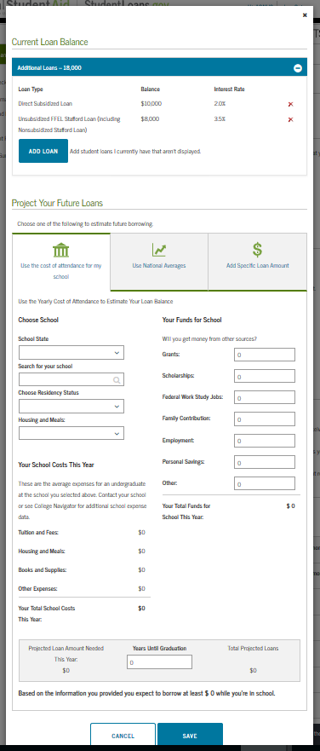

English Text
Use the cost of attendance for my school
Use the Yearly Cost of Attendance to Estimate Your Loan Balance
Choose School
School State
Search for your school
Choose Residency Status
In-State
Out-of-State
Housing and Meals:
On-Campus
Off-Campus
Your School Costs This Year
These are the average expenses for an undergraduate at the school you selected above. Contact your school or see College Navigator for additional school expense data.
Tuition and Fees:
Housing and Meals:
Books and Supplies:
Other Expenses:
Your Total School Costs This Year:
Your Funds for School
Will you get money from other sources?
Grants:
Scholarships:
Federal Work Study Jobs:
Family Contribution:
Employment:
Personal Savings:
Other:
Your Total Funds for School This Year:
Projected Loan Amount Needed This Year:
Years Until Graduation
Total Projected Loans
Based on the information you provided you expect to borrow at least
while you're in school.
CANCEL
SAVE

Add Loan – Use National Averages

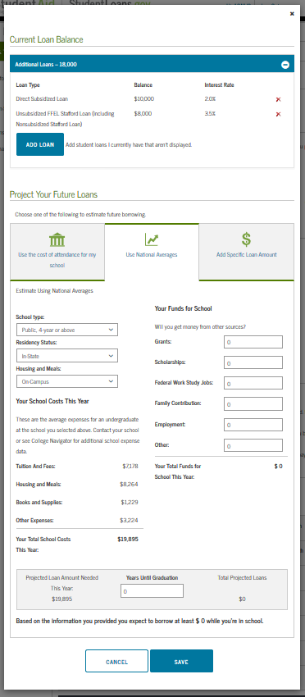

English Text
Use National Averages
Estimate Using National Averages
School type:
Residency Status:
In-State
Out-of-State
Housing and Meals:
On-Campus
Off-Campus
Your School Costs This Year
These are the average expenses for an undergraduate at the school you selected above. Contact your school or see College Navigator for additional school expense data.
Tuition And Fees:
Housing and Meals:
Books and Supplies:
Other Expenses:
Your Total School Costs This Year:
Your Funds for School
Will you get money from other sources?
Grants:
Scholarships:
Federal Work Study Jobs:
Family Contribution:
Employment:
Other:
Your Total Funds for School This Year:
Projected Loan Amount Needed This Year:
Years Until Graduation
Total Projected Loans
Based on the information you provided you expect to borrow at least
while you're in school.
CANCEL
SAVE

Income and Non-School Expenses

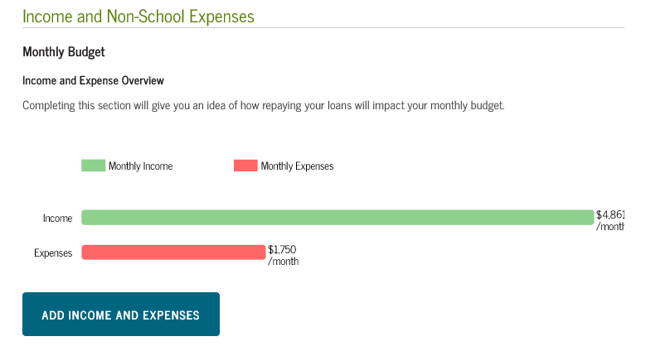

English Text
Income and Non-School Expenses
Monthly Budget
Income and Expense Overview
Completing this section will give you an idea of how repaying your loans will impact your monthly budget.
Monthly Income
/month
Monthly Expenses
/month
ADD INCOME AND EXPENSES

Add Income and Expenses

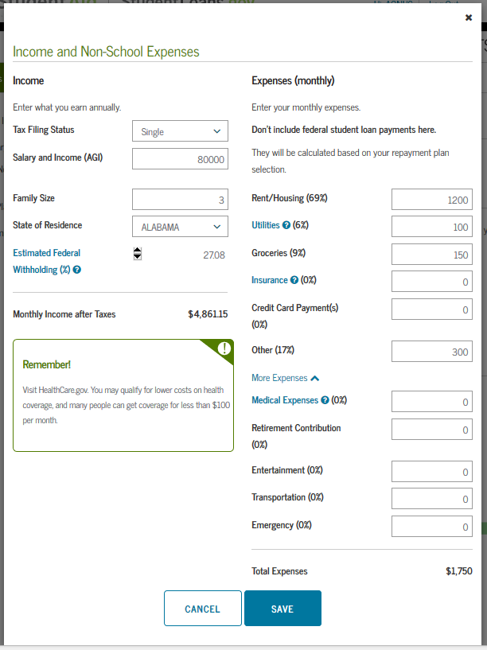

English Text
Income and Non-School Expenses
Income
Enter what you earn annually.
Tax Filing Status
Single
Married Filing Jointly
Married Filing Separately
Head of Household
Salary and Income (AGI)
Family Size
State of Residence
Estimated Federal Withholding (%)
Federal Income Taxes
Social Security
Medicare
Monthly Income after Taxes
Expenses (monthly)
Enter your monthly expenses.
Don't include federal student loan payments here.
They will be calculated based on your repayment plan selection.
Rent/Housing ( %)
Utilities [tooltip] ( %)
Groceries ( %)
Insurance [tooltip] ( %)
Credit Card Payment(s) ( %)
Other ( %)
More Expenses
Medical Expenses [tooltip] ( %)
Retirement Contribution ( %)
Entertainment ( %)
Transportation ( %)
Emergency ( %)
Total Expenses
Remember!
Visit HealthCare.gov. You may qualify for lower costs on health coverage, and many people can get coverage for less than $100 per month.
CANCEL
SAVE

Repayment Plans

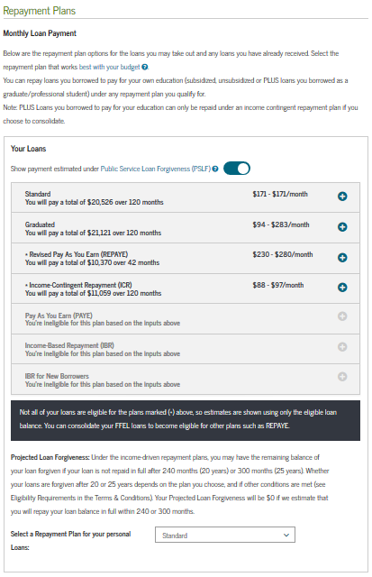

English Text
Repayment Plans
Monthly Loan Payment
Below are the repayment plan options for the loans you may take out and any loans you have already received.
Select the repayment plan that works best with your budget [tooltip].
You can repay loans you borrowed to pay for your own education (subsidized, unsubsidized or PLUS loans you borrowed as a graduate/professional student) under any repayment plan you qualify for.
Note: PLUS Loans you borrowed to pay for your education can only be repaid under an income contingent repayment plan if you choose to consolidate.
[tooltip text]
Your Loans
Show payment estimated under Public Service Loan Forgiveness (PSLF) [tooltip]
You’re ineligible for this plan based on the inputs above
[Displayed conditionally]
You will pay a total of {0} over {0} months
First Monthly Payment
Last Monthly Payment
Total Amount Paid
Projected Loan Forgiveness
Public Service Loan Forgiveness
Repayment Period
months
More Information
[link will open Repayment Plan pop-up, see Shared Page Components text baseline]
Not all of your loans are eligible for the plans marked (*) above, so estimates are shown using only the eligible loan balance. You can consolidate your FFEL loans to become eligible for other plans such as REPAYE.
[appears when user has a combination of DL and FFEL loans]
Consolidation Repayment Plans:
Projected Loan Forgiveness: Under the income-driven repayment plans, you may have the remaining balance of your loan forgiven if your loan is not repaid in full after 240 months (20 years) or 300 months (25 years). Whether your loans are forgiven after 20 or 25 years depends on the plan you choose, and if other conditions are met (see Eligibility Requirements in the Terms & Conditions). Your Projected Loan Forgiveness will be $0 if we estimate that you will repay your loan balance in full within 240 or 300 months.
Repayment Plan selection is only available if your loan information is retrieved from NSLDS [tooltip] or you manually entered it.
Select a Repayment Plan for your personal loans:

Financial Summary

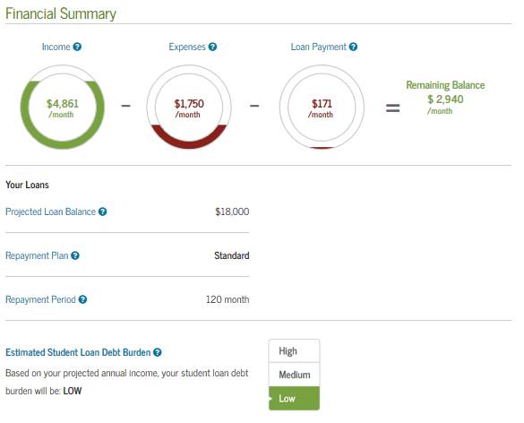

English Text
Financial Summary
Income [tooltip]
/month
Expenses [tooltip]
/month
Loan Payment [tooltip]
/month
Remaining Balance
/month
Your Loans
Projected Loan Balance [tooltip]
Repayment Plan [tooltip]
Repayment Period [tooltip]
Estimated Student Loan Debt Burden [tooltip]
Based on your projected annual income, your student loan debt burden will be:
High
Medium
Low
EXIT
CONTINUE

All Borrower Types - Avoid Default (Step 2)

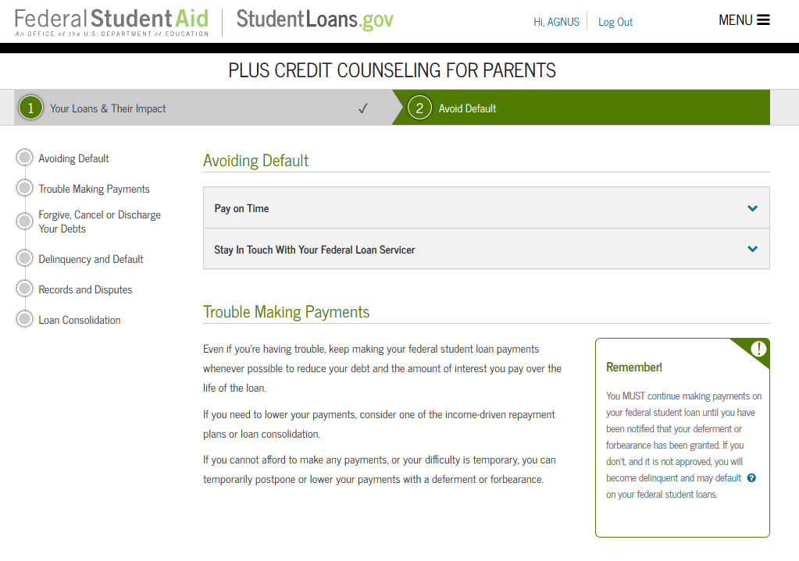
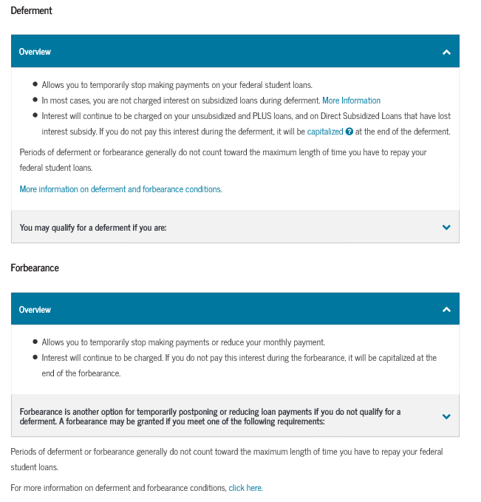

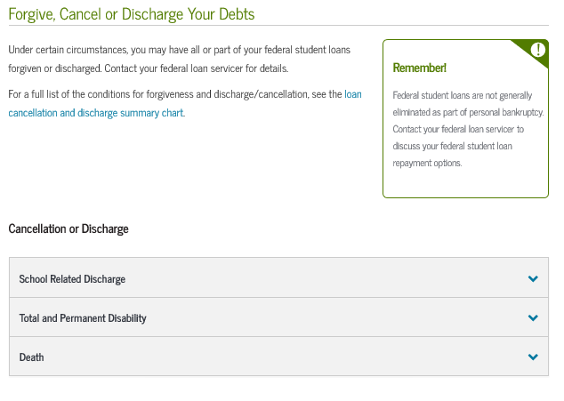
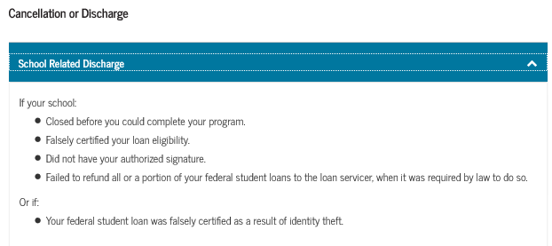
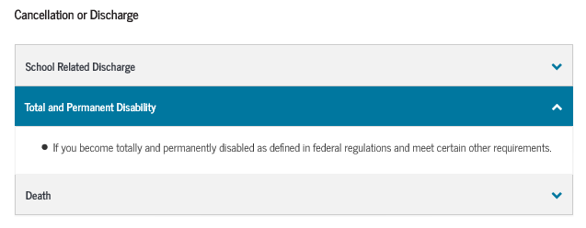
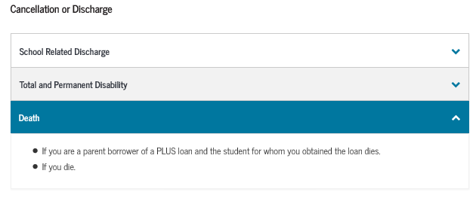
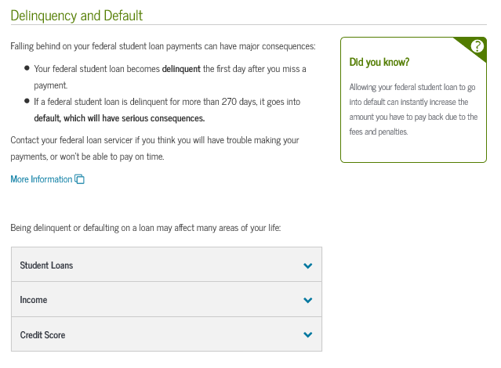
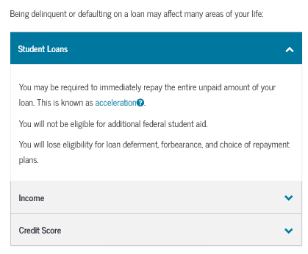
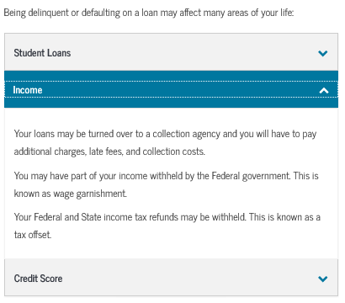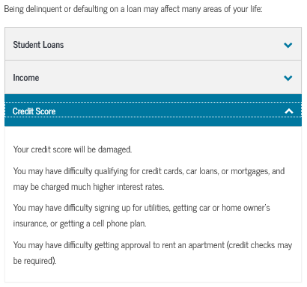

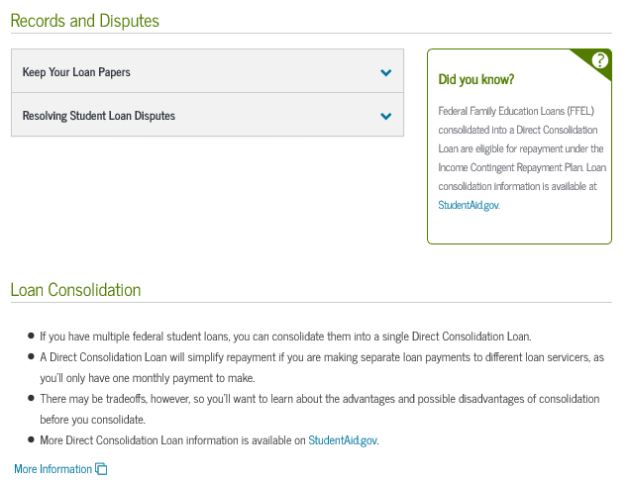
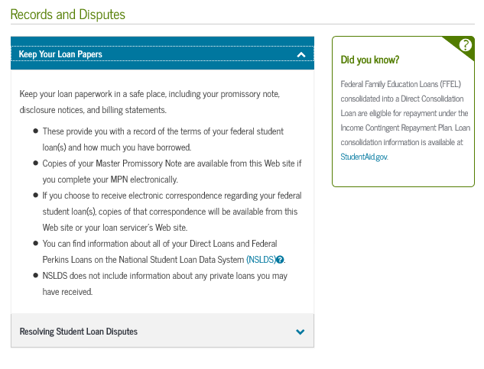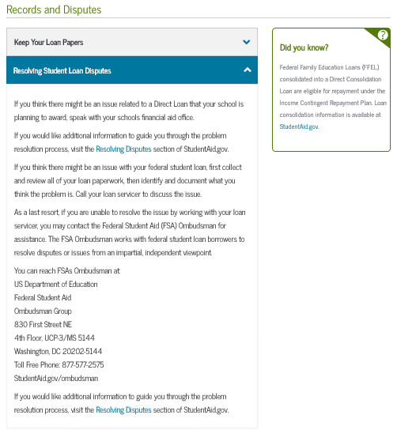

English Text
You're currently not logged in!
[if unauthenticated]
Log in to view your federal student loan data, notify schools of counseling completion, and save proof of counseling completion.
If you are not logged in, you cannot meet requirements for completing counseling.
[if unauthenticated]
LOG IN
[if unauthenticated]
Avoiding Default
Finish Your Program and Graduate
[appears for Grad only]
Graduation is the first step to successfully repaying your federal student loans.
- You will increase your employability, career options, and potential income.
- Once you graduate, making smart choices about your occupation and career path can also ensure you have the resources to meet your federal student loan obligations.
- Graduation before exceeding your maximum eligibility period protects Direct Subsidized Loans received from interest subsidy loss. More Information
[appears for Grad only]
Did you know?
[appears for Grad only]
It's important to graduate! According to U.S. Census Bureau Data, the average college graduate from a 4-year degree program earns almost $1,000,000 more over a lifetime than a high school graduate.
[appears for Grad only]
Pay on Time
It is very important that you make your federal student loan payments on time. If you are having trouble making your monthly payment, you should immediately contact your federal loan servicer for assistance.
Stay In Touch With Your Federal Loan Servicer
Open all your mail and read everything pertaining to your federal student loans. Signing up for electronic correspondence can help you ensure that you never miss a letter or bill.
Contact your loan servicer [tooltip] BEFORE you miss a payment on your federal student loan. They can help review and advise you of your repayment options. If you are unable to make your Perkins loan payment, contact your schools financial aid office.
Trouble Making Payments
Even if you're having trouble, keep making your federal student loan payments whenever possible to reduce your debt and the amount of interest you pay over the life of the loan.
If you need to lower your payments, consider one of the income-driven repayment plans or loan consolidation.
If you cannot afford to make any payments, or your difficulty is temporary, you can temporarily postpone or lower your payments with a deferment or forbearance.
Remember!
You MUST continue making payments on your federal student loan until you have been notified that your deferment or forbearance has been granted. If you don't, and it is not approved, you will become delinquent and may default [tooltip] on your federal student loans.
Deferment
Overview
- Allows you to temporarily stop making payments on your federal student loans.
- In most cases, you are not charged interest on subsidized loans during deferment. More Information
- Interest will continue to be charged on your unsubsidized and PLUS loans, and on Direct Subsidized Loans that have lost interest subsidy. If you do not pay this interest during the deferment, it will be capitalized [tooltip] at the end of the deferment.
Periods of deferment or forbearance generally do not count toward the maximum length of time you have to repay your federal student loans.
More information on deferment and forbearance conditions.
You may qualify for a deferment if you are:
- Enrolled at least half-time at an eligible postsecondary school.
- In a full-time course of study in a graduate fellowship program.
- In an approved full-time rehabilitation program for individuals with disabilities.
- Unemployed or unable to find full-time employment (for a maximum of three years).
- Experiencing an economic hardship (including Peace Corps service) as defined by federal regulations.
- Serving on active duty during a war or other military operation or national emergency and, if you were serving on or after October 1, 2007, for an additional 180-day period following the demobilization date for your qualifying service.
- Performing qualifying National Guard duty during a war or other military operation or national emergency and, if you were serving on or after October 1, 2007, for an additional 180-day period following the demobilization date for your qualifying service.
- A member of the National Guard or other reserve component of the U.S. Armed Forces (current or retired) and you are called or ordered to active duty while you are enrolled at least half-time at an eligible school or within 6 months of having been enrolled at least half-time, during the 13 months following the conclusion of your active duty service, or until you return to enrolled student status on at least a half-time basis, whichever is earlier.
Forbearance
Overview
- Allows you to temporarily stop making payments or reduce your monthly payment.
- Interest will continue to be charged. If you do not pay this interest during the forbearance, it will be capitalized at the end of the forbearance.
Forbearance is another option for temporarily postponing or reducing loan payments if you do not qualify for a deferment. A forbearance may be granted if you meet one of the following requirements:
- You are unable to make your scheduled loan payments for reasons including, but not limited to, financial hardship and illness.
- You are serving in a medical or dental internship or residency program, and you meet specific requirements.
- The total amount you owe each month for all of the student loans you received under Title IV of the Act is 20% or more of your total monthly gross income (for a maximum of three years).
- You are serving in an approved AmeriCorps position.
- You are performing teaching service that would qualify for loan forgiveness under the requirements of the Teacher Loan Forgiveness Program.
- You qualify for partial repayment of your loans under the Student Loan Repayment Program, as administered by the Department of Defense.
- You are called to active duty in the U.S. Armed Forces.
Periods of deferment or forbearance generally do not count toward the maximum length of time you have to repay your federal student loans.
More information on deferment and forbearance conditions.
Forgive, Cancel or Discharge Your Debts
Under certain circumstances, you may have all or part of your federal student loans forgiven or discharged. Contact your federal loan servicer for details.
For a full list of the conditions for forgiveness and discharge/cancellation, see the loan cancellation and discharge summary chart.
Remember!
Federal student loans are not generally eliminated as part of personal bankruptcy. Contact your federal loan servicer to discuss your federal student loan repayment options.
Forgiveness

[Forgiveness section appears for grad only]
Teacher Loan Forgiveness
If you teach full-time at certain elementary or secondary schools or educational service agencies that serve low-income students.
Forgives up to $5,000 (up to $17,500 for teachers in certain subject areas) of your Direct Loans, except for Direct PLUS Loans, provided you teach for five consecutive years as a highly-qualified teacher or as a highly-qualified teacher in certain subjects.
More Information
Public Service Loan Forgiveness
(Direct Loans Only)
If you work full-time for a qualifying public service organization while making 120 qualifying monthly payments.
Forgives all of your remaining Direct Loan debt after you have made the 120 qualifying payments.
More Information
Cancellation or Discharge
School Related Discharge
If your school:
- Closed before you could complete your program.
- Falsely certified your loan eligibility.
- Did not have your authorized signature.
- Failed to refund all or a portion of your federal student loans to the loan servicer, when it was required by law to do so.
Or if:
- Your federal student loan was falsely certified as a result of identity theft.
Total and Permanent Disability
- If you become totally and permanently disabled as defined in federal regulations and meet certain other requirements.

Check Eligibility
Death
- If you are a parent borrower of a PLUS loan and the student for whom you obtained the loan dies.
- If you die.
Delinquency and Default
Falling behind on your federal student loan payments can have major consequences:
- Your federal student loan becomes delinquent the first day after you miss a payment.
- If a federal student loan is delinquent for more than 270 days, it goes into default, which will have serious consequences.
Contact your federal loan servicer if you think you will have trouble making your payments, or won't be able to pay on time.
More Information

Being delinquent or defaulting on a loan may affect many areas of your life:
Student Loans
You may be required to immediately repay the entire unpaid amount of your loan. This is known as acceleration [tooltip].
You will not be eligible for additional federal student aid.
You will lose eligibility for loan deferment, forbearance, and choice of repayment plans.

Future Income
Your loans may be turned over to a collection agency and you will have to pay additional charges, late fees, and collection costs.
You may have part of your income withheld by the Federal government. This is known as wage garnishment.
Your Federal and State income tax refunds may be withheld. This is known as a tax offset.

Credit Score
Your credit score will be damaged.
You may have difficulty qualifying for credit cards, car loans, or mortgages, and may be charged much higher interest rates.
You may have difficulty signing up for utilities, getting car or home owner's insurance, or getting a cell phone plan.
You may have difficulty getting approval to rent an apartment (credit checks may be required).

Did you know?
Allowing your federal student loan to go into default can instantly increase the amount you have to pay back due to the fees and penalties.
Alert!
Although your credit history is not taken into account for Direct Subsidized Loans and Direct Unsubsidized Loans, your credit history will be affected if you do not repay your federal student loans under the repayment plan you agree to when you enter repayment.
Records and Disputes
Keep Your Loan Papers
Keep your loan paperwork in a safe place, including your promissory note, disclosure notices, and billing statements.
- These provide you with a record of the terms of your federal student loan(s) and how much you have borrowed.
- Copies of your Master Promissory Note are available from this Web site if you complete your MPN electronically.
- If you choose to receive electronic correspondence regarding your federal student loan(s), copies of that correspondence will be available from this Web site or your loan servicer's Web site.
- You can find information about all of your Direct Loans and Federal Perkins Loans on the National Student Loan Data System (NSLDS) [tooltip].
- NSLDS does not include information about any private loans you may have received.
Resolving Student Loan Disputes
If you think there might be an issue related to a Direct Loan that your school is planning to award, speak with your schools financial aid office.
If you would like additional information to guide you through the problem resolution process, visit the Resolving Disputes section of StudentAid.gov.
If you think there might be an issue with your federal student loan, first collect and review all of your loan paperwork, then identify and document what you think the problem is. Call your loan servicer to discuss the issue.
As a last resort, if you are unable to resolve the issue by working with your loan servicer, you may contact the Federal Student Aid (FSA) Ombudsman for assistance. The FSA Ombudsman works with federal student loan borrowers to resolve disputes or issues from an impartial, independent viewpoint.

You can reach FSAs Ombudsman at:
US Department of Education
FSA
Ombudsman Group
P.O. Box 1843
Monticello, KY 42633
Fax: 606-396-4821
StudentAid.gov/ombudsman
If you would like additional information to guide you through the problem resolution process, visit the Resolving Disputes section of StudentAid.gov.

Did you Know?
Federal Family Education Loans (FFEL) consolidated into a Direct Consolidation Loan are eligible for repayment under the Pay As You Earn and ICR plans. Loan consolidation information is available at StudentAid.gov.
Loan Consolidation
- If you have multiple federal student loans, you can consolidate them into a single Direct Consolidation Loan.
- A Direct Consolidation Loan will simplify repayment if you are making separate loan payments to different loan servicers, as you'll only have one monthly payment to make.
- There may be trade-offs, however, so you'll want to learn about the advantages and possible disadvantages of consolidation before you consolidate.
- More Direct Consolidation Loan information is available on StudentAid.gov.
More Information
CONSOLIDATION LOANS
A consolidation loan may help make payments more manageable by combining several federal student loans into one loan with one monthly payment. You need to apply for loan consolidation and choose a repayment plan. Depending on the amount of your debt and the repayment plan that you choose, the repayment period for a Direct Consolidation Loan may range from 10 to 30 years.
The interest rate for a Direct Consolidation Loan is a fixed rate. The fixed rate is the weighted average of the interest rates on all of the loans you consolidate, rounded up to the nearest one-eighth of one percent.
How can consolidation help me manage my debt?
Loan consolidation can offer you benefits to help manage your education debt. You will:
- Make lower monthly payments by increasing the repayment period (However, this will increase the total amount you repay over the life of your loan).
- Make a single monthly loan payment on one bill to one lender.
As with other loan types, you may prepay a consolidation loan without penalty and may change repayment plans if you find that your current plan no longer meets your needs.
Is there a downside to consolidation?
Although consolidation can help many students manage their monthly payments, there are some cases when consolidation may not be right for you.
- You may lose repayment incentives on FFEL Program loans that you consolidate.
- You will lose cancellation and interest subsidy benefits on any Federal Perkins Loans that you consolidate.
- Any outstanding interest on the loans you consolidate will be capitalized when you consolidate.
- Because Direct Consolidation Loans can have a repayment period of up to 30 years, you may be increasing the total amount you pay in interest.
CLOSE
EXIT
SUBMIT COUNSELING

All Borrower Types - Summary

English Text
You're currently not logged in!

[if unauthenticated]
Log in to view your federal student loan data, notify schools of counseling completion, and save proof of counseling completion.
If you are not logged in, you cannot meet requirements for completing counseling.

[if unauthenticated]
LOG IN

[if unauthenticated]
PLUS CREDIT COUNSELING FOR GRADUATE/PROFESSIONAL STUDENTS
[User’s Name], you have successfully completed PLUS Credit Counseling!
[if authenticated]
The following is a summary of the information you entered during this session and future actions you can take.
Financial Summary
Income [tooltip]
/month
Expenses [tooltip]
/month
Loan Payment [tooltip]
/month
Remaining Balance
/month
Repayment Plan Details
Projected Loan Balance [tooltip]
Repayment Plan [tooltip]
Repayment Period [tooltip]
Financial Takeaway
Debt Burden [tooltip] Based on your projected annual income, your student loan debt burden will be:
High
Medium
Low
Additional Resources
College Planning
- College Navigator
- StudentAid.gov
Career Planning
- Department of Labor Employment Statistics
- AnnualCreditReport.com
Financial Planning
- Financial Awareness Counseling
- Money Matters
- MyMoney.gov
- National Student Loan Database System (NSLDS)
Check out our Youtube Playlist:
Export Budget/Repayment
Export your budget and repayment information.
E-mail
E-mail a summary of your budget and repayment information.
Print
Print a summary of your counseling session.
Tweet
Tweet about completing your counseling session.
Next Steps
View/Print Borrower's Rights & Responsibilities for Direct PLUS Loans
Document Extenuating Circumstances
Complete an MPN
Complete Direct Consolidation Loan Application and Promissory Note
View Completed Counseling

