Section 12(b) Export Notification Application User Guide – Primary Authorized Official

Environmental Protection Agency

Office of Pollution Prevention and Toxics

Delivery Order #: GS00Q09BGD0022

Task Order #: GSQ0017AJ0034

Project #: TDD 9.21

Version 0.01

September 29, 2017

Table of Contents
Table of Contents i
List of Exhibits ii
Revision Log iii
1 Introduction 1
2 System Requirements 2
2.1 Supported Browsers 2
2.2 Screen Resolution 2
3 Primary Authorized Official (AO) Functions 3
3.1 Log into Section 12(b) Application 4
3.2 Section 12(b) Home Screen Navigation 4
3.3 Submission History 5
3.4 Create Passphrase 7
3.5 Enter Passphrase 8
3.6 Action Bar 9
3.7 Upload Chemical(s) Using .CSV File 11
4 Export Notification 12
4.1 Create an Online Export Notification 12
4.2 Exporter Information 12
4.3 Exported Chemicals 14
4.4 Instructions for Substantiating Confidential Business Information (CBI) Claims 24
4.5 Review Submission Information 28
5 Preview 30
6 Validate 32
7 Submit to EPA via CDX 33
7.1 TSCA Certification 33
7.2 Submission Validation 33
7.3 PDF Generation 34
7.4 CROMERR Certification 35
7.5 eSignature Widget 36
7.6 Submission Finished 36
8 Download Copy of Record 38
9 Create an Amendment 39
10 Appendix A 40

List of Exhibits
Exhibit 3-1 Section 12(b) User Roles Matrix 3
Exhibit 3-2 Chemical Information Submission System Screen 4
Exhibit 3-3 Section 12(b) Home Screen 5
Exhibit 3-4 Section 12(b) Submission History Section 7
Exhibit 3-5 Create Passphrase Screen 8
Exhibit 3-6 Enter Passphrase Screen 9
Exhibit 3-7 Action Bar – Save 10
Exhibit 3-8 Action Bar – Preview 10
Exhibit 3-9 Action Bar – Validate 10
Exhibit 3-10 Action Bar – Submit 10
Exhibit 3-11 CDX Links 11
Exhibit 4-1 Exporter Information Screen (Scroll 1) 13
Exhibit 4-2 Exporter Information Screen (Scroll 2) 14
Exhibit 4-3 Exported Chemicals Screen – Countries to a Chemical (Scroll 1) 16
Exhibit 4-4 Exported Chemicals Screen – Countries to a Chemical (Scroll 2) 17
Exhibit 4-5 Exported Chemicals Screen – Chemicals to a Country (Scroll 1) 18
Exhibit 4-6 Exported Chemicals Screen – Chemicals to a Country (Scroll 2) 19
Exhibit 4-7 Search Substance Registry Services (SRS) Pop-Up Window 20
Exhibit 4-8 Add Chemical to Section 12(b) Window 21
Exhibit 4-9 Exported Chemicals Screen – Chemicals by Uploading a CSV File 22
Exhibit 4-10 Exported Chemicals Screen (Populated) (Scroll 1) 23
Exhibit 4-11 Exported Chemicals Screen (Populated) (Scroll 2) 24
Exhibit 4-12 Instructions for Substantiating CBI Claims Screen (Scroll 1) 26
Exhibit 4-13 Instructions for Substantiating CBI Claims Screen (Scroll 2) 27
Exhibit 4-14 Instructions for Substantiating CBI Claims Screen (Scroll 3) 27
Exhibit 4-15 Instructions for Substantiating CBI Claims Screen (Scroll 4) 28
Exhibit 4-16 Review Submission Information Screen 29
Exhibit 5-1 Preview Section 12(b) Export Notification PDF 31
Exhibit 6-1 Section 12(b) Export Notification Validation Window 32
Exhibit 7-1 TSCA Certification Screen 33
Exhibit 7-2 Submission Validation Screen 34
Exhibit 7-3 PDF Generation Screen 35
Exhibit 7-4 CROMERR Certification Window 35
Exhibit 7-5 eSignature Widget Window 36
Exhibit 7-6 Submission Finished Screen 37
Exhibit 8-1 Download Copy of Record Screen 38

Revision Log
Date | Version No. | Description | Author | Reviewer | Review Date
09/29/17 | 0.01 | Initial Draft of OPPT Section 12(b) Export Notification Application User Guide – Primary Authorized Official | M. Griffin | J. Bronick | 09/29/17

Introduction
This document presents the user guide for the Office of Pollution Prevention and Toxics (OPPT) Section 12(b) Export Notification submission process. This document is the user guide for the Primary Authorized Official of the Section 12(b) application.
The Section 12(b) application is the electronic, web-based tool provided by Environmental Protection Agency (EPA) for the submission of Section 12(b) data. As a Primary Authorized Official you can create, modify, and submit a Section 12(b) form. You can also delete Section 12(b) forms, create amendments, and download the Copy of Record (CoR).
For questions concerning the Toxic Substances Control Act (TSCA) Section 12(b) software requirements, please contact the Central Data Exchange (CDX) Help Desk at helpdesk@epacdx.net or call 1-888-890-1995 between the hours of 8 am – 6 pm Eastern Standard Time (EST).

System Requirements
To use the Section 12(b) Export Notification application to submit a Section 12(b) form, the following are required:
- An e-mail account
- JavaScript enabled web browser
- Internet access
- Adobe Acrobat Reader 5.0 or higher
- CDX username and password

Supported Browsers
One of the following supported browsers is required to access the Section 12(b) application:
- Vendor supported versions of Internet Explorer (IE) or Edge
Go to the following link to download:
https://support.microsoft.com/en-us/help/17621/internet-explorer-downloads
- Vendor supported versions of Mozilla Firefox
Go to the following link to download:
https://www.mozilla.org/en-US/firefox/new/
- Vendor supported versions of Safari
Go to the following link to download:
https://support.apple.com/downloads/
- Vendor supported versions of Google Chrome
Go to the following link to download:
http://www.google.com/chrome

Screen Resolution
Screen resolution should be set to 1024 x 768 or greater.

Primary Authorized Official (AO) Functions
This section describes how to:
- Access the application
- Navigate the Section 12(b) Export Notification ‘Home’ screen
- Assign Supports to complete a form
- Start, complete, and submit a Section 12(b) Export Notification form
- Upload an extensible markup language (XML) file
- Download a Copy of Record
- Create an amendment
The Primary AO is responsible for the submission of main forms. As a Primary AO, you can create a new form. You are also responsible for submitting amendments, unlocking submissions, and deleting forms. You can assign Supports (or other authorized individuals) to edit and complete a form on your behalf. The Primary AO can be thought of as a primary company authorized official, specifically in regards to any sponsored individuals.
You can save the form at any point during the data entry process. The save functionality allows you to return to that same form at any point in the future. You can print the form at any point; however, the ‘Not for Submission’ watermark will be placed on the form anytime the form is printed prior to actual submission.
Exhibit 3-1 displays a table of the user role capabilities within the Section 12(b) application:
Exhibit 3-1 Section 12(b) User Roles Matrix
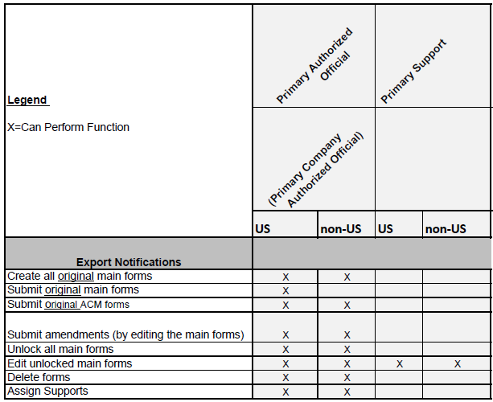

Log into Section 12(b) Application
After you create an account in CDX, click the ‘Primary Authorized Official’ link for the Chemical Safety and Pesticide Programs (CSPP) data flow to navigate to the ‘Chemical Information Submission System’ screen.
Exhibit 3-2 shows a screen capture of the ‘Chemical Information Submission System’ screen:
Exhibit 3-2 Chemical Information Submission System Screen
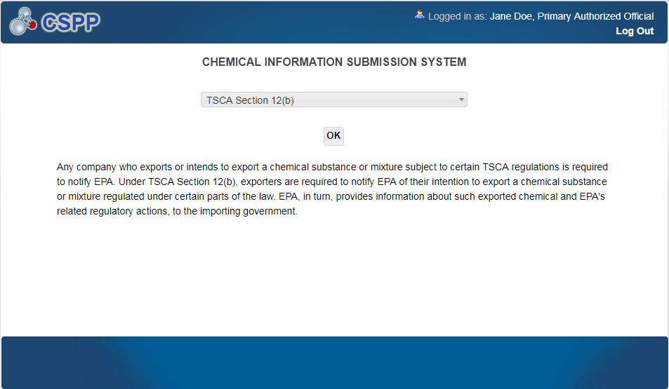
Navigation: To access the Section 12(b) ‘Home’ screen, select ‘TSCA Section 12(b)’ from the submission type drop-down menu and click the ‘OK’ button.

Section 12(b) Home Screen Navigation
You can access the Section 12(b) ‘Home’ screen by selecting ‘TSCA Section 12(b)’ from the submission type drop-down menu on the ‘Chemical Information Submission System’ screen and clicking the ‘OK’ button.
The Section 12(b) ‘Home’ screen is the first screen within the Section 12(b) application. It displays the ‘Quick Tasks,’ ‘Useful Resources,’ and ‘Submission History’ panels. There is also a ‘Help’ drop-down menu within the application header, which provides a link to the user guide.
There is a ten (10) minute logout timer for this application; the application will automatically log you out after ten minutes of inactivity and navigate you back to the CDX login screen.
- Quick Tasks: Click the ‘Start Export Notification’ button to create an online export notification, or click the ‘Upload CSV File’ button to upload information in bulk.
- Useful Resources: Click the links within the ‘Useful Resources’ section.
- Submission History: Modify or delete a Section 12(b) form using the ‘Submission History’ section. For additional details about the ‘Submission History’ panel, please refer to Section 3.3.
Exhibit 3-3 shows a screen capture of the Section 12(b) ‘Home’ screen:
Exhibit 3-3 Section 12(b) Home Screen
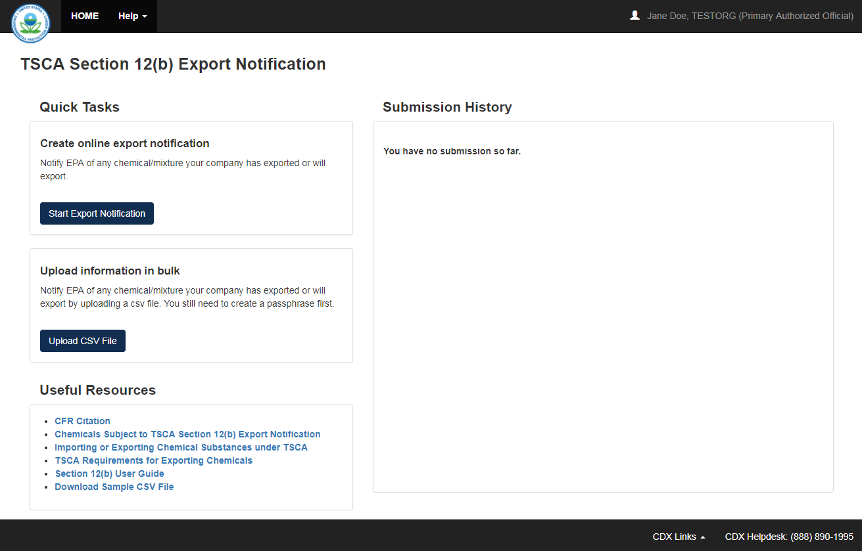

Submission History
Only one Section 12(b) form is created per form alias, which helps differentiate between forms. Each column within the table of the ‘Submission History’ screen can be sorted by clicking the individual column headers.
Start New Form: To create a new Section 12(b) Export Notification form, click the ‘Start Export Notification’ button. You are required to create a passphrase that will be associated with that particular form. Make sure to create a passphrase that you will remember, as it cannot be retrieved or reset. Refer to Section 3.4 for further instructions on creating a passphrase.
Edit an ‘In Progress’ Form: To modify an existing Section 12(b) Export Notification, click the ‘Form Alias’ link for a form with a status of ‘In Progress.’ You are required to enter the passphrase associated with that particular form to access and edit the form. It is possible for more than one user to modify a form simultaneously; the user that clicks the ‘Save’ button first will have his/her changes saved.
Amend a ‘Submitted’ Form: To edit an already submitted Section 12(b) form (i.e., to create an amendment), you must first unlock the particular submission by clicking the ‘Lock’ icon () under the ‘Action’ column. You will be required to enter the passphrase associated with that particular submission to gain access and continue amending the submission. All further changes that are made will be submitted as an amendment. Refer to Section 9 for further instructions on creating an amendment.
The ‘Submission History’ section displays the following fields and columns of information:
- # Entries Found: Displays the number of entries found under this user account for Section 12(b).
- Submission Alias: Displays the form alias of a Section 12(b) form. Click the form alias link to navigate to the ‘Enter Passphrase’ page and complete/edit a form.
- Modification Date: Displays the date that a form was last modified.
- Submission Date: Displays the date that a form was successfully submitted to EPA via CDX. This date populates only after the form has been submitted.
- Status: Displays the status of a Section 12(b) form (either ‘In Progress,’ ‘Submitted,’ or ‘Completed’).
- Actions: Click the ‘Delete’ icon () to delete an in-progress form. Click the ‘Lock’ icon () to unlock a form for an amendment. The form remains unlocked until the form is resubmitted by the AO.
- Export Options: Click the ‘XML,’ ‘CSV,’ ‘PDF,’ or ‘Excel’ button to download the ‘Submission History’ table as an .xml, .csv, .pdf, or .xlsx file, respectively.

Exhibit 3-4 shows a screen capture of the Section 12(b) ‘Submission History’ section:
Exhibit 3-4 Section 12(b) Submission History Section
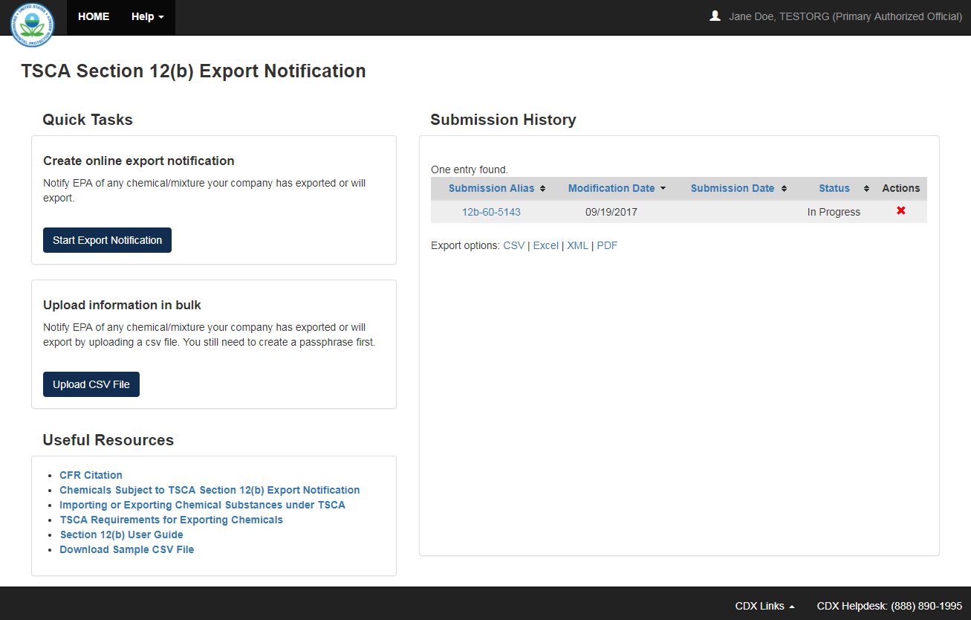

Navigation: Click the ‘Start Export Notification’ button to create a new Section 12(b) form and navigate to the ‘Create Passphrase’ screen.

Create Passphrase
To start a new Section 12(b) form, click the ‘Start Export Notification’ button on the Section 12(b) ‘Home’ screen to navigate to the ‘Create Passphrase’ screen, which allows you to create a passphrase and associate that passphrase with your newly created form.
The application uses the passphrase as an encryption key to protect the contents of the form. You are responsible for remembering the passphrase and distributing it to the appropriate individuals.
If you lose or forget your passphrase, you will not be able to access your Section 12(b) form to print, submit, or make changes. You will need to complete a new Section 12(b) form and create a new passphrase. For security reasons, the system administrator will not have access to your passphrase and will not be able to retrieve it or reset it.
- New Passphrase: Enter a passphrase that is between 8 to 20 characters. For maximum security, your passphrase should contain a combination of letters and numbers. Your passphrase should not contain special characters (for example, +, ?, and *). As a Primary user, you are responsible for remembering your passphrase and distributing it to only authorized individuals. The passphrase is used as an encryption key to protect the contents of the form data.
- Confirm Passphrase: Enter the same passphrase that was entered into the ‘New Passphrase’ field. The same passphrase may be associated with multiple forms. The user can choose to have the same passphrase for all forms. Supports do not have the ability to start a new form or create a passphrase for a form.
Exhibit 3-5 shows a screen capture of the ‘Create Passphrase’ screen:
Exhibit 3-5 Create Passphrase Screen
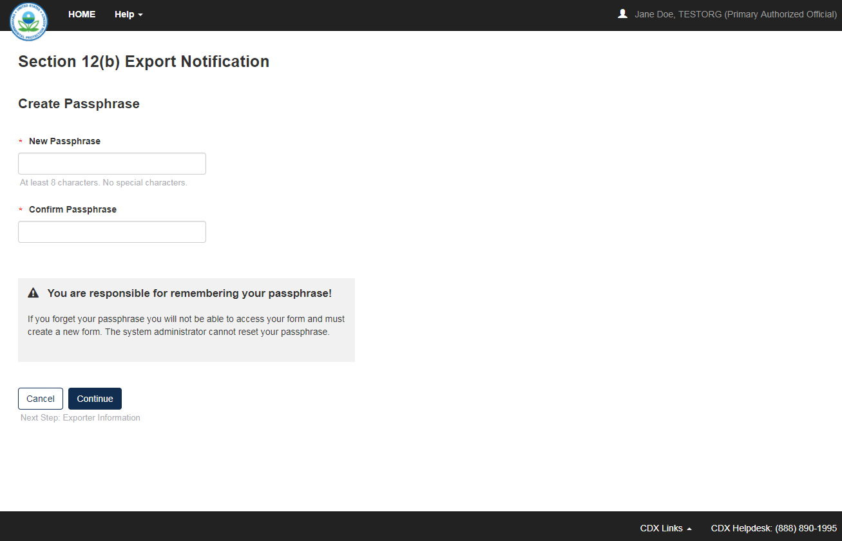
Navigation: Create a passphrase and click the ‘Continue’ button to navigate to the ‘Exporter Information’ screen in a Section 12(b) Export Notification form.

Enter Passphrase
To edit a form, click the ‘Form Alias’ link for a Section 12(b) form with a status of ‘In Progress.’ The ‘Enter Passphrase’ screen requires you to enter the passphrase that is associated with the form.
- Submission Alias: Displays the form alias that is used to identify the form.
- Enter Passphrase: Enter the passphrase that is associated with the form.

Exhibit 3-6 shows a screen capture of the ‘Enter Passphrase’ screen:
Exhibit 3-6 Enter Passphrase Screen
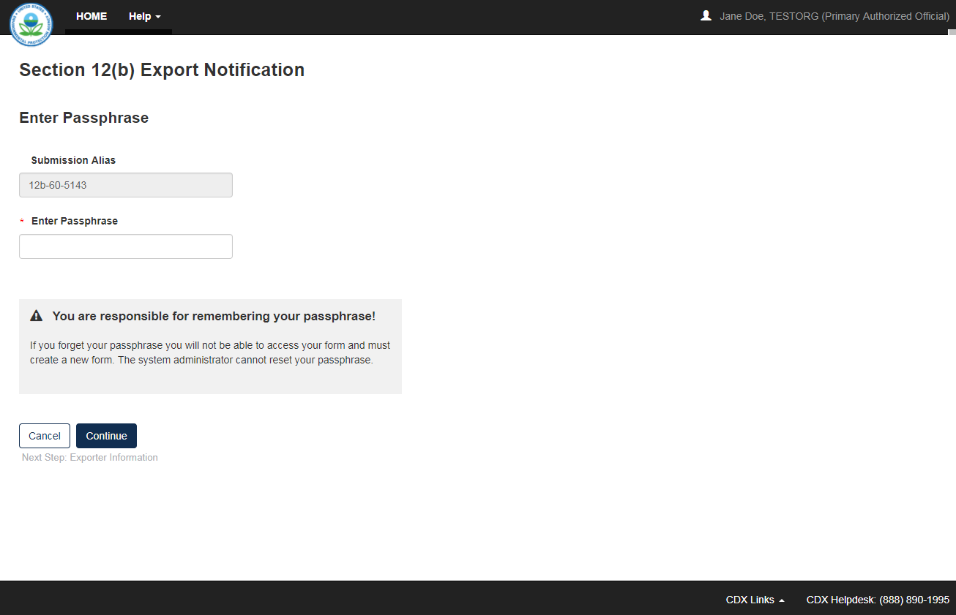

Navigation: Enter the passphrase originally created and associated with the form and click the ‘Continue’ button to navigate to the ‘Exporter Information’ screen.

Action Bar
The action bar is located at the top and bottom of the form on each screen. You can perform the following functions using the top action bar:
- Home: Click the ‘Home’ link to navigate to the Section 12(b) ‘Home’ screen.
- Help: Click the ‘Help’ link to generate a drop-down menu, which displays a link to the user guide.
- User ID: Click the user ID link to log out of the application.
The following exhibits, Exhibit 3-7, Exhibit 3-8, Exhibit 3-9, and Exhibit 3-10, show screen captures for the bottom action bar:
- Save: Click the ‘Save’ link at any stage of completing a Section 12(b) form to save the form. To generate and access links to other pages of the form within the navigation tree, you must click the ‘Save’ link within the action bar. After you click the ‘Save’ link, you will receive a message indicating that all data entered in the form has been saved successfully. The save function does not validate any entered data. Click the ‘Previous’ and ‘Next’ buttons on a form to save the data entered within a form. Click the ‘X’ button in the upper right-hand corner of the form in your browser to close the form without saving.
Exhibit 3-7 Action Bar – Save
- Preview: Click the ‘Preview’ link after uploading a minimum of one chemical to preview the form. After you click the ‘Preview’ link, you will be given the option to view a regular version of the PDF(s) or a sanitized version of the PDF(s). Choosing either option will download (a) watermarked PDF version(s) of each chemical identified within the form in a .zip file.
Exhibit 3-8 Action Bar – Preview
- Validate: Click the ‘Validate’ link at any stage of completing a Section 12(b) Notice of Activity form. A ‘TSCA Section 12(b) Validation’ window generates when you click the ‘Validate’ link if you disable the pop-up blocker within your internet browser. The ‘Section 12(b) Validation’ pop-up window displays a report of all warning messages. Refer to Section 6 for more information on validating a form.
Exhibit 3-9 Action Bar – Validate
- Submit: Click the ‘Submit’ link to submit a Section 12(b) form after completing all sections of a Section 12(b) form. After you click the ‘Submit’ link a pop-up message displays to confirm the submission process. The form validates during the submission process and displays any applicable warning or error messages. Refer to Section 6 for further instructions on validation errors. You can continue with the submission process only after clearing all validation errors. Upon successful submission of the form, the application generates and sends an email indicating the successful submission of the form to the submitter’s email address. Refer to Section 7 for more information on submitting a Section 12(b) Export Notification form.
Exhibit 3-10 Action Bar – Submit
- CDX Links: Click any of the ‘CDX Links,’ located at the bottom of each screen within the ‘CDX Links’ drop-down menu, at any stage of completing a Section 12(b) form.
  - Click the ‘CDX Homepage’ link to navigate to the ‘CDX’ homepage.
  - Click the ‘MyCDX Homepage’ link to navigate to the ‘MyCDX’ page.
  - Click the ‘EPA Homepage’ link to navigate to the EPA Homepage.
  - Click the ‘Terms and Conditions’ link to navigate to the CDX Terms and Conditions screen.
  - Click the ‘Privacy Notice’ link to navigate to the CDX Privacy and Security Notice screen.
Exhibit 3-11 shows a screen capture of the action bar ‘CDX Links’:
Exhibit 3-11 CDX Links
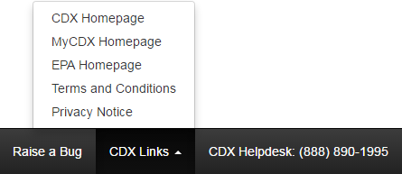

Upload Chemical(s) Using .CSV File
The ‘Upload CSV File’ button displays on the Section 12(b) ‘Home’ screen within the ‘Quick Tasks’ panel. Upon clicking this button you will be asked to create a passphrase before navigating to the ‘Exported Chemicals’ screen within a newly created Section 12(b) Export Notification form. Refer to Section 3.4 for further information on the passphrase creation process.
‘Chemicals by Uploading a CSV File’ will be automatically selected within the ‘Add one or more’ drop-down menu, thus displaying fields of information on uploading a .csv file. Refer to Section 4.3.4 for further information on uploading a .csv file within a Section 12(b) form. You will still have to complete all other parts of the Export Notification, including the ‘Exporter Information’ screen, before being able to submit to EPA. Refer to Section 4 through Section 4.5 for the entire walkthrough of a Section 12(b) form.

Export Notification
Any company who exports or intends to export a chemical substance or mixture subject to certain TSCA regulations is required to notify EPA. Under TSCA Section 12(b), exporters are required to notify EPA of their intention to export a chemical substance or mixture regulated under certain parts of the law. EPA, in turn, provides information about such exported chemical and EPA's related regulatory actions, to the importing government.

Create an Online Export Notification
To create a new Export Notification form, navigate to the Section 12(b) ‘Home’ screen and click the ‘Start Export Notification’ button. Refer to Section 3.2 for additional details regarding the Section 12(b) ‘Home’ screen.
Refer to Section 3.4 for additional details regarding the passphrase creation process.

Exporter Information
You can navigate to the ‘Exporter Information’ screen by clicking the ‘Start Export Notification’ button and creating a new passphrase, or by accessing a Section 12(b) form that is ‘In Progress’ and entering the passphrase associated with the selected form.
This screen displays two sections – ‘Submitter Information’ and ‘Exporter Information.’ You will also have the option to assign a ‘Submission Alias’ to identify the form. A unique submission alias is helpful when a user or company has multiple forms and/or when you must differentiate between forms to the help desk. Upon navigating to the ‘Exporter Information’ screen, the system auto-generates a default alias comprised of a form type in the following format: <12b-XX-XXXX>. This is a required field.

Submitter Information
The ‘Submitter Information’ section of the ‘Exporter Information’ screen displays the organization or individual preparing the Section 12(b) submission. This information is pre-populated from CDX registration. If the information listed is incorrect please make the appropriate edits to your user information in CDX registration.
- CBI: Check this checkbox to claim the submitter information as CBI.
- User Information: Displays the name, email address, and phone number of the submitter.
- Organization: Displays the company’s name, mailing address, city, state (if applicable), postal code, and country of the submitter.
- Job Title (optional): Enter the submitter’s job title.

Exporter Information
The ‘Exporter Information’ section of the ‘Exporter Information’ screen provides fields to input identifying information for the manufacturing or processing establishment that is exporting chemicals or mixtures outside the United States.
- Copy Organization Information from Above?: Click this link to copy CDX registration information, as shown above within the ‘Submitter Information’ section.
- Company Name: Enter the company name of the exporter. This is a required field.
- CBI: Check this checkbox to claim the company name as CBI.
- Address Line 1: Enter line 1 of the address of the exporter. This is a required field.
- CBI: Check this checkbox to claim the entire address as CBI.
- Address Line 2 (optional): Enter line 2 of the address of the exporter, if applicable.
- City: Enter the city of the exporter. This is a required field.
- State: Enter the state of the exporter. This is a required field.
- Postal Code: Enter the postal code of the exporter. This is a required field.
Exhibit 4-1 shows a screen capture of the ‘Exporter Information’ screen (Scroll 1):
Exhibit 4-1 Exporter Information Screen (Scroll 1)
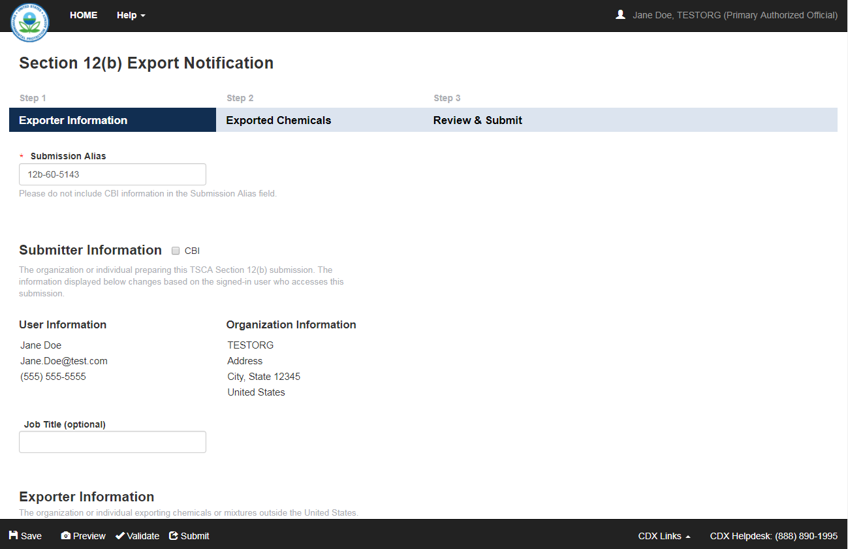

Exhibit 4-2 shows a screen capture of the ‘Exporter Information’ screen (Scroll 2):
Exhibit 4-2 Exporter Information Screen (Scroll 2)
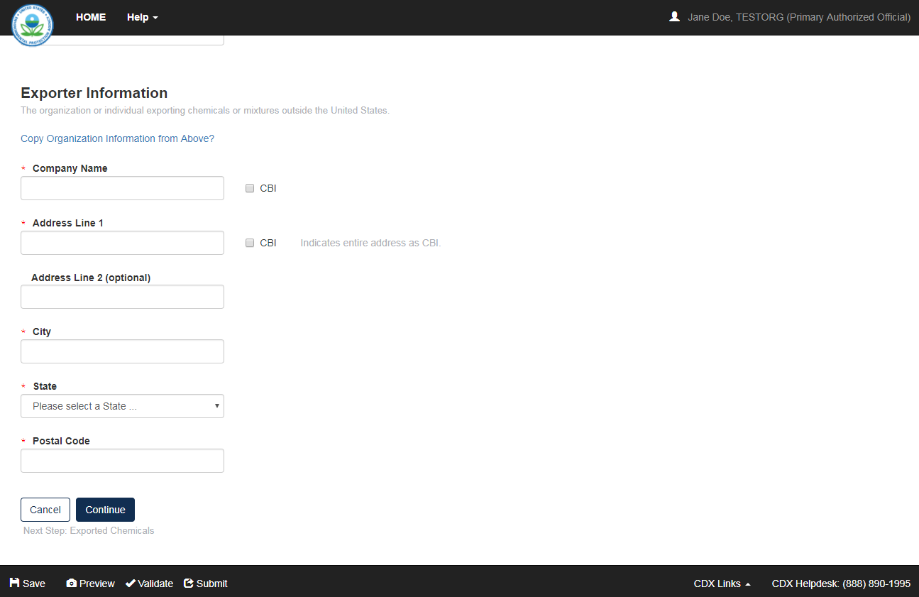
Navigation: Click the ‘Continue’ button to navigate to the ‘Exported Chemicals’ screen. You can also access this screen by clicking the ‘Exported Chemicals’ link within the navigation header.

Exported Chemicals
You can navigate to the ‘Exported Chemicals’ screen by clicking the ‘Continue’ button from the ‘Exporter Information’ screen, or by clicking the ‘Exported Chemicals’ link within the navigation header.
This screen displays the ‘TSCA Section 12(b) Exported Chemicals Table’ and the ‘Add Exported Chemicals’ section.
The ‘Add Exported Chemicals’ section within the ‘Exported Chemicals’ screen displays a drop-down menu labeled ‘Add one or more.’ Select one of the following from this drop-down menu – ‘Countries to a Chemical,’ ‘Chemicals to a Country,’ or ‘Chemicals by Uploading a CSV File.’

Add Exported Chemicals – Countries to a Chemical
The following information is displayed when ‘Countries to a Chemical’ is selected from the ‘Add one or more’ drop-down menu:
- Search SRS for 12(b) Chemicals or Create a New Chemical: Click this link to generate the ‘Search Substance Registry Services (SRS)’ pop-up window. Refer to Section 4.3.3 for further information on adding a chemical using SRS.
Upon adding a chemical using SRS, a new section will generate within the ‘Exported Chemicals’ screen, labeled ‘Provide Chemical Details.’ This section will be prepopulated with the identified chemical name and the following fields of information:
- Chemical Name: Displays the chemical name of the chemical substance selected within the ‘Search Substance Registry Services (SRS)’ pop-up window. This is a required field.
- TSCA Section: Select the TSCA section for the identified chemical substance (either Section 4, Section 5, Section 5(a)(2), Section 5(b), Section 5(e), Section 6, Section 7, Section 5(a)(2)(e), or Section 5(f)). This is a required field.
- Section 12(b) Category: Select the Section 12(b) category for the identified chemical substance. This is a required field. Refer to Appendix A for a list of categories that this drop-down menu provides.
- Import Country: Select the country from the drop-down menu to which the chemical(s) are imported. Check the ‘CBI’ checkbox next to this field to claim the import country as CBI. This is a required field.
- Export Date or Intended Export Date: Click the calendar widget to select the anticipated or set date for export. Check the ‘CBI’ checkbox next to this field to claim the export date as CBI. This is a required field.
- Add Import Country and Export Date to Chemical: Click this button to add the selected country and date to the chemical, which will then be populated into the ‘List of Import Countries and Export Dates’ panel.
- Delete: Click the ‘Delete’ icon () to remove an import country and export date entry from the ‘List of Import Countries and Export Dates’ panel.
- Add to Exported Chemicals Table: Once all countries and export dates have been added to the ‘List of Import Countries and Export Dates,’ click this button to add this chemical substance to the ‘TSCA Section 12(b) Exported Chemicals Table.’
- Cancel: Click this button to close the ‘Provide Chemical Details’ section and the ‘List of Import Countries and Export Dates’ without saving.

Exhibit 4-3 shows a screen capture of the ‘Exported Chemicals’ screen with ‘Countries to a Chemical’ selected (Scroll 1):
Exhibit 4-3 Exported Chemicals Screen – Countries to a Chemical (Scroll 1)
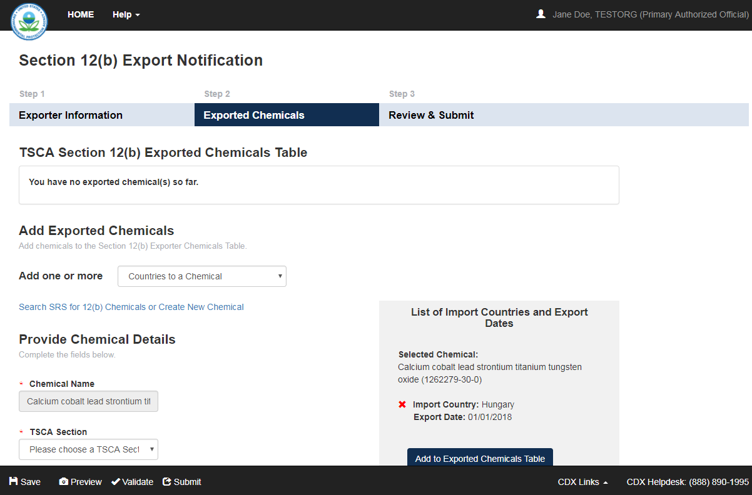

Exhibit 4-4 shows a screen capture of the ‘Exported Chemicals’ screen with ‘Countries to a Chemical’ selected (Scroll 2):
Exhibit 4-4 Exported Chemicals Screen – Countries to a Chemical (Scroll 2)
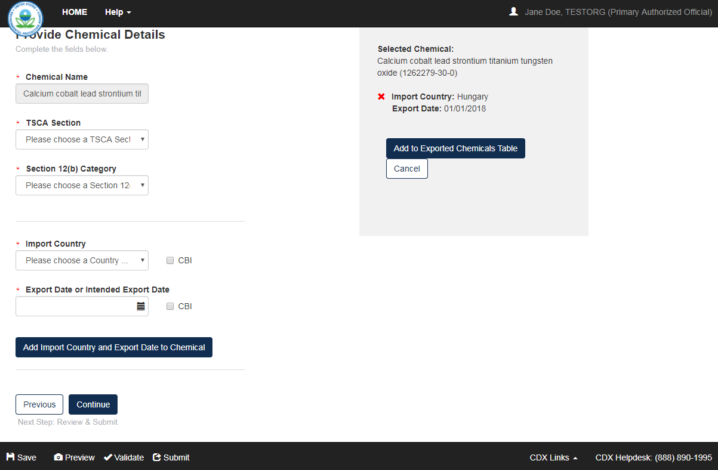

Add Exported Chemicals – Chemicals to a Country
The following information is displayed when ‘Chemicals to a Country’ is selected from the ‘Add one or more’ drop-down menu:
- Search SRS for 12(b) Chemicals or Create a New Chemical: Click this link to generate the ‘Search Substance Registry Services (SRS)’ pop-up window. Refer to Section 4.3.3 for further information on adding a chemical using SRS.
Upon adding a chemical using SRS, a new section will generate within the ‘Exported Chemicals’ screen, labeled ‘Provide Chemical Details.’ This section will be prepopulated with the identified chemical name and the following fields of information:
- Import Country: Select the country from the drop-down menu to which the chemical(s) are imported. Check the ‘CBI’ checkbox next to this field to claim the import country as CBI. This is a required field.
- Export Date or Intended Export Date: Click the calendar widget to select the anticipated or set date for export. Check the ‘CBI’ checkbox next to this field to claim the export date as CBI. This is a required field.
- Chemical Name: Displays the chemical name of the chemical substance selected within the ‘Search Substance Registry Services (SRS)’ pop-up window. This is a required field.
- TSCA Section: Select the TSCA section for the identified chemical substance (either Section 4, Section 5, Section 5(a)(2), Section 5(b), Section 5(e), Section 6, Section 7, Section 5(a)(2)(e), or Section 5(f)). This is a required field.
- Section 12(b) Category: Select the Section 12(b) category for the identified chemical substance. This is a required field. Refer to Appendix A for a list of categories that this drop-down menu provides.
- Add Chemical to Import Country and Export Date: Click this button to add the identified chemical to the selected date and country, which will then be populated into the ‘List of Exported Chemicals’ panel.
- Delete: Click the ‘Delete’ icon () to remove an import country and export date entry from the ‘List of Exported Chemicals’ panel.
- Add to Exported Chemicals Table: Once all chemicals have been added to the ‘List of Exported Chemicals,’ click this button to add the chemical substance(s) to the ‘TSCA Section 12(b) Exported Chemicals Table.’
- Cancel: Click this button to close the ‘Provide Chemical Details’ section and the ‘List of Exported Chemicals’ without saving.
Exhibit 4-5 shows a screen capture of the ‘Exported Chemicals’ screen with ‘Chemicals to a Country’ selected (Scroll 1):
Exhibit 4-5 Exported Chemicals Screen – Chemicals to a Country (Scroll 1)
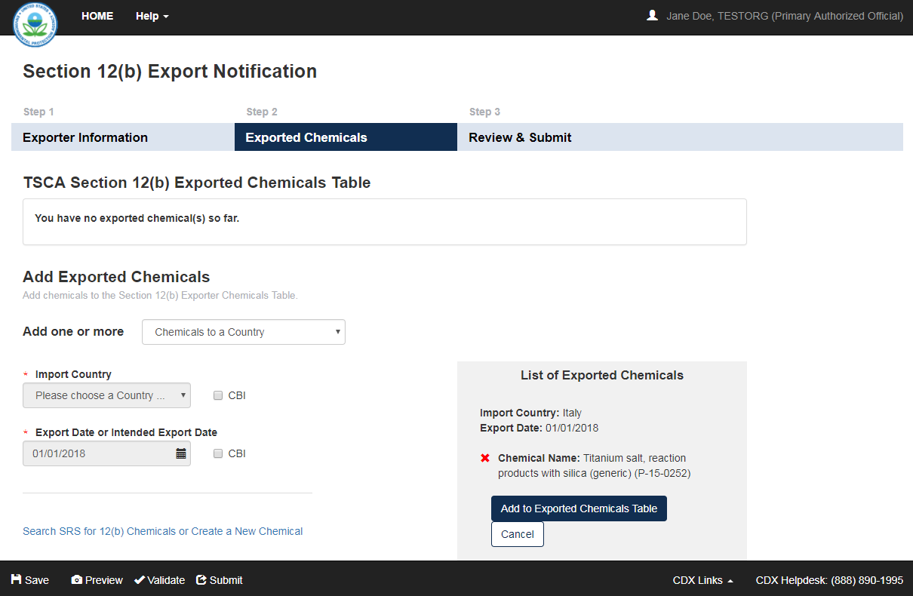

Exhibit 4-6 shows a screen capture of the ‘Exported Chemicals’ screen with ‘Chemicals to a Country’ selected (Scroll 2):
Exhibit 4-6 Exported Chemicals Screen – Chemicals to a Country (Scroll 2)
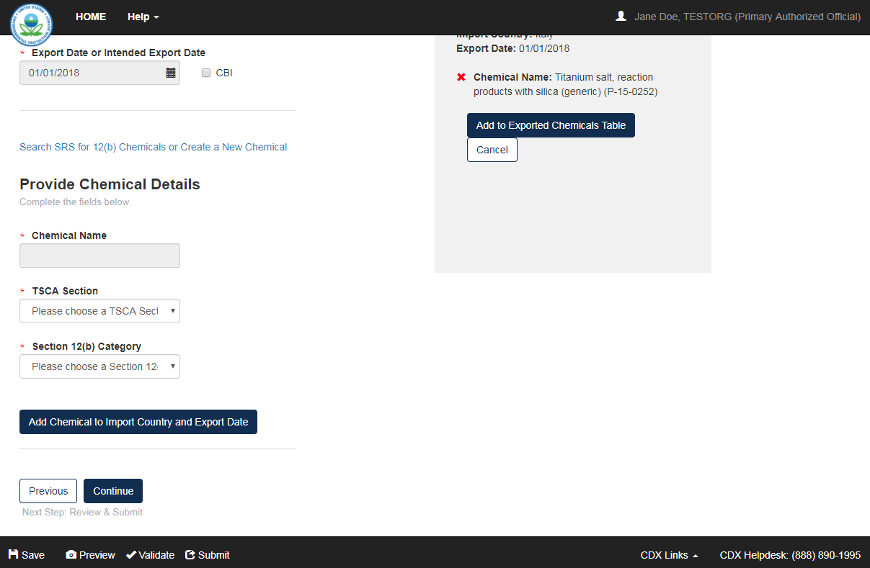

Add Chemical using Substance Registry Services (SRS)
The ‘Search SRS for 12(b) Chemicals or Create New Chemical’ link displays on the ‘Exported Chemicals’ screen, when either ‘Countries to a Chemical’ or ‘Chemicals to a Country’ is selected from the ‘Add one or more’ drop-down menu under the ‘Add Exported Chemicals’ section.
Search SRS for 12(b) Chemicals or Create New Chemical: Click this button to generate the ‘Search Substance Registry Services (SRS)’ pop-up window. You can search for the reported chemical(s) by either the ‘Chemical Name/Synonym’ or the ‘Chemical Abstracts Service Registry Number (CASRN).’ You can also limit the search to certain categories of Section 12(b).
The system allows you to save each chemical by clicking the ‘Add Chemical to Submission’ button located at the bottom of the ‘Search Substance Registry Services (SRS)’ pop-up window. Once you select the specified chemical substance and click the ‘Add Chemical to Submission’ button, the chemical information populates into a generated section titled ‘Provide Chemical Details’ within the ‘Exported Chemicals’ screen.
- Chemical Name/Synonym: Select this radio button to search by the chemical name or synonym.
- CASRN: Select this radio button to search by the Chemical Abstracts Service Registry Number of the chemical; this field accommodates dashes.
- Limit search to: Select the appropriate category in this drop-down menu. Refer to Appendix A for a list of categories that this drop-down menu provides.
- Search SRS: Click the ‘Search SRS’ button to search SRS using the entered search criteria.
- Add Chemical to Submission: Click the ‘Add Chemical to Submission’ button to populate the chemical substance information into the ‘Exported Chemicals’ screen.
- Close: Click the ‘Close’ button to stop the process of adding chemical substance information and return to the ‘Exported Chemicals’ screen.
- Create New Chemical: Click the ‘Create New Chemical’ button to identify a new chemical. Refer to Section 4.3.3.1 for further information on creating a new chemical.
Exhibit 4-7 shows a screen capture of the ‘Search Substance Registry Services (SRS)’ pop-up window:
Exhibit 4-7 Search Substance Registry Services (SRS) Pop-Up Window
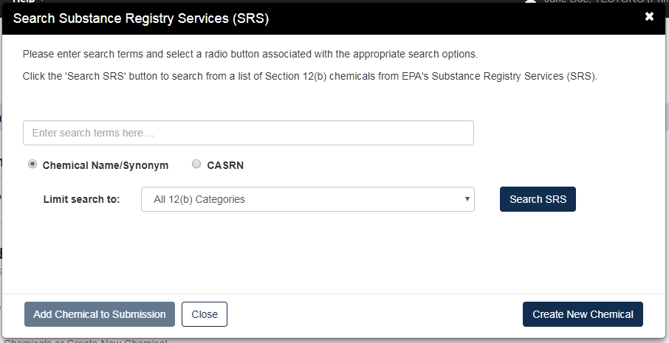
Navigation: Click the ‘Add Chemical to Submission’ button to populate the selected chemical into a generated section titled ‘Provide Chemical Details’ within the ‘Exported Chemicals’ screen. Click the ‘Close’ button to close the window and return to the ‘Exported Chemicals’ screen.

Create New Chemical
The ‘Create New Chemical’ button displays on the ‘Search Substance Registry Services (SRS)’ window to identify new chemicals.
- Create New Chemical: Click the ‘Create New Chemical’ button to generate the ‘Add Chemical to Section 12(b)’ window.
- Chemical Name: Enter the name of the identified chemical substance. This is a required field.
- Identifier: Enter the identifying number associated with the identified chemical substance. This is a required field.
- CASRN: Select this radio button if the identifier is a Chemical Abstracts Service Registry Number.
- PMN No.: Select this radio button if the identifier is a Premanufacture Notice number.
- Accession No.: Select this radio button if the identifier is an Accession number.
- Save New 12(b) Chemical: Click this button to populate the entered chemical information into the chemical fields within the ‘Exported Chemicals’ screen.
- Close: Click the ‘Close’ button to close the ‘Add Chemical to Section 12(b)’ window without saving the entered data.
- Search SRS: Click this button to navigate back to the ‘Search Substance Registry Services (SRS)’ window.
Exhibit 4-8 shows a screen capture of the ‘Add Chemical to Section 12(b)’ window:
Exhibit 4-8 Add Chemical to Section 12(b) Window
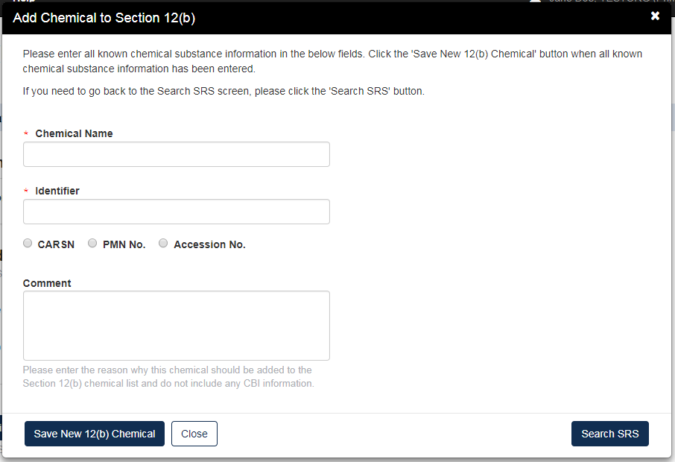

Add Exported Chemicals – Chemicals by Uploading a CSV File
The following information is displayed when ‘Chemicals by Uploading a CSV File’ is selected from the ‘Add one or more’ drop-down menu:
- example: Click this link to download an example of how the .csv file should be arranged.
- The .csv file has a header in row 1.: Check this checkbox if the uploaded .csv file has a header in the first row.
- Browse…: Click this button to search for and select a .csv file to upload.
Exhibit 4-9 shows a screen capture of the ‘Exported Chemicals’ screen with ‘Chemicals by Uploading a CSV File’ selected:
Exhibit 4-9 Exported Chemicals Screen – Chemicals by Uploading a CSV File
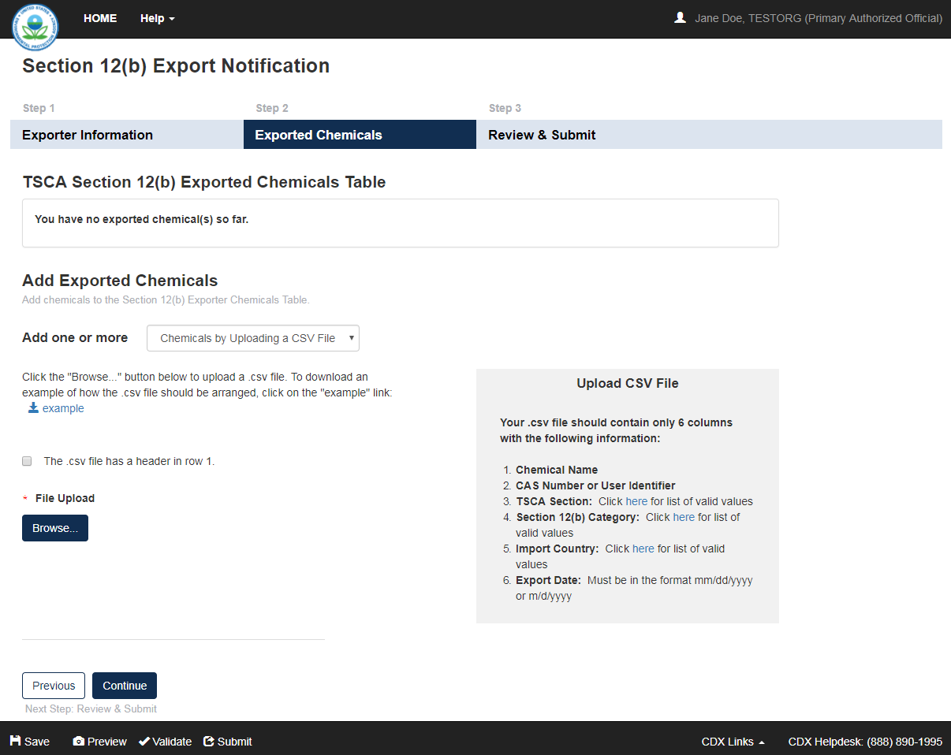

TSCA Section 12(b) Exported Chemicals Table
The ‘TSCA Section 12(b) Exported Chemicals Table’ within the ‘Exported Chemicals’ screen displays the following columns of information:
- Chemical Name: Displays the name of the identified chemical.
- Identifier: Displays the identifying number of the identified chemical.
- TSCA Section: Displays the TSCA Section of the identified chemical.
- Category: Displays the Section 12(b) category for the identified chemical.
- Import Country: Displays the import country for the identified chemical.
- Export Date: Displays the export date for the identified chemical.
- Action: Click the ‘Delete’ icon () to remove the identified chemical from the chemicals table.
Exhibit 4-10 shows a screen capture of the ‘Exported Chemicals’ screen with chemicals populated within the ‘TSCA Section 12(b) Exported Chemicals Table’ (Scroll 1):
Exhibit 4-10 Exported Chemicals Screen (Populated) (Scroll 1)
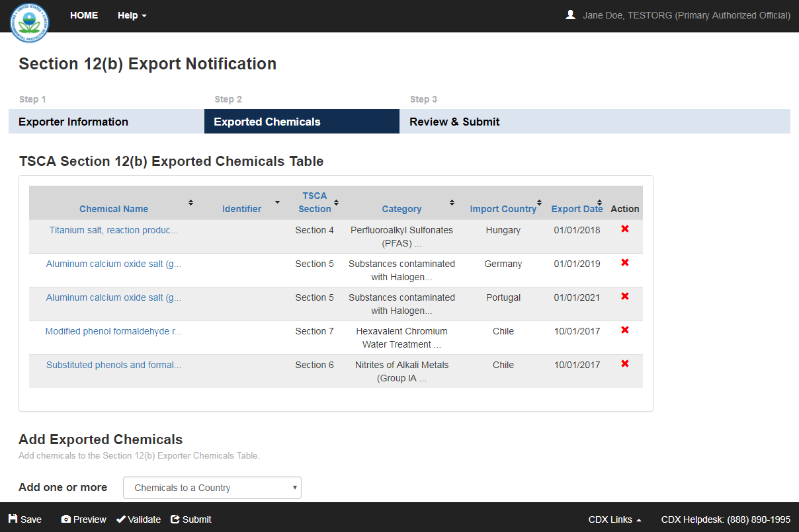

Exhibit 4-11 shows a screen capture of the ‘Exported Chemicals’ screen with chemicals populated within the ‘TSCA Section 12(b) Exported Chemicals Table’ (Scroll 2):
Exhibit 4-11 Exported Chemicals Screen (Populated) (Scroll 2)
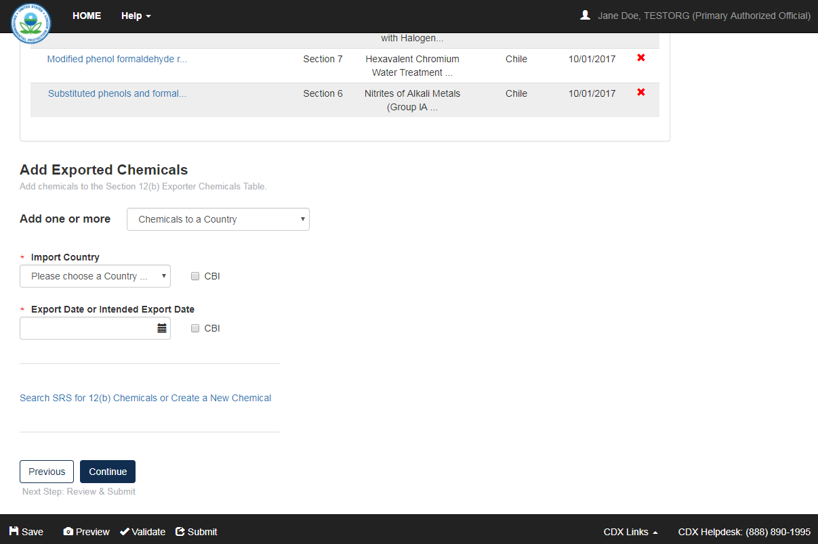
Navigation: If any CBI claims were made, click the ‘Continue’ button to navigate to the ‘Instructions for Substantiating Confidential Business Information (CBI) Claims’ screen. If no CBI claims were made, click the ‘Continue’ button to navigate to the ‘Review Submission Information’ screen.

Instructions for Substantiating Confidential Business Information (CBI) Claims
EPA modified the electronic reporting applications for TSCA submissions to accept CBI substantiations for CBI claims made during the creation of electronic submissions. Other than information exempt from substantiation under TSCA Section 14(c)(2), users who wish to assert CBI claims for data within a submission must substantiate those claims at the time of submission as required by TSCA Section 14(c)(3).
You can access the ‘Instructions for Substantiating Confidential Business Information (CBI) Claims’ screen by claiming information as CBI within a form and clicking the ‘Instructions for Substantiating CBI Claims’ link within the navigation header. The link and screen will not generate until a CBI claim is made within a submission. Information claimed CBI must either be substantiated or claimed exempt pursuant to TSCA Section 14(c)(2) at the time of submission.
To substantiate a CBI claim, upload documentation asserting your claim(s) on the ‘Instructions for Substantiating CBI Claims’ screen within the form. You may also opt-out of substantiation on the ‘Instructions for Substantiating CBI Claims’ screen if, for example, you believe your CBI claim is exempt under TSCA Section 14(c)(2). Common exemption reasons can be found at https://www.epa.gov/tsca-cbi/what-information-include-cbi-substantiations. To opt-out of substantiation at the time of submission, all CBI claims within a submission must be exempt.
- Substantiation Opt-Out: Certain data claimed CBI may be exempt from substantiation at the time of submission. If all information contained within the submission was previously substantiated or you believe it to be exempt pursuant to TSCA Section 14(c)(2), check the ‘Substantiation Opt-Out’ checkbox to generate the ‘Substantiation Opt-Out Reason’ text box and hide the ‘File Upload’ button. If a substantiation document is uploaded, checking the ‘Substantiation Opt-Out’ checkbox clears the uploaded attachments. Either a substantiation opt-out reason or CBI substantiation document must be provided if a CBI claim is made in a submission.
- Substantiation Opt-Out Reason: Enter information explaining why you believe your CBI claim(s) to be exempt from substantiation. Either a substantiation opt-out reason within the text box or CBI substantiation document must be provided if a CBI claim is made in a submission.
- File Upload: Click the ‘File Upload’ button to search your local machine and upload a file that contains your CBI substantiation. To overwrite an uploaded file, click the ‘File Upload’ button again to search for and upload a new file. If the ‘Substantiation Opt-Out’ checkbox is checked after you upload a file, the application will delete the uploaded file. Either a substantiation opt-out reason or CBI substantiation document must be provided if a CBI claim is made in a submission.
- Check if the Substantiation Document is CBI: If the uploaded substantiation document contains CBI, check the ‘Check if the Substantiation Document is CBI’ checkbox to generate the ‘Sanitized Upload’ button. A sanitized CBI substantiation document must be provided if the original substantiation document is claimed CBI.
- Sanitized Upload: Click the ‘Sanitized Upload’ button to search your local machine and upload a file that contains your sanitized CBI substantiation. To overwrite an uploaded file, click the ‘Sanitized Upload’ button again to search for and upload a new file. If the ‘Substantiation Opt-Out’ checkbox is checked after you upload a file, the application will delete the uploaded sanitized file. A substantiation attachment must be provided if the original substantiation document is claimed CBI.
If you are unfamiliar with substantiating CBI claims or require assistance preparing substantiation documents, EPA offers a link to templates and other information for substantiating CBI claims on the ‘Instructions for Substantiating Confidential Business Information (CBI) Claims’ screen. It is suggested that you right-click the link and open in a new tab or new window so you do not leave your submission as this may affect your saved data.

The following exhibits, Exhibit 4-12, Exhibit 4-13, Exhibit 4-14, and Exhibit 4-15, show screen captures of the ‘Instructions for Substantiating Confidential Business Information (CBI) Claims’ screen:
Exhibit 4-12 Instructions for Substantiating CBI Claims Screen (Scroll 1)
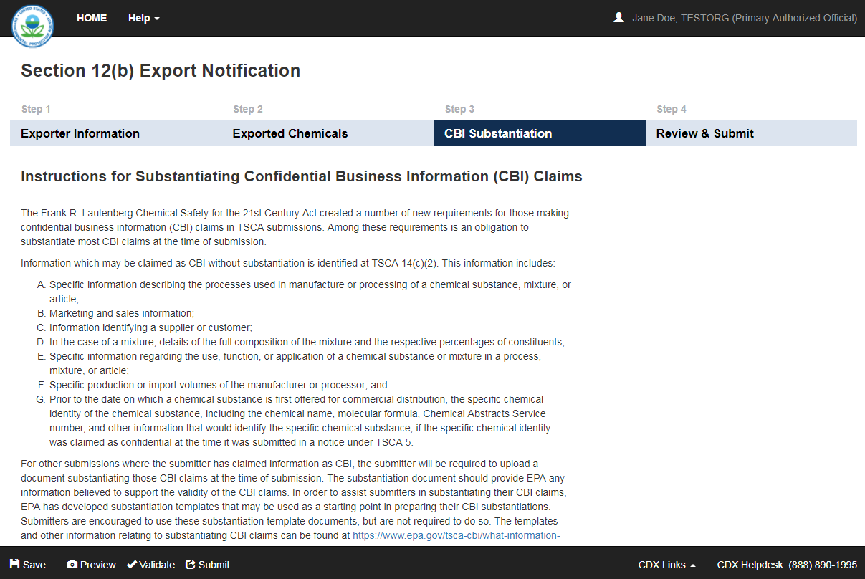
Exhibit 4-13 Instructions for Substantiating CBI Claims Screen (Scroll 2)
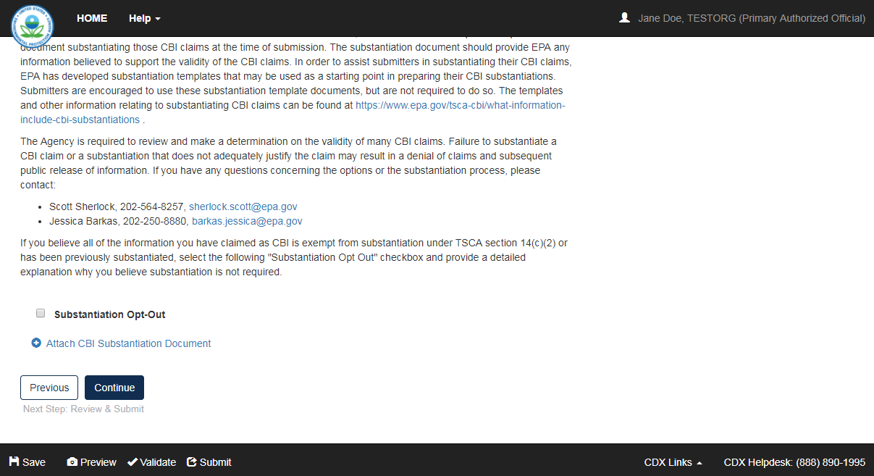
Exhibit 4-14 Instructions for Substantiating CBI Claims Screen (Scroll 3)
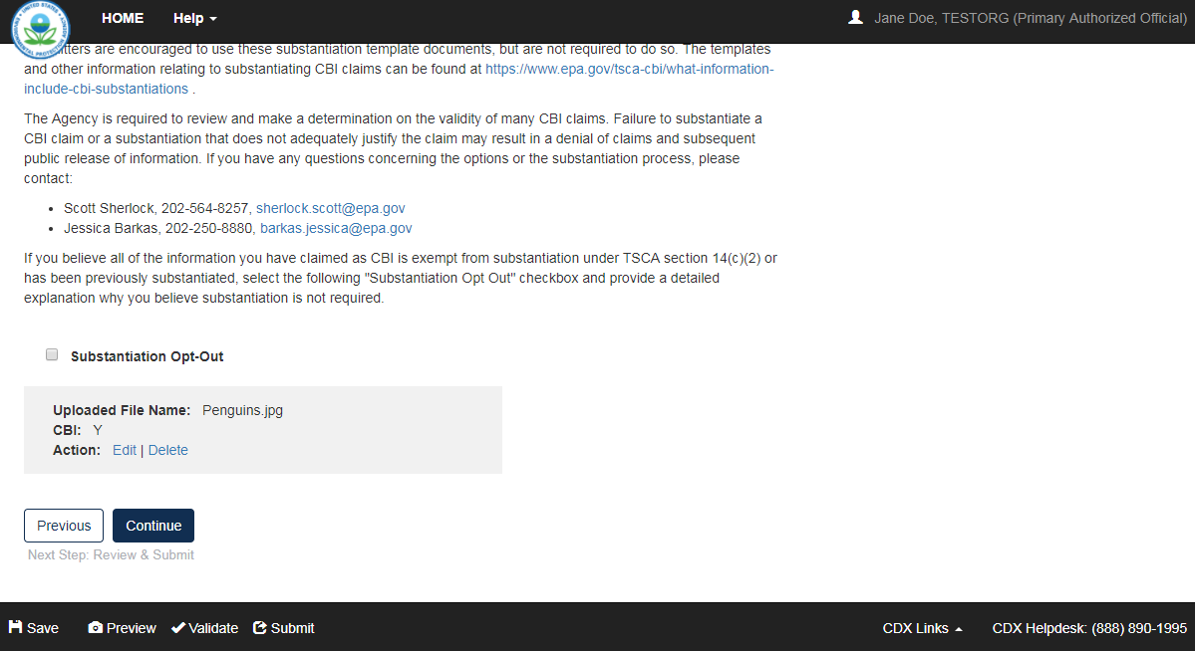
Exhibit 4-15 Instructions for Substantiating CBI Claims Screen (Scroll 4)
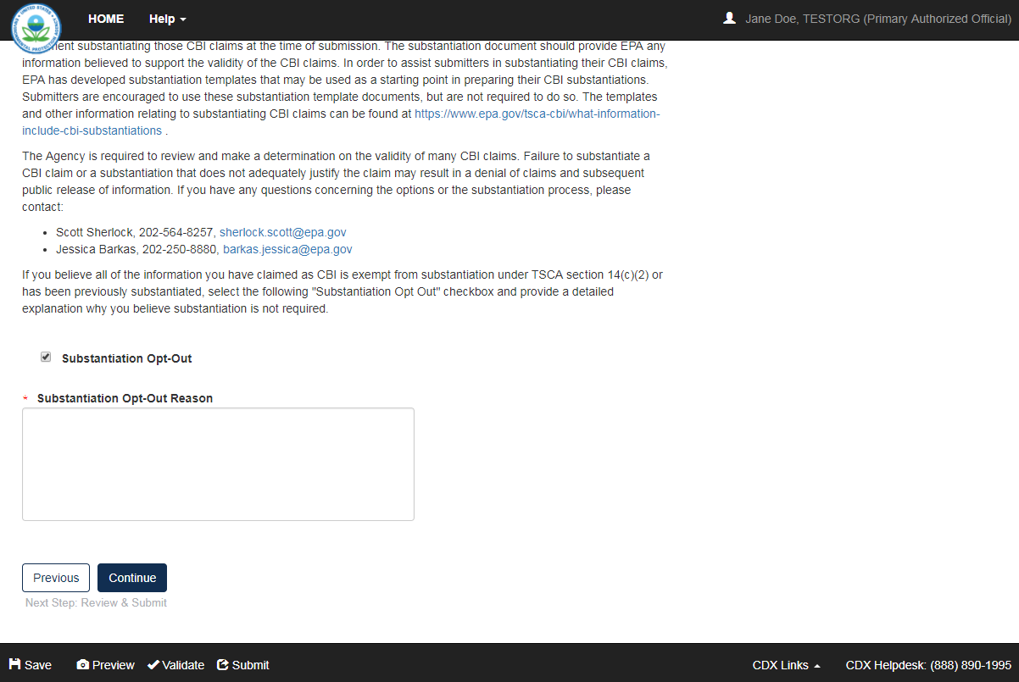
Navigation: Click the ‘Continue’ button to navigate to the ‘Review Submission Information’ screen. You can also access this screen by clicking the ‘Review & Submit’ link within the navigation header.

Review Submission Information
You can navigate to the ‘Review Submission Information’ screen by clicking the ‘Continue’ button from either the ‘Instructions for Substantiating Confidential Business Information (CBI) Claims’ screen if any CBI claims were made, or the ‘Exported Chemicals’ screen if no CBI claims were made. You can also access this screen by clicking the ‘Review & Submit’ link within the navigation header.
This screen displays a summary of information that was entered throughout this form, including ‘Submitter Information,’ ‘Exporter Information,’ and a ‘List of Exported Chemicals.’
The following information is displayed within the ‘Review Submission Information’ screen:
- Submitter Name: Displays the name of the submitter.
- Phone Number: Displays the phone number of the submitter.
- Email Address: Displays the email address of the submitter.
- Company Name: Displays the company name of the exporter.
- Company Address: Displays the company address of the exporter.
- List of Exported Chemicals: Displays a duplicate of the ‘TSCA Section 12(b) Exported Chemicals Table,’ as shown within the ‘Exported Chemicals’ screen.
Exhibit 4-16 shows a screen capture of the ‘Review Submission Information’ screen:
Exhibit 4-16 Review Submission Information Screen
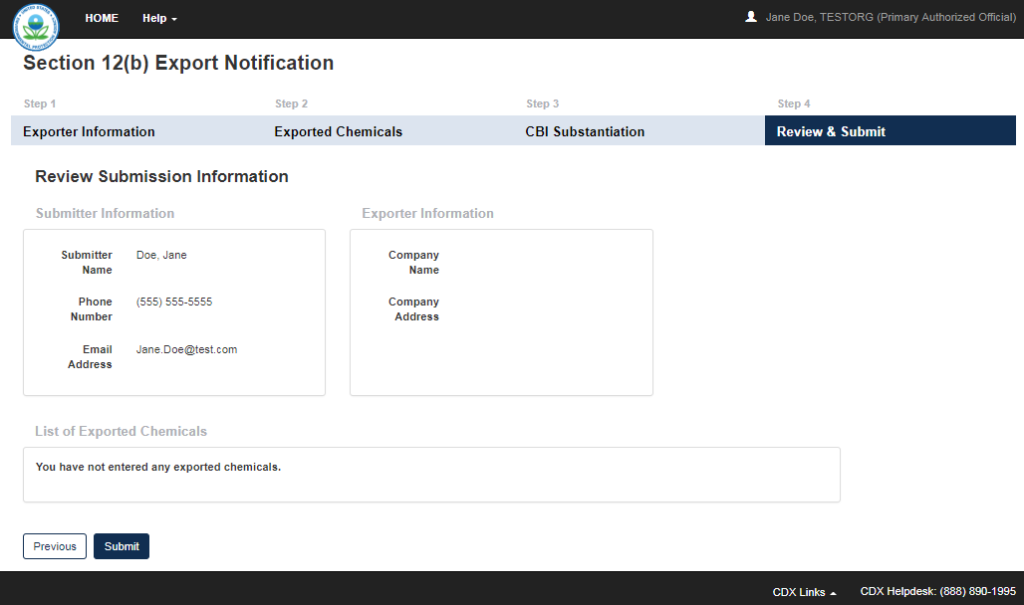
Navigation: Click the ‘Submit’ button to begin the submission process. Refer to Section 7 for further information on the submission process.

Preview
The system provides the option to preview a form during the submission process. Click the ‘Preview’ link, located within the bottom action bar, to preview a PDF file of the regular or sanitized version of the form. After you choose either the ‘Regular’ or ‘Sanitized’ PDF, the application generates a watermarked PDF draft of the form.
The watermark reads ‘Not For Submission’ and displays across each page in the background. The form preview displays the entire form in a printable format. The preview functionality provides the flexibility to track the status of the form and see the entire form in a single viewpoint.

Exhibit 5-1 shows a screen capture for the ‘Preview Section 12(b) Export Notification PDF’ form:
Exhibit 5-1 Preview Section 12(b) Export Notification PDF
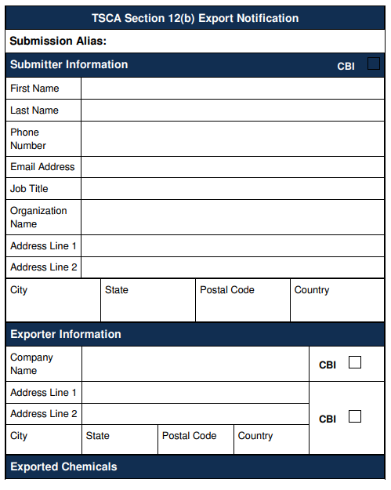

Validate
You can click the ‘Validate’ link located within the bottom action bar at any stage of completing a Section 12(b) form. The ‘Section 12(b) Export Notification Validation’ window displays when you click the ‘Validate’ link. Disable the pop-up blocker within your internet browser so that the ‘Section 12(b) Export Notification Validation’ window displays correctly. This validation window displays a report of all validation errors. During the validation process, the application validates each screen of the form to find missing and invalid data.
Validation Errors: Errors can be fixed by clicking the error link. The links will display the Screen Title Name (e.g., Exporter Information) and the associated error. After you click a link, the main application screen will display the section where the error occurred so you can easily fix the error. Once you have fixed the error(s), click the ‘Validate’ link again to refresh the ‘Section 12(b) Export Notification Validation’ window. If the information you fixed passes validation, the error will be removed from the validation window. You must fix all validation errors to submit the form to CDX successfully.
Click the ‘X’ button located at the upper right-hand corner of the window to close the ‘Section 12(b) Export Notification Validation’ window.
Exhibit 6-1 shows a screen capture of the ‘Section 12(b) Export Notification Validation’ window:
Exhibit 6-1 Section 12(b) Export Notification Validation Window
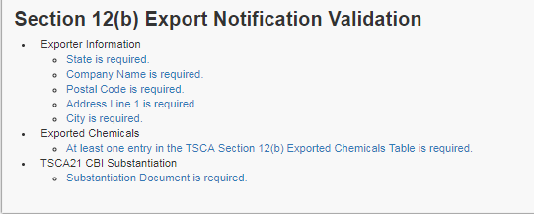

Submit to EPA via CDX
As a Primary AO, you have the ability to sign and submit a Section 12(b) Export Notification form to EPA via CDX. You can save your form at any point during the data entry process. Any assigned Supports for your form cannot submit the Section 12(b) form. The save functionality will allow you to return to that same form at any point in the future.
Once you complete all required information and correct all items failing validation, the system will allow the form to be successfully submitted.

TSCA Certification
Click the ‘Submit’ button from the ‘Review Submission Information’ screen to access the ‘TSCA Certification’ screen.
Exhibit 7-1 shows a screen capture of the ‘TSCA Certification’ screen:
Exhibit 7-1 TSCA Certification Screen
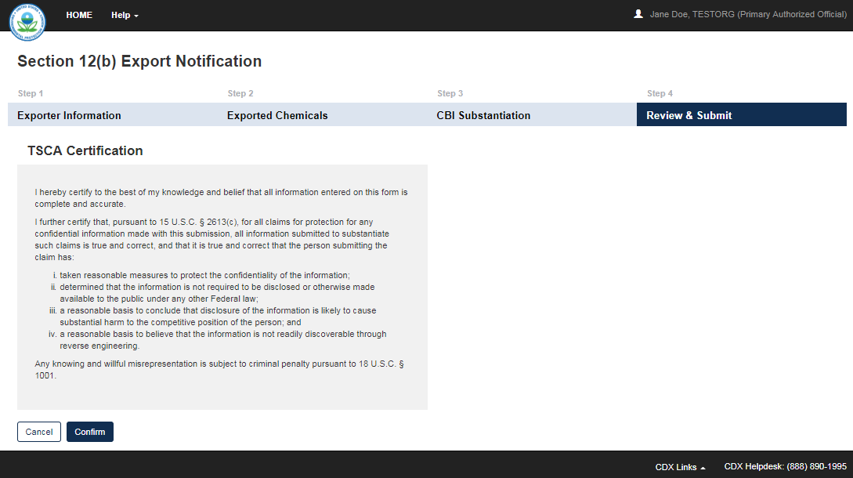
Navigation: Click the ‘Confirm’ button to certify regarding the contents of the form and navigate to the ‘Submission Validation’ screen.

Submission Validation
Click the ‘Confirm’ button from the ‘TSCA Certification’ screen to access the ‘Submission Validation’ screen. If no validation errors are found, you will be able to continue with the submission process. If any validation errors are found, you will have to correct those errors before continuing with submission. Refer to Section 6 for further information on the validation process.

Exhibit 7-2 shows a screen capture of the ‘Submission Validation’ screen:
Exhibit 7-2 Submission Validation Screen
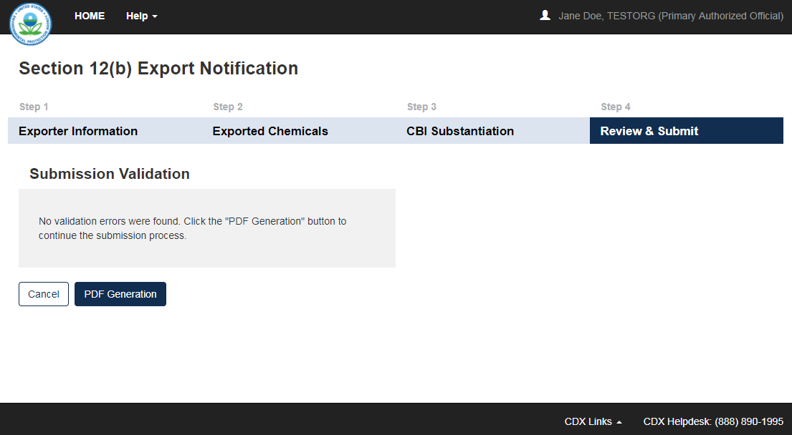
Navigation: Click the ‘PDF Generation’ button to continue to the ‘PDF Generation’ screen. A pop-up window will display informing you that a regular and sanitized PDF will be made. Click the ‘OK’ button to navigate to the ‘PDF Generation’ screen.

PDF Generation
Click the ‘PDF Generation’ button from the ‘Submission Validation’ screen to access the ‘PDF Generation’ screen.

Exhibit 7-3 shows a screen capture of the ‘PDF Generation’ screen:
Exhibit 7-3 PDF Generation Screen
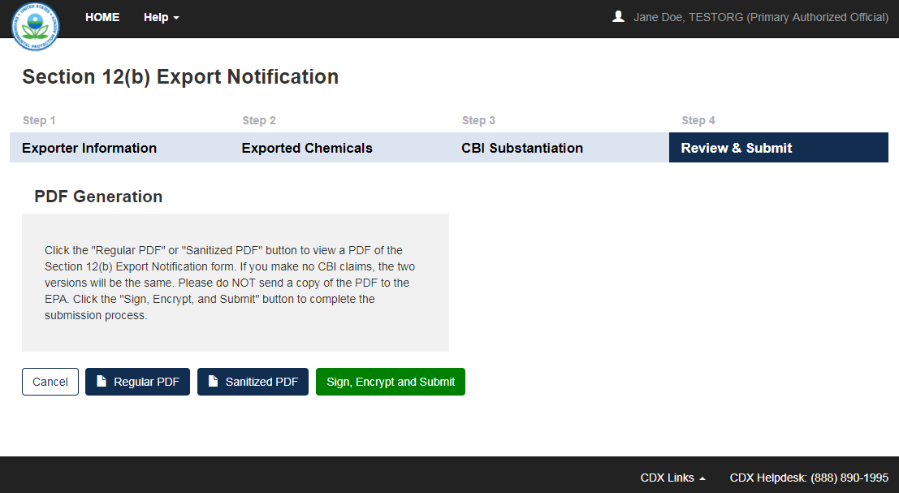
Navigation: Click the ‘Regular PDF’ button to generate a regular version of the Section 12(b) PDF. Click the ‘Sanitized PDF’ button to generate a sanitized version of the Section 12(b) PDF. Click the ‘Sign, Encrypt and Submit’ button to begin the CROMERR certification process.

CROMERR Certification
Click the ‘Sign, Encrypt and Submit’ button from the ‘PDF Generation’ screen to generate the ‘CROMERR Certification’ window.
Exhibit 7-4 shows a screen capture of the ‘CROMERR Certification’ window:
Exhibit 7-4 CROMERR Certification Window
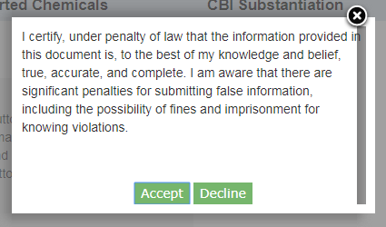
Navigation: Click the ‘Accept’ button to agree to the certification statement and generate the ‘eSignature Widget.’

eSignature Widget
Click the ‘Accept’ button on the ‘CROMERR Certification’ window to accept the certification statement and generate the ‘eSignature Widget.’ The ‘eSignature Widget’ will prompt for the CDX login password and an answer to one of your security questions. Click the ‘Sign’ button on the ‘eSignature Widget’ to navigate to the ‘Submission Finished’ screen.
Exhibit 7-5 shows a screen capture of the ‘eSignature Widget’ window:
Exhibit 7-5 eSignature Widget Window
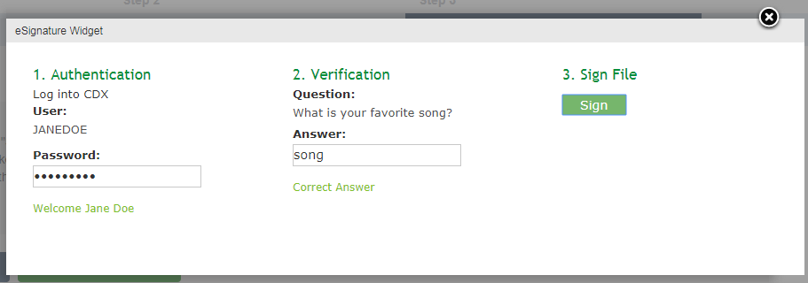
Navigation: Click the ‘Sign’ button on the ‘eSignature Widget’ to navigate to the ‘Submission Finished’ screen.

Submission Finished
Click the ‘Sign’ button on the ‘eSignature Widget’ to navigate to the ‘Submission Finished’ screen.

Exhibit 7-6 shows a screen capture of the ‘Submission Finished’ screen:
Exhibit 7-6 Submission Finished Screen
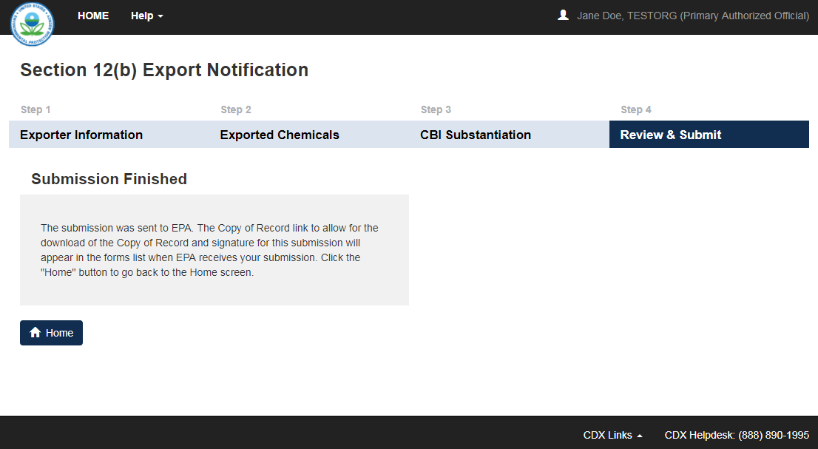
Navigation: Click the ‘Home’ button to navigate back to the Section 12(b) ‘Home’ screen.

Download Copy of Record
To download a Copy of Record, navigate to the Section 12(b) ‘Home’ screen and locate a form alias for which you have successfully completed a submission and which has a status of ‘Completed.’
Click the ‘Copy of Record’ icon () from the ‘Submission History’ section of the Section 12(b) ‘Home’ screen to navigate to the ‘Enter Passphrase’ screen to login into CDX. The ‘Enter Passphrase’ screen requires you to enter the passphrase originally associated with the form. If the passphrase is entered correctly, you will view the ‘CROMERR Certification’ message where you can acknowledge the certification. Once you accept the certification, the ‘eSignature Widget’ displays where you provide the correct CDX password, answer the 20-5-1 question, and click the ‘Sign’ button. The copy of record .pdf files generate on the current page.
Exhibit 8-1 shows a screen capture of the ‘Download Copy of Record’ screen:
Exhibit 8-1 Download Copy of Record Screen
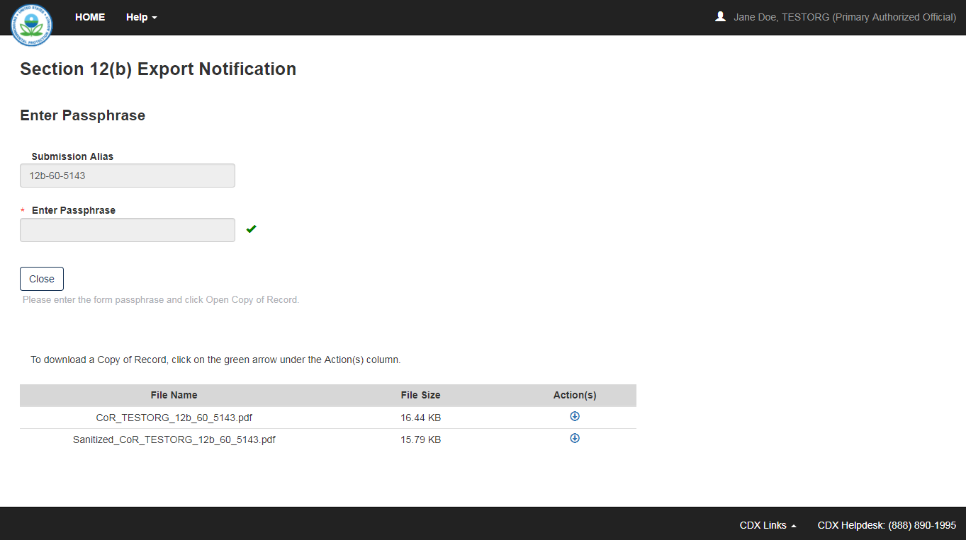
Navigation: The screen displays the ‘File Name,’ ‘File Size,’ and ‘Action’ columns in a table format. Click the ‘Copy of Record’ icon () to automatically download the .pdf file consisting of the individual regular or sanitized PDF.

Create an Amendment
To amend a submitted Section 12(b) form, navigate to the Section 12(b) ‘Home’ screen and locate a submission that you previously submitted with a status of ‘Completed’ within the ‘Submission History’ table. In addition to displaying a status of ‘Completed’ under the ‘Status’ column, the ‘Lock’ icon () will be displayed under the ‘Action’ column. Click the ‘Lock’ icon () under the ‘Action’ column to start an amendment.
A pop-up window will appear after clicking the ‘Lock’ icon (), confirming that you wish to begin the amendment process. After you click the ‘OK’ button, you will be taken to the ‘Enter Passphrase’ screen. You must enter the passphrase originally associated with the submission to start the amendment process. After you enter the passphrase and click the ‘Next’ button, you will be taken to the first screen in the specific form. Refer to Section 3.5 for further instructions on the ‘Enter Passphrase’ screen.
After a submission has been unlocked, the Section 12(b) ‘Submission History’ screen will display a status of ‘In Progress’ under the ‘Status’ column, and the ‘Lock’ icon () will no longer display under the ‘Action’ column; however, you will not see these changes until you navigate back to the Section 12(b) ‘Submission History’ screen. The only way to lock the submission again is by resubmitting it to EPA.
- Refer to Section 4 through Section 4.5 for instructions on editing a revised Section 12(b) Export Notification form.

Appendix A
The following is a list of the options available for the drop-down menu for a ‘Section 12(b) Category’:
- All 12(b) Categories
- Perfluoroalkyl Sulfonates (PFAS)
- Polychlorinated Biphenyls (PCBs)
- Polybrominated Diphenyl Ethers
- Substances contaminated with Halogenated Dibenzodioxins (HDDs)/ Halogenated Dibenzofurans (HDFs)
- Hexavalent Chromium Water Treatment
- Long Chain Perfluoroalkyl Carboxylate
- Nitrites of Alkali Metals (Group IA elements)
- N/A

