(Displayed Only to Wireless Auction Applicants Seeking a Small Business Bidding Credit Where Preceding 5 Years of Gross Revenues Must Be Disclosed)
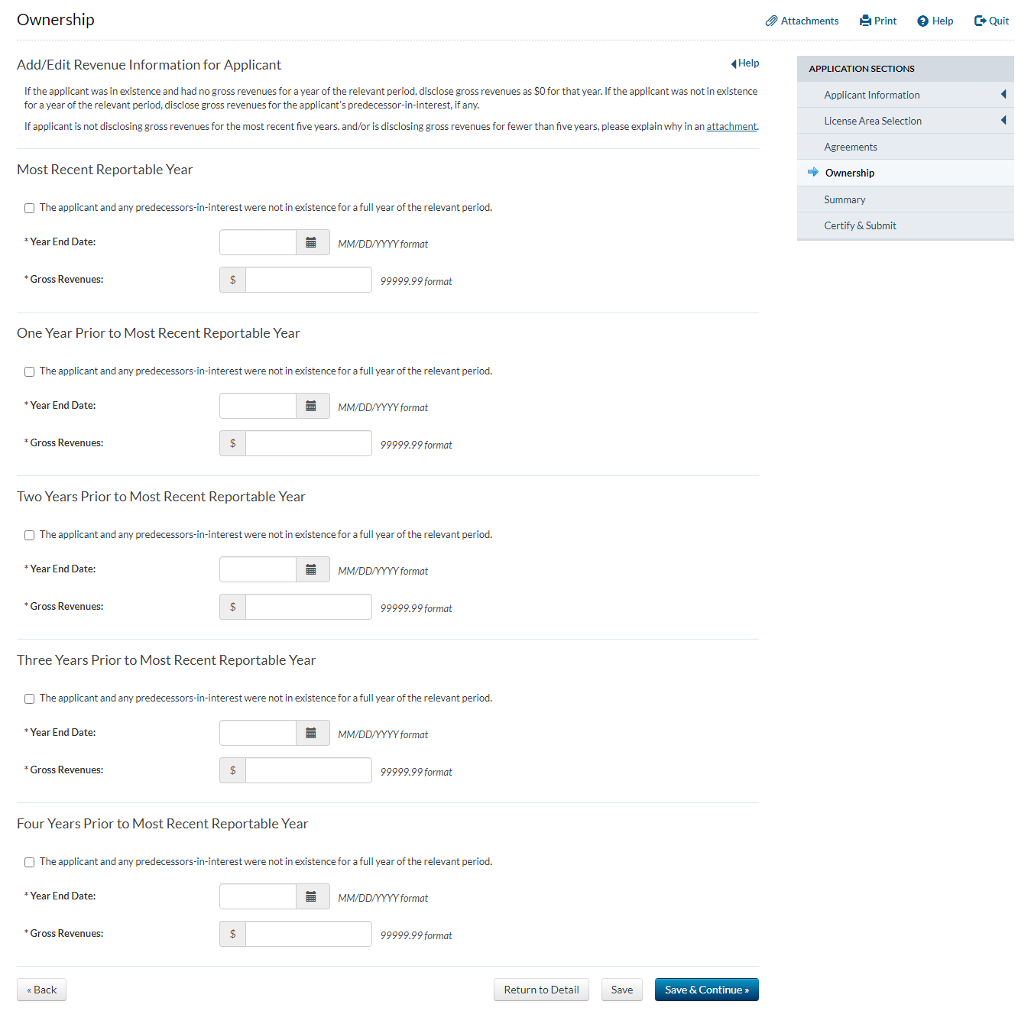

(Displayed Only to Wireless Auction Applicants Seeking a Small Business Bidding Credit Where Preceding 5 Years of Gross Revenues Must Be Disclosed)
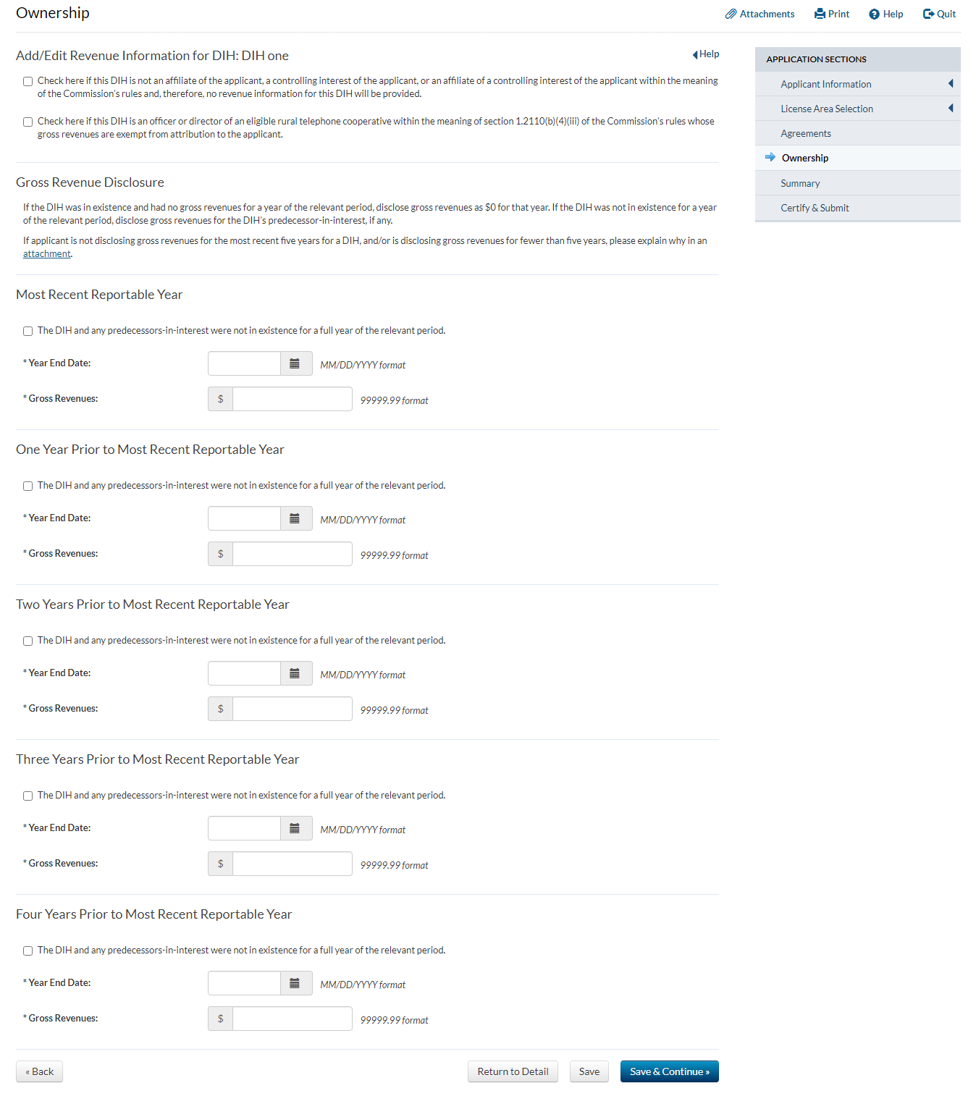
(Displayed Only to Wireless Auction Applicants Seeking a Small Business Bidding Credit Where Preceding 5 Years of Gross Revenues Must Be Disclosed)
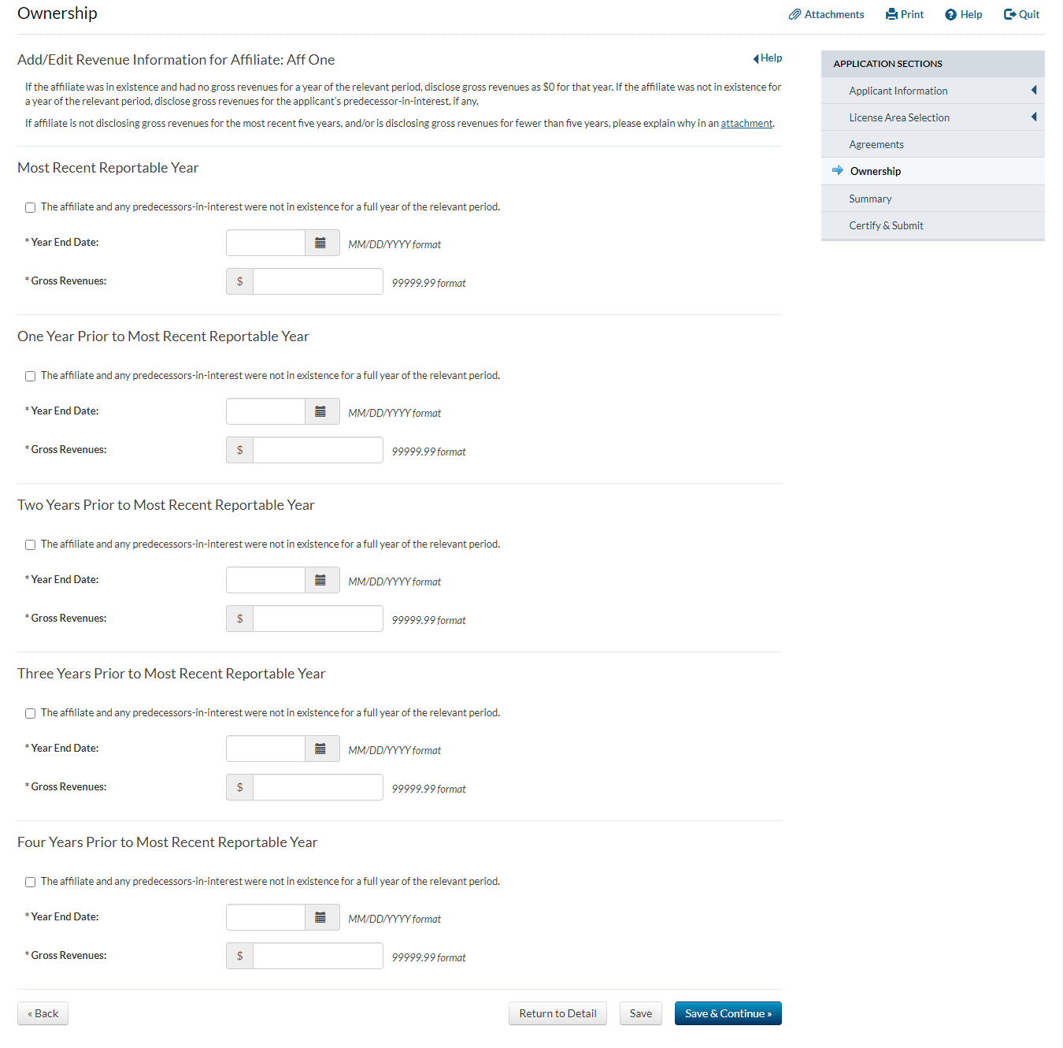
(Displayed Only to Wireless Auction Applicants Seeking a Small Business Bidding Credit Where Preceding 5 Years of Gross Revenues Must Be Disclosed)
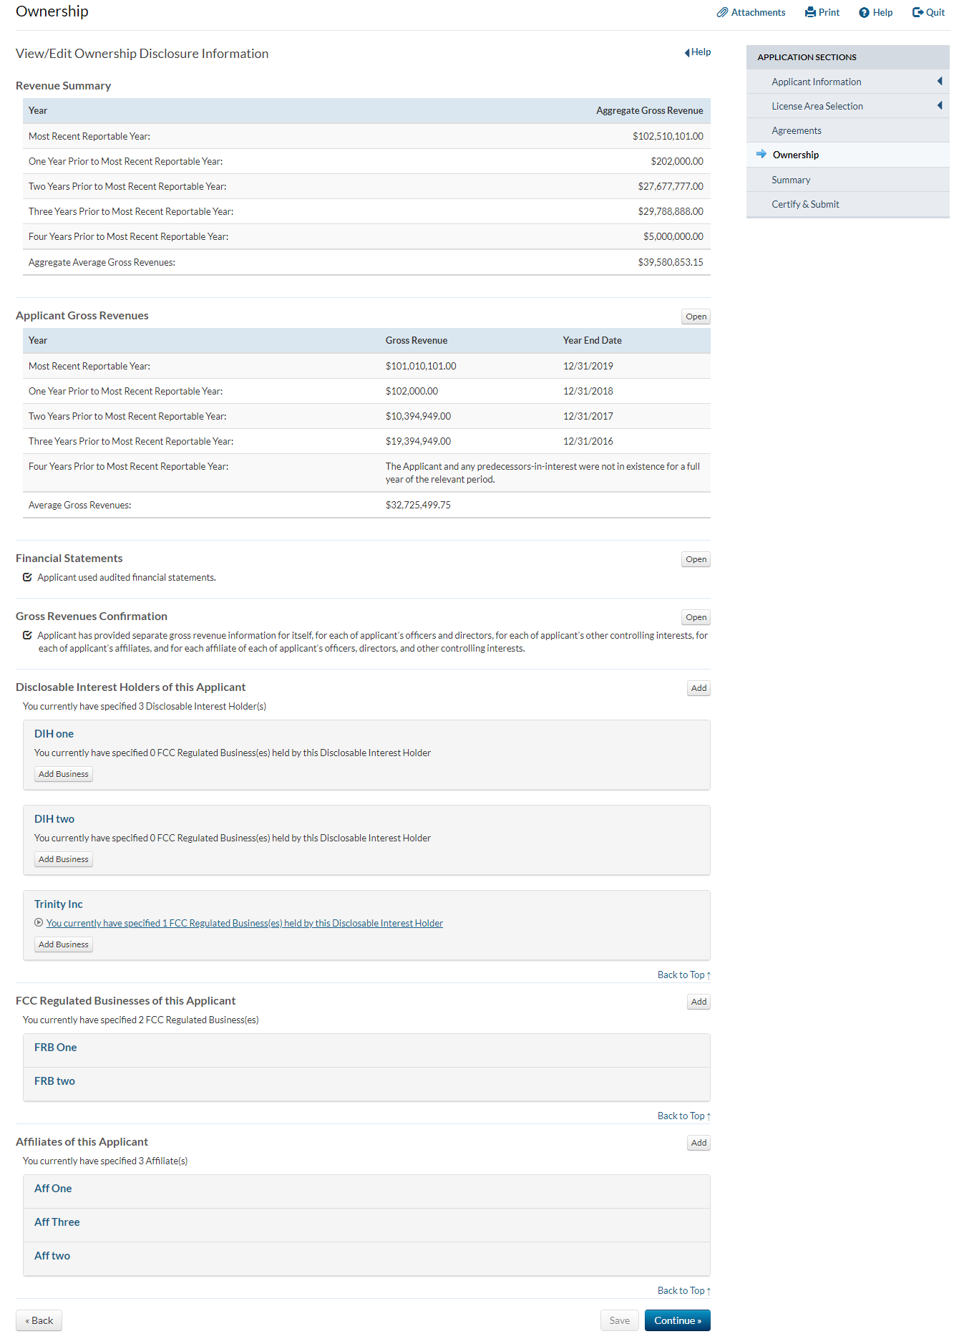
(Displayed Only to Wireless Auction Applicants Seeking a Small Business Bidding Credit Where Preceding 5 Years of Gross Revenues Must Be Disclosed)

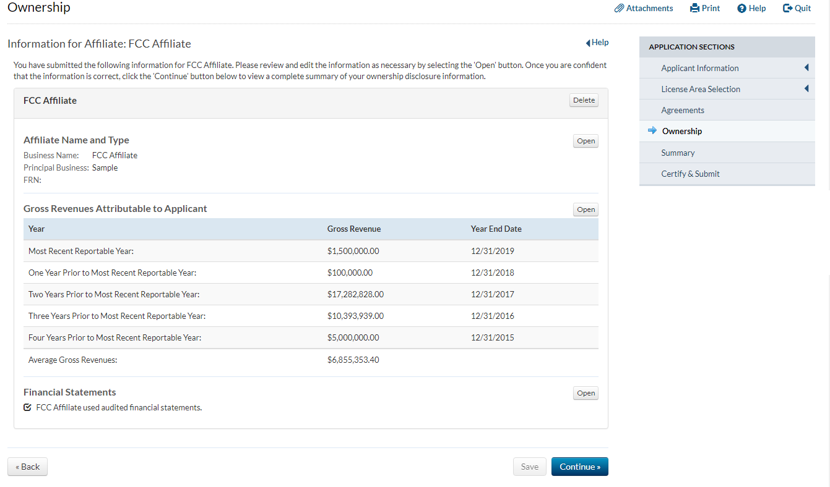

(Displayed Only to Wireless Auction Applicants Seeking a Small Business Bidding Credit Where Preceding 5 Years of Gross Revenues Must Be Disclosed)
