Pest Reporting Form 1: Citrus Disease
https://www.aphis.usda.gov/aphis/ourfocus/planthealth/plant-pest-and-disease-programs/pests-and-diseases/citrus/report-it

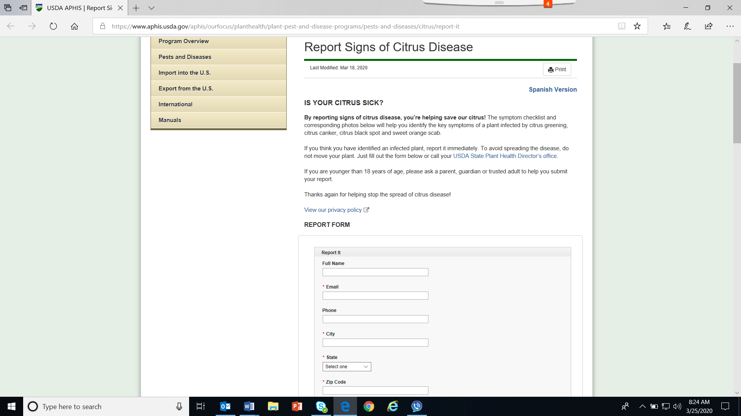
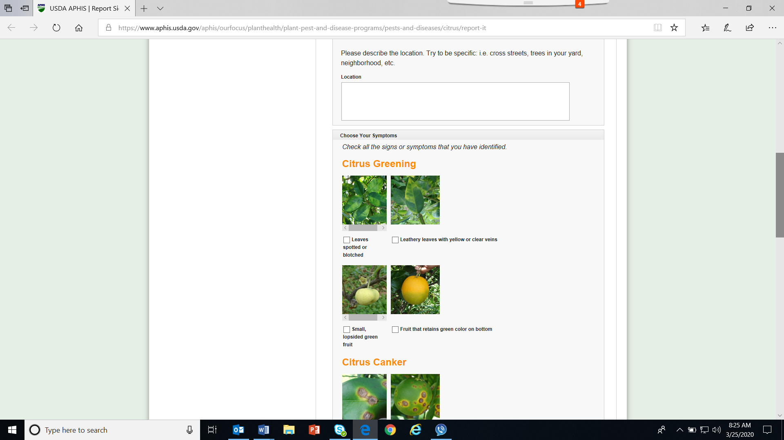
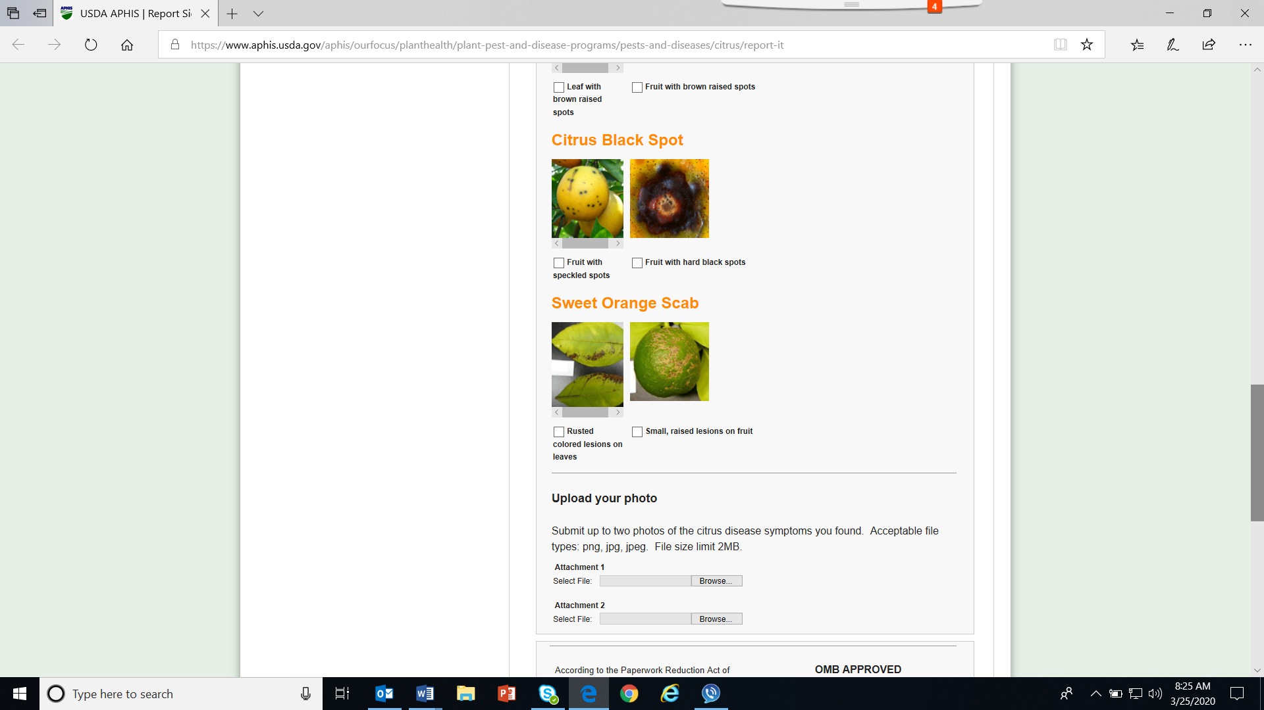
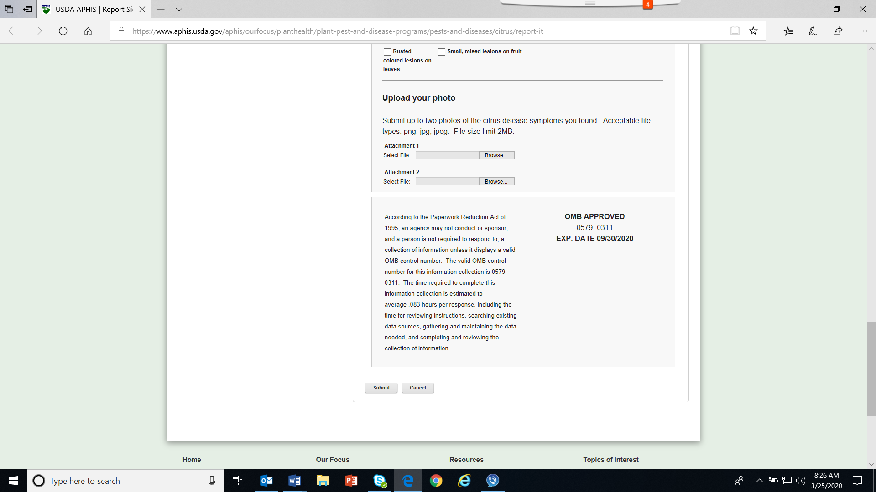

Pest Reporting Form 2: Asian Longhorned Beetle
https://www.aphis.usda.gov/aphis/resources/pests-diseases/asian-longhorned-beetle/report-it

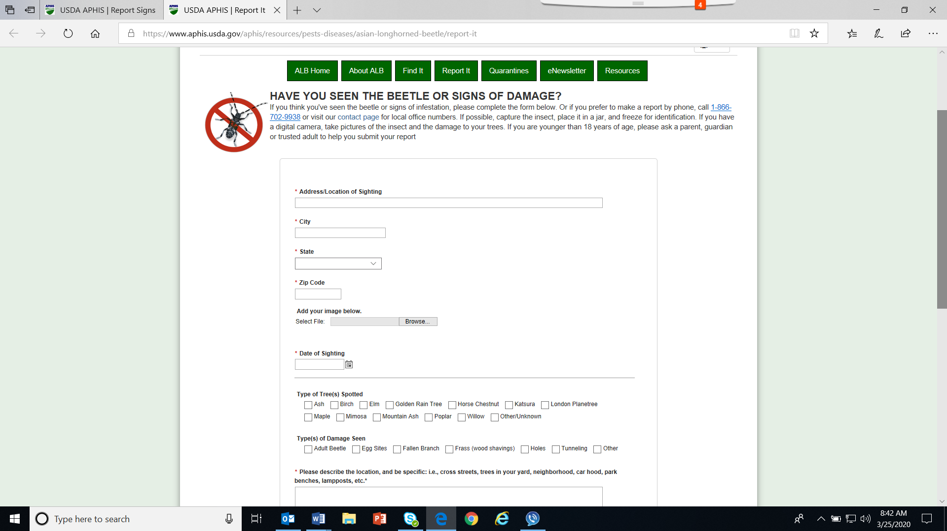
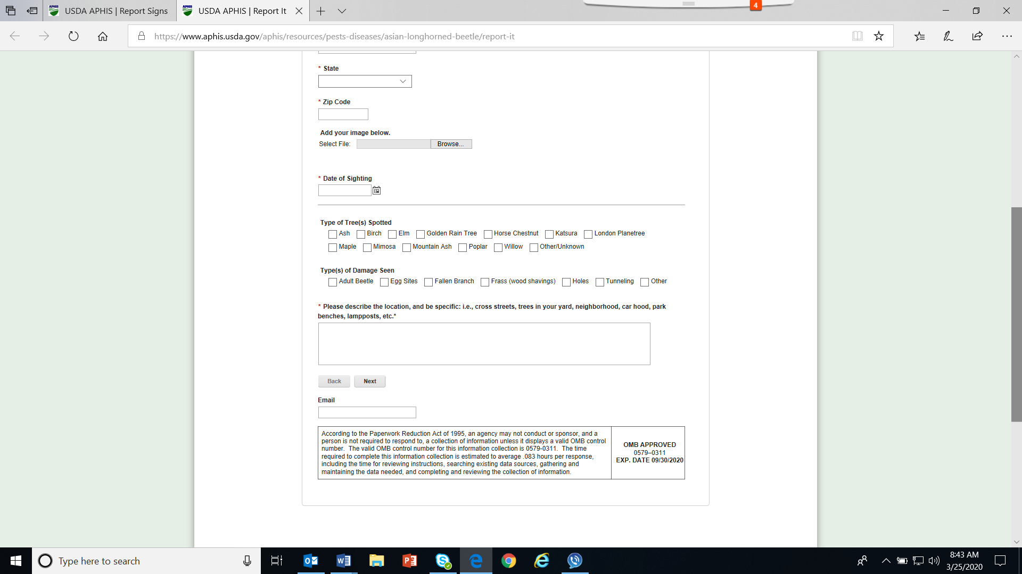

Pest Reporting Form 3: Emerald Ash Borer
https://www.aphis.usda.gov/aphis/ourfocus/planthealth/plant-pest-and-disease-programs/pests-and-diseases/emerald-ash-borer/report-it

