# Questionnaire for Satisfaction

*Please Note: The questionnaire will be electronic with word labels on either end of 7 radio buttons. See image below for an idea of what the final format will look like.*

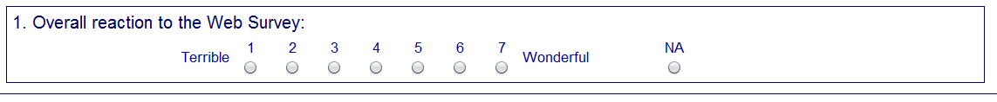

|  |
| --- |
| 1. Overall experience with the online form   Unpleasant to Pleasant |
| 1. The screens on the online form are visually pleasing   Never to Always |
| 1. The screens on the online form look professional   Never to Always |
| 1. Characters (words/text) on the screen   Barely legible to Very legible |
| 1. The questions in the online form follow a logical sequence   Never to Always |
| 1. Words used in the online form questions and answers   Hard to understand to Easy to understand |
| 1. Coming up with answers to the questions in the online form   Never bothered me to Always bothered me |
| 1. Instructions for correcting errors   Confusing to Clear |
| 1. Entering your answers into the online form   Difficult to Easy |
| 1. You knew what to do if you needed help answering the questions in the online form   Never to Always |
| 11. Additional Comments__________________________________________________________________ |