SUPPORTING STATEMENT
U.S. Department of Commerce
National Oceanic & Atmospheric Administration
Alaska Rockfish Program: Permits and Reports
OMB Control No. 0648-0545

Abstract

This request is for extension and revision of an existing information collection.

The collection is revised due to an associated rule (RIN 0648-BJ73) to implement Amendment 111 to the Fishery Management Plan for Groundfish of the Gulf of Alaska and a regulatory amendment to reauthorize the Central Gulf of Alaska Rockfish Program (Rockfish Program). The rule also effects information collection requirements approved under OMB Control No. 0648-0678, Alaska Council Cooperative Annual Reports. Concurrent with this request to extend and revise 0648-0545, the National Marine Fisheries Service (NMFS) is submitting a separate request to revise 0648-0678.

This information collection contains requirements for the Rockfish Program and is necessary for NMFS to effectively administer and monitor compliance with the management provisions of the Rockfish Program. The Rockfish Program is a catch share program for the rockfish fisheries and other related groundfish species conducted in Federal waters near Kodiak, Alaska, primarily by trawl vessels, and to a lesser extent by longline vessels.

The rule would retain the conservation, management, safety, and economic gains realized under the existing Rockfish Program and make minor revisions to improve administration of the Rockfish Program. This rule is necessary to continue the conservation benefits, improve efficiency, and provide economic benefits of the Rockfish Program that will expire on December 31, 2021, without this proposed rule.

This information collection is revised to remove the requirement for a rockfish cooperative to submit a fishing plan with its annual application for cooperative quota (CQ) and to reduce the submission time for a cooperative check-in report from at least 48 hours to at least 24 hours before the vessel begins a fishing trip to fish under a CQ permit. These changes are necessary to remove unnecessary reporting requirements and to reduce the reporting burden for all directly regulated entities including small entities.

Justification
- Explain the circumstances that make the collection of information necessary. Identify any legal or administrative requirements that necessitate the collection. Attach a copy of the appropriate section of each statute and regulation mandating or authorizing the collection of information.

NMFS manages the groundfish fisheries in the Exclusive Economic Zone off the coast of Alaska under the Fishery Management Plan for Groundfish of the Bering Sea and Aleutian Islands Management Area, the Fishery Management Plan for Groundfish of the Gulf of Alaska (GOA FMP), and the Northern Pacific Halibut Act of 1982, 16 U.S.C. 773c. The fishery management plans were prepared by the North Pacific Fishery Management Council (Council). The Magnuson-Stevens Fishery Conservation and Management Act, 16 U.S.C. 1801 et seq. (Magnuson-Stevens Act) authorizes the Council to prepare and amend fishery management plans for any fishery in waters under its jurisdiction.

The Rockfish Program is a catch share program for the rockfish fisheries and other related groundfish species conducted in Federal waters near Kodiak, Alaska, primarily by trawl vessels, and to a lesser extent by longline vessels. From 2007 to 2011, these rockfish fisheries were managed under the Rockfish Pilot Program. The Council then developed and adopted the Rockfish Program to replace the Rockfish Pilot Program, which was scheduled to expire December 31, 2011. NMFS published the final rule to implement Amendment 88 to the GOA FMP on December 27, 2011. Fishing under the Rockfish Program began in 2012, and the program was authorized for 10 years, until December 31, 2021.

The Council adopted Amendment 111 to the GOA FMP in January 2020. This information collection is being revised due to the rule by NMFS to implement Amendment 111 and a regulatory amendment to reauthorize Rockfish Program (RIN 0678-BJ73). This rule would retain the conservation, management, safety, and economic gains realized under the existing Rockfish Program and make minor revisions to improve administration of the Rockfish Program. This rule is necessary to continue the conservation benefits, improve efficiency, and provide economic benefits of the Rockfish Program that will expire on December 31, 2021, without this rule.

The Rockfish Program allocates exclusive fish harvesting privileges to cooperatives composed of eligible License Limitation Program (LLP) license holders and processors. Through the Rockfish Program, NMFS assigned quota share (QS) to LLP licenses for rockfish primary and secondary species based on legal landings associated with that LLP license. Primary rockfish species are northern rockfish, Pacific ocean perch, and dusky rockfish. Secondary rockfish species are Pacific cod, rougheye rockfish, shortraker rockfish, sablefish, and thornyhead rockfish.

Only persons who hold rockfish QS may join a rockfish cooperative. Each year the holder of an LLP license with rockfish QS must assign that LLP license to a rockfish cooperative in order to participate in the Rockfish Program. Rockfish QS can only be fished through cooperative membership.

Each rockfish cooperative receives an annual cooperative fishing quota (CQ) permit, which is an amount of primary and secondary rockfish species the cooperative is authorized to harvest in that fishing year. Halibut prohibited species catch is also allocated to participants based on historic halibut mortality rates in the primary rockfish species fisheries. Shore-based processors receiving rockfish CQ must be located within the boundaries of the City of Kodiak. The rockfish cooperative fishing season is authorized May 1 through November 15 of each year. An entry level fishery starts January 1 of each year for harvesters who are directed fishing for rockfish primary species using longline gear only.

LLP license holders may opt-out of the Rockfish Program but are subject to certain sideboard limitations that prevent rockfish eligible harvesters from increasing their participation in fisheries other than the Central GOA rockfish fisheries.

This collection contains the information collection requirements for the annual rockfish cooperative report quota, inter-cooperative quota transfers, and vessel check-in/check-out and termination of fishing report. A related element, the transfer of LLP licenses with Rockfish QS associated with the LLP (§ 679.80 and § 679.80(f)) is approved under OMB Control No. 0648-0334 (LLP Program).
This collection of information is necessary for NMFS to effectively administer and monitor compliance with the management provisions of the Rockfish Program. This collection of information is required in Rockfish Program regulations at 50 CFR part 679. The regulations and uses for the instruments in this information collection are provided in the table in question #2 below.

Revision due to associated rule (RIN 0648-BJ75)
This information collection is revised due to the associated rule that includes minor changes to regulations implementing the Rockfish Program. This collection is revised to remove the requirement for a rockfish cooperative to submit a fishing plan with its annual application for cooperative quota, and to reduce the submission time for a cooperative check-in report from at least 48 hours to at least 24 hours before the vessel begins a fishing trip to fish under a CQ permit. These changes are necessary to remove unnecessary reporting requirements and to reduce the reporting burden for all directly regulated entities including small entities.

Indicate how, by whom, and for what purpose the information is to be used. Except for a new collection, indicate the actual use the agency has made of the information received from the current collection.

The following table lists each element of this collection, the statute and regulation, the purpose, the respondent, and how the information is submitted and how often. Additional information on the data collected under each component, the use of these data, and a description of the how these collections have changed over time is provided below in the subsections below.

Information Requirements and Needs and Uses of Information Collected
Item # | Requirement | Statute | Regulation  (50 CFR) | From whom will the information be collected? | Submission Method | How often  is the information collected? | Needs and Uses
1 | Application for Rockfish Cooperative Fishing Quota (CQ) | 16 U.S.C. ch. 38 § 1801 et seq. | § 679.81(f) | cooperative representative | Mail, deliver, or fax the application form^{/1} | Annually | Used by a rockfish cooperative to apply for a CQ permit.  Used by NMFS to annually issue Rockfish cooperative fishing permits.
2 | Application for Inter-Cooperative Transfer of Rockfish Cooperative Quota (CQ) | 16 U.S.C. ch. 38 § 1801 et seq. | § 679.81(g) | cooperative representative | Online using eFISH^{/2} | As needed | Used by a rockfish cooperative to transfer CQ to another rockfish cooperative.  Used by NMFS to monitor and account for inter-cooperative transfers of rockfish cooperative quota.
3 | Rockfish Program Vessel Check-In/Check-Out and Termination of Fishing Report | 16 U.S.C. ch. 38 § 1801 et seq. | § 679.5(r)(8) | cooperative representative | Online using eFISH^{/2} | As needed | Used by rockfish cooperative manager to manage cooperative fishing activity.  Used by NMFS to monitor compliance with fishery stand down requirements specified at 50 CFR 679.23(h)(1).
^{/1} The form is available as fillable pdfs on the NMFS Alaska Region website or by calling NMFS at 907-586-7228 or 800-304-4846, Option 2. Mail: NMFS Alaska Region, Restricted Access Management, P.O. Box 21668, Juneau, AK 99802-1668. Delivery: 709 West 9th Street, Room 713, Juneau, AK, 99801. Fax: (907) 586-7354.
^{/2} eFISH is the NMFS Alaska Region’s online Fisheries Information System.

Section 515 of Public Law 106-554 (the Information Quality Act) requires NMFS to ensure the quality, objectivity, utility, and integrity of information it publicly disseminates. If data submitted about rockfish CQ transfers and check-in/check-out/termination of fishing reports is used in any reports or analyses provided to the public, these data are aggregated, synthesized, summarized, and presented in a non-confidential format. Public dissemination of these data are governed by NOAA's information quality guidelines, which were issued on October 30, 2004 (http://www.cio.noaa.gov/services_programs/IQ_Guidelines_103014.html).

Reports and analyses prepared with these data generally fall under NOAA's information quality category "synthesized products." These products have been developed through analysis of original data by applying methods that require some scientific evaluation and judgment; however, these methods of analysis generally are well documented and relatively routine. Therefore, peer review is generally not required for reports and analyses prepared using VMS data.

Reports and analyses undergo internal agency review by people familiar with the underlying data and fisheries being described. In addition, analyses presented to the Council are reviewed by its Scientific and Statistical Committee.

NMFS publishes some information from the Application for Rockfish Cooperative Fishing CQ on the NMFS Alaska Region website (www.alaskafisheries.noaa.gov). See question 15 for more information.

Other information provided in this collection is confidential under section 402(b) of the Magnuson-Stevens Act (16 U.S.C. 1801 et seq.); and also under NOAA Administrative Order (AO) 216-100, which sets forth procedures to protect confidentiality of fishery statistics.

- Application for Rockfish Cooperative Fishing Quota (CQ) [REVISED to remove the submission of a fishing plan]

This information is submitted by the representative of a rockfish cooperative to receive the cooperative’s annual CQ permit, which is an amount of primary and secondary rockfish species the cooperative is authorized to harvest in that fishing year. Rockfish Cooperative must submit this information once annually. Requiring an annual Application for Rockfish Cooperative Fishing Quota (CQ) is necessary to allow the rockfish cooperatives to establish their membership annually and provides some flexibility for license holders and vessel owners to change cooperative or renegotiate cooperative terms.

The cooperative must form an association with the processor to which it historically delivered the most rockfish. The cooperative/processor associations are intended to ensure that a cooperative lands a substantial portion of its catch with its members’ historic processor. The exact terms of the association are subject to negotiation, are confidential to the parties, and require the approval of the associated processor.

A completed application must be received by NMFS no later than 1700 hours, A.l.t., March 1, or if sent by U.S. mail, the application must be postmarked by that time. A copy of all applications must be retained by the submitter, regardless of submittal method.

The application collects rockfish cooperative identification information, LLP holder and ownership documentation for the members of the cooperative applying for QS, identification information for vessels of the cooperative members, shoreside processor associate identification information, and certifications of the cooperative representative and processor associate(s).

In addition to the information required to be submitted on the application form, the applicant also must submit the following information with the application:
- a copy of business license issued by the state in which the cooperative is registered as a business entity;
- a copy of articles of incorporation or partnership agreement of the rockfish cooperative; and
- a copy of the cooperative agreement signed by the members of the rockfish cooperative (if different from the articles of incorporation or partnership agreement of the rockfish cooperative).

This collection of information has been ongoing since implementation of the Rockfish Pilot Program in 2007. The associated rule (RIN 0648-BJ73) revises this information collection by removing the requirement to submit a fishing plan with this application. The justification for removing it from the application process is the veracity of the information, given that this application must be submitted before the cooperative develops its true and final fishing plan for the year. At this time, no change is made to the estimated reporting burden for this application as it contains a buffer to allow for differences in the time needed to complete and submit this application. However, as comments are being solicited, this may change after the proposed rule public comment period.

The form has been revised to remove the fishing plan from the list of required attachments on page 1 of the application.

- Application for Inter-Cooperative Transfer of CQ. [No Change]

This application is necessary for NMFS to appropriately account for inter-cooperative transfers of CQ after annual CQ has been issued to participating rockfish cooperatives. Once NMFS issues annual CQ to a cooperative, the members of the cooperative may fish on that amount or may transfer catch amounts to another cooperative. This information is submitted to NMFS by the designated representative of a rockfish cooperative using the online application eFISH for each transfer transaction.

To access eFISH a rockfish cooperative representative uses their NMFS ID and password to login to the application and submit the transfer request. Information submitted includes rockfish cooperative identification information for the cooperative transferring QS and the cooperative receiving QS, and the amount of QS to be transferred. A rockfish cooperative may transfer all or part of its annual CQ to another rockfish cooperative. A cooperative may only transfer or receive by transfer an annual catch amount if the cooperative submits online an application for inter-cooperative transfer to NMFS. In order for NMFS to approve an inter-cooperative transfer, both parties must have already submitted an Application for Rockfish Cooperative Fishing Quota as described in item 1 above prior to the transfer.

The attached screenshots from eFISH show the landing page with the link to application titled “Transfer Rockfish CQ” and the Rockfish CQ transfer page with all required information fields for this application. Once this information in entered, the designated cooperative representative certifies that all information is true, correct, and complete.

This information is used by NMFS to monitor transfers to ensure they do not exceed ownership or use caps for the fishery.

Application for Inter-Cooperative Transfer of CQ eFISH screenshots.

Landing Page:
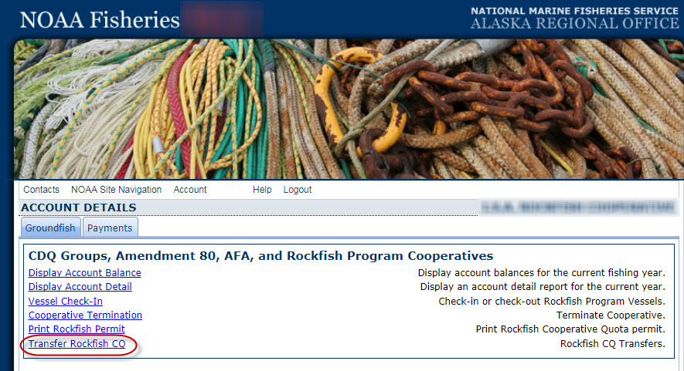

Rockfish CQ Transfer Data Entry Page:
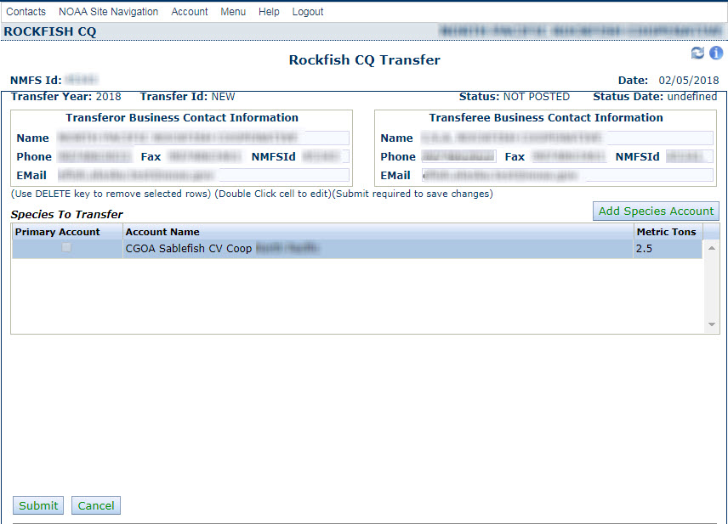

With the information provided when logging into eFISH using a NMFS ID, eFISH autofills the following information about the transferor: name, phone number, fax number, and e-mail address. This information is based on the information the transferring cooperative representative submitted in the Application for Rockfish Fishing CQ.

For each transfer, the following information is autofilled by eFISH:
- Date of the transfer
- Transfer Year
- Transfer ID
- Status
- Status Date

The applicant enters the transferee NMFS ID and eFISH autofills the transferees name, phone number, fax number, and e-mail address based on information the receiving cooperative representative submitted on the Application for Rockfish Fishing CQ.

The applicant selects the species to transfer and enters the weight of the species to transfer, and selects “Submit.” The applicant receives a system generated response notifying them that either the transfer request has been received and processed successfully, or there was an error in their submission. If there is an error in their submission, the applicant may go back to the data entry screen and try again to submit the transfer request.

- Cooperative check-in/check-out reports and termination of fishing report. [REVISED, timing of submission of catcher vessels check-in report changes from 48 to 24 hours prior to a fishing trip]

The designated representative for a rockfish cooperative must submit a check-in report before a vessel authorized to fish under the cooperative’s permit starts fishing for a cooperative and a check-out report when a vessel stops fishing for a cooperative during the fishing season. The check-in/check-out reports are necessary so that NMFS’s catch accounting system can identify catch by a vessel that should accrue to a rockfish cooperative quota allocation from catch that occurs in other, non-Rockfish Program fisheries.

The designated representative for a rockfish cooperative must submit to NMFS a check-in report for a vessel:
- At least 24 hours prior to the time the catcher vessel begins a fishing trip to fish under a CQ permit; or
- At least 1 hour prior to the time the catcher/processor begins a fishing trip to fish under a CQ permit; and
- A check-in designation is effective at the beginning of the first fishing trip after the designation has been submitted.

The designated representative of a rockfish cooperative must designate any vessel that is no longer fishing under a CQ permit for that rockfish cooperative through a check-out report. A check-out report must be submitted to NMFS within 6 hours after the effective date and time the rockfish cooperative ends the vessel’s authority to fish under the CQ permit.
- If the vessel is fishing under a CQ permit for a catcher vessel cooperative, a check-out designation is effective at the end of a complete offload;
- If the vessel is fishing under a CQ permit for a catcher/processor cooperative, a check-out designation is effective upon submission to NMFS.

A rockfish cooperative may choose to terminate its CQ permit through a termination of fishing report submitted to NMFS. This declaration notifies NMFS that all vessels fishing for the cooperative have completed fishing in the Rockfish Program for the year.

The Check-in Report, Check-out Report, and Declaration of Termination of Fishing Report must be submitted to NMFS online through eFISH on the NMFS Alaska Region website at https://alaskafisheries.noaa.gov/webapps/efish/login.

Following are screen shots from eFISH showing the data entry screens and information requirements for the check-in report, check-out report, and termination of fishing report.

Once logged in to eFISH, the applicant selects “Vessel Check-In” or “Cooperative Termination.”

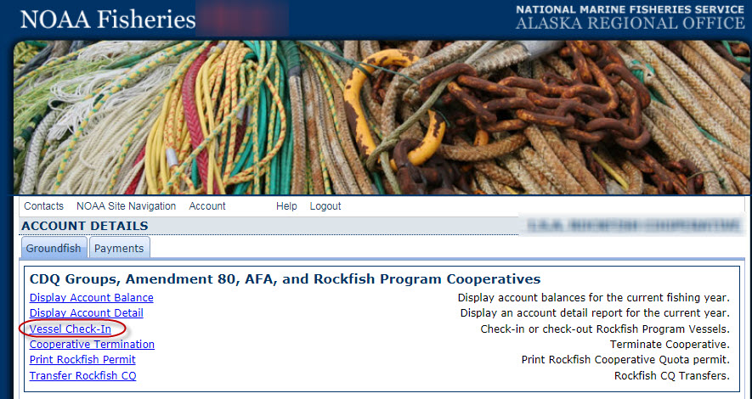

With the information provided when logging in to eFISH using a NMFS ID, eFISH autofills the NMFS ID number, name of the rockfish cooperative, and the date.

For each check-in or check out report, the applicant enters the vessel name, check-in date and time or check-out date and time.

Following are eFISH data entry screens for the check-in report and check-out report.

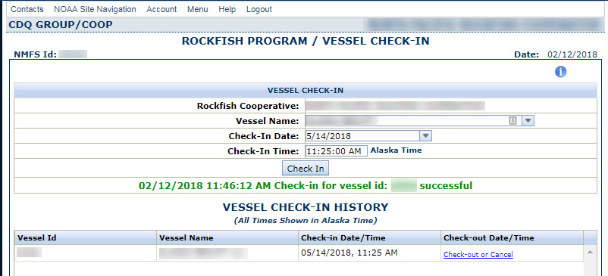

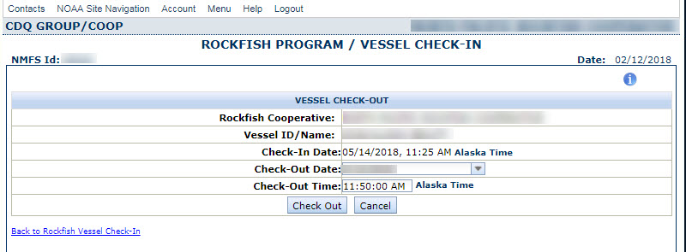

If a cooperative representative elects to submit a termination of fishing report, the representative submits the cooperative name and selects the option “Terminate,” as shown in the eFISH data entry screen below. No termination of fishing reports have been submitted by any of the cooperatives since prior to 2012 under the Rockfish Pilot Program.

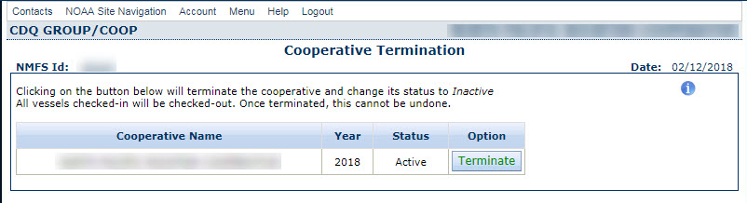

- Describe whether, and to what extent, the collection of information involves the use of automated, electronic, mechanical, or other technological collection techniques or other forms of information technology, e.g. permitting electronic submission of responses, and the basis for the decision for adopting this means of collection. Also, describe any consideration of using information technology to reduce burden.

The Application for Inter-Cooperative Transfer of Rockfish Cooperative Quota (CQ) and the Rockfish Program Vessel Check-In/Check-Out and Termination of Fishing Reports are required to be submitted via eFISH.

The Application for Rockfish Cooperative Fishing Quota (CQ) is available as a fillable pdf posted on the NMFS Alaska Region website at www.alaskafisheries.noaa.gov. It may be completed electronically by the participant, downloaded and printed. This form must be submitted by mail, delivery, or fax because it requires the submission of copies of attached documents, and some information may contain personal identifying information, which cannot be transmitted via email. NMFS Alaska Region is currently working on offering submission of this application online through eFISH.

eFISH is the NMFS Alaska Region online Fisheries Information System. eFISH provides an online method to submit applications and access to participants’ NMFS permit accounts. eFISH allows participants to renew certain fishery permits; report landings; print certificates or permits; conduct quota transfers; pay fees and submit landing value reports; and check account balances, vessel balances, and landing ledger reports. Permit holders access eFISH through a User ID and password issued by NMFS. Instructions for using eFISH are posted on the NMFS Alaska Region website at https://alaskafisheries.noaa.gov/node/30749.

- Describe efforts to identify duplication. Show specifically why any similar information already available cannot be used or modified for use for the purposes described in Question 2
NMFS has not identified any duplication with other information collections or information collection requirements. Duplication of application contact information is minimized through the use of eFISH because, by logging in with a NMFS Identification Number, eFISH autofills some data entry fields.

- If the collection of information impacts small businesses or other small entities, describe any methods used to minimize burden.

NMFS attempts to minimize the burden of this information collection on all respondents by collecting only information necessary to manage the Rockfish Program, by providing and supporting the online data collection program eFISH and by providing assistance to users in writing and by phone. eFish has a “help” link within the application that users can click on to view help options and user guides. See https://alaskafisheries.noaa.gov/node/30749 . NMFS also maintains documentation about eFISH in the eLandings Wiki (Confluence), located here: https://elandings.atlassian.net/wiki/spaces/doc/pages/31096857/eFISH+Web+Application
In addition, NMFS maintains a help/support call center with contractors available by phone Monday through Friday from 8:00 am to 4:30 pm Alaska time.

- Describe the consequence to Federal program or policy activities if the collection is not conducted or is conducted less frequently, as well as any technical or legal obstacles to reducing burden.

The Application for Rockfish Fishing CQ and the Application for Inter-Cooperative Transfer of Rockfish Cooperative Quota (CQ) are required if the license holder, vessel owner, or processor wants to participate in the Rockfish Program. No cooperative representative is compelled to submit this application and no license holder, vessel owner, or processor is required to be a member of a cooperative. However, if the information on this application form were not collected, NMFS could not effectively manage and provide the benefits of the Rockfish Program to eligible participants. Requiring an annual Application for Rockfish Cooperative Fishing Quota (CQ) is necessary to allow the rockfish cooperatives to establish their membership annually and provides some flexibility for license holders and vessel owners to change cooperative or renegotiate cooperative terms. Once a Rockfish CQ permit has been issued to a cooperative, transfers of CQ and halibut prohibited species catch may only be done by formal notification to NMFS. In addition, once a Rockfish Program CQ permit is issued, the cooperative representative is required to submit vessel check-in and check-out reports to ensure that NMFS accrues catch under the Rockfish Program to the correct CQ account. The termination of fishing report is a voluntary report at the discretion of the cooperative representative.

- Explain any special circumstances that would cause an information collection to be conducted in a manner inconsistent with OMB guidelines.

This collection includes two elements that may be submitted more often than quarterly. The Rockfish Program Vessel Check-In/Check-Out and Termination of Fishing Report and Application for Rockfish Cooperative Fishing Quota (CQ) may be submitted to NMFS more often than quarterly. It is only required if the respondent chooses to participate in the Rockfish Program to receive the benefits of the program and submission of this information more often than quarterly is dependent on respondent participation.
This collection of information will otherwise be conducted in a manner consistent with OMB guidelines.
This collection requires the submission of confidential information and NMFS has instituted procedures to protect the information's confidentiality to the extent permitted by law.

- If applicable, provide a copy and identify the date and page number of publications in the Federal Register of the agency's notice, required by 5 CFR 1320.8 (d), soliciting comments on the information collection prior to submission to OMB. Summarize public comments received in response to that notice and describe actions taken by the agency in response to these comments. Specifically address comments received on cost and hour burden.

A proposed rule (RIN 0648-BJ73) soliciting public comments will be published coincident with this submission.

- Explain any decision to provide any payment or gift to respondents, other than remuneration of contractors or grantees.

No payment or gifts are provided to respondents included in this collection.

- Describe any assurance of confidentiality provided to respondents and the basis for the assurance in statute, regulation, or agency policy. If the collection requires a systems of records notice (SORN) or privacy impact assessment (PIA), those should be cited and described here.

All information collections by NMFS, Alaska Region, are protected under confidentiality provisions of section 402(b) of the Magnuson-Stevens Act as amended in 2006 (16 U.S.C. 1801, et seq.) and under NOAA Administrative Order 216-100, which sets forth procedures to protect confidentiality of fishery statistics.

The System of Records Notice that covers this information collection is COMMERCE/NOAA-19, Permits and Registrations for United States Federally Regulated Fisheries. An amended Privacy Act system of records notice was published in the Federal Register on August 7, 2015 (80 FR 47457), and became effective September 15, 2015 (80 FR 55327).

The Privacy Impact Assessment that covers this information collection is NOAA NMFS Alaska Region Local Area Network (NOAA4700).

- Provide additional justification for any questions of a sensitive nature, such as sexual behavior or attitudes, religious beliefs, and other matters that are commonly considered private. This justification should include the reasons why the agency considers the questions necessary, the specific uses to be made of the information, the explanation to be given to persons from whom the information is requested, and any steps to be taken to obtain their consent.

This collection does not include any questions of a sensitive nature.

- Provide estimates of the hour burden of the collection of information.

Information Collection | Type of Respondent (e.g., Occupational Title) | # of Respondents/year  (a) | Annual # of Responses / Respondent  (b) | Total # of Annual Responses  (c) = (a) x (b) | Burden Hrs / Response  (d) | Total Annual Burden Hrs  (e) = (c) x (d) | Hourly Wage Rate^{/1} (for Type of Respondent)  (f) | Total Annual Wage Burden Costs  (g) = (e) x (f)
Application for Rockfish Cooperative Fishing Quota (CQ) | Cooperative representative | 8 | 1 | 8 | 2 hrs | 16 | 34 | 544
Application for Inter-Cooperative Transfer of Rockfish Cooperative Quota (CQ) | Cooperative representative | 8 | 10 | 80 | 10 minutes | 13 | 34 | 442
Rockfish Program Vessel Check-In/Check-Out and Termination of Fishing Report | Cooperative representative | 8 | 8 | 64 | 10 minutes | 11 | 34 | 374
Totals |  |  |  | 152 |  | 40 |  | 1,360
^{/1} The hourly wage rate is based on the wage rates reported for the same respondents in comments received during the 2019 renewal of OMB Control No. 0648-0678. The wage rates reported were $32 and $36. These were averaged to $34 for this analysis.

- Provide an estimate for the total annual cost burden to respondents or record keepers resulting from the collection of information. (Do not include the cost of any hour burden already reflected on the burden worksheet).

Information Collection | # of Respondents/year  (a) | Annual # of Responses / Respondent  (b) | Total # of Annual Responses  (c) = (a) x (b) | Cost Burden / Respondent  (h) | Total Annual Cost Burden  (i) = (c) x (h)
Application for Rockfish Cooperative Fishing Quota (CQ) | 8 | 1 | 8 | Operating costs $5^{1/} | 40
Application for Inter-Cooperative Transfer of Rockfish Cooperative Quota (CQ) | 8 | 10 | 80 | 0 | 0
Rockfish Program Vessel Check-In/Check-Out and Termination of Fishing Report | 8 | 8 | 64 | 0 | 0
TOTALS |  |  | 152 |  | 40
^{1/} Operating costs account for the typical inclusive general office services packages that include expenses for email, fax, copying, mailing, printing, and internet.

- Provide estimates of annualized cost to the Federal government. Also, provide a description of the method used to estimate cost, which should include quantification of hours, operational expenses (such as equipment, overhead, printing, and support staff), and any other expense that would not have been incurred without this collection of information.

A cost recovery program is in effect for the Rockfish Program as specified in regulations at 50 CFR 679.85. Under this cost recovery program, NMFS is authorized to collect direct program costs from the rockfish cooperatives. Therefore, the information collection requirements of the Rockfish Program do not impose a cost on the Federal government. Direct program costs are the costs NMFS incurs to manage, collect data from, and conduct enforcement for the Rockfish Program fisheries.

The direct program costs for the Rockfish Program in 2019 were $319,324. Rockfish program costs calculated annually and Annual Cost recovery reports are published on the Alaska Region website at: https://www.fisheries.noaa.gov/alaska/commercial-fishing/cost-recovery-programs-fee-collection-and-fee-payment-alaska.

The following are examples of the types of tasks that were included under the 2019 Rockfish Program direct program costs:
- maintenance of electronic reporting systems, including the catch accounting system
- programming and web design for online applications
- determination of annual cooperative allocations of CQ and PSC
- issuance and transfers of CQ, responding to questions about CQ
- observer debriefing
- catch monitoring control plan specialist
- monitoring cooperative fisheries CQ and PSC, answer questions on cooperative activities, respond to data requests
- determination of standard ex-vessel prices using value and volume reports submitted by rockfish processors
- fee determination, collection, and reporting
- analysis and rulemaking activities

- Explain the reasons for any program changes or adjustments reported in ROCIS.
The adjustments reflect recent participation in the fishery. The proposed rule removed the requirement for a fishing plan to be submitted with the Application for Rockfish Cooperative Fishing Quota. At this time, no change is made to the estimated reporting burden for this application as it contains a buffer to allow for differences in the time needed to complete and submit this application. However, as comments are being solicited, this may change after the proposed rule public comment period.

Information Collection | Respondents |  | Responses |  | Burden Hours |  | Reason for change or adjustment
 | Current Renewal / Revision | Previous Renewal / Revision | Current Renewal / Revision | Previous Renewal / Revision | Current Renewal / Revision | Previous Renewal / Revision
Application for Rockfish Cooperative Fishing Quota (CQ) | 8 | 9 | 8 | 9 | 16 | 18 | Respondents have been adjusted to reflect the most current data.
Application for Inter-Cooperative Transfer of Rockfish Cooperative Quota (CQ) | 8 | 9 | 80 | 135 | 13 | 23 | Respondents and responses have been adjusted to reflect the most current data.
Rockfish Program Vessel Check-In/Check-Out and Termination of Fishing Report | 8 | 9 | 64 | 54 | 11 | 9 | Respondents and responses have been adjusted to reflect the most current data.
Total for Collection | 8* | 9 | 152 | 198 | 40 | 50
Difference | - 1 |  | - 46 |  | - 10
*Unique entities: 2 catcher/processor cooperatives and 6 catcher vessel cooperatives.

Information Collection | Labor Costs |  | Miscellaneous Costs |  | Reason for change or adjustment
 | Current | Previous | Current | Previous
Application for Rockfish Cooperative Fishing Quota (CQ) | 544 | 666 | 40 | 87 | Labor costs: Revised amount due to comments received on 2019 renewal of 0648-0678 for these respondents.  Misc. costs: Revised amount to account for typical inclusive general office services packages.
Application for Inter-Cooperative Transfer of Rockfish Cooperative Quota (CQ) | 442 | 851 | 0 | 0 | Labor costs: Revised amount due to comments received on 2019 renewal of 0648-0678 for these respondents.
Rockfish Program Vessel Check-In/Check-Out and Termination of Fishing Report | 374 | 333 | 0 | 0 | Labor costs: Revised amount due to comments received on 2019 renewal of 0648-0678 for these respondents.
Total for Collection | 1,360 | 1,850 | 40 | 87
Difference | - 490 |  | - 47

- For collections of information whose results will be published, outline plans for tabulation and publication. Address any complex analytical techniques that will be used. Provide the time schedule for the entire project, including beginning and ending dates of the collection of information, completion of report, publication dates, and other actions.

NMFS publishes some information from the Application for Rockfish Cooperative Fishing CQ on the NMFS Alaska Region website (www.alaskafisheries.noaa.gov), including the name of the cooperative, the name of the authorized representative of the cooperative, the business address of the cooperative, the names of the license holders who are members of the cooperative, and the names of the vessels that will be fishing for the cooperative.

- If seeking approval to not display the expiration date for OMB approval of the information collection, explain the reasons that display would be inappropriate.
The agency plans to display the expiration date for OMB approval of the information collection on all instruments.

- Explain each exception to the certification statement identified in “Certification for Paperwork Reduction Act Submissions."
The agency certifies compliance with 5 CFR 1320.9 and the related provisions of 5 CFR 1320.8(b)(3).

