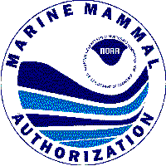**MARINE MAMMAL AUTHORIZATION PROGRAM**

#### MORTALITY/INJURY REPORTING FORM

National Marine Fisheries Service, 1315 East-West Highway, Silver Spring, MD 20910

**PLEASE PRINT NEATLY AND IN CAPITAL LETTERS**

1. LAST NAME OF VESSEL OWNER/OPERATOR 2. FIRST NAME OF VESSEL OWNER/OPERATOR 3. MI

4.MAILING ADDRESS

5. EMAIL ADDRES

6. CITY 7. PHONE NUMBER

8. STATE 9. ZIP 10. VESSEL NAME

11. COAST GUARD DOC. NO. **OR** VESSEL STATE REG. NO. 12. STATE COMMERCIAL VESSEL NO.

13. FISHERY GEAR TYPE AND TARGET SPECIES

_____________________________________________________________________________________

14. DATE OF MORTALITY/INJURY (MM DD YYYY) 15. APPROXIMATE TIME OF MORTALITY/INJURY 16. OBSERVER PRESENT

**AM/PM** YES NO

**.**

**.**

17.LOCATION OF MORTALITY/INJURY 18. DETERRENT USED

LATITUDE o ‘ LONGITUDE o ‘ YES NO

19. NUMBER OF ATTEMPTS 20. TYPE OF DETERRENT USED AND SPECIES TARGETED 21. VISUAL SCAN CONDUCTED

YES NO

22. ENTER SPECIES CODE, TYPE OF MORTALITY/INJURY (SEE LIST OF CODES ON PREVIOUS PAGE), AND THE NUMBER OF EACH SPECIES INVOLVED. MAKE ONE ENTRY FOR EACH SPECIES INVOLVED IN THIS INCIDENT. YOU MAY MAKE UP TO THREE MORTALITY/INJURY CODES PER SPECIES.

SPECIES MORTALITY/INJURY CODE NUMBER

DESCRIPTION OF UNKNOWN SPECIES. CIRCUMSTANCES OF MORTALITY/INJURY INCIDENT, DETERRENT USE

Please provide a detailed description of the animal involved, including color patterns, length, and body shape and size (drawings are helpful). State whether the animal involved was a whale, dolphin, porpoise, seal, sea lion, walrus, manatee, or sea otter. If a deterrent was used, please provide any other relevant information, such as specifications of the device, how it was deployed, the behavior of the animal in response to the deterrent, and the occurrence/behavior of other protected species in the area. You may also use this space for other comments regarding this incident, including length of interaction and behavior of animal after release.

NOAA/NMFS

NO POSTAGE NECESSARY IF MAILED

IN THE UNITED STATES

OFFICE OF PROTECTED RESOURCES F/PR2 1315 EAST WEST HIGHWAY

SILVER SPRING MD 20910-9721

**BUSINESS REPLY MAIL**

FIRST-CLASS MAIL PERMIT NO . 7411 SILVER SPRING, MD

POSTAGE WILL BE PAID BY ADDRESSEE

##### NATIONAL OCEANIC & ATMOSPHERIC ADMINISTRATION NATIONAL MARINE FISHERIES SERVICE

OFFICE OF PROTECTED RESOURCES F/ PR2 1315 EAST WEST HIGHWAY

SILVER SPRING MD 20910-9721

**1 • • 1 .111 • • • 1 .1• • • • • 11 11 • • • 1 .1• • 1 • • • 1 • • 1 .1• • • 11 1 .1• • 1**

# IMPORTANT!

**MARINE MAMMAL REPORTING FORM**

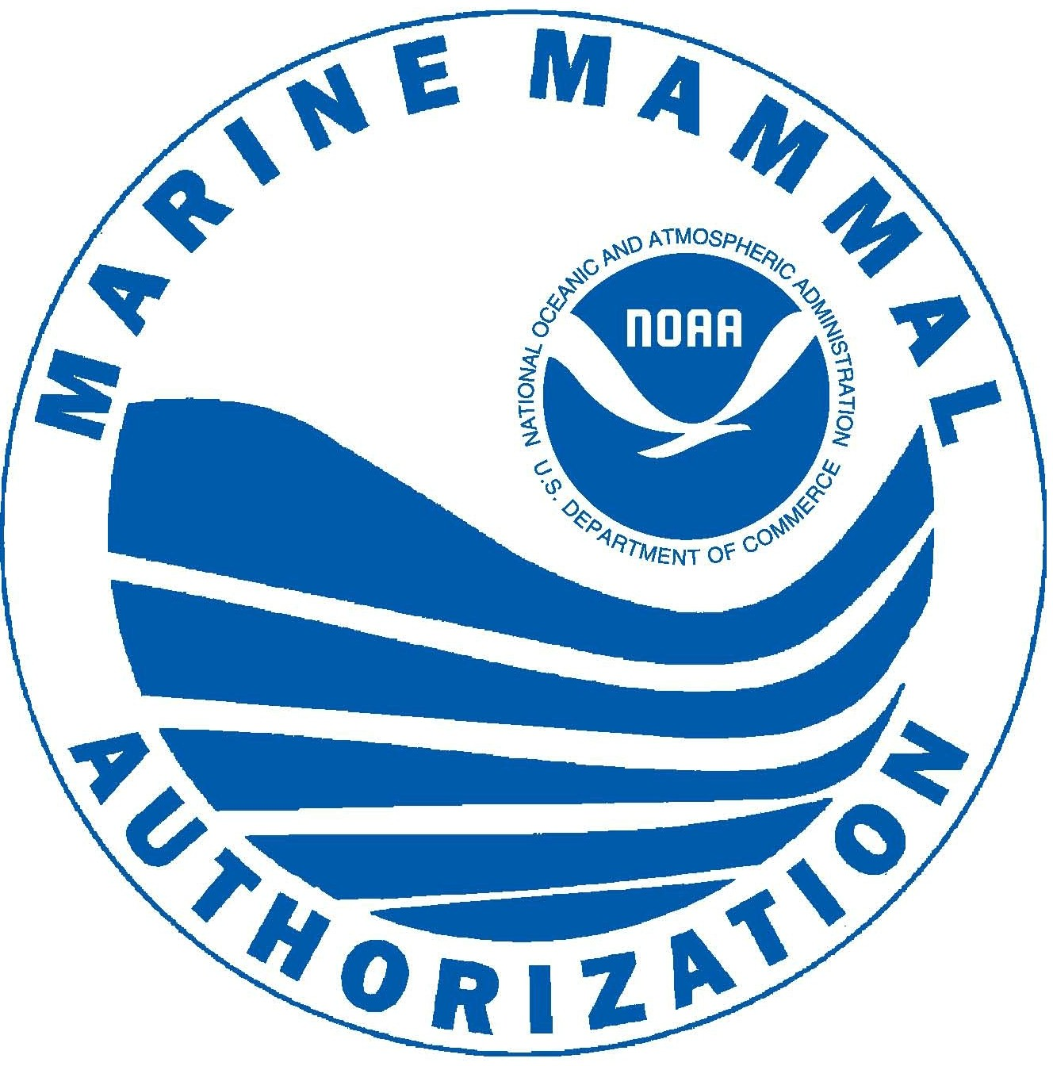

## MARINE MAMMAL AUTHORIZATION PROGRAM

### MORTALITY/INJURY REPORTING FORM

##### National Marine Fisheries Service, 1315 East-West Highway, Silver Spring, MD 20910

#### INSTRUCTIONS FOR COMPLETING THE MORTALITY/INJURY REPORTING FORM

This reporting form is required ONLY WHEN there is an incidental mortality or injury (M/I) to a marine mammal during commercial fishing activities. You are required to report the incidental mortality or injury within 48 hours after the end of the fishing trip (even if an observer is on board), or, for non-vessel fisheries, within 48 hours of an occurrence of an incidental mortality or injury. A separate report form is required for each fishery, for each date, and for each location.

PLEASE PRINT NEATLY AND IN CAPITAL LETTERS.

The reporting form should be detached from this instruction sheet, folded, and sealed prior to mailing. No postage is necessary for mailing. Forms may also be filled out online, emailed to nmfs.mireport@noaa.gov, or faxed to NMFS at 301-713-0376. Questions regarding completion of this form, and requests for additional forms, may be directed to the NMFS Office of Protected Resources, 1315 East-West Hwy., Silver Spring, MD 20910-3226, 301-427-8402.

#### MORTALITY/INJURY REPORT FIELD DEFINITIONS

**VESSEL NAME:** Enter the name of the vessel as it is identified for commercial fishing operations. For non-vessel fisheries, leave this blank.

**COAST GUARD DOCUMENT NO.:** Enter the vessel’s Coast Guard Documentation number; OR Enter the **VESSEL’S STATE REGISTRATION NO**.: One of these numbers must be provided. For non-vessel fisheries, enter the state fishery permit number.

**STATE COMMERCIAL VESSEL LICENSE NO.:** Enter the vessel’s state commercial vessel license number, if applicable.

**GEAR TYPE AND TARGET SPECIES:** Enter the type of fishing gear used and the target species being fished when this incident occurred.

**DATE OF MORTALITY/INJURY:** Enter the date the mortality/injury occurred. For example: November 1, 2018 is entered as 11/01/2018.

**TIME OF MORTALITY/INJURY:** Enter the approximate time of day the mortality/injury occurred. Indicate AM if the mortality/injury occurred between midnight & noon, or PM if the mortality/injury occurred between noon and midnight.

**OBSERVER PRESENT:** Check yes if the trip was observed, check no if the trip was not observed.

**LOCATION OF MORTALITY/INJURY LATITUDE & LONGITUDE:** Use standard entries in degrees and minutes.

**DETERRENT USED:** Check yes if a deterrent was used, check no if no deterrent was used.

**NUMBER OF ATTEMPTS:** Enter the number of times a deterrent was deployed.

**TYPE OF DETERRENT USED/SPECIES TARGETED:** Describe the deterrent used when the mortality/injury occurred. Categories of deterrents include visual; physical barriers; tactile – projectiles, manual, electric, water; acoustic; explosive. Enter the category as well as the specific deterrent. Enter the species code for the marine mammal that was targeted to deter.

**VISUAL SCAN CONDUCTED**: If seal bombs, underwater cracker shells, banging objects, pulsed power devices, or low frequency broadband devices were used check yes if a visual scan for certain marine mammals within 100-m was conducted before use, check no if a visual scan was not conducted before use.

**SPECIES INCIDENTALLY KILLED OR INJURED:** Enter the species code and the mortality/injury code of the animal(s)

Involved. Refer to the species and mortality/injury code lists included on page 2 of these instructions. Enter the number of animals involved in each mortality/injury. You may enter up to three (3) injury codes per species. Make as many entries as apply to the date, time, and location entered in items 14-17.

**DESCRIPTION OF UNKNOWN SPECIES, CIRCUMSTANCES OF M/I INCIDENT, DETERRENT USE:** If you have entered a species code for an unidentified species, please provide a detailed description of the animal involved, including color patterns, length, and body shape (drawings are helpful), and photos if possible. Photos can be emailed to [nmfs.mireport@noaa.gov](mailto:nmfs.mireport@noaa.gov). State whether the animal involved was a cetacean (whale, dolphin, or porpoise), pinniped (seal or sea lion), walrus, manatee or sea otter. If a deterrent was used, please provide any other relevant information such as specifications of the device, how the deterrent was deployed, the approximate distance between the deterrent and the animal, the behavior of the animal(s) that prompted the deterrence, the behavior of the animal(s) in response to the deterrent, and occurrence/behavior of other protected species in the area. You may also use this space for other comments regarding this incident.

## MARINE MAMMAL AUTHORIZATION PROGRAM

### MORTALITY/INJURY REPORTING FORM

National Marine Fisheries Service, 1315 East-West Highway, Silver Spring, MD 20910

#### SPECIES AND STOCK CODES FOR MARINE MAMMALS

###### Seals and sea lions Dolphins and porpoises Toothed and baleen whales

|  |  |  |  |  |  |
| --- | --- | --- | --- | --- | --- |
| 100- | Steller (northern) sea lion | 047- | Atlantic white-sided dolphin | 002- | North Atlantic right whale |
| 101- | California sea lion | 049- | Pacific white-sided dolphin | 005- | Gray whale |
| 105- | Northern (Pribilof) fur seal | 053- | Common dolphin | 007- | Fin whale |
| 115- | Harbor seal | 054- | Bottlenose dolphin | 010- | Minke whale |
| 116- | Spotted seal | 055- | Grampus (Risso’s) dolphin | 011- | Humpback whale |
| 117- | Ringed seal | 058- | Spotted dolphin | 012- | Sperm whale |
| 121- | Ribbon seal | 060- | Spinner dolphin | 016- | Beluga whale |
| 124- | Gray seal | 061- | Striped dolphin | 038- | False killer whale |
| 127- | Hawaiian monk seal | 063- | Northern right whale dolphin | 039- | Killer whale |
| 129- | Northern elephant seal | 068- | Harbor porpoise | 221- | Pilot whale |
| 130- | Bearded seal | 072- | Dall’s porpoise | 230- | Beaked whale |
| 131- | Harp seal | 073- R | Rough-toothed dolphin | 231- | Bryde’s whale |
| 132- | Hooded seal | 235- | Unidentified small cetacean | 232- | Dwarf sperm whale |
| 203- | Unidentified sea lion |  | (porpoise or dolphin) | 210- | Unidentified baleen whale |
| 204- | Unidentified seal |  |  | 220- | Unidentified toothed whale |
|  |  |  |  |  |  |

###### Other Marine Mammals

114- Walrus 135- Sea otter 139- Manatee

#### MORTALITY/INJURY CODES FOR MARINE MAMMALS

01- Visible blood flow 08- Listlessness or inability to defend

02- Loss of/damage to appendage/jaw 09- Inability to swim or dive

1. Inability to use appendage(s) 10- Equilibrium imbalance
2. Asymmetry in shape of body or body position 11- Ingestion of gear

05- Any noticeable swelling or hemorrhage (bruising) 12- Released trailing gear/gear perforating body 06- Laceration (deep cut) 13- Other wound or injury

07- Rupture or puncture of eyeball 14- Killed

**COLLECTION MANDATE**

This collection of information is mandated by the Marine Mammal Protection Act of 1972, as amended (16 U.S.C. 1361 *et. seq*.), and by implementing regulations contained at 50 CFR 229.4. The information supplied on this form will be used by the National Marine Fisheries Service to estimate levels of incidental mortalities and injuries in U.S. commercial fisheries. Certain information supplied on this form may be considered proprietary and therefore subject to data confidentiality restrictions of 50 CFR Part 229.11.

Public reporting burden for this collection of information is estimated to average 0.25 hours per response, including the time for reviewing instructions, searching existing data sources, gathering and maintaining the data needed, and completing and reviewing the collection of information. Send comments regarding this burden estimate or any other aspect of this collection of information, including suggestions for reducing this burden, to Director, Office of Protected Resources, National Marine Fisheries Service, 1315 East-West Hwy., Silver Spring, MD 20910-3226.

The National Marine Fisheries Service may not conduct or sponsor, and a person is not required to respond to, a collection of information unless it displays a current and valid OMB control number. The OMB control number for this form is 0648-0292, which expires on 12/31/2022.