**Appendix D**

**Heat stress app – shift questionnaire for field**

Form Approved

OMB No. 0920-XXXX

Exp. Date xx/xx/20xx

Questions to be taken on smart phone app (see screen shots below)

1. I am physically exhausted right now (not at all, a little, moderately, quite a bit, extremely)
2. I feel mentally tired or unable to concentrate right now (not at all, a little, moderately, quite a bit, extremely)
3. Please indicate which work tasks you just completed, starting with the most recent:

Task _________

What time did you start this work task? _______

What time did you end this work task? _______

Describe your exertion level during this task

1. Describe how hot or cool you are right now (scale 0.0 unbearably cold, 0.5, 1.0 very cold, 1.5, 2.0 cold, 2.5, 3.0 cool, 3.5, 4.0 comfortable, 4.5, 5.0 warm, 5.5, 6.0 hot, 6.5, 7.0 very hot, 7.5, 8.0 unbearably hot)
2. Describe your location where you were working when you received the alert (i.e., where are you in the mine): ________________

Heat stress app screen shots

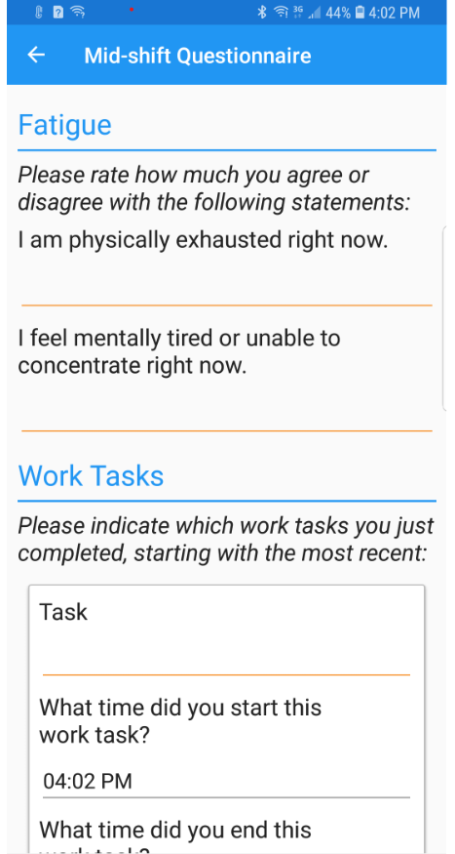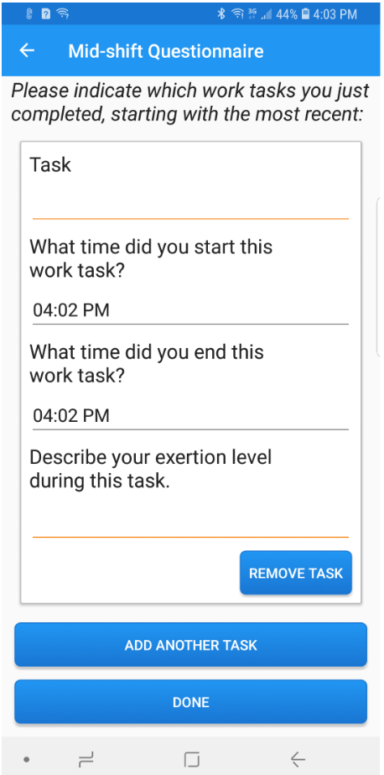

CDC estimates the average public reporting burden for this collection of information as 1 min per response, including the time for reviewing instructions, searching existing data/information sources, gathering and maintaining the data/information needed, and completing and reviewing the collection of information. An agency may not conduct or sponsor, and a person is not required to respond to a collection of information unless it displays a currently valid OMB control number. Send comments regarding this burden estimate or any other aspect of this collection of information, including suggestions for reducing this burden to CDC/ATSDR Information Collection Review Office, 1600 Clifton Road NE, MS D-74, Atlanta, Georgia 30333; ATTN: PRA (0920-XXXX).