Permits Online (PONL) —Application for New Firearms or Ammunition
Tax-Free Registration (Equivalent to TTB F 5300.28)
General PONL Introductory Page:
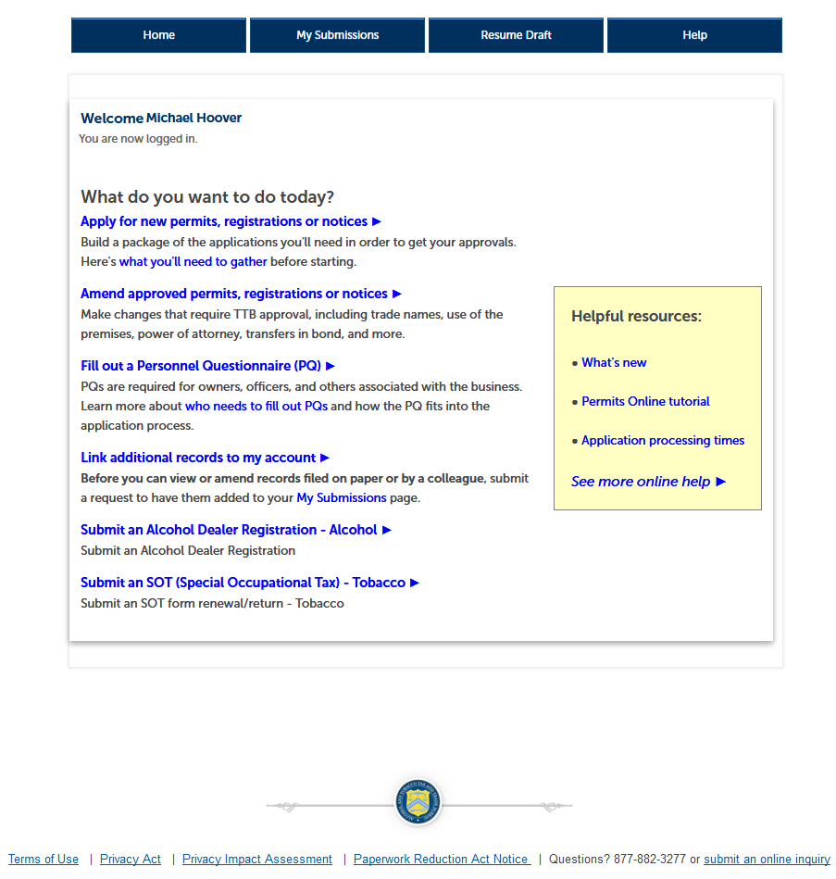

(NOTE: The PONL Privacy Act and Paperwork Reduction Act notices are shown at the end of this document.)

Clicking on “Apply for new permits, registrations or notices” results in the Penalty of Perjury” page:
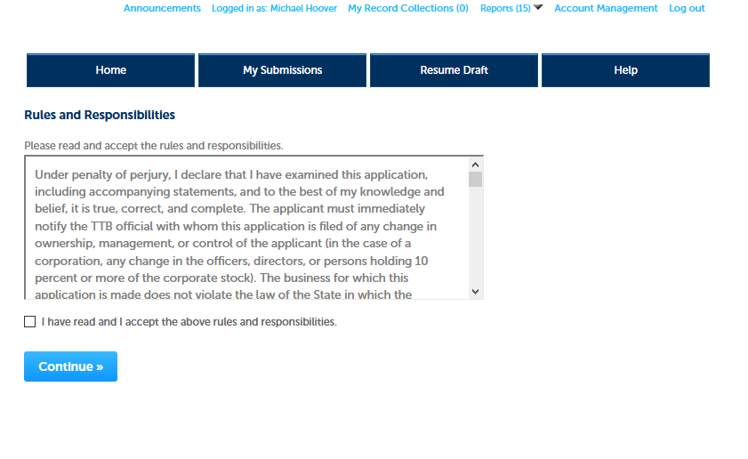

PONL screens continue below.

After accepting the Penalty of Perjury statement, respondents complete basic identification data fields:
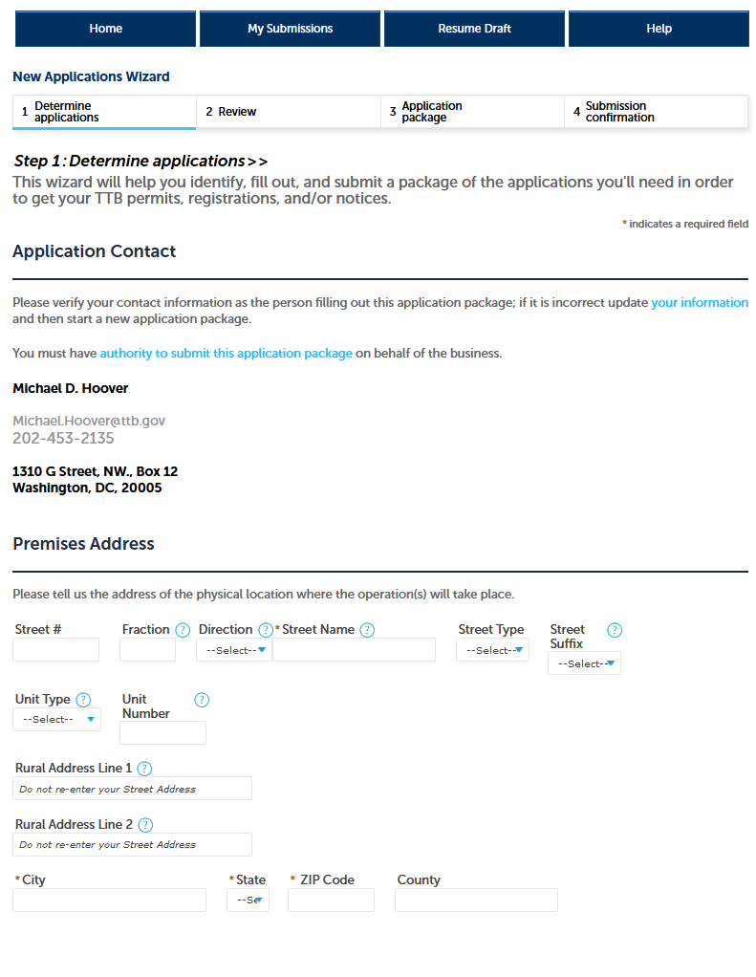
Then respondent completes Commodity Selection by selecting “Firearms and ammunition” from drop-down box, and selections “Firearms and Ammunition Tax-Free Registration” the Application Type:
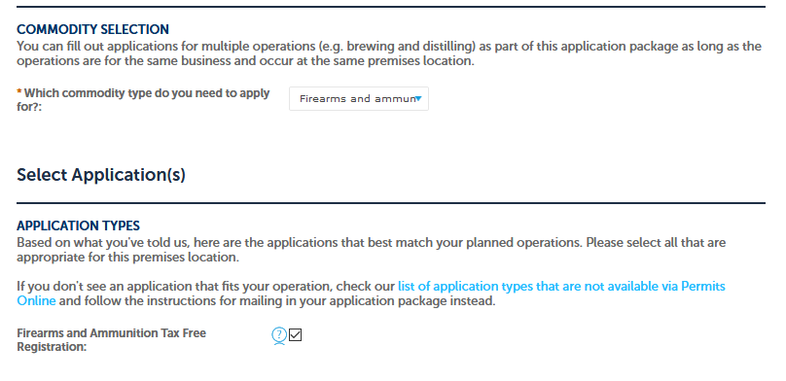
Respondent then completes the Business Entity data fields:
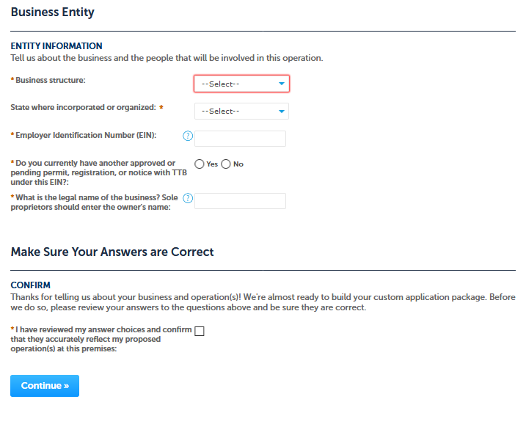
Then, PONL requests respondents to edit or confirm the information submitted to this point:
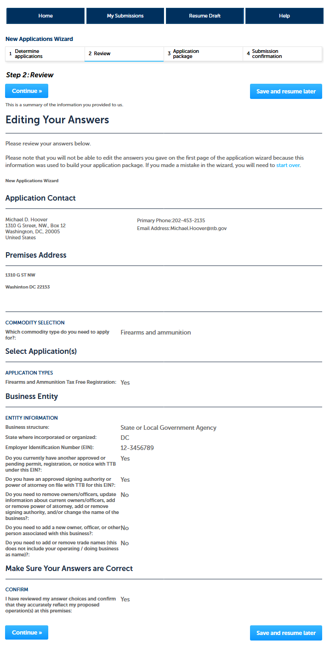
After editing and/or confirming previous information, respondenst then may select “Start” to immediately complete the application package, or may select “Save and resume later” to complete the application package later:
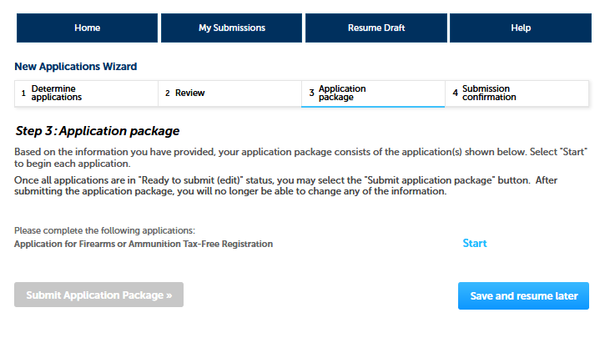

PONL screens continue below.

PONL then presents respondents with the Application for Firearms or Ammunition Tax-Free Registration screens. The first is Step 1: Mailing Address, which collects data about the entity requesting tax-free registration --
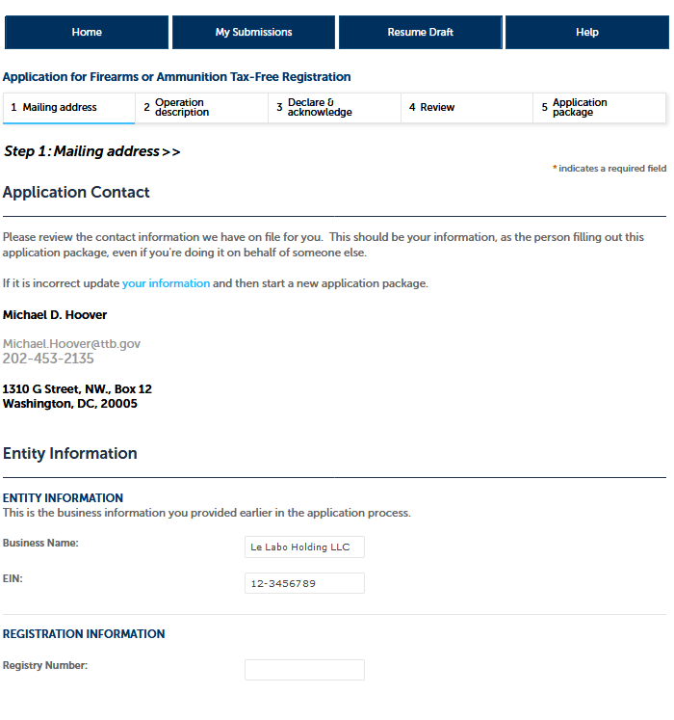
(continued below)

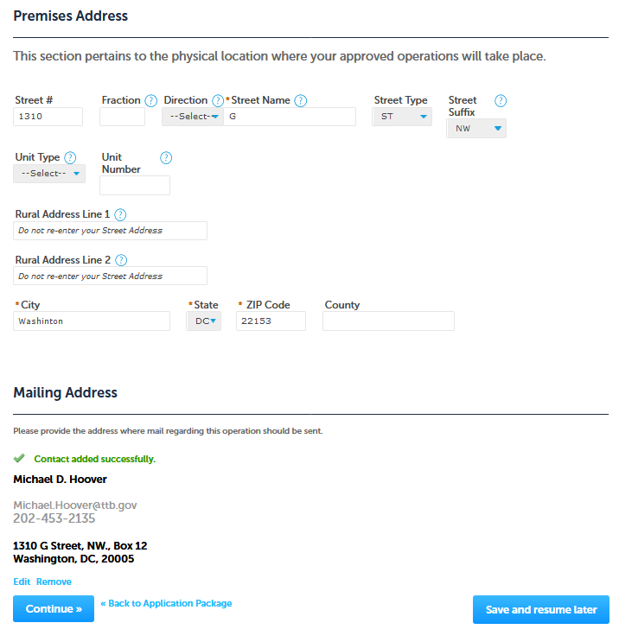
(NOTE: “Mailing Address” section at bottom of screen may be Auto-filled from Premises Data or entered separately if different from premises address.)

Step 2: Operations description data fields --

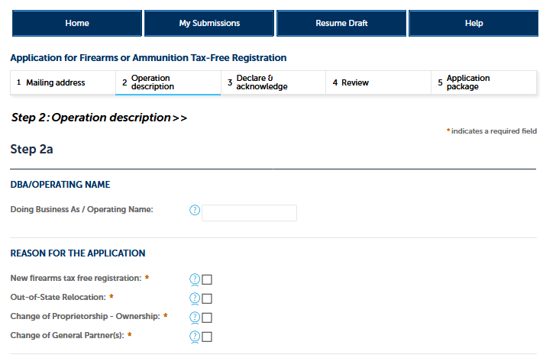

PONL screens continue below.

The Step 2 screen continues:

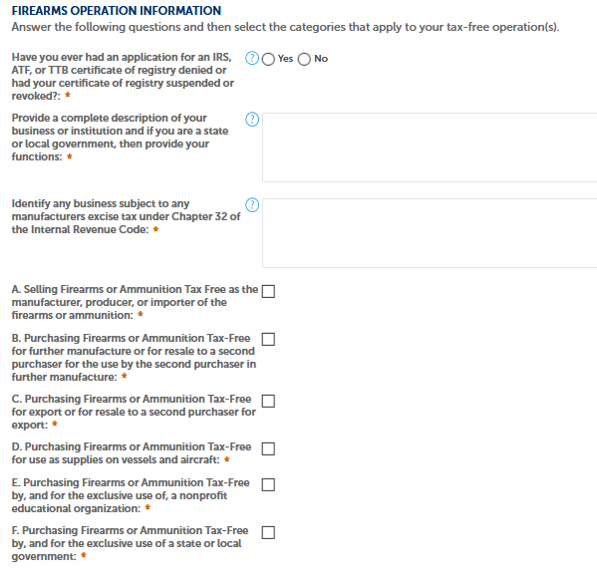
PONL screens continue below.

Step 2b data fields:
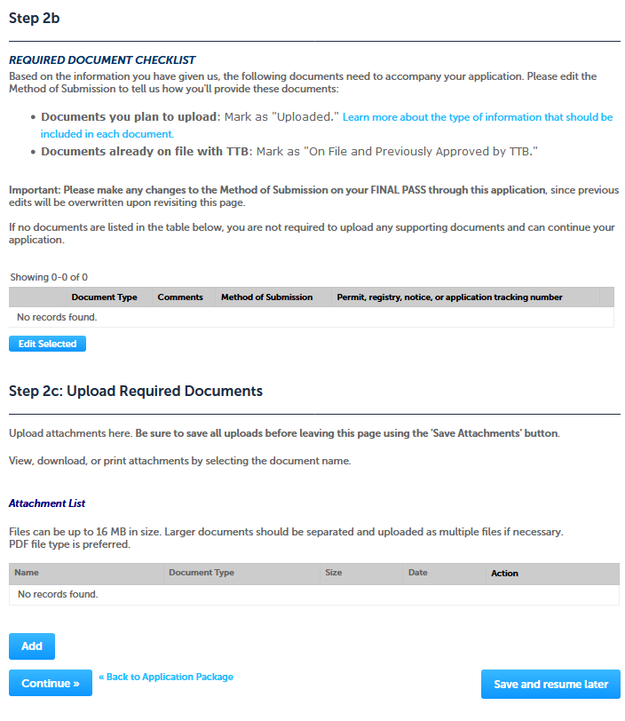

Step 3: Declare & acknowledge screen --
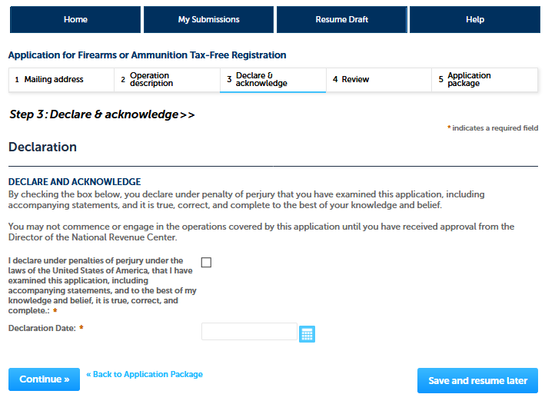

PONL screens continue below.

Submit application package screen:
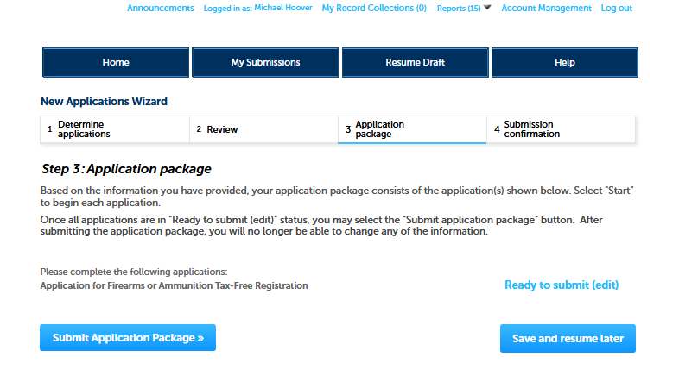

After submission of the application package, the respondent receives a receipt acknowledgement from the PONL system.

PONL Privacy Act and Paperwork Reduction Act notices are shown below.

PONL Privacy Act Notice:
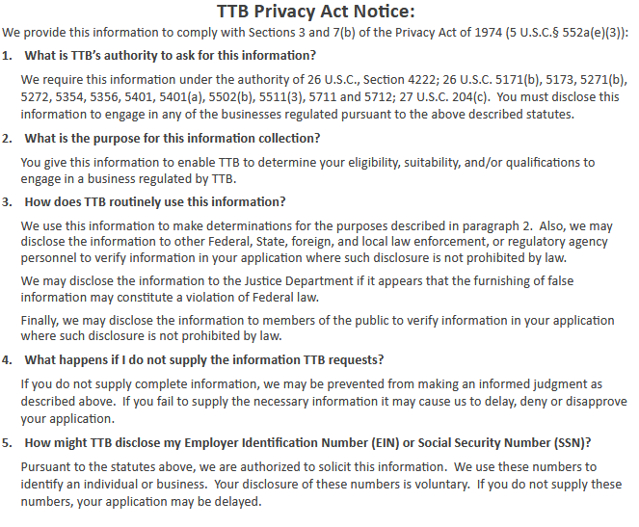

PONL screens continues below.

PONL Paperwork Reduction Act Notice (includes the notice for this information collection,
OMB No. 1513–0095):
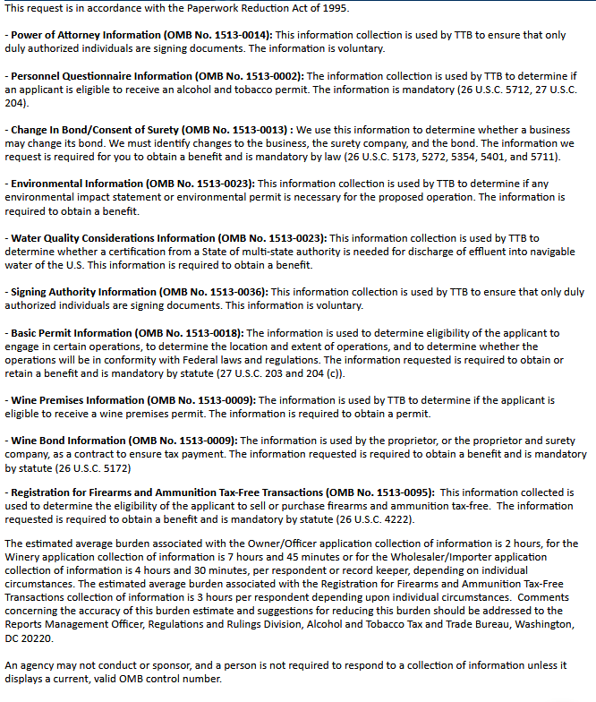
-- END –

