**Permits Online (PONL)**

**Amended Application for Alcohol Fuel Plant (Small, Medium, or Large)**

**Approved under OMB No. 1513–0051**

*Information on PONL is available on the TTB website at:* https://www.ttb.gov/ponl/customer-support.

*PONL Login Screen is at:* https://www.ttbonline.gov/permitsonline/Default.aspx.

=============================================================

**PONL Login Screen:**

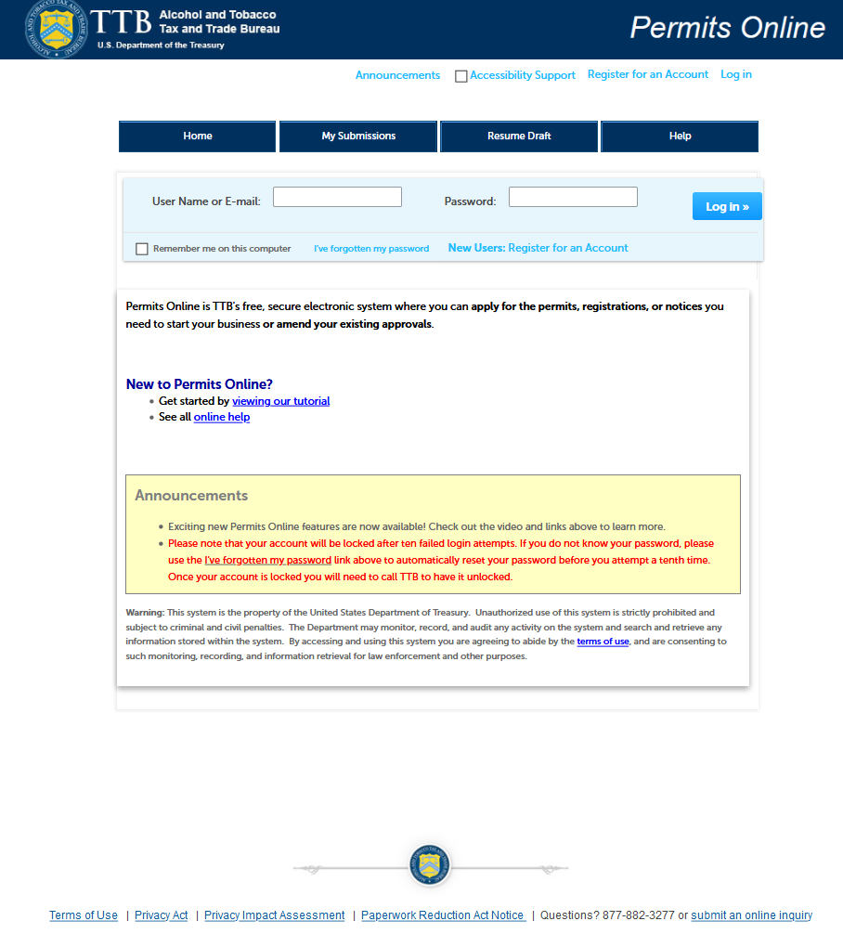

*The PONL Terms of Use, Privacy Act, Privacy Impact Assessment, and the Paperwork Reduction Act Notice statements for PONL are shown at the end of this document, beginning on page 18.*

**PONL Welcome Screen:**

*On the screen shown below, an existing Alcohol Fuel Producer Permit holder will select “Amend approved permits, registrations or notices.”*

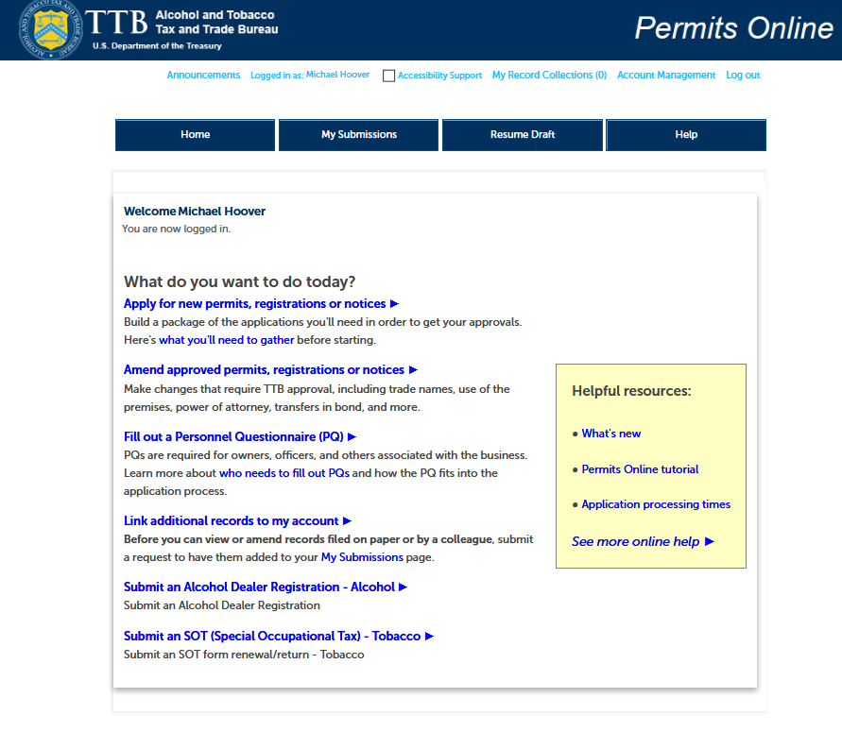

**PONL My Records Screen**

On this screen, the user will select the permit they wish to amend by clicking on the appropriate “Create Amendment link. (In this case, the Create amendment link for Permit “AFP-DC-20004.”)

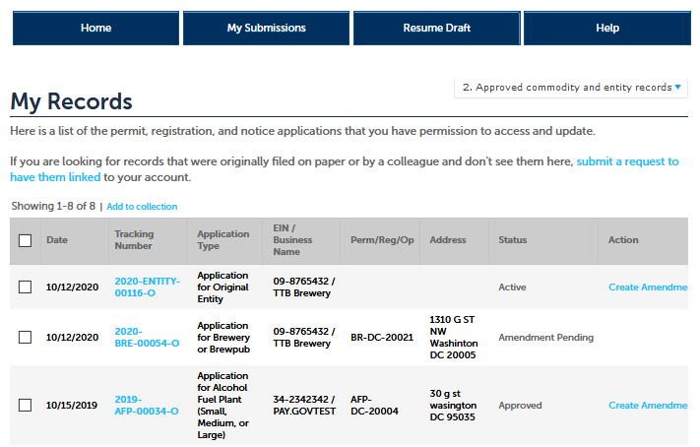

**Amendment Wizard – Step 1: Determine changes needed.**

*The user checks the appropriate boxes on this screen.*

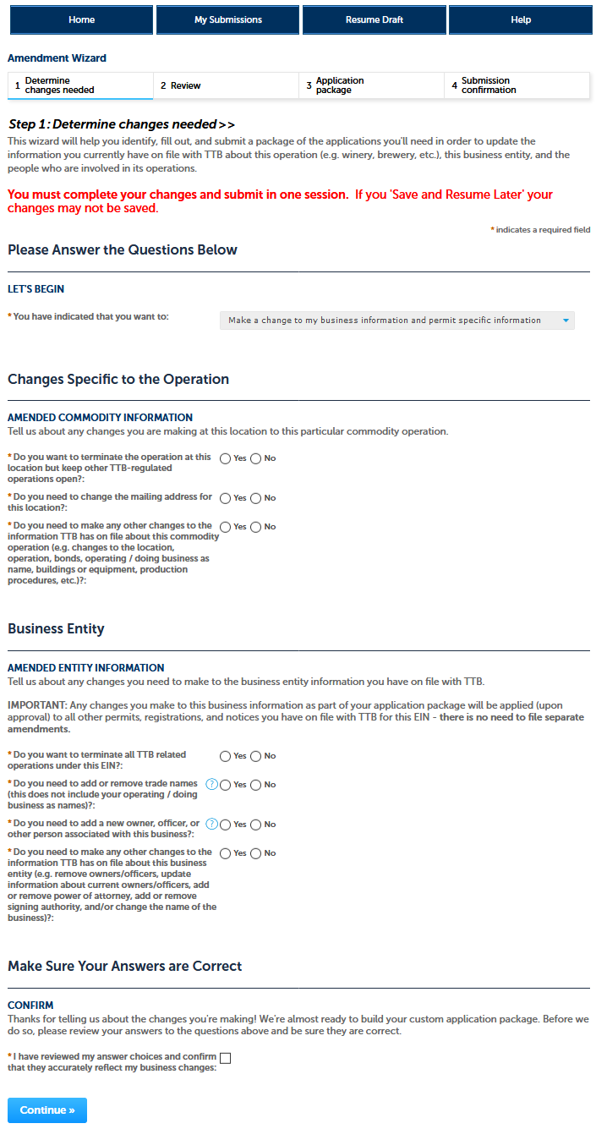

**Amendment Wizard – Step 2: Review.**

*On this screen, the user reviews the answers provided on the previous screen.*

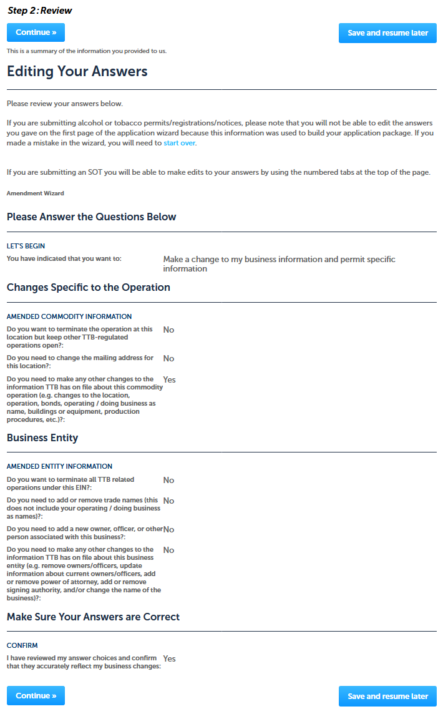

**Amendment Wizard – Step 3: Application package.**

*On this screen, the user will see and then select the Application Package to be completed, in this case the “Amended Application for Alcohol Fuel Plant (Small, Medium, or Large). The user clicks “Start” to begin the application.*

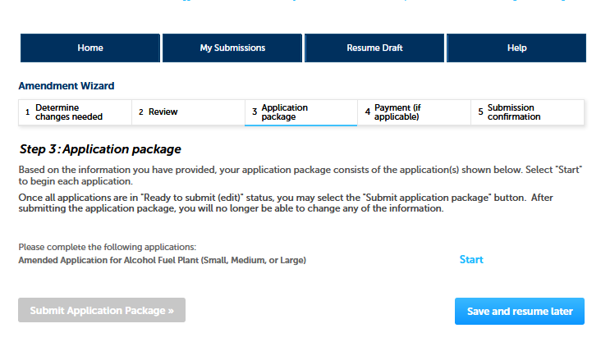

**Amended Application for Alcohol Fuel Plant (Small, Medium, or Large) – Step 1: Select amendment.**

*On this screen, the user selects the reason for the amendment application.*

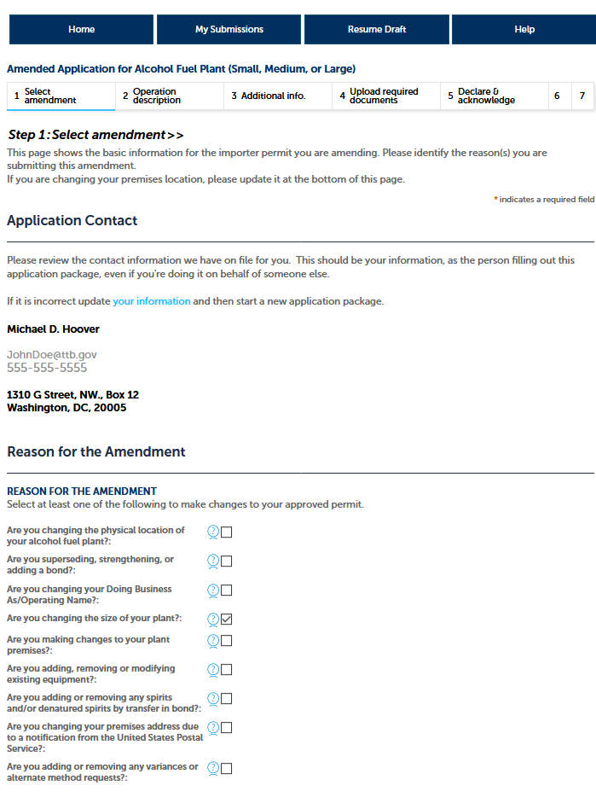

**Amended Application for Alcohol Fuel Plant (Small, Medium, or Large) – Step 1: Select amendment (continued).**

*The Select Amendment screen continues as follows:*

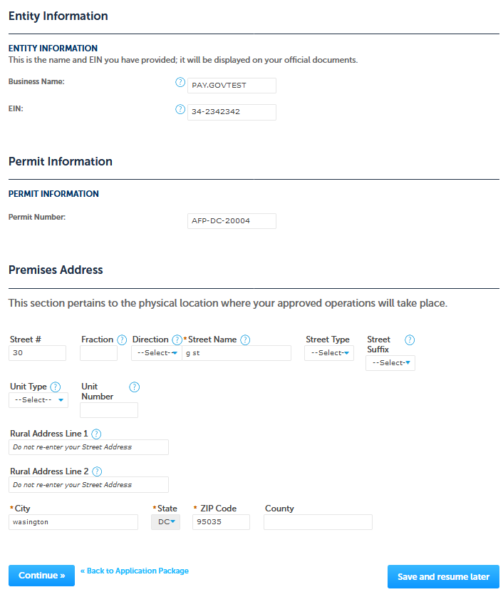

**Amended Application for Alcohol Fuel Plant (Small, Medium, or Large) – Step 2: Operation description.**

*The user adds or alters information as appropriate.*

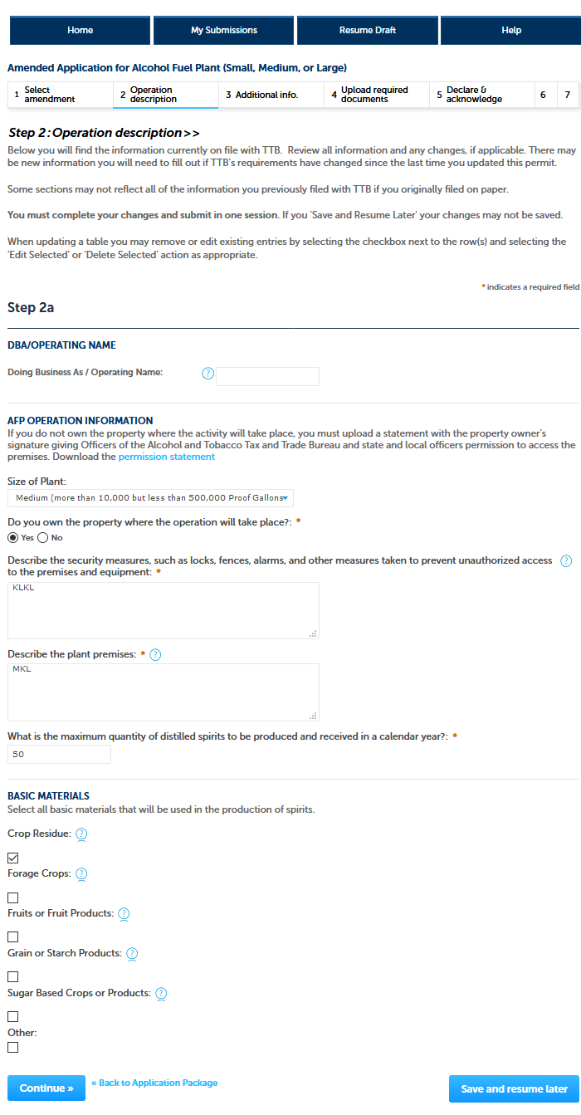

**Amended Application for Alcohol Fuel Plant (Small, Medium, or Large), Step 3 – Additional info.:**

*If applicable, the applicant next completes the “Still Information” section of the Additional Information screen:*

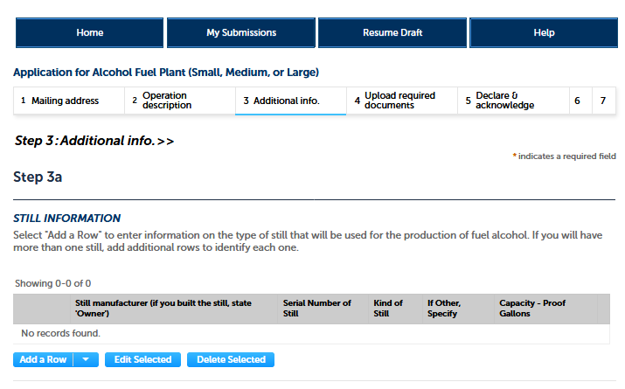

*Clicking on “Add a Row” allows the user to enter information regarding their stills via this screen:*

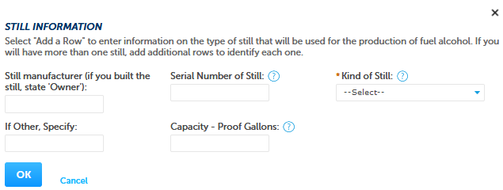

*After entering the required information, the user clicks “OK” and is returned to the Additional Information screen, as shown below:*

**Amended Application for Alcohol Fuel Plant (Small, Medium, or Large), Step 3 – Additional info. (continued):**

*The collections of the information shown on the remainder of the Additional Information screen are approved under other OMB control numbers, as described below:*

|  |  |
| --- | --- |
|  | If the applicant must file a bond, the user completes the AFP Bond section and will also later upload form TTB F 5110.56, Distilled Spirits Bond. This collection is approved under OMB No. 1513–0125. See “Add a Row” screen shot on next page. |

*Medium and Large alcohol fuel plants require a bond. Below is an example of the AFP Bond “Add a Row” screen:*

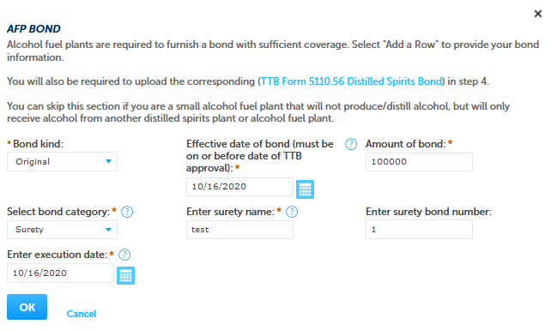

**Amended Application for Alcohol Fuel Plant (Small, Medium, or Large), Step 3 – Additional info. (continued):**

*The additional information screen continues as shown:*

|  |  |
| --- | --- |
|  | If a bond is required and that bond will cover additional operations, the user completes the Consent of Surety section and will also later upload form TTB F 5000.18. This collection is approved under OMB No. 1513–0013.  If required, the user will complete the Transfer in Bond section for each supplier as described. The PONL system will generate the corresponding Transfer in Bond form, TTB F 5100.16. This collection is approved under OMB No. 1513–0038.  If needed, the user completes the Request for Variance section and later uploads a Letterhead Application for the variance. This collection is approved under OMB No. 1513–0052, Alcohol Fuel Plant (AFP) Records, Reports, and Notices (TTB REC 5110/10).  The user then clicks “Continue” to proceed to the next screen. |

**Amended Application for Alcohol Fuel Plant (Small, Medium, or Large), Step 4 – Upload required documents:**

*This screen shows the additional, supporting documents required as part of this application, and allows for their uploading to the PONL application package.*

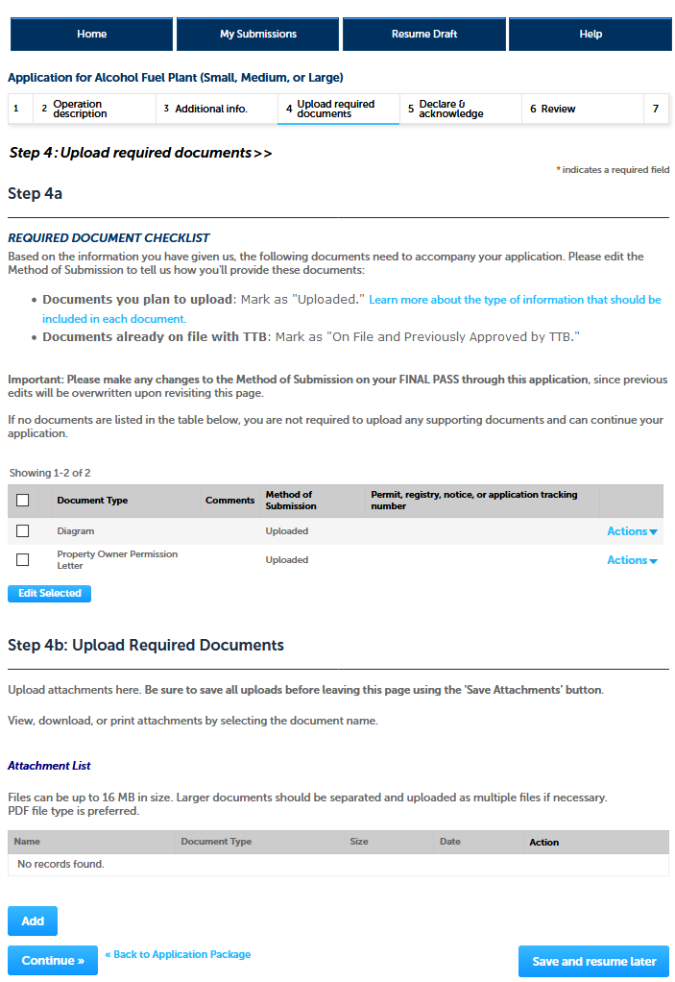

**Amended Application for Alcohol Fuel Plant (Small, Medium, or Large), Step 4 – Upload required documents (continued):**

*In Step 4b (see above), clicking on “Add” presents the upload function screen to the user:*

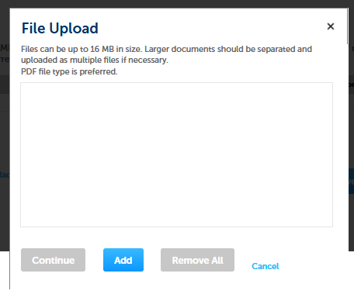

*Upload is completed as follows:*

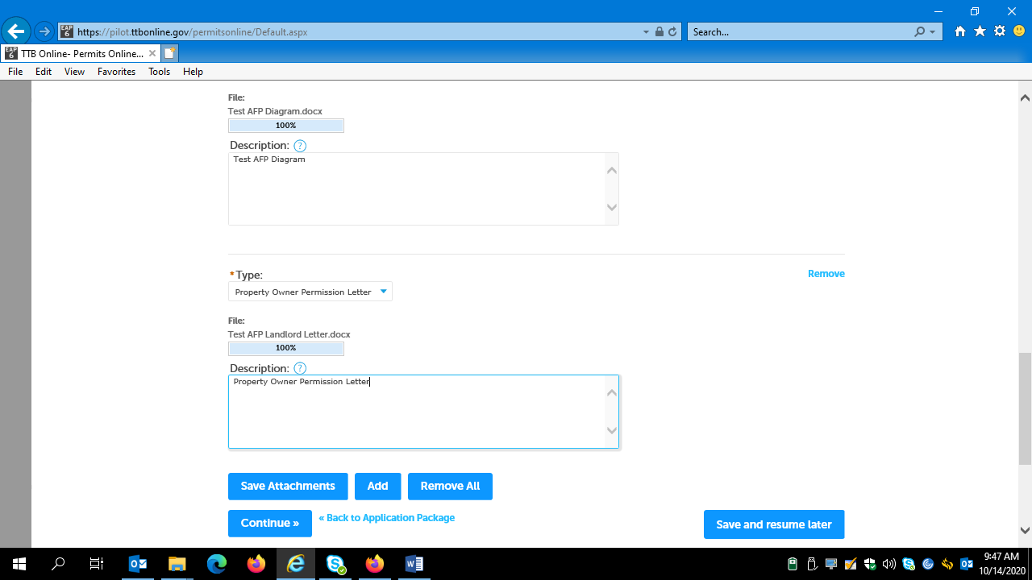

*After entering Type and Description information, the user clicks “Save Attachments” and then “Continue.”*

**Amended Application for Alcohol Fuel Plant (Small, Medium, or Large), Step 5 – Declare and acknowledge:**

*The user then completes the Declare and Acknowledge statement:*

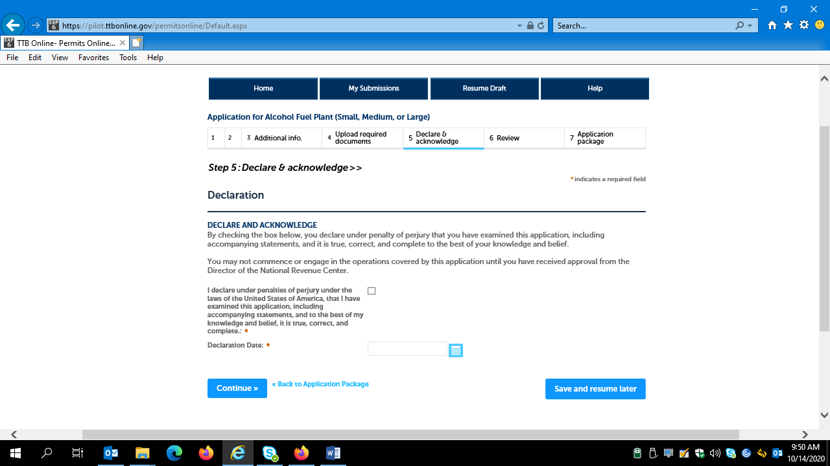

**Amended Application for Alcohol Fuel Plant (Small, Medium, or Large), Step 6 – Review:**

*The user is then presented with a review screen showing all submitted information:*

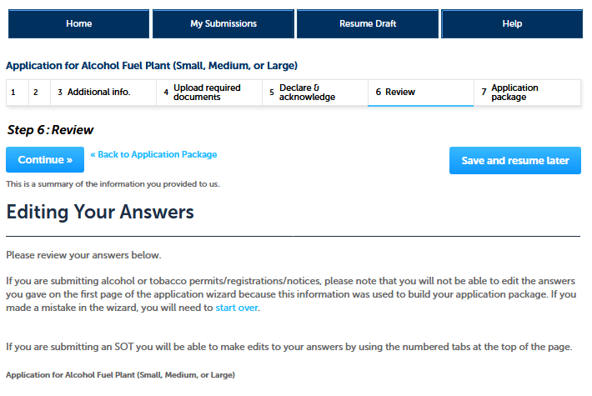

*[Remainder of review screen not shown.]*

*User clicks “Continue” at the bottom of screen and is present with the Submit Application Package page, as shown below:*

**Amendment Wizard — Step 3: Application Package (submission page.**

*The use clicks on “Submit Application Package” to submit this amendment application to TTB via PONL.*

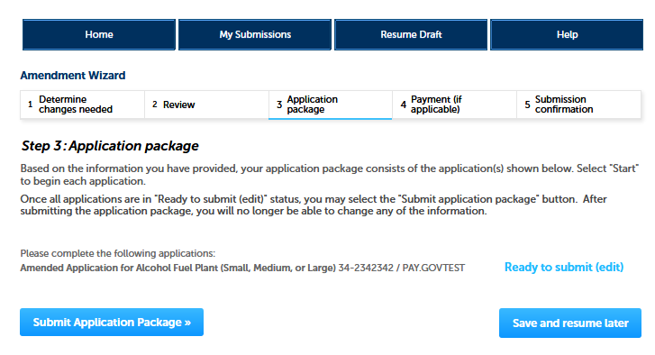

**PONL Submission Confirmation Screen:**

*After the user submits the application package, the PONL system will generate a Submission Confirmation screen, as follows:*

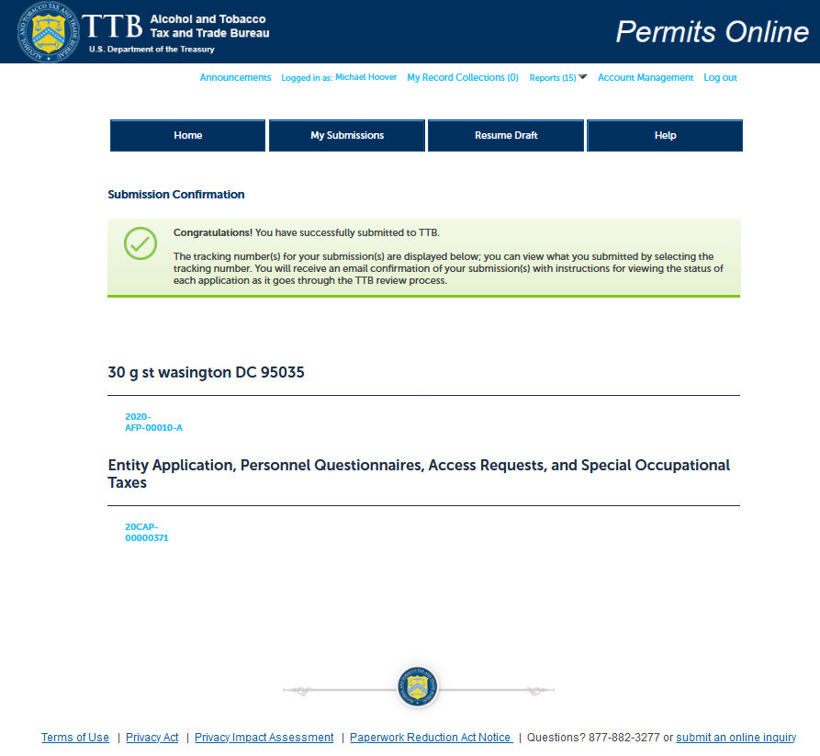

[END OF AMENDED APPLICATION FOR ALCOHOL FUEL PLANT (SMALL, MEDIUM, OR LARGE)]

*The PONL Terms of Use, Privacy Act, Privacy Impact Assessment, and the Paperwork Reduction Act Notice statements for PONL are shown below:*

**PONL Terms of Use Statement:**

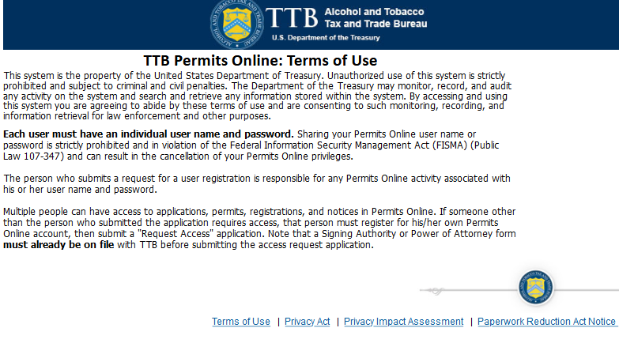

**PONL Privacy Act Notice:**

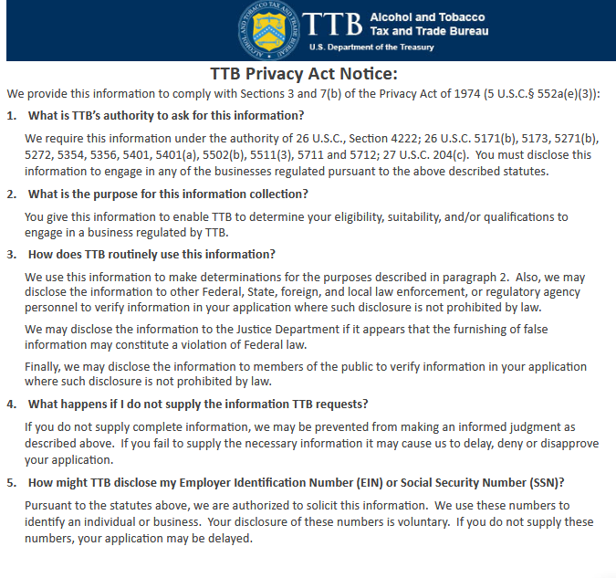

**PONL Privacy Act Assessment:**

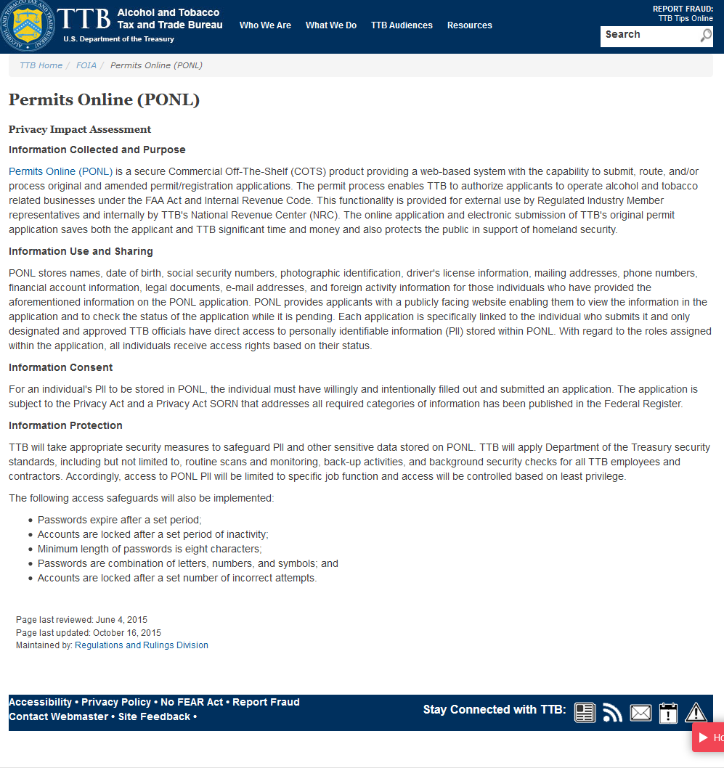

**PONL Paperwork Reduction Act Notice:**

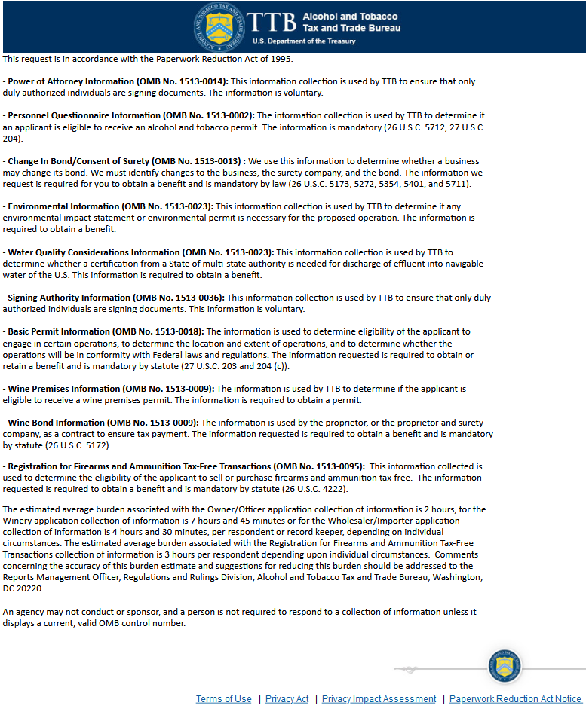

**[END OF PONL SCREENS]**