Memorandum United States Department of Education
Institute of Education Sciences

National Center for Education Statistics

DATE: August 4, 2020

TO: Robert Sivinski, OMB

THROUGH: Carrie Clarady, OMB Liaison, NCES

FROM: Nancy Sharkey, Senior Program Officer, Statewide Longitudinal Data System Program

SUBJECT: Statewide Longitudinal Data System (SLDS) Survey 2020-2022 Online Data Collection Tool Update Change Request (OMB# 1850-0933 v.9)
The National Center for Education Statistics (NCES), of the Institute of Education Sciences (IES), within the U.S. Department of Education, is requesting clearance to continue the Statewide Longitudinal Data System (SLDS) Survey collection, which is intended to provide insight on State and U.S. territory SLDS capacity for automated linking of K-12, teacher, postsecondary, workforce, career and technical education (CTE), adult education, and early childhood data. The SLDS Survey will continue to be collected annually from State Education Agencies (SEAs), and will help inform NCES ongoing evaluation and targeted technical assistance efforts to enhance the quality of the SLDS Program’s support to States regarding systems development, enhancement, and use. This submission is to request OMB clearance to conduct the annual SLDS Survey from 2020 through 2022. Upon clearance of this package, a change request will be submitted with screenshots of the Google Form (see section A.3 for more information) that is still being programmed. While the date of that change request is entirely dependent upon the clearance of this package, we anticipate that the subsequent change request will be submitted in late Spring 2020.

The request is to conduct all activities related to SLDS 2020-22, including materials and procedures, was approved by OMB in May 2020 (OMB#1859-0933 v.8). The SLDS 2020 data collection will take place in October 2020.

This request submits screenshots of the Google Form that will be used in the 2020 SLDS Data Collection, and associated updates to the webinar (one or two) that will be conducted to provide guidelines to respondents. This request does not introduce significant changes to the estimated respondent burden or the costs to the federal government. The following revisions were made to Part A (p. 2) and the Appendices.

Modifications to Part A

Section 1 (Circumstances Making Collection of Information Necessary)

The National Center for Education Statistics (NCES), of the Institute of Education Sciences (IES), within the U.S. Department of Education, is requesting clearance to continue the Statewide Longitudinal Data System (SLDS) Survey collection, which is intended to provide insight on State and U.S. territory SLDS capacity for automated linking of K-12, teacher, postsecondary, workforce, career and technical education (CTE), adult education, and early childhood data. The SLDS Survey will continue to be collected annually from State Education Agencies (SEAs), and will help inform NCES ongoing evaluation and targeted technical assistance efforts to enhance the quality of the SLDS Program’s support to States regarding systems development, enhancement, and use. This submission is to request OMB clearance to conduct the annual SLDS Survey from 2020 through 2022. Upon clearance of this package, a change request will be submitted with screenshots of the Google Form (see section A.3 for more information) that is still being programmed. While the date of that change request is entirely dependent upon the clearance of this package, we anticipate that the subsequent change request will be submitted in late Spring 2020. The request to conduct all activities related to SLDS 2020-22, including materials and procedures, was approved by OMB in May 2020 (OMB#1859-0933 v.8). This request submits screenshots of the Google Form that will be used in the 2020 SLDS Data Collection (see Appendix E).

Section 3 (Appropriate Use of Information Technology)
In the instance that a State is unable to access the online platform or need a paper copy as a reference copy to use during their consultations with other program offices, a Microsoft Word version of the document (pre-populated with as much information as is available to program staff) can be provided upon request via email (see Appendix E, Section 2). In cases where the Google Form is unavailable, States may elect to complete the flat file instrument and return it via email.

Modifications to Appendix A

Deleted prefatory note: (An updated version with accurate dates and links to the new Google Form information collection tool may be included in the post-clearance change request, estimated for late Spring 2020)

Modifications to Appendix B

Deleted prefatory note: (Below is the version for 2019. An updated version with accurate dates and screenshots of the new Google Form information collection tool will be included in the post-clearance change request, estimated for late Spring 2020.)

The webinar slides have been updated to reflect a 2020 presentation, completion using the online Google form.

See Attachment 1 (pp. 3-8 of this document) to see copies of screenshots deleted and added.

Modifications to Appendix E

- The prefatory note has been removed from Appendix E, as the Google form has now been completed. There were significant delays impacting the development of the project, resulting in deviation from the expected completion timelines. Screenshots of the functional Google form can be found in Appendix E, Section 1. Definitions have been embedded within the online tool, with a link to a complete list of definitions within the Instructions.

Deleted prefatory note: The online Survey platform is still in development. All questions proposed for the 2020 Survey collection are included in the Word version of the instrument, found below the preliminary online Survey form screenshots below. The following timeline is proposed to facilitate the shift from the instrument in flat file (below) to an online Survey form. An updated version of Appendix E, complete with new screenshots of the finalized instrument as well as a cleaner version of the instrument that will be distributed to respondents who are unable to complete the Google Form, will be included in the post-clearance change request, estimated for late Spring 2020.

Activity | Expected Completion Date
Draft survey in Google Forms | March 1, 2020
QA survey and skip logic | March 15, 2020
Revise survey and finalize | April 1, 2020

*Online Survey development takes place in tandem with Statistics in Brief development and ultimate release, currently utilizing the same staff for both processes. The release of the 2018 and 2019 collection Statistics in Brief documents have been prioritized as our commitment to release information and analysis back to the field as soon as possible.
- Appendix E has been broken into a Section 1 (Online Google Form Platform) and Section 2 (Flat File Instrument). A complete collection of screenshots of the Online Google Form can now be seen in the attached Appendix E (pp.2 – 61) and have not been duplicated here for the sake of brevity.
  - The Google Form can also be seen at the below link: https://docs.google.com/forms/d/e/1FAIpQLSdT0_ghbK7iv-WaT_7smc3X0lzDv-yvLhRz21-PRqfE8fzuLw/viewform?fbzx=-643560529780376193

- A prefatory note has been added to the beginning of Appendix E Section 2 (Flat File Instrument), as seen below

NOTE: As discussed in Part A, section 3, “In the instance that a State is unable to access the online platform or need a paper copy as a reference copy to use during their consultations with other program offices, a Microsoft Word version of the document (pre-populated with as much information as is available to program staff) can be provided upon request via email (see Appendix E, Section 2). In cases where the Google Form is unavailable, States may elect to complete the flat file instrument and return it via email.”

- The due date for surveys submitted via email has been updated to match the due date for submission via the Google Doc.

To ensure the success of the SLDS Survey, we need your help. Included in this package you will find the SLDS Survey and completion instructions. We encourage all respondents to complete the online version to ease both completion and analysis time. Should you have issues accessing or completing the online version of the Survey, please do not hesitate to contact us. We will accept completed surveys via email until the deadline of: November 15 30, 2020.

Attachment 1 – Detailed Changes to Appendix B

v. 8
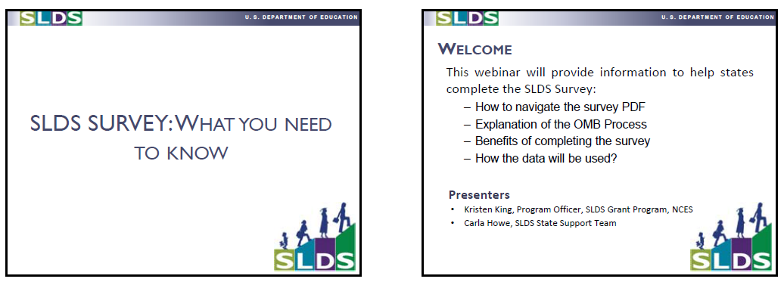
v. 9
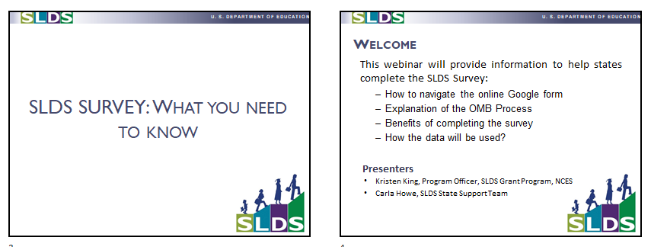
Change: changed “the survey PDF” to “the online Google form”

v. 8
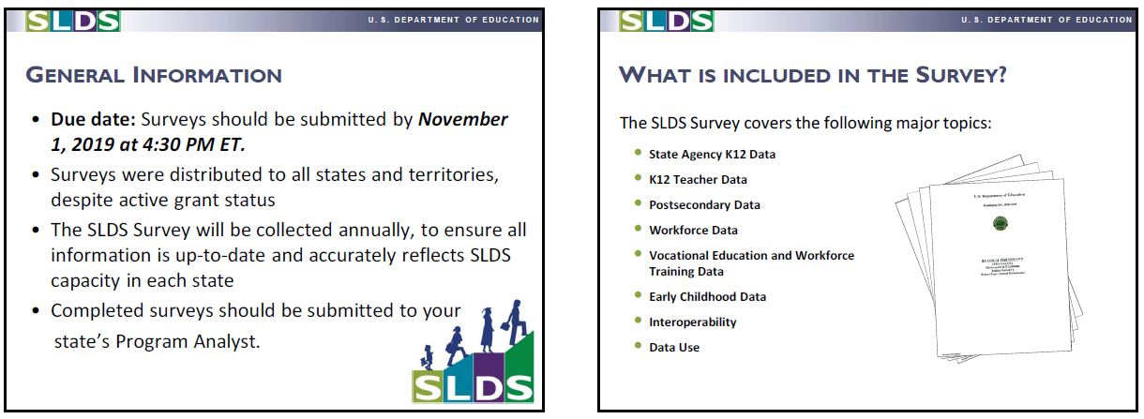
v. 9
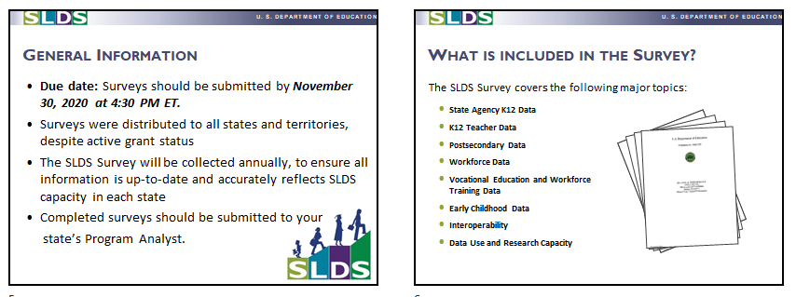
Change: changed the date of submission from November 1, 2019 to November 30, 2020.

v. 8
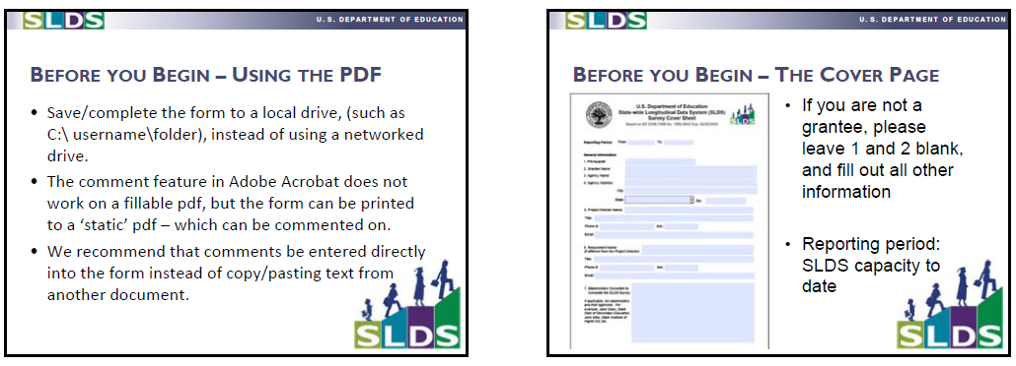
v. 9
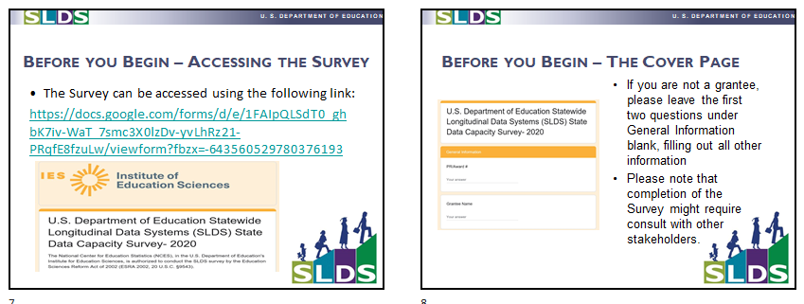
Changes: provided link to Google Form, changed text and screenshots referring to the instrument.

v. 8
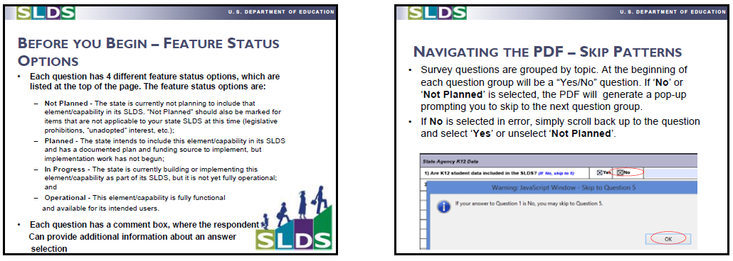
v. 9
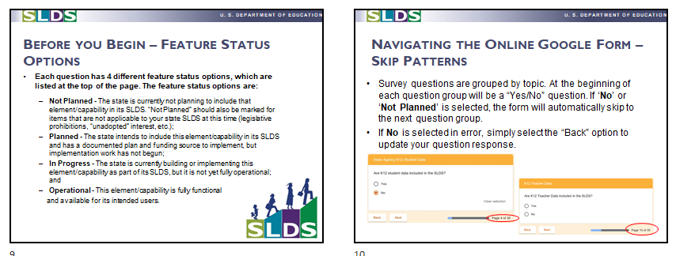
Change: removed information about comment boxes, as the form has changed; changed screenshot

v. 8
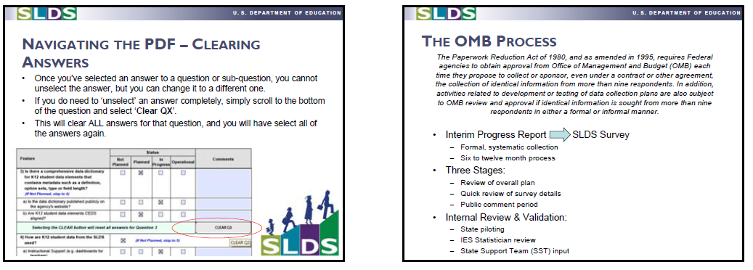
v. 9
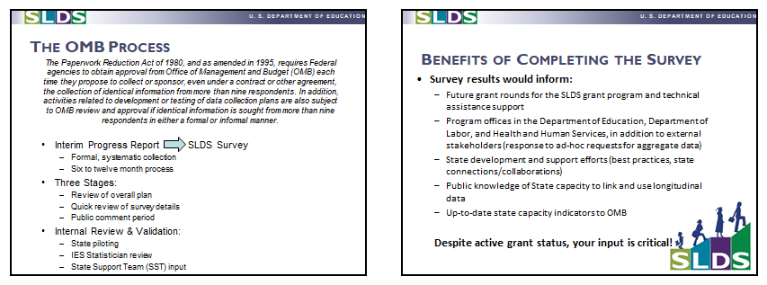
Change: deleted a now irrelevant slide about clearing answers (only applied to the old form)

v. 8
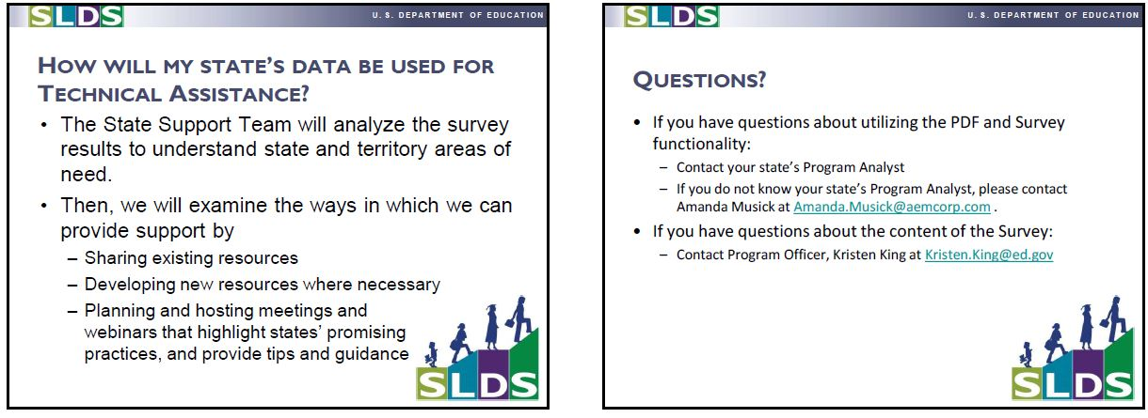
v. 9
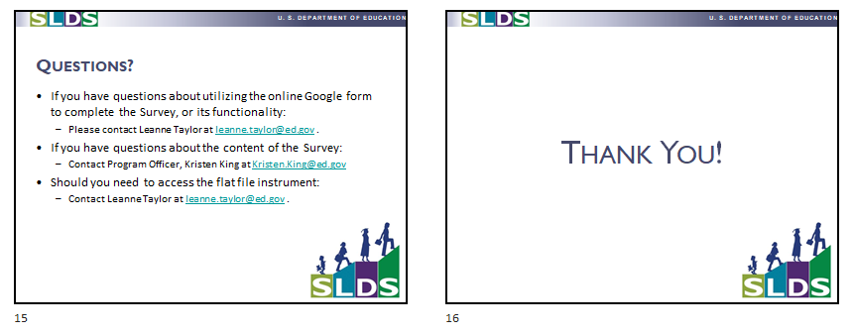

Change: changed contact information

