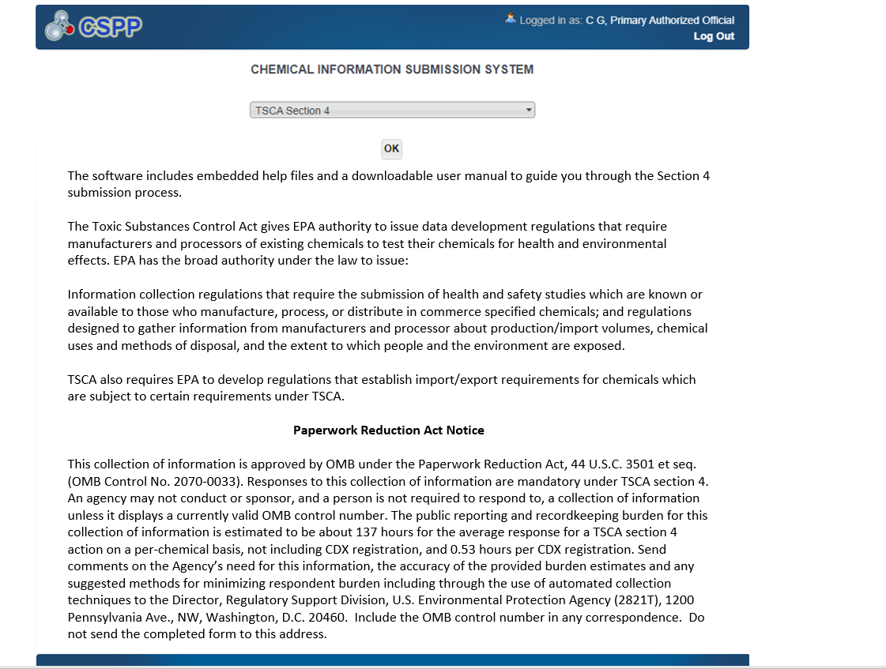

‘Initial Response to Order’ Screen (Populated)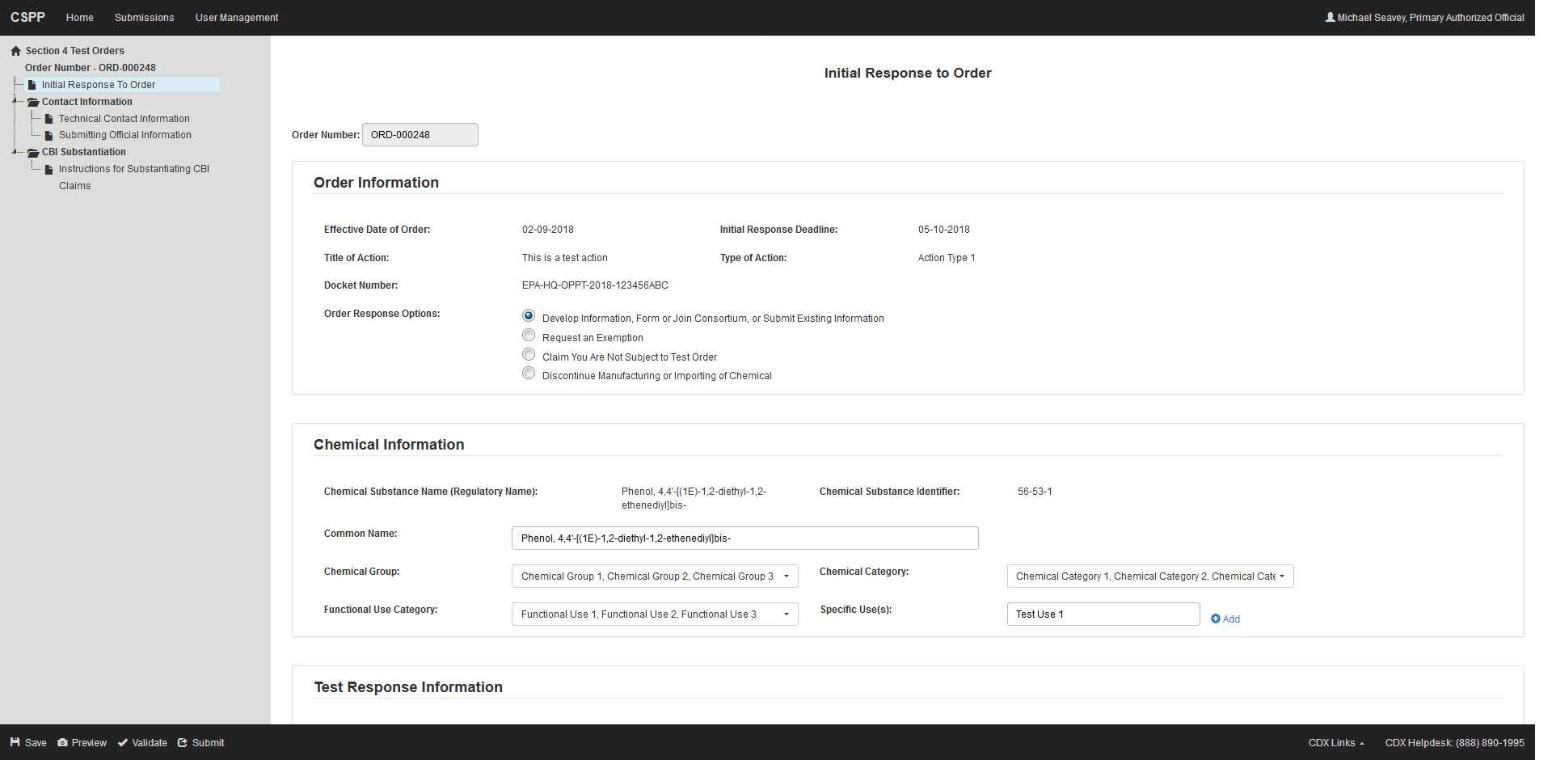

‘Initial Response to Order’ Screen  
Develop Information, Form or Join Consortium, or Submit Existing Information

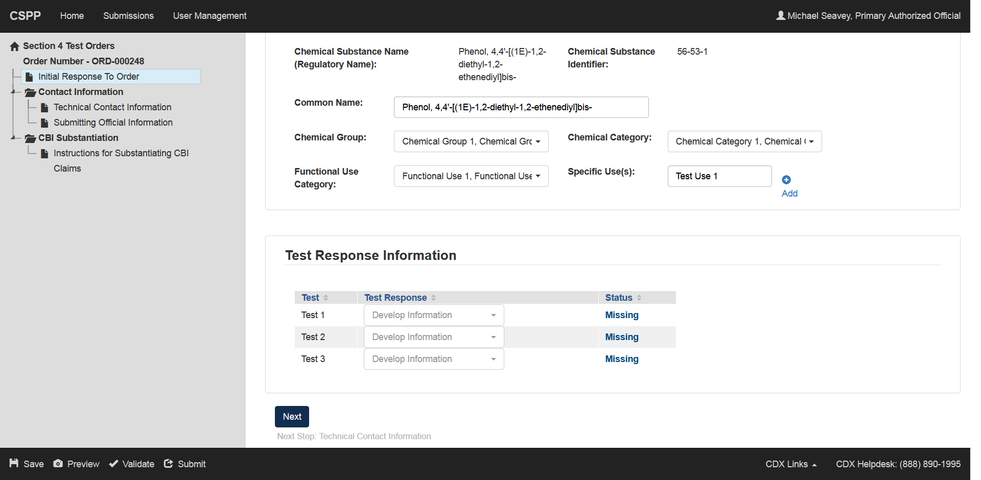

‘Initial Response to Order’ Screen  
 (Request an Exemption)

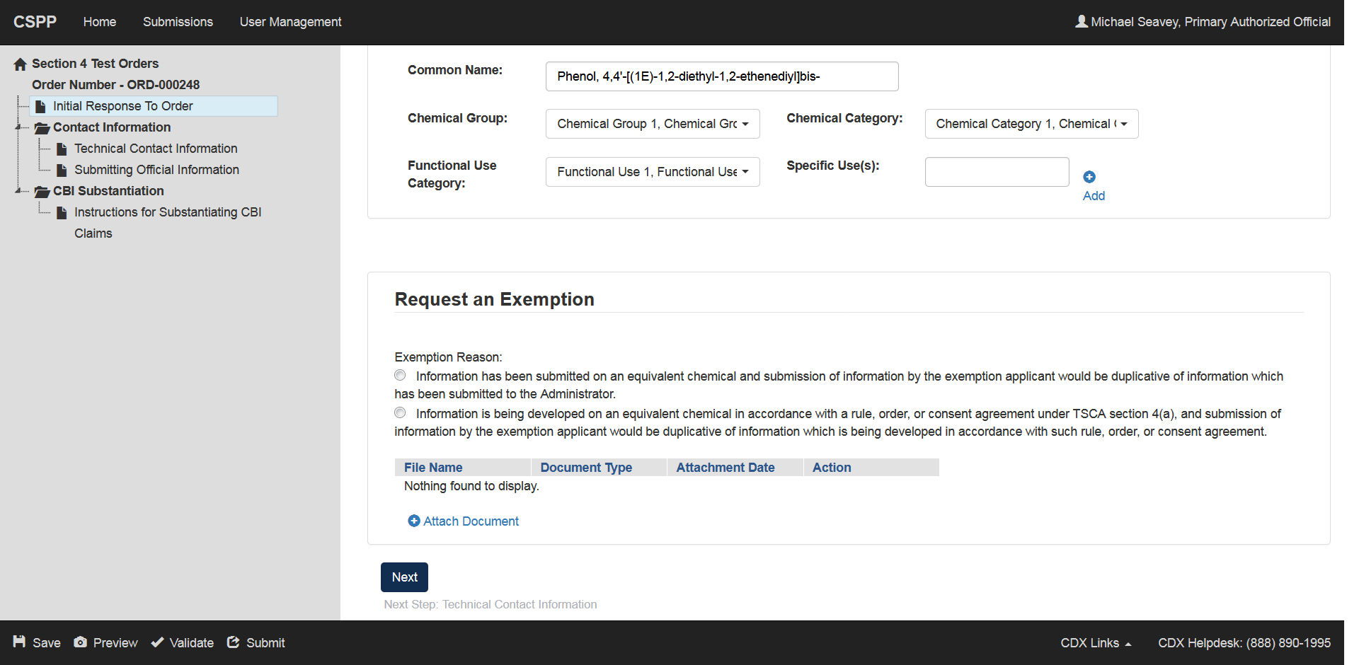

‘Initial Response to Order’ Screen  
Claim You Are Not Subject to Test Order

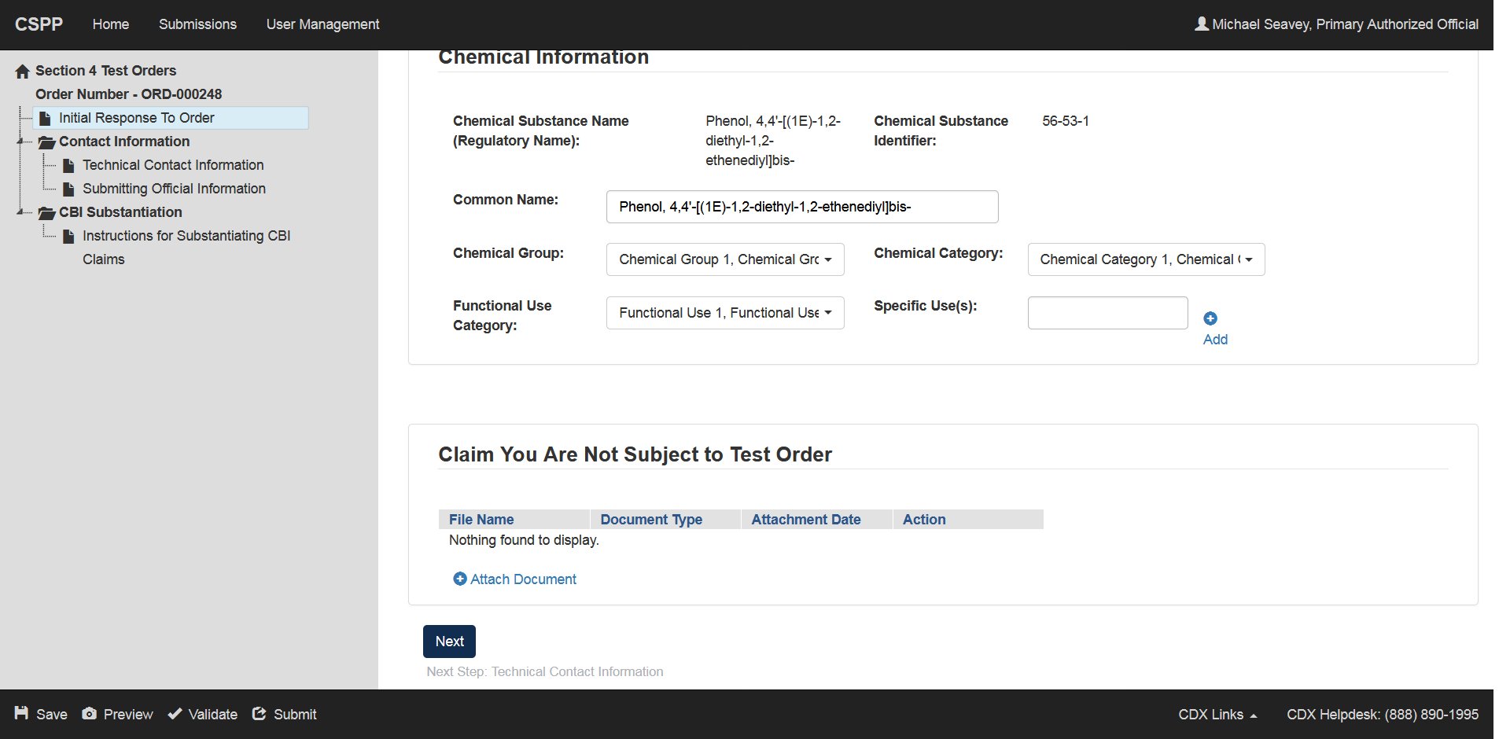

‘Initial Response to Order’ Screen  
Discontinue Manufacturing or Importing of Chemical

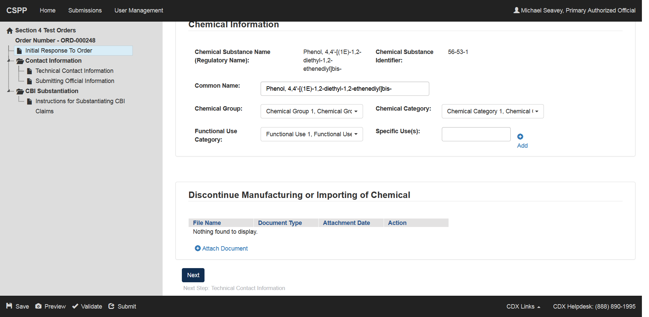

‘Technical Contact’ Screen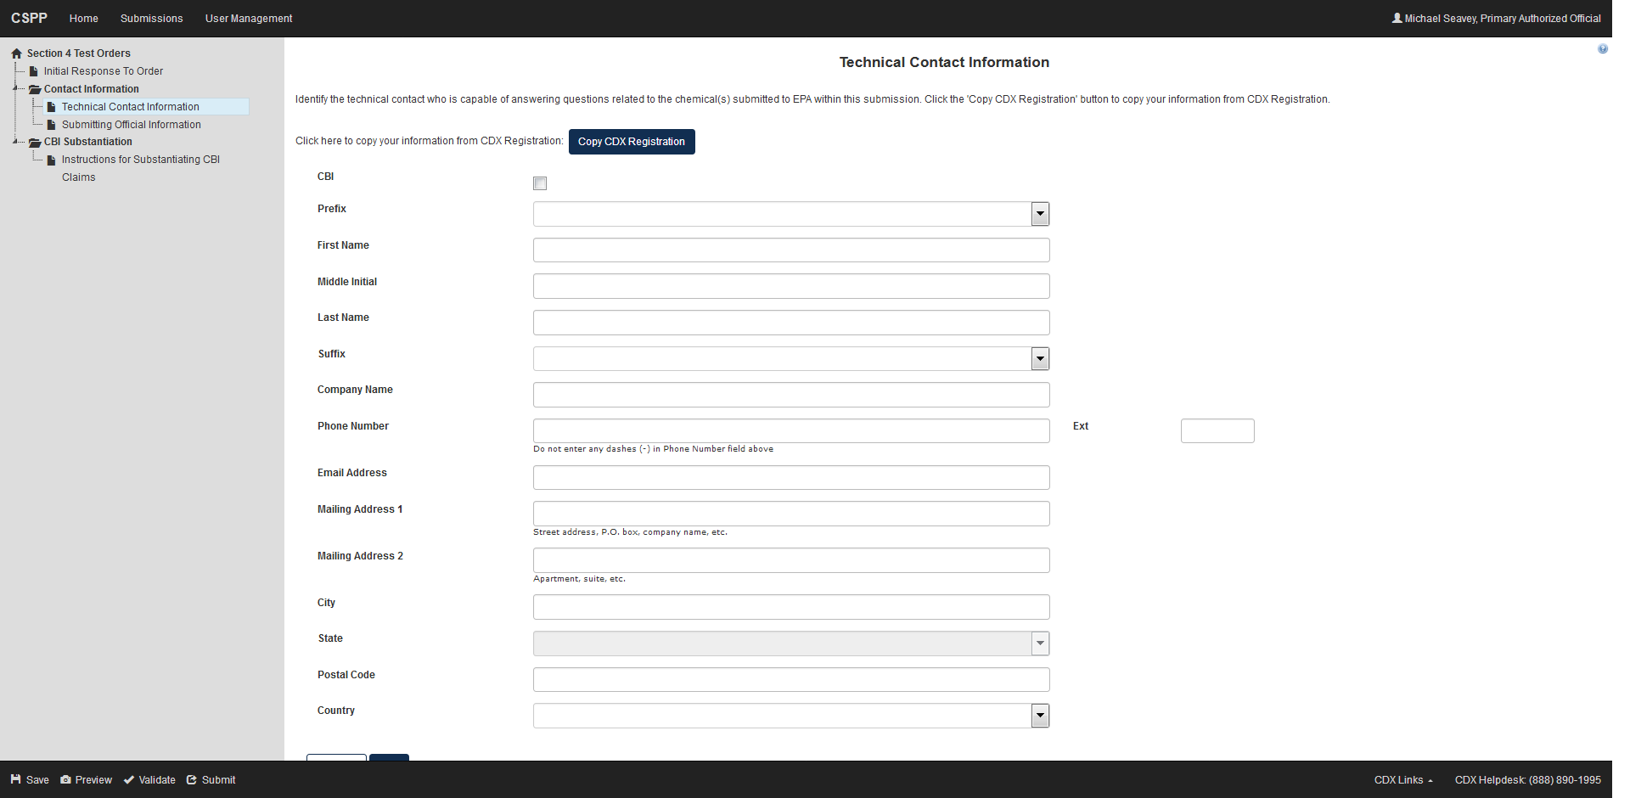

‘Submitting Official Information’ Screen

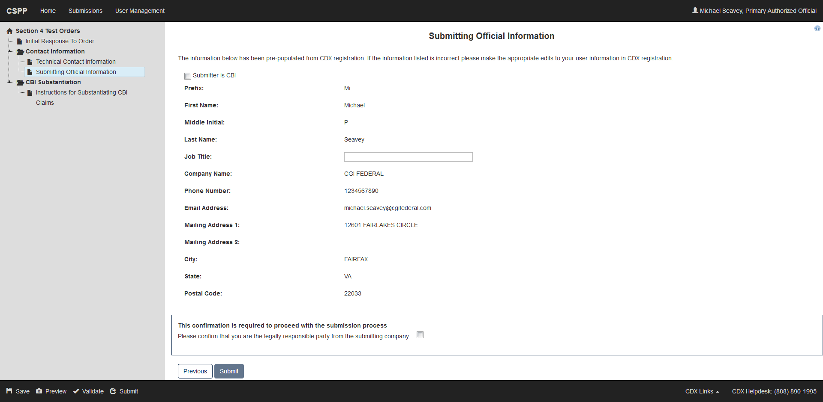

‘Instructions for Substantiating Confidential Business Information (CBI) Claims’ Screen

