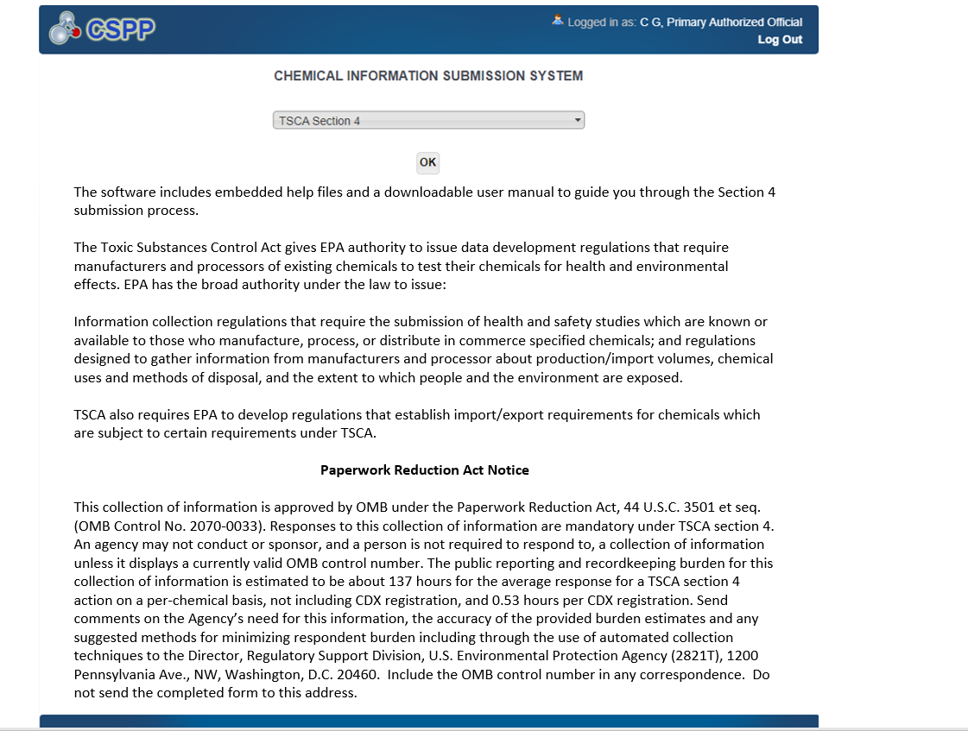
‘Initial Response to Order’ Screen (Populated)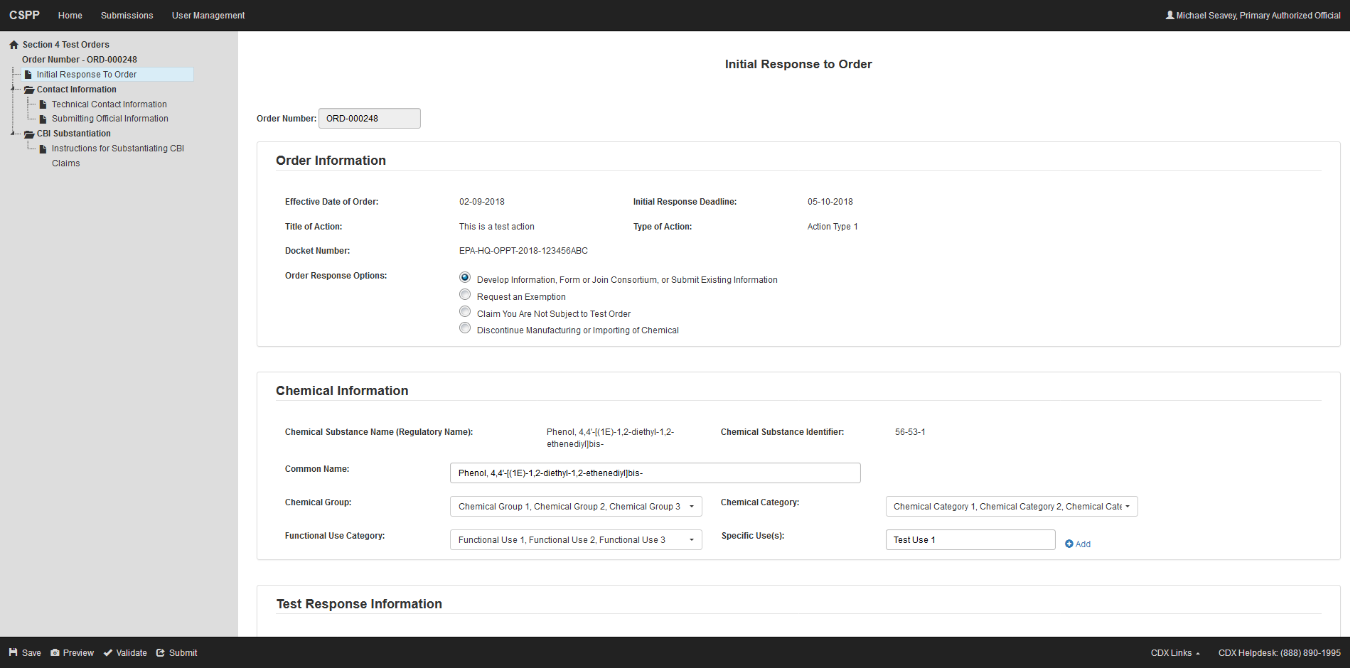

‘Initial Response to Order’ Screen
Develop Information, Form or Join Consortium, or Submit Existing Information
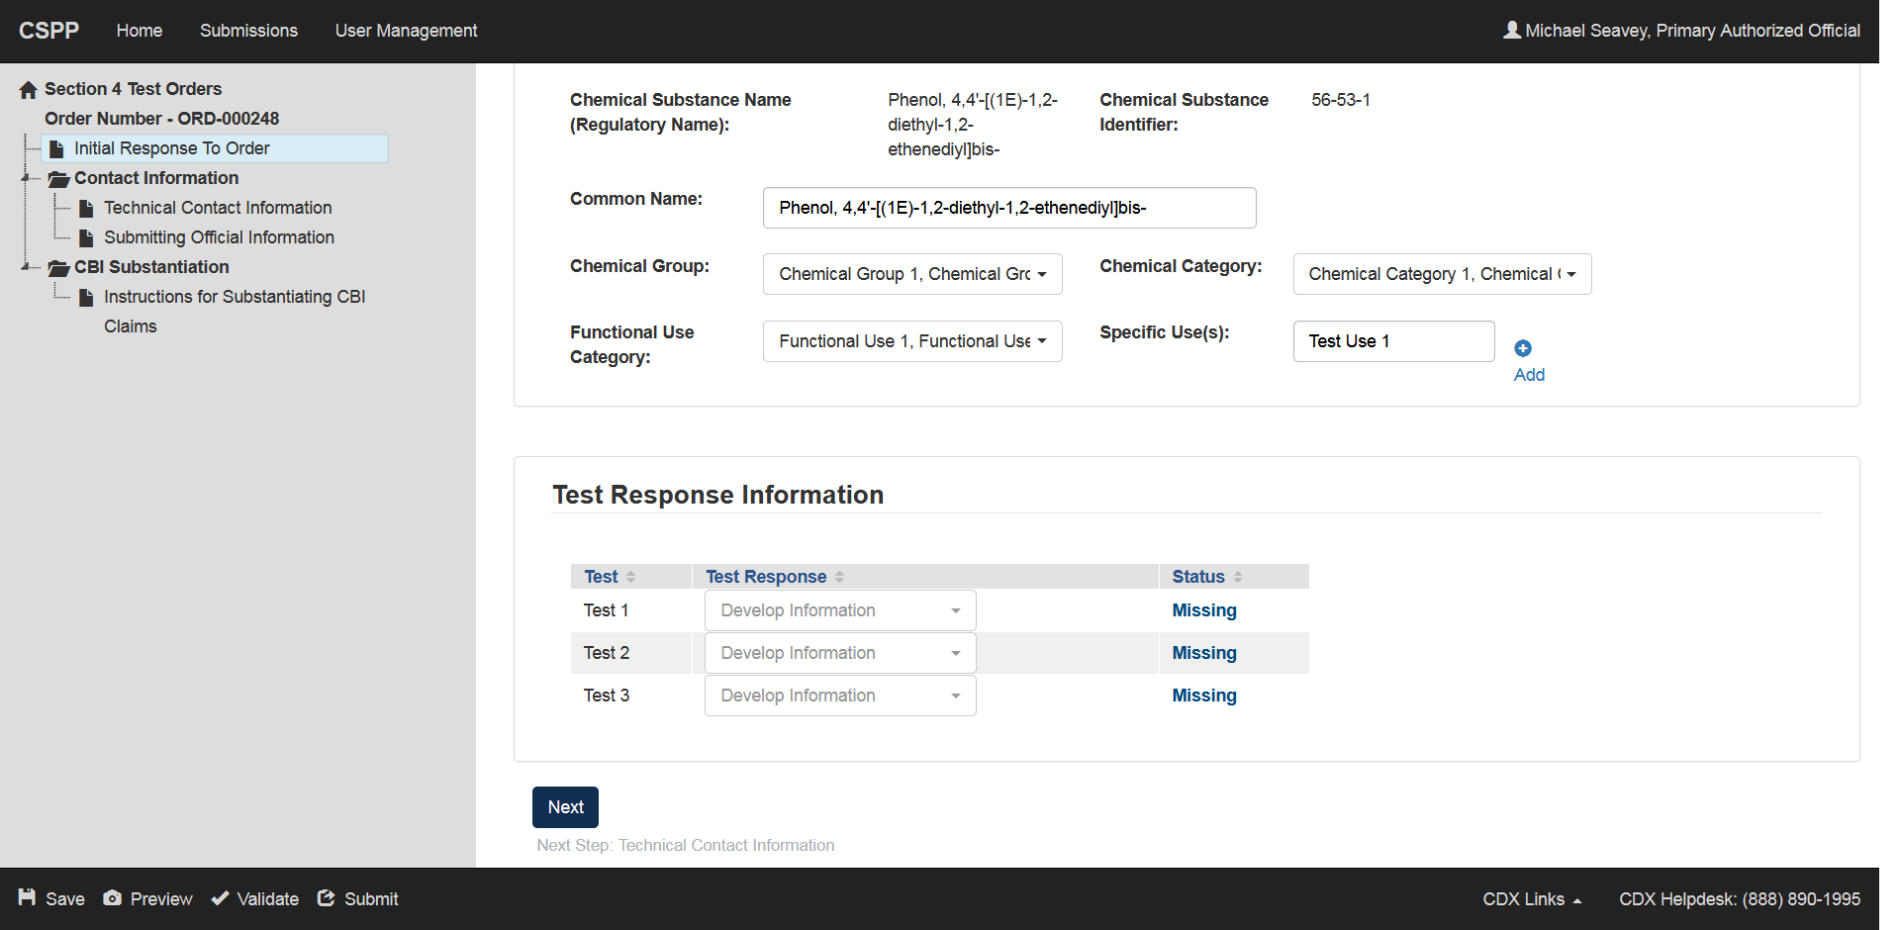

‘Initial Response to Order’ Screen
(Request an Exemption)
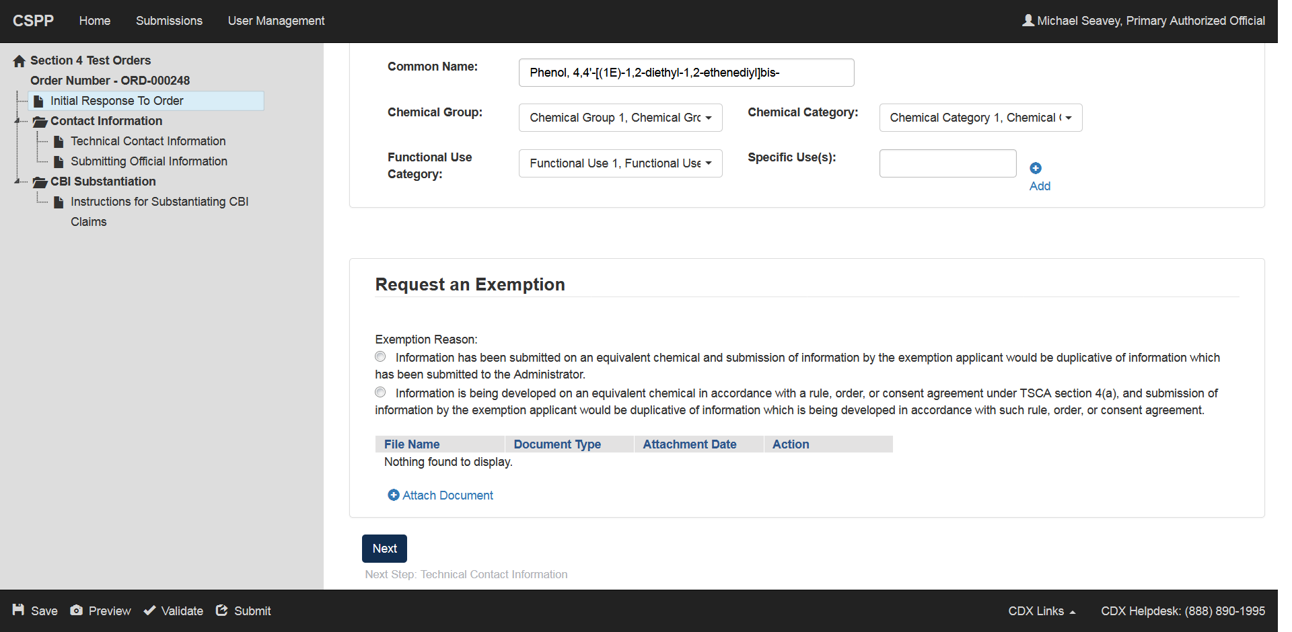

‘Initial Response to Order’ Screen
Claim You Are Not Subject to Test Order
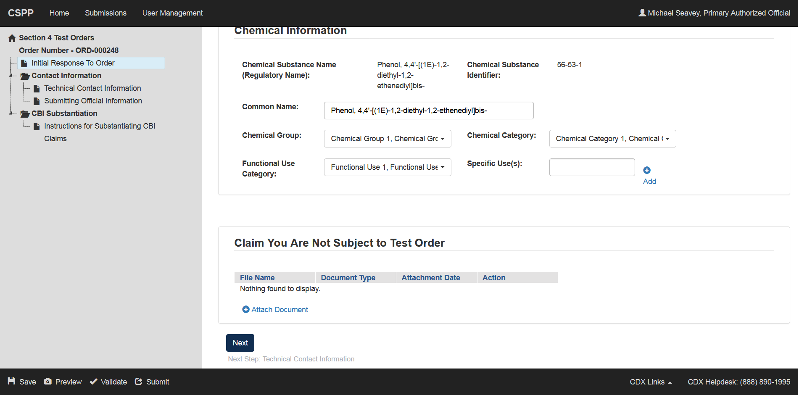

‘Initial Response to Order’ Screen
Discontinue Manufacturing or Importing of Chemical
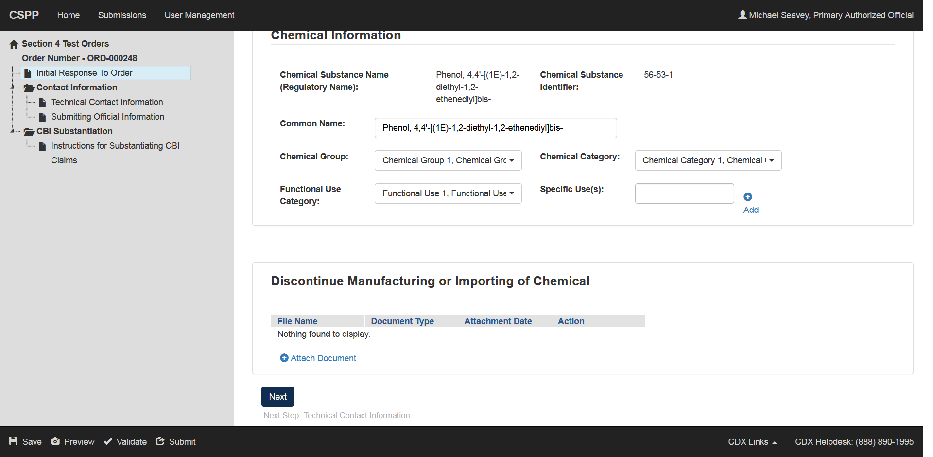

‘Technical Contact’ Screen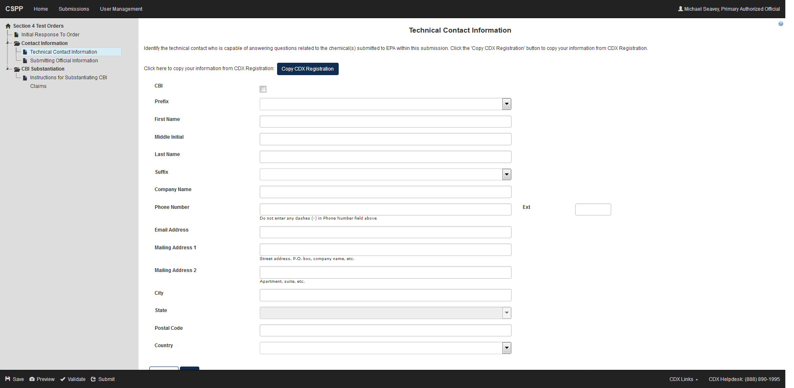

‘Submitting Official Information’ Screen
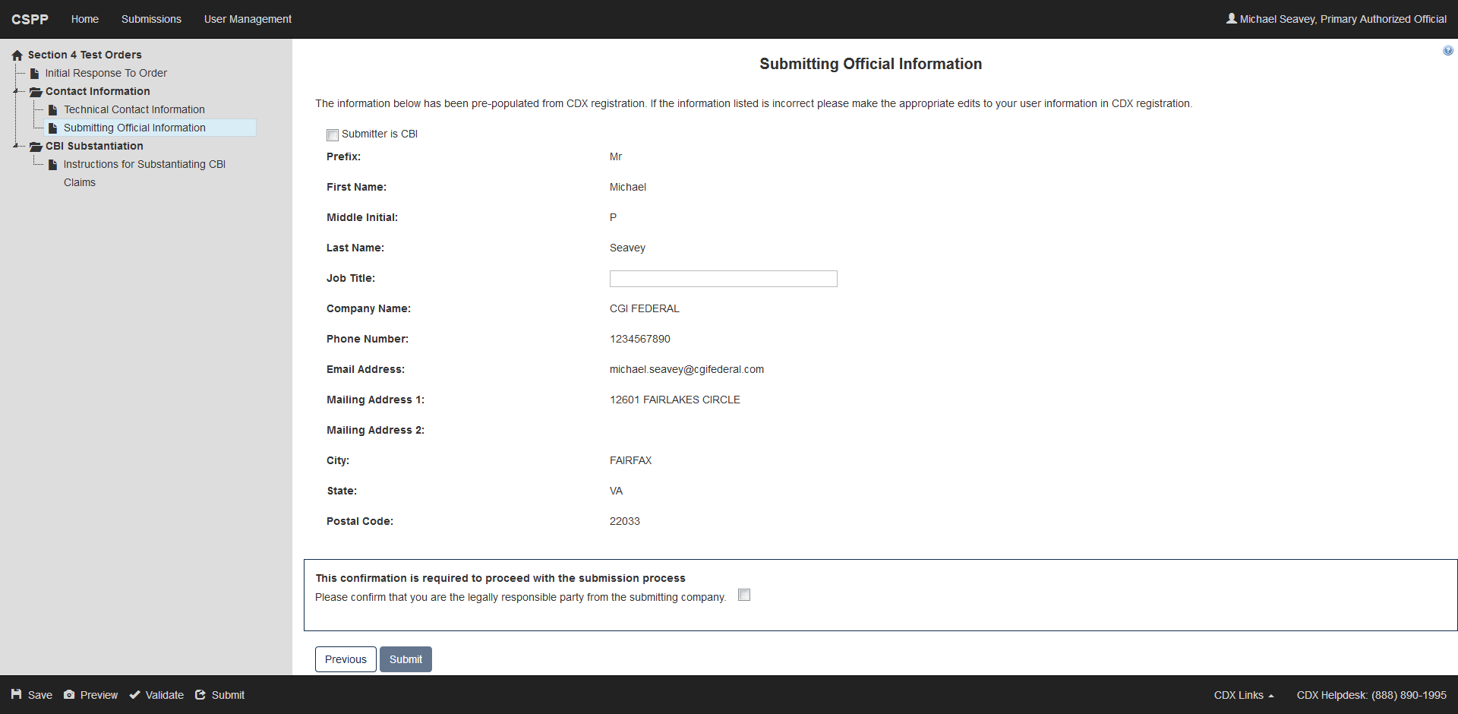

‘Instructions for Substantiating Confidential Business Information (CBI) Claims’ Screen
