Department of Transportation

Federal Aviation Administration

SUPPORTING STATEMENT

Limited Recreational Unmanned Aircraft Operation Applications

2120-XXXX

INTRODUCTION

This information collection is submitted to the Office of Management and Budget (OMB) to request approval for the information collection entitled “Limited Recreational Unmanned Aircraft Operation Applications”.

**Part A. Justification**

1. **Circumstances that make collection of information necessary.**

In 2018, Congress passed the FAA Reauthorization Act of 2018 (Public Law 115-254). § 44809 of Public Law 115-254 allows a person to operate a small unmanned aircraft (sUA) without specific certification or operating authority from the Federal Aviation Administration (FAA) if the operation adheres to certain limitations.

These limitations require the FAA to recognize Community Based Organizations (CBOs), facilitate the administration of an aeronautical knowledge and safety test by CBOs and other entities, establish fixed flying sites, and approve standards and limitations for unmanned aircraft weighing more than 55lbs.

§ 44809 specifically places the following requirements on the FAA which necessitate the collection of information:

**§ 44809(c)(1) Operations at Fixed Sites – Operating Procedure Required**

*Persons operating unmanned aircraft under subsection (a) from a fixed site within Class B, Class C, or Class D airspace or within the lateral boundaries of the surface area of Class E airspace designated for an airport, or a community-based organization conducting a sanctioned event within such airspace, shall make the location of the fixed site known to the Administrator and shall establish a mutually agreed upon operating procedure with the air traffic control facility.*

The FAA is establishing recreational flyer fixed sites (“fixed sites”) to permit sUA operations in Class B, Class C, Class D, or Surface E2 airspace without the need for each individual operator to receive an airspace authorization from Air Traffic Control (ATC). When a fixed site is approved, individuals are permitted to fly sUA at that location, within the limitations of § 44809 and any additional conditions and limitations placed on the fixed site authorization from ATC.

Sanctioned event sites located in Class B, Class C, Class D, or Surface E2 airspace must also request a fixed site authorization from the FAA. Additionally, recreational flyer requests to operate above a UAS Facility Map (UASFM) altitude ceiling or above 400 feet in Class G airspace must submit a request and receive approval from ATC.

**§ 44809(c)(2)(a) Operations at Fixed Sites – Unmanned Aircraft Weighing More Than 55 Pounds**

*A person may operate an unmanned aircraft weighing more than 55 pounds, including the weight of anything attached to or carried by the aircraft, under subsection (a) if…the unmanned aircraft complies with standards and limitations developed by a community-based organization and approved by the Administrator.*

Operations of unmanned aircraft heavier than 55 pounds require an FAA-recognized CBO to submit their standards and limitations for FAA approval.

**§ 44809(c)(2)(b) Operations at Fixed Sites – Unmanned Aircraft Weighing More Than 55 Pounds**

*A person may operate an unmanned aircraft weighing more than 55 pounds, including the weight of anything attached to or carried by the aircraft, under subsection (a) if…the aircraft is operated from a fixed site as described in paragraph (1).*

CBOs operating unmanned aircraft weighing more than 55 pounds must request a fixed site location from the FAA. The unmanned aircraft must be operated within the limitations of § 44809, the CBO standards and limitations approved by the FAA, and any additional conditions and limitations placed on the fixed site authorization from ATC.

**§ 44809(g)(1) Aeronautical Knowledge and Safety Test – General**

*Not later than 180 days after the date of enactment of this section, the Administrator, in consultation with manufacturers of unmanned aircraft systems, other industry stakeholders, and community-based organizations, shall develop an aeronautical knowledge and safety test, which can then be administered electronically by the Administrator, a community-based organization, or a person designated by the Administrator.*

Per § 44809(a)(7), any person flying under the Exception for Limited Recreational Operations of Unmanned Aircraft, must pass an aeronautical knowledge and safety test described in § 44809(g) and maintain proof of test passage to be made available to the Administrator or law enforcement upon request. This test is required to be made available electronically and can be delivered by the FAA, a CBO, or person(s) designated by the FAA.

The FAA intends that the test be administered by industry to facilitate the largest reach to the recreational flyer stakeholder community. This requires potential Test Administrators (TAs) to submit application packages to the FAA for review. In addition to the application, approved TAs will be required to provide information to the FAA regarding the number of tests issued and a record of the unique individual token alphanumeric numbers assigned to aeronautical knowledge and safety completion certificates.

The FAA will provide all topics, scripts, and test questions. All the test administrator needs to do is upload the content into their Learning Management System.

**§ 44809(i) Recognition of Community-Based Organizations**

*In collaboration with aeromodelling stakeholders, the Administrator shall publish an advisory circular within 180 days of the date of enactment of this section that identifies the criteria and process required for recognition of community-based organizations.*

An organization or institution of higher education requesting CBO status must submit information to the FAA which demonstrates compliance with § 44809(h), including their comprehensive safety guidelines. This application package will be reviewed by the FAA and a determination will be made to formally recognize the organization as a CBO. Recognized CBOs will be issued a recognition letter and be listed on the FAA website.

CBOs are the only entities that may request fixed sites for sanctioned events, heavier than 55 pound unmanned aircraft fixed sites, and have standards and limitations approved for heavier than 55 pound unmanned aircraft.

1. **How, by whom, and for what purpose is the information used.**

The information will be collected by the FAA through a module on the FAA website at https://www.faa.gov/uas/. The information related to fixed flying sites and CBO recognition will be collected through the FAA DroneZone site, while testing-administration information will be collected through the TRUST database. The information collected will be available for review by FAA Flight Standards and Air Traffic personnel.

The FAA uses the information collected under Section 44809 Operational Applications to recognize, accept, approve, or deny applications required under § 44089. This includes airspace authorizations though fixed sites, CBO recognition, comprehensive safety guideline review, heavier than 55 pound unmanned aircraft standards and limitations approval, and aeronautical knowledge and safety test administration.

Responding to this collection is voluntary. Only those entities that wish to be recognized as a CBO, establish fixed flying sites, or administer the aeronautical knowledge and safety test need to respond. Information collected will be on an as-needed basis, used to review applications, and will be kept as a record. Specific information to be collected is detailed in Section 3 of this document and include names of applicants, locations, and documents needed to support an applicant’s request.

The FAA estimates that 30 CBOs and other entities will apply to be test administrators. Once approved as a test administrator, these entities will collect only the name and email address of persons applying to take a knowledge test. Once an applicant has passed a test and a certificate has been issued, the testing administrator will be required to destroy any record of the name and email address of the test-taker.

1. **Extent of information collection.**

The FAA is creating a website as part of Section 44809 Operational Applications. All information will be collected electronically. The FAA will use the new TRUST website and database for test administration, and the existing DroneZone website for other information under this collection.

The collection of information will be managed through either the FAA UAS website and use ‘form-fillable’ interfaces which will gather the necessary information to allow FAA personnel to review the application (see Appendix A).

The use of a ‘form-fillable’ interface will provide the applicant with a clear understanding of what information is needed for the type of request they are making. This will also ensure that submitted applications contain only necessary information for FAA personnel to complete their review. Collecting information in this manner will expedite the timeline for application and review.

The extent of information collected will be limited to that which is necessary for FAA personnel to complete their review. The information collected will vary, based on the type of request being submitted:

**§ 44809(c)(1) Operations at Fixed Sites – Operating Procedure Required (Will use Drone Zone)**

1. FAA-recognized CBO name (if applicable)
2. Copy of the FAA-recognized CBO safety guidelines to be followed
3. Application point of contact
   1. First and last name
   2. Email address
   3. Phone number
4. Latitudes and longitudes that define the boundaries of the proposed site
5. Nearest airport
6. Maximum altitudes requested
7. Hours of operation
8. Description of any unique operations (if applicable)

**§ 44809(c)(2)(a) Operations at Fixed Sites – Unmanned Aircraft Weighing More Than 55 Pounds: Standards and Limitations approval (Will use Drone Zone)**

1. FAA-recognized CBO name
2. Copy of the FAA-recognized CBO safety guidelines
3. Copy of the CBO standards and limitations for approval
4. Application point of contact
   1. First and last name
   2. Email address
   3. Phone number

**§ 44809(c)(2)(b) Operations at Fixed Sites – Unmanned Aircraft Weighing More Than 55 Pounds: Fixed Flying Site approval (Will use Drone Zone)**

1. FAA-recognized CBO name
2. Copy of the FAA-recognized CBO safety guidelines to be followed
3. Copy of the FAA-approved standards and limitations
4. Application point of contact
   1. First and last name
   2. Email address
   3. Phone number
5. Latitudes and longitudes that define the boundaries of the proposed site
6. Nearest airport
7. Maximum altitudes requested
8. Hours of operation
9. Description of any unique operations

**§ 44809(g)(1) Aeronautical Knowledge and Safety Test – General (Will use TRUST website and database)**

1. Individual or organization name
2. Application point of contact
   1. First and last name
   2. Email address
   3. Phone number
3. Learning Management System (LMS) to be used for test deployment
4. Statement of compliance to meet token database exchange requirements

**§ 44809(i) Recognition of Community-Based Organizations (Will use Drone Zone)**

1. CBO name
2. Mailing address
   1. Physical address (if different)
3. Website (if applicable)
4. Application point of contact
   1. First and last name
   2. Email address
   3. Phone number
5. Documentation to show:
   1. Compliance with § 501(c)(3) of the Internal Revenue Code of 1986
   2. Tax exemption under § 501(a) of the Internal Revenue Code of 1986
      1. Copy of the EIN/Tax number for verification
   3. Mission is demonstrably the furtherance of model aviation
   4. Comprehensive set of safety guidelines for all aspects of model aviation
   5. Programming and support for any local charter organizations, affiliates, or clubs
   6. Provides assistance and support in the development and operation of locally designated model aircraft flying sites
6. **Efforts to identify duplication.**

The FAA’s Flight Standards and Air Traffic organizations are working closely to ensure no duplication of efforts. LAANC and DroneZone will continue to be the systems used for individual airspace authorization requests under § 44089. Currently, Air Traffic utilizes an email address to accept application for fixed sites under § 44809(c)(1). That process will be stopped once enhancements are made to the DroneZone website.

With the exception of fixed site applications per § 44809(c)(1) mentioned in the previous paragraph, the information needed under Section 44809 Operational Applications is not being collected elsewhere.

1. **Efforts to minimize the burden on small businesses.**

Using an online system (DroneZone and TRUST) for information collection is deliberate and driven by the need to make the application process as transparent and simple as possible. Many UAS operators are not familiar with FAA processes and therefore have struggled in the past with waiver applications under § 107 and airspace authorizations through DroneZone. Utilizing a ‘form-field’ type of interface, will provide an applicant with simple, easy-to-understand instructions, thereby reducing the burden on small business and individuals.

This will also reduce workload on FAA personnel as they will only receive complete applications for review. In turn, this will not require as many additional information requests to the application point of contact, further minimizing the burden.

The information being sought is either the minimum required by § 44089 or the minimum required for the FAA to complete its review. None of the information requires the applicant to have a specialized set of skills or knowledge base to be successful.

1. **Impact of less frequent collection of information.**

Recreational flyers operating under § 44089 are not required to submit any information specified in Section 44809 Operational Applications. Applications for airspace authorizations though fixed sites, CBO recognition, heavier than 55 pound unmanned aircraft standards and limitations approval, and aeronautical knowledge and safety test administration are voluntary.

1. **Special circumstances.**

There are no special circumstances for this information collection.

1. **Compliance with 5 CFR 1320.8.**

The FAA published a 60-day notice on this collection on March 13, 2020 (85 FR 14723). Three comments were received, all from individuals.

Comments mainly centered on the FAA Recognized Identification Area (FRIA) applications. It is impossible for the FAA to estimate the total number of FRIA applications it will receive, but expects the number to be similar to fixed flying site applications. It is noted that existing aeromodelling organizations may have hundreds or thousands of flying fields for which they may want a FRIA status. However, since the rule for Remote ID (and FRIA) has not been published, the ability for flying fields to qualify for FRIA cannot be determined. Moreover, since FRIAs will be part of the Remote ID final rule, they have been removed from this collection.

The other issue raised discussed fixed flying site applications. The commenters believed that all fixed flying locations (even in uncontrolled airspace) would place an inappropriate burden on the FAA. The FAA disagrees. The only fixed flying sites in uncontrolled airspace which will need FAA review are those operating greater than 55 pound unmanned aircraft. The FAA believes that its estimate of 25 applications in the first year is accurate, considered the overwhelming majority of recreational unmanned aircraft are 55 pounds or below.

1. **Payments or gifts to respondents.**

No gifts or payments are provided for any application submitted under Section 44809 Operational Applications.

1. **Assurance of confidentiality.**

There is no confidentiality requested or provided.

1. **Justification for collection of sensitive information.**

The information collected under Section 44809 Operational Applications is not of a sensitive nature. Only basic identifying information such as name, email, phone number, location of fixed flying sites, and public information (such as 501(c)(3) status) are collected.

1. **Estimate of burden hours for information requested.**

The FAA, where possible, has used historical data to estimate the number of burden hours for the following applications. Where historical data was missing, the FAA used industry practices from current aeromodelling organizations in its estimates. The FAA anticipates that the majority of stakeholders operating under § 44809 will not need to make a request under Section 44809 Operational Applications.

**§ 44809(c)(1) Operations at Fixed Sites – Operating Procedure Required**

The FAA anticipates approximately 450 applications for fixed flying sites with an average of 150 per year for the first three years. This number is based upon FAA Air Traffic historical data from current fixed site flying requests under § 44809(c)(1). It is expected that the majority of applications will be in the first two years. The estimated number of hours to submit an application for a fixed flying site is 0.5 hours per application. This results in an estimated total of 225 hours.

**§ 44809(c)(2)(a) Operations at Fixed Sites – Unmanned Aircraft Weighing More Than 55 Pounds: Standards and Limitations approval**

Based on current aeromodelling organizations operating UAS weighing more than 55 pounds, the FAA estimates 10% of total CBO applications will apply for approval under § 44809(c)(2)(a). This results in an average of three applications per year for a total of nine applications through the first three years. It is expected that the majority of applications will be in the first two years. The FAA has estimated the number of hours to submit standards and limitations for FAA approval to be 1.0 hours per application. This results in an estimated total of 9 hours.

**§ 44809(c)(2)(b) Operations at Fixed Sites – Unmanned Aircraft Weighing More Than 55 Pounds: Fixed Flying Site approval**

Based on current aeromodelling organization information, the FAA estimates 10% of the total fixed flying site applications will involve operations under § 44809(c)(2)(b). This results in an average of 15 applications per year for a total of 45 applications through the first three years. It is expected that the majority of applications will be in the first two years. The FAA has estimated the number of hours to submit an application for a fixed flying site for UAS weighing more than 55 pounds to be 0.5 hours per application. This results in an estimated total of 22.5 hours.

**§ 44809(g)(1) Aeronautical Knowledge and Safety Test – General**

The FAA anticipates approximately 30 applications for entities seeking Test Administrator status for an average of 10 per year during the first three years. This estimate is derived from the number of interested stakeholder organizations during the test development phase where the FAA sought industry input. It is expected that the majority of applications will be in the first two years. The estimated number of hours to prepare an application and prepare a knowledge test is 20 hours, and 2 hours to submit an application to be authorized as a Test Administrator (TA). This results in an estimated total of 660 hours.

Test administrators must upload completion tokens to the FAA’s database, once per month. This data collection and upload is estimated to take less than 1 hour per month, or 12 hours per year. This results in an estimated annual total of 360 hours.

The FAA is not calculating a burden per test-taker, because once the test has been uploaded and activated, the burden on the test administrator will be de minimis.

**§ 44809(i) Recognition of Community-Based Organizations**

The FAA anticipates approximately 90 applications from organizations seeking FAA-recognition as a Community Based Organization with an average of 30 per year for the first three years. This number is based upon existing aeromodelling organizations and eligible educational institutions. It is expected that the majority of applications will be in the first two years. The FAA has estimated the number of hours to submit an application for CBO recognition to be 2.0 hours per application. This results in an estimated total of 180 hours.

|  |  |  |  |
| --- | --- | --- | --- |
| **Breakdown of Burden over First Three Years** | | | |
| Section | Respondents/Year | Time per Response | Average Burden over 3 Years |
| § 44809(c)(1) Operations at Fixed Sites – Operating Procedure Required | Year 1: 300 | 0.5 hours | 150 respondents/year  75 hours/year |
| Year 2: 125 |
| Year 3: 25 |
| § 44809(c)(2)(a) Operations at Fixed Sites – Unmanned Aircraft Weighing More Than 55 Pounds: Standards and Limitations approval | Year 1: 4 | 1 hour | 3 respondents/year  3 hours/year |
| Year 2: 3 |
| Year 3: 2 |
| § 44809(c)(2)(b) Operations at Fixed Sites – Unmanned Aircraft Weighing More Than 55 Pounds: Fixed Flying Site approval | Year 1: 20 | 0.5 hours | 15 respondents/year  7.5 hours/year |
| Year 2: 20 |
| Year 3: 5 |
| § 44809(g)(1) Aeronautical Knowledge and Safety Test – General | Year 1: 20 | 34 hours | 10 respondents/year  340 hours/year |
| Year 2: 5 |
| Year 3: 5 |
| § 44809(i) Recognition of Community-Based Organizations | Year 1: 75 | 2 hours | 30 respondents/year  60 hours/year |
| Year 2: 10 |
| Year 1: 5 |

Small UAS operators are not confined to any one occupation. Therefore, the FAA is using a general private sector wage, including benefits, of $34.72 per hour, provided by the Bureau of Labor Statistics. In addition, the FAA uses a 17 percent estimate for overhead costs such as rent, equipment and utilities. $34.72*1.17 = **$40.62** for a fully loaded wage rate. [1] [2]

|  |  |  |  |
| --- | --- | --- | --- |
| Section | Respondents/Year | Time per Response | Total Time (hours) per Year |
| § 44809(c)(1) Operations at Fixed Sites – Operating Procedure Required | 150 | 0.5 hours | 75 |
| § 44809(c)(2)(a) Operations at Fixed Sites – Unmanned Aircraft Weighing More Than 55 Pounds: Standards and Limitations approval | 3 | 1 hour | 3 |
| § 44809(c)(2)(b) Operations at Fixed Sites – Unmanned Aircraft Weighing More Than 55 Pounds: Fixed Flying Site approval | 15 | 0.5 hour | 7.5 |
| § 44809(g)(1) Aeronautical Knowledge and Safety Test – General | 10 | 34 hours | 340 |
| § 44809(i) Recognition of Community-Based Organizations | 30 | 2 hours | 60 |
| TOTALS: | 208 |  | 485.5 hours |

Total economic burden is thus estimated at $19,721 (485.5 hours * fully loaded wage of $40.62).

1. **Estimate of total annual costs to respondents.**

The FAA estimates that there will be no additional costs for Section 44809 Operational Applications. No special equipment is required for persons to submit requests under Section 44809 Operational Applications.

1. **Estimate of cost to the Federal government.**

The FAA estimates that 3 aviation safety inspectors and 10 air-traffic control specialists will be assigned to review and approve or deny the applications covered by this ICR. This task is expected to consume 25 percent of their time. The FAA further estimates that all of these employees will be paid at a mid-grade GS-14 level, rest of U.S. locality. The annual salary for these positions is therefore $122,180.[3] The FAA uses a load factor of 100% for federal employees. [4]

13 FTEs * $122,180 * 200% = $3,176,680.

$3,176,680 * 25% = TOTAL ANNUAL FAA COST of **$794,170**

1. **Explanation of program changes or adjustments.**

New collection in accordance with Title 49 of the United States Code (49 U.S.C.) § 44809, the Exception for Limited Recreational Operations of Unmanned Aircraft requiring the FAA to recognize Community Based Organizations (CBOs), develop and administer an aeronautical knowledge and safety test, establish fixed flying sites, and approve standards and limitations for unmanned aircraft weighing more than 55lbs.

1. **Publication of results of data collection.**

There is no requirement for any of the information collected to be published for statistical use.

1. **Approval for not displaying the expiration date of OMB approval.**

The FAA is not seeking approval not to display the date of expiration of this information collection.

1. **Exceptions to certification statement.**

There are no exceptions to the certification statement for this information collection.

APPENDIX A

*Figure 1: DroneZone Welcome Screen*

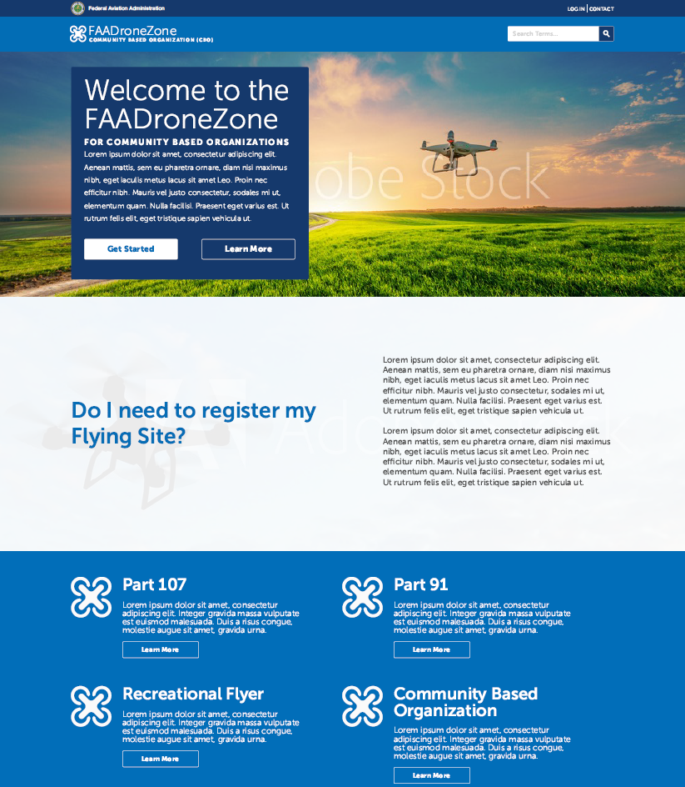

*Figure 2: Log In Screen*

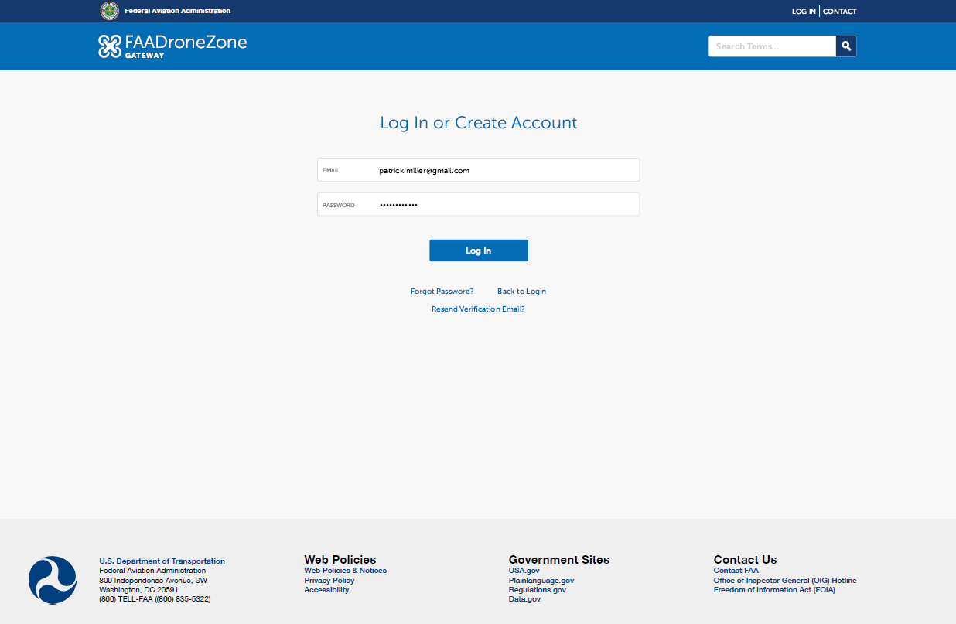

*Figure 3: CBO Application Portal*

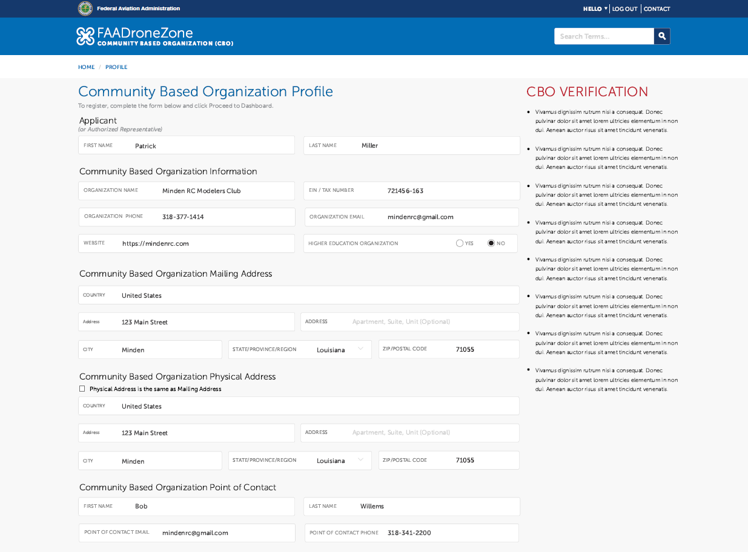

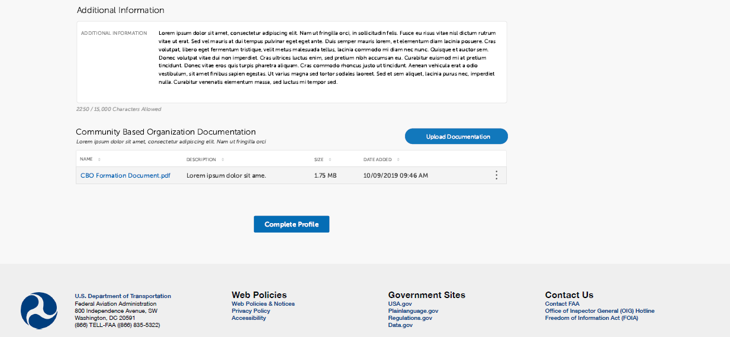

*Figure 4: Document Upload*

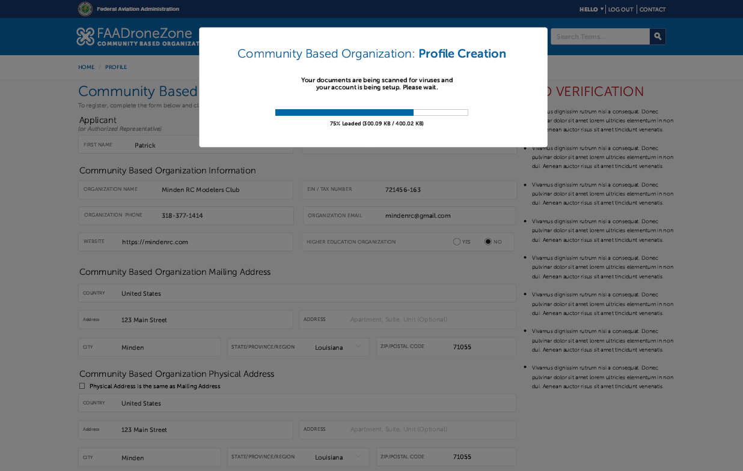

*Figure 5: Institutions of Higher Education*

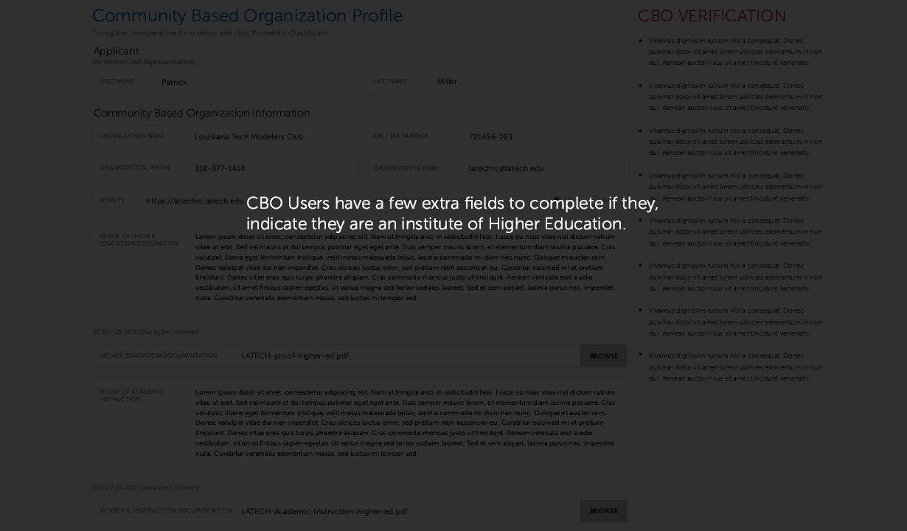

*Figure 6: Account created, status pending*

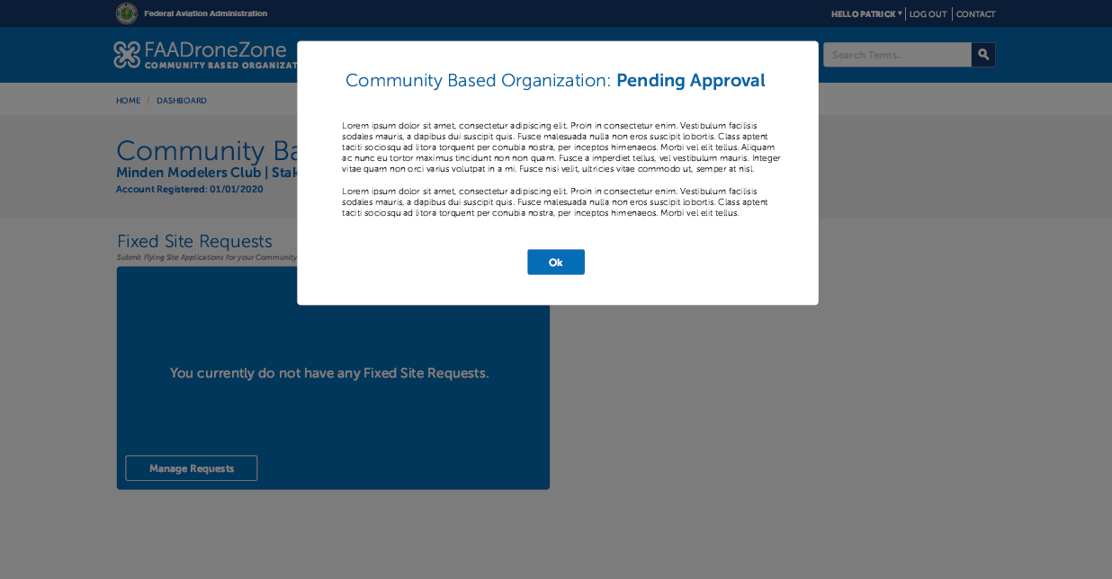

*Figure 7: CBO Fixed Flying Site requests*

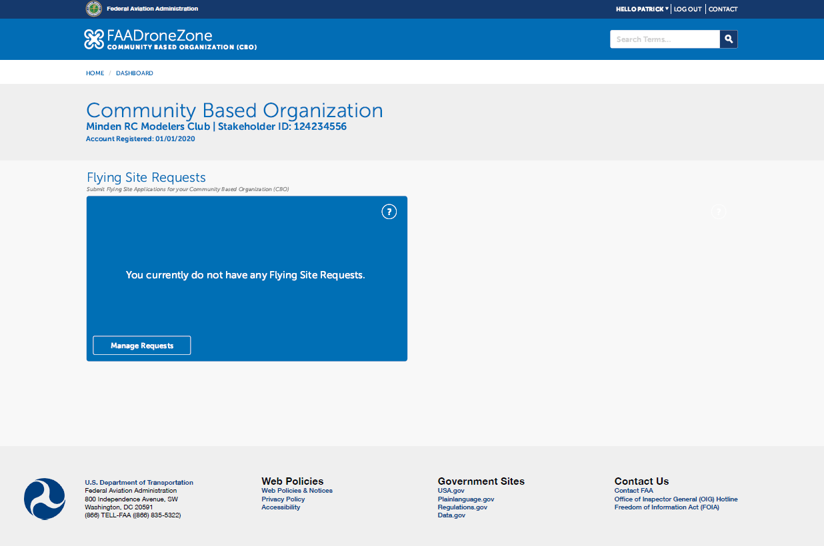

*Figure 8: Fixed Flying Site application portal*

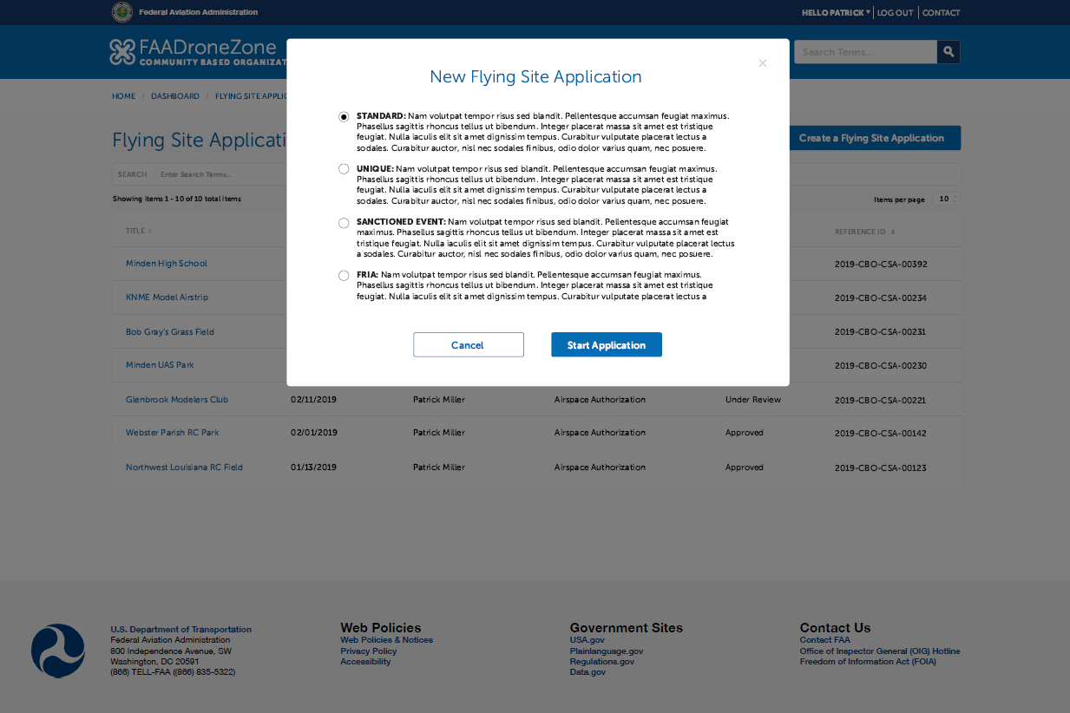

*Figure 9: Fixed Flying Site data entry*

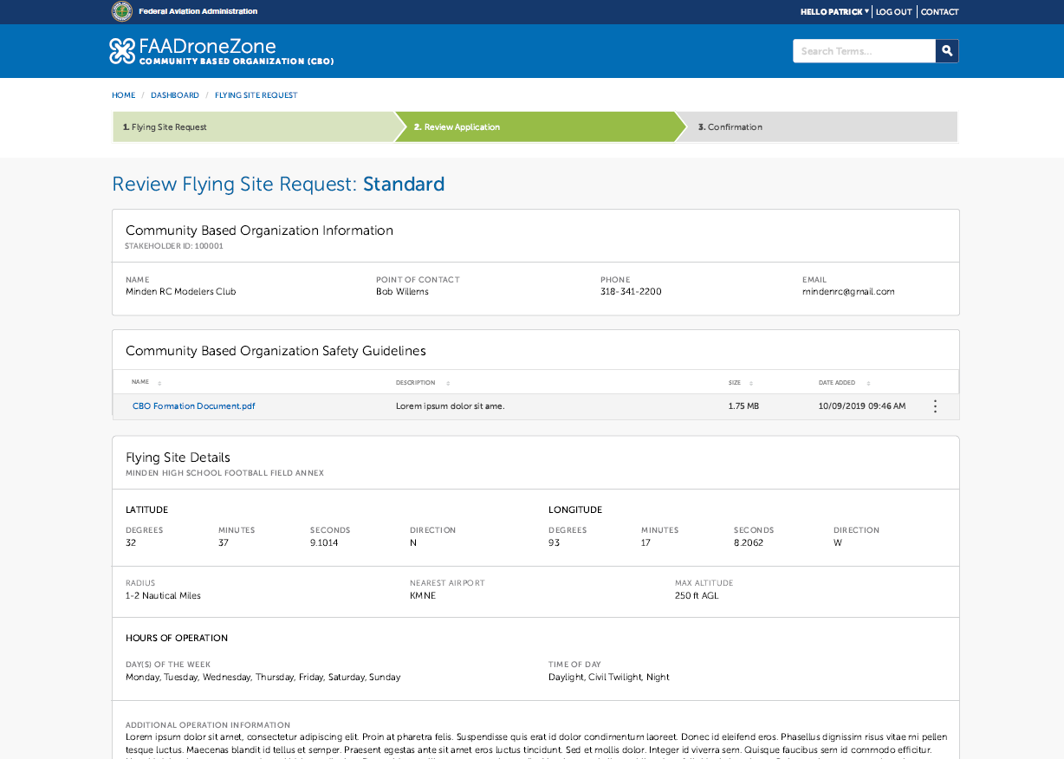

*Figure 10: Fixed Flying Site management page*

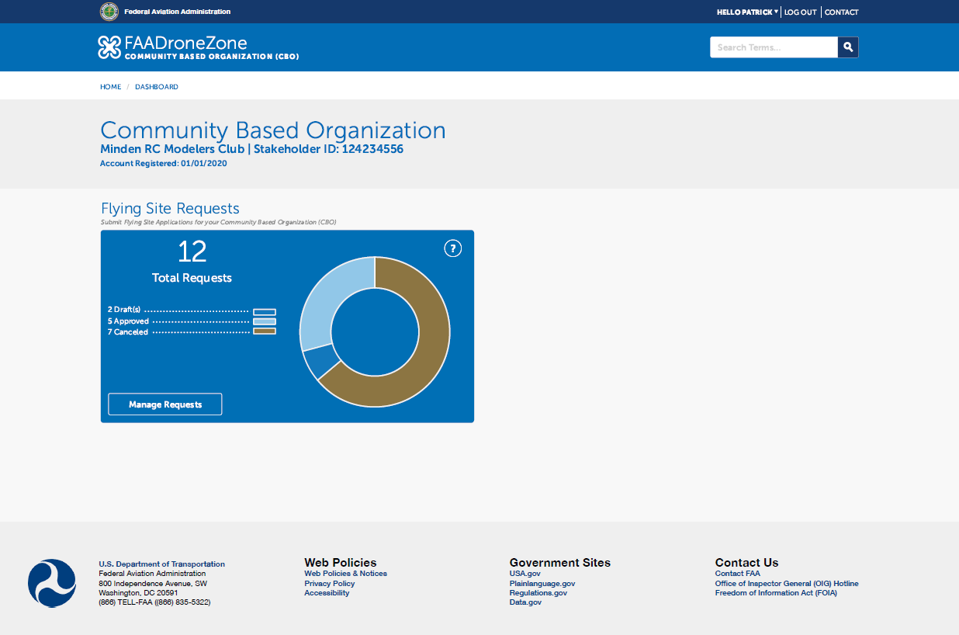

*Figure 11: Fixed Flying Site status page*

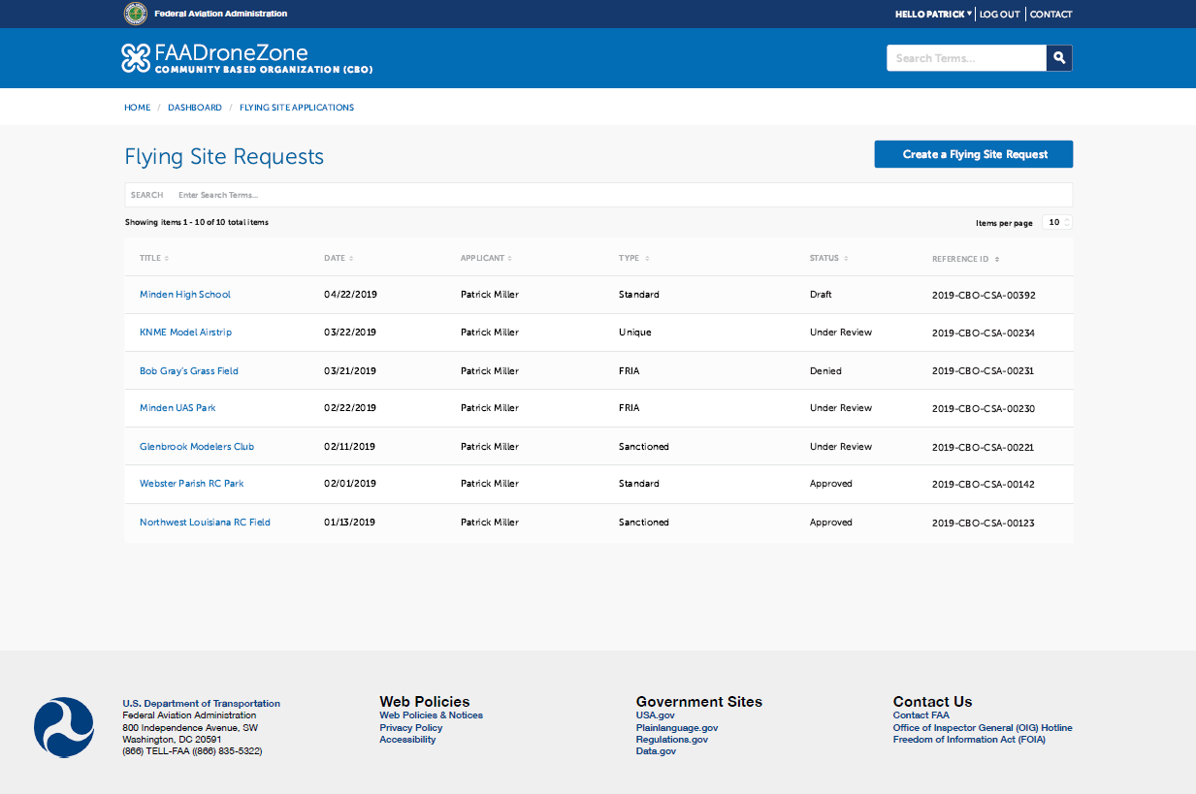

1. <https://www.bls.gov/news.release/ecec.nr0.htm>; “Private industry employers spent an average of $34.72 per hour worked for total employee compensation in December 2019, the U.S. Bureau of Labor Statistics reported today. Wages and salaries averaged $24.36 per hour worked and accounted for 70.1 percent of these costs, while benefit costs averaged $10.37 and accounted for the remaining 29.9 percent.”
2. https://www.regulations.gov/document?D=EPA-HQ-OPPT-2014-0650-0005
3. <https://www.opm.gov/policy-data-oversight/pay-leave/salaries-wages/salary-tables/pdf/2020/RUS.pdf>
4. U.S. Department of Health and Human Services, “Guidelines for Regulatory Impact Analysis” (2016), <https://aspe.hhs.gov/system/files/pdf/242926/HHS_RIAGuidance.pdf>. On page 30, HHS states, “As an interim default, while HHS conducts more research, analysts should assume overhead costs (including benefits) are equal to 100 percent of pretax wages….”