This set of screen shots captures the FM Commercial Construction Permit flow in the LMS application.
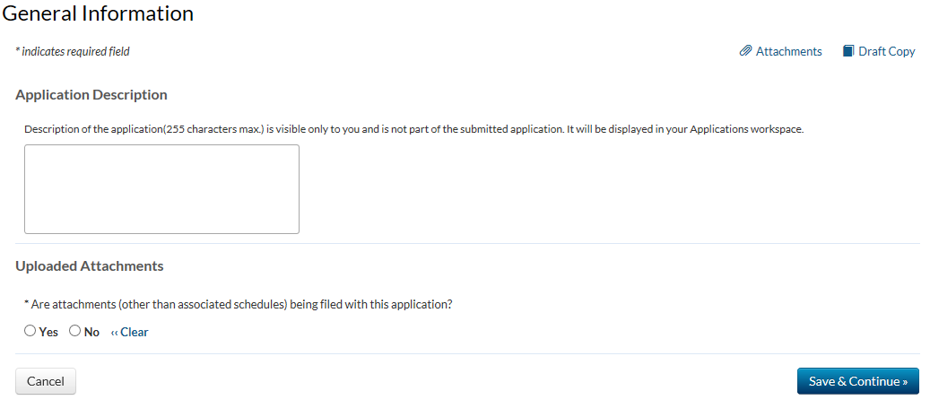

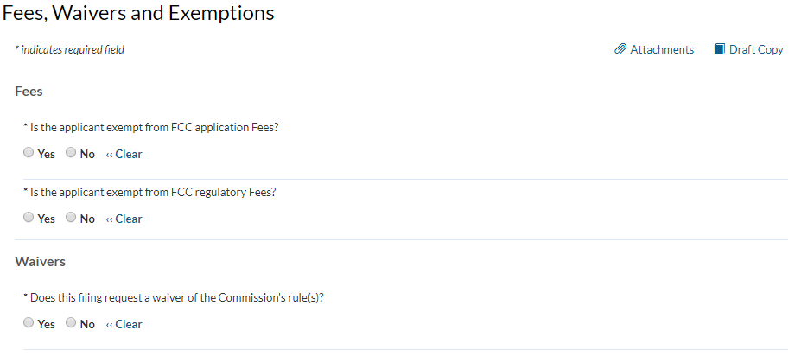

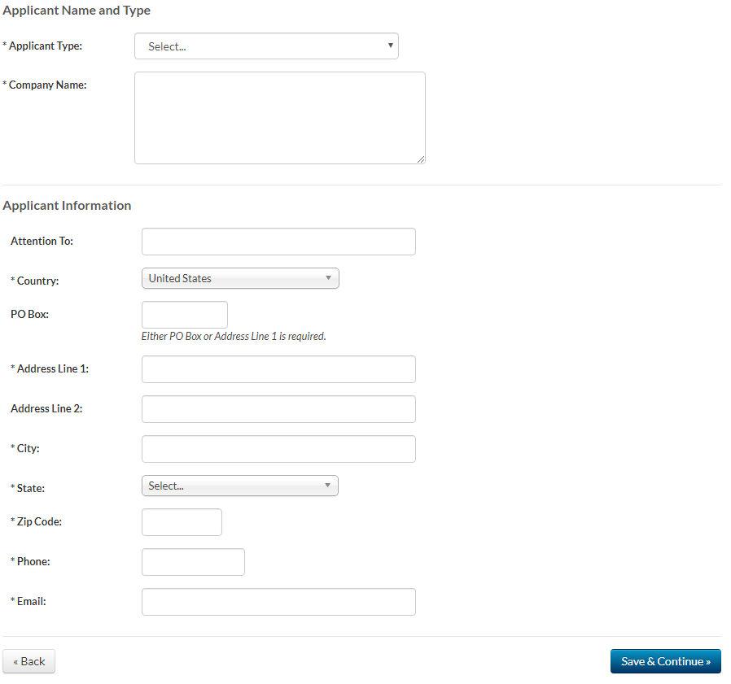

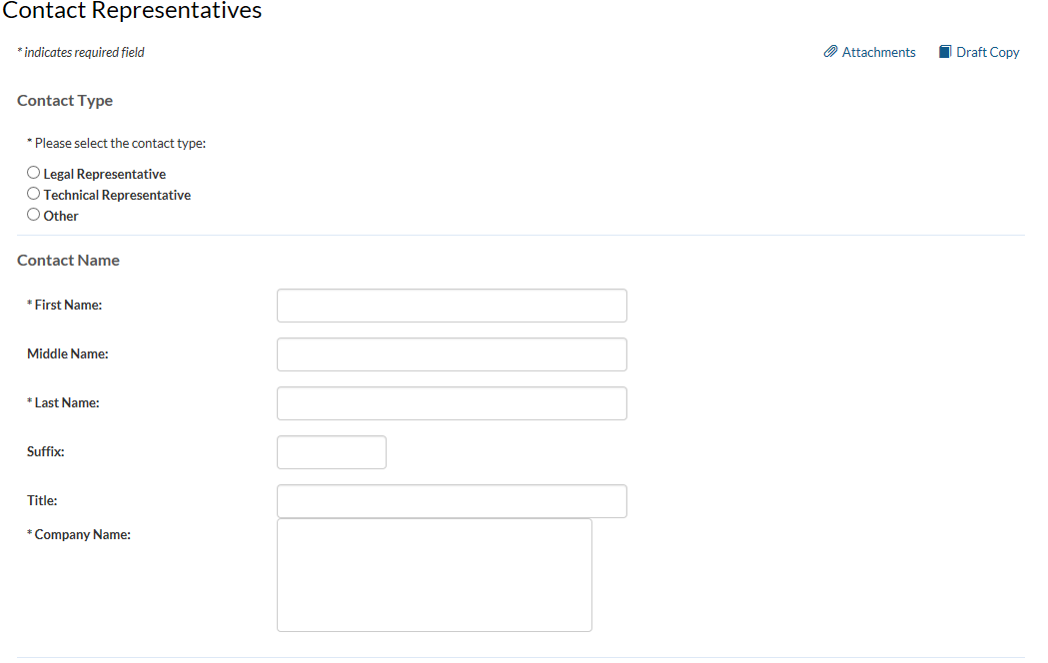
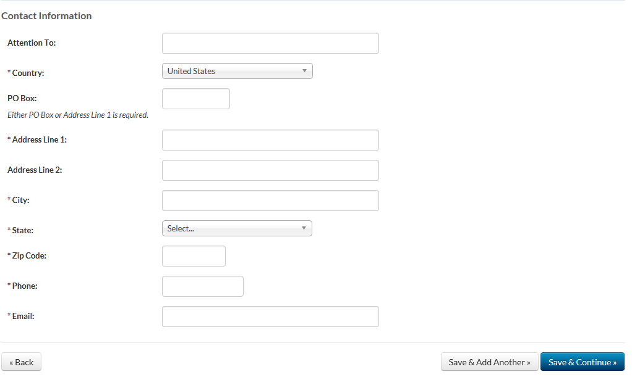

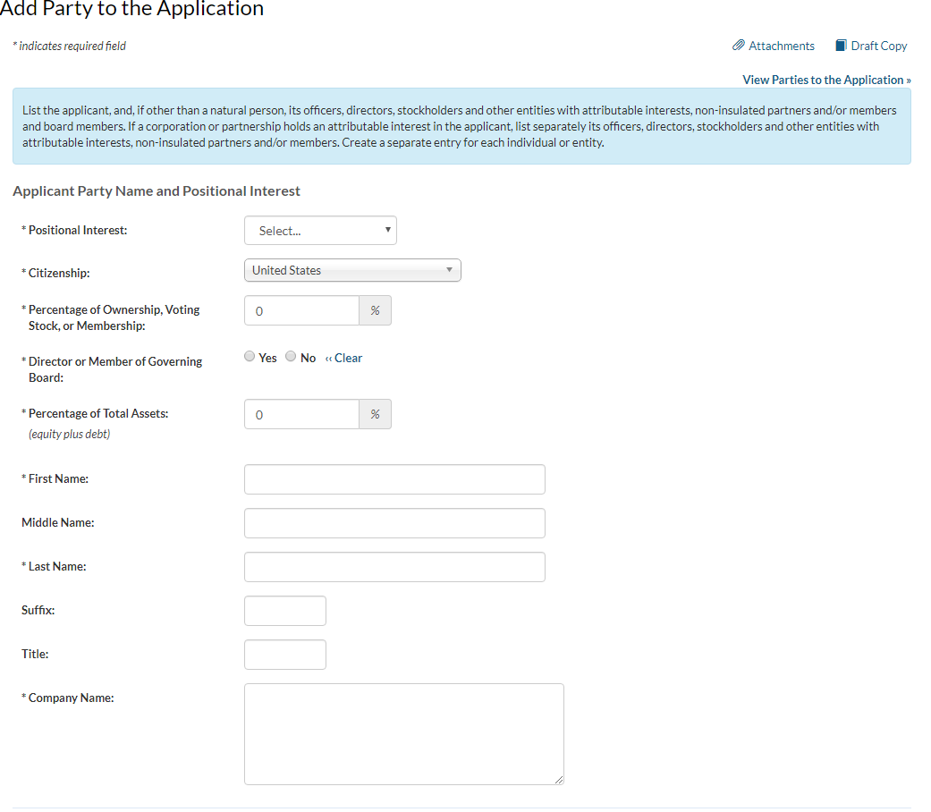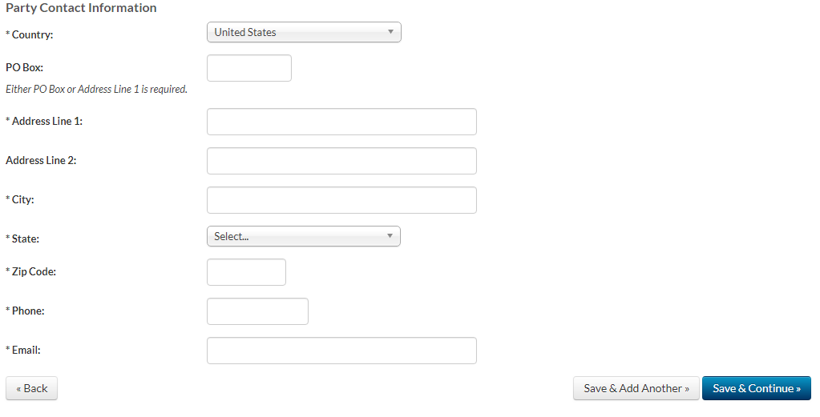

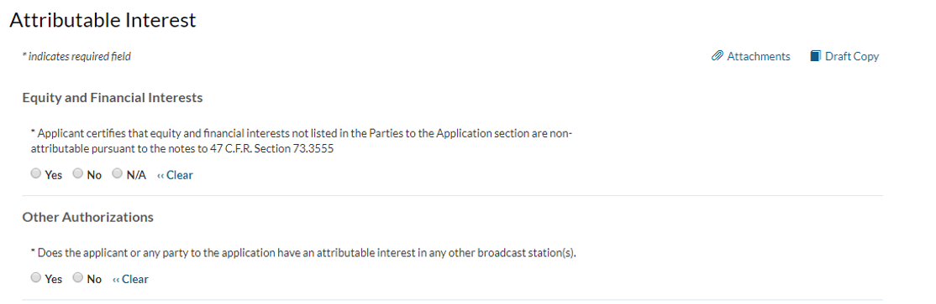
Broadcast Incubator Program
* Is the proposed facility the subject of an incubation proposal or a ‘reward’ waiver request
under the Commission’s Broadcast Incubator Program?

Multiple Ownership
* Is the applicant or any party to the application the holder of an attributable radio joint sales agreement or an attributable radio time brokerage agreement in the same market as the station subject to this application?
Yes No ‹‹ Clear

* Applicant certifies that the proposed facility complies with the Commission's multiple ownership rules.
Yes No ‹‹ Clear

* Applicant certifies that the proposed facility: (a) does not present an issue under the Commission's policies relating to media interests of immediate family members; (b) complies with the Commission's polices relating to future ownership interests; and (c) complies with the Commission's restrictions relating to the insulation and non-participation of non-party investors and creditors.
Yes No ‹‹ Clear

* Does the Applicant claim status as an "eligible entity," that is, an entity that qualifies as a small business under the Small Business Administration's size standards for its industry grouping (as set forth in 13 C.F.R. § 121.201), and holds: (a) 30 percent or more of the stock or partnership interests and more than 50 percent of the voting power of the corporation or partnership that will own the media outlet; or (b) 15 percent or more of the stock or partnership interests and more than 50 percent of the voting power of the corporation or partnership that will own the media outlet, provided that no other person or entity owns or controls more than 25 percent of the outstanding stock or partnership interests; or (c) more than 50 percent of the voting power of the corporation that will own the media outlet (if such corporation is a publicly traded company)?
Yes No ‹‹ Clear

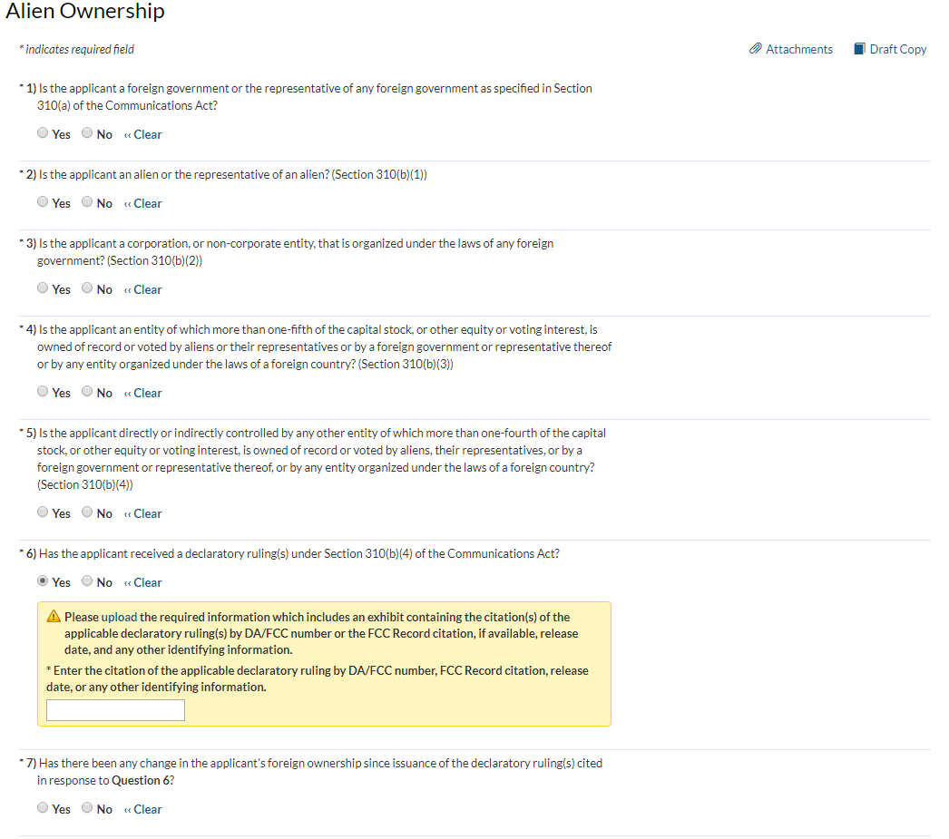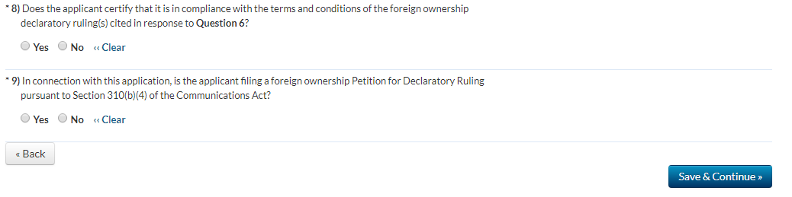

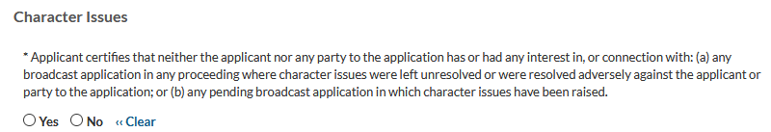
* Licensee certifies that, with respect to the licensee and each party to the application, no adverse finding has been made, nor has an adverse final action been taken by any court or administrative body in a civil or criminal proceeding brought under the provisions of any laws related to any of the following: any felony; mass media-related antitrust or unfair competition; fraudulent statements to another governmental unit; or discrimination.
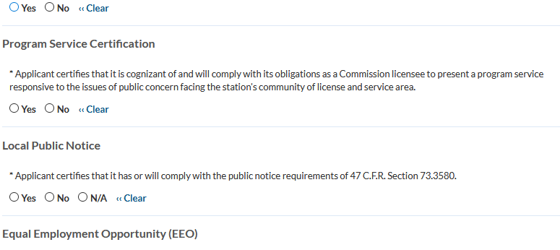
* If the applicant proposes to employ five or more full-time employees, applicant certifies that it is filing simultaneously with this application a Broadcast EEO Model Program Report.
