This set of screen shots captures the Low Power FM Station Construction Permit flow in the LMS application.
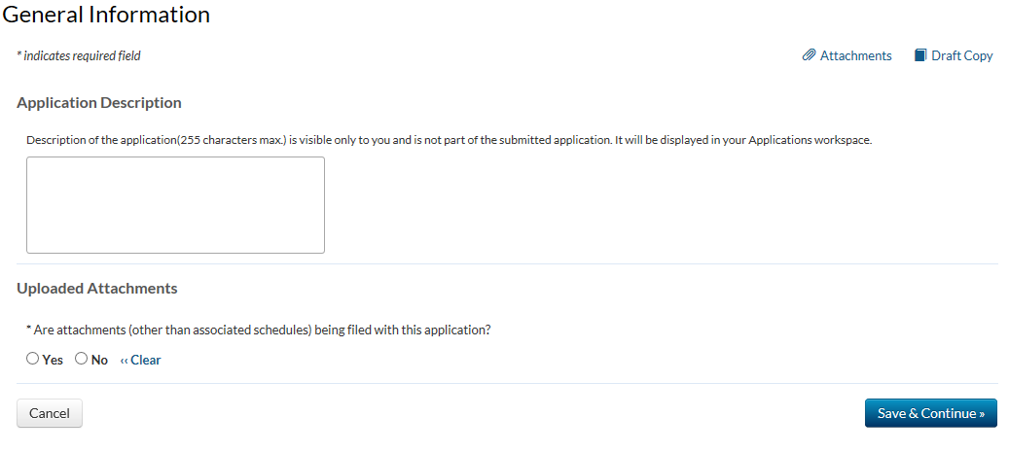

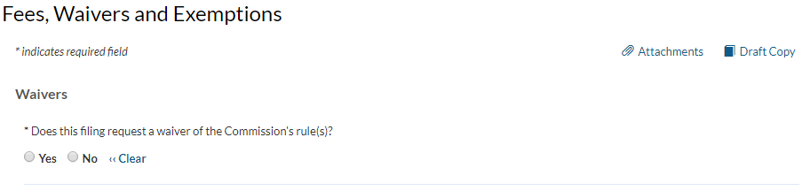

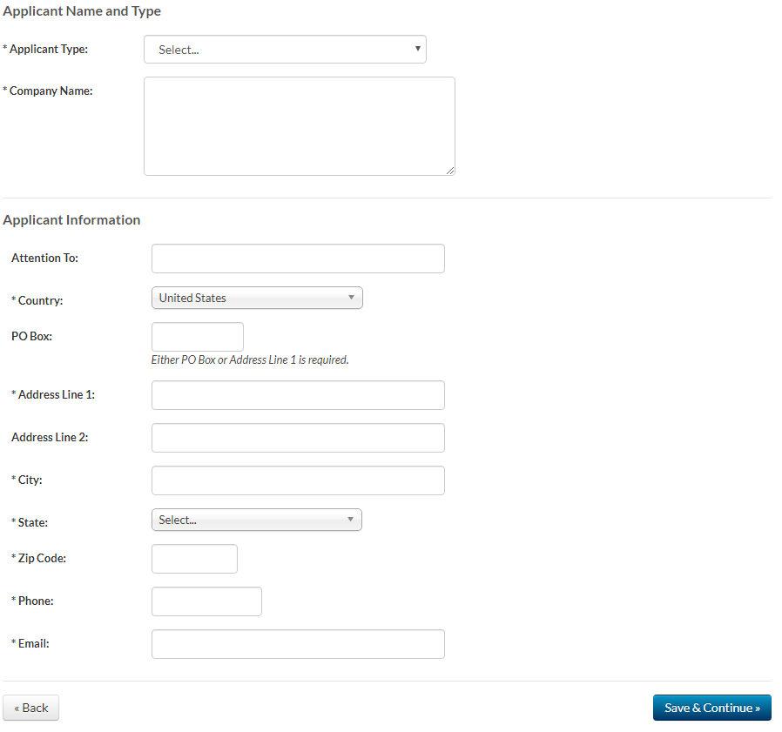

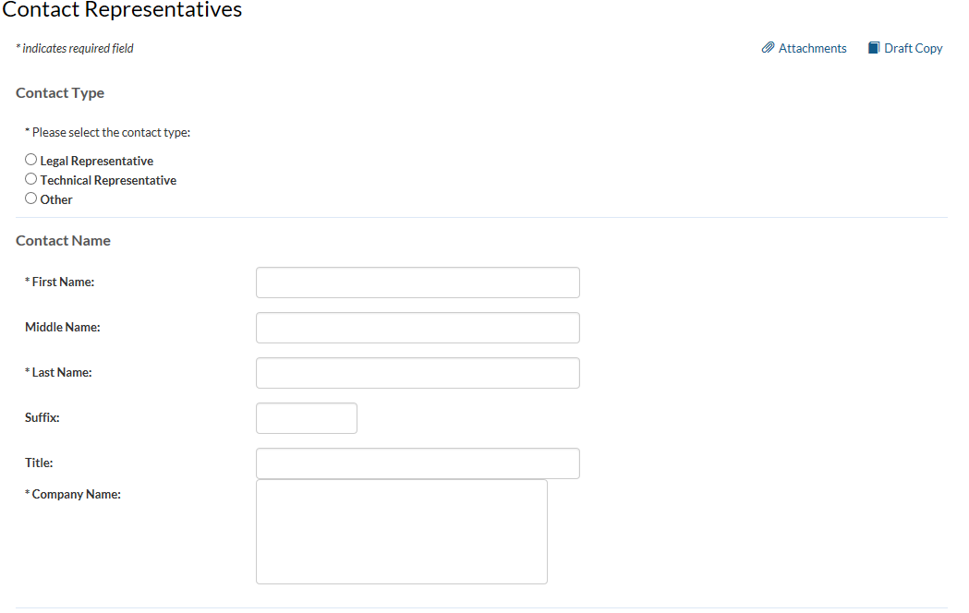
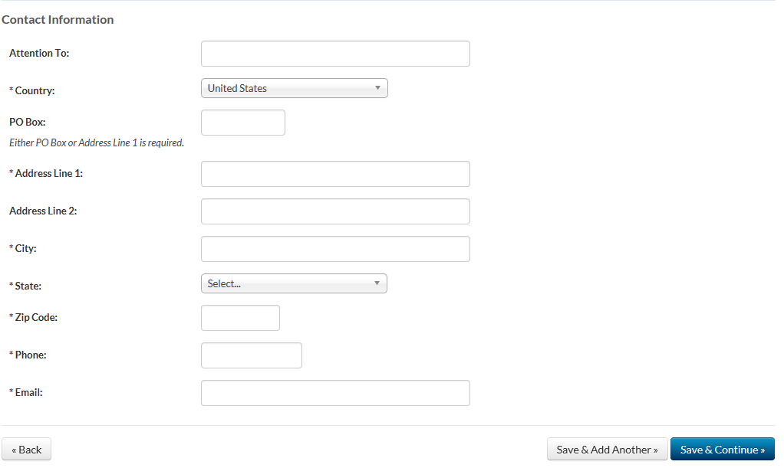
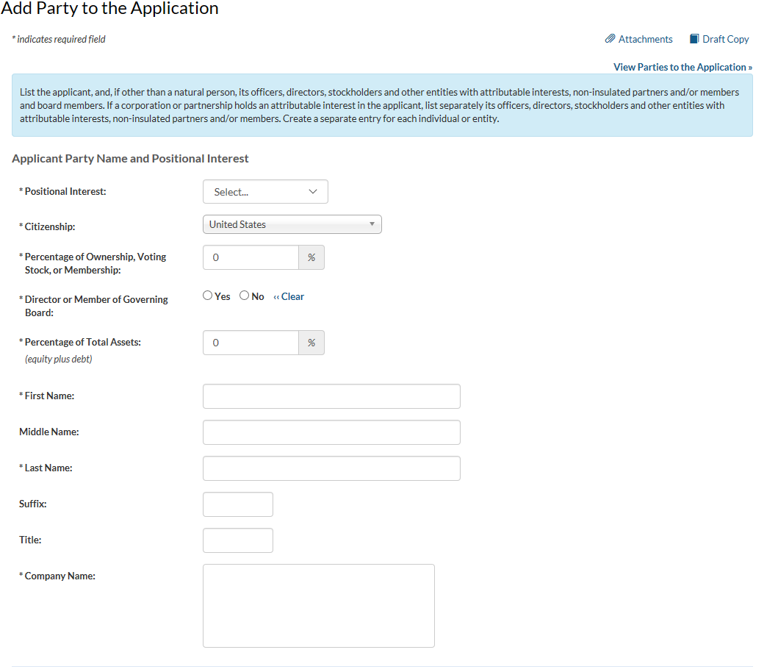
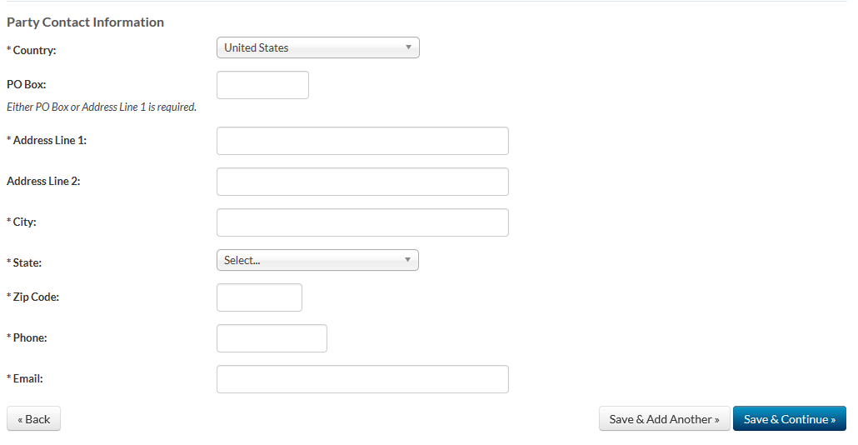

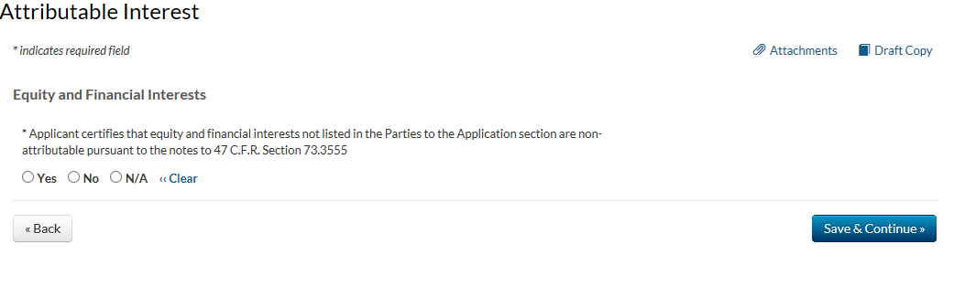

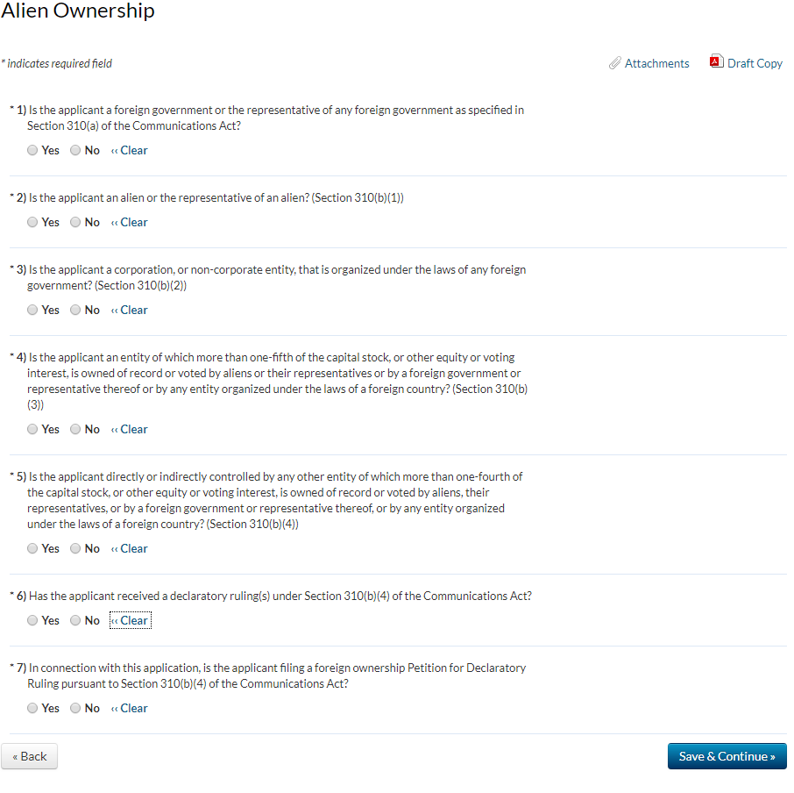

* Each applicant must check one of the three radio buttons for this question indicating the category under which it is eligible. The applicant certifies that it is a:
^{or organization}
An applicant answering “Yes” must include an exhibit that describes the applicant's educational program and how its proposed station will be used to advance its educational program. If the applicant is incorporated, the exhibit must include the state and date of applicant's incorporation. If the applicant is unincorporated, the exhibit must include the state in which it is registered or otherwise recognized and the date of such registration or recognition.

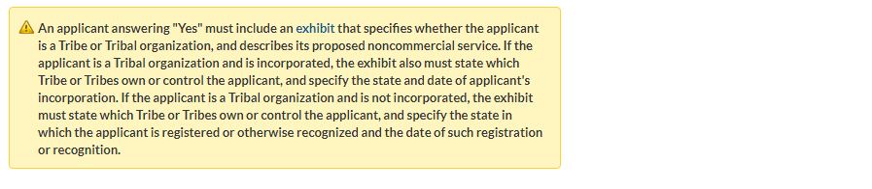
If the answer is “Yes,” and the applicant is submitting multiple applications, is this application the “priority” application? (See Creation of a Low Power Radio Service, Memorandum Opinion and Order on Reconsideration, 15 FCC Rcd 19208, 19239-40, paras. 79-80 (2000).
An applicant answering “Yes” must include an exhibit that describes the applicant's public safety radio program and how the proposed station will be used to protect the safety of life, health or property. If the applicant is a non-governmental entity and is incorporated, the exhibit must include the state and date of applicant’s incorporation. If the applicant is a non-governmental entity and is not incorporated, the exhibit must include the state in which it is registered or otherwise recognized and the date of such registration or recognition.

Applicants must certify that they are local to be eligible for LPFM authorizations. An applicant must select “yes” to one of the certifications below to be eligible for an LPFM license. The applicant certifies that:
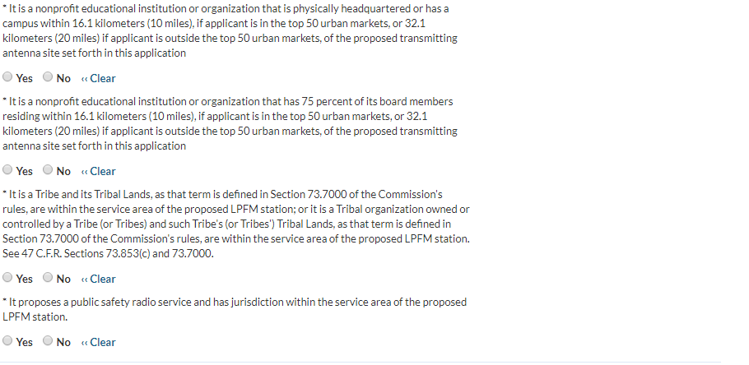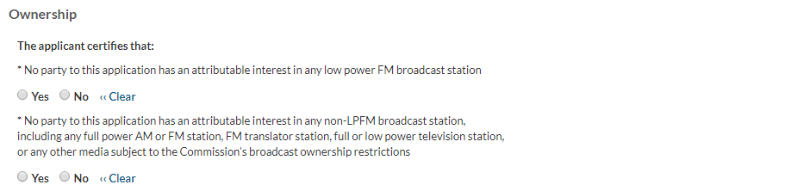
* No party to this application has pending an application for a low power FM, full power AM or
FM station, FM translator station, or full or low power television station
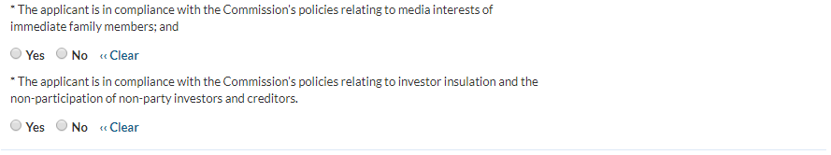

* Applicant certifies that neither the applicant nor any party to the application has or had any interest in, or connection with: (a) any broadcast application in any proceeding where character issues were left unresolved or were resolved adversely against the applicant or party to the application; or (b) any pending broadcast application in which character issues have been raised.
* Applicant certifies that, with respect to the applicant and any party to the application, no adverse finding has been made, nor has an adverse final action been taken by any court or administrative body in a civil or criminal proceeding brought under the provisions of any laws related to any of the following: any felony; mass media-related antitrust or unfair competition; fraudulent statements to another governmental unit; or discrimination.
* The applicant certifies, under penalty of perjury, that neither the applicant nor any party to the application has engaged in any manner, individually or with other persons, groups, organizations, or other entities, in the unlicensed operation of any station in violation of Section 301 of the Communications Act of 1934, as amended, 47 U.S.C. Section 301.

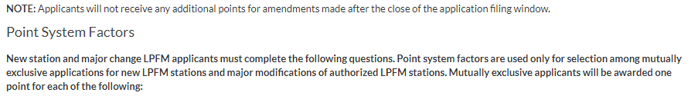
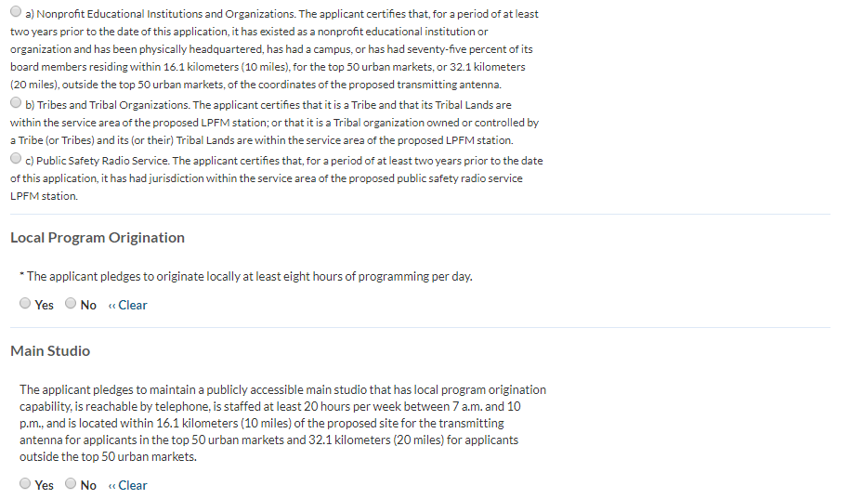

An applicant claiming a point under the main studio criterion must provide the proposed address and telephone number for the main studio.
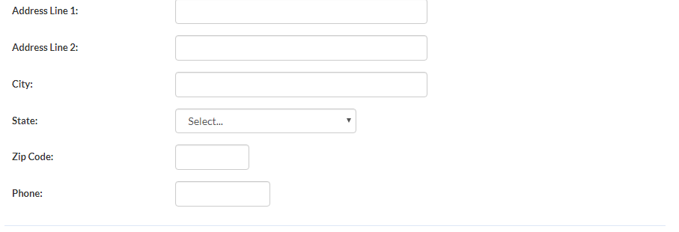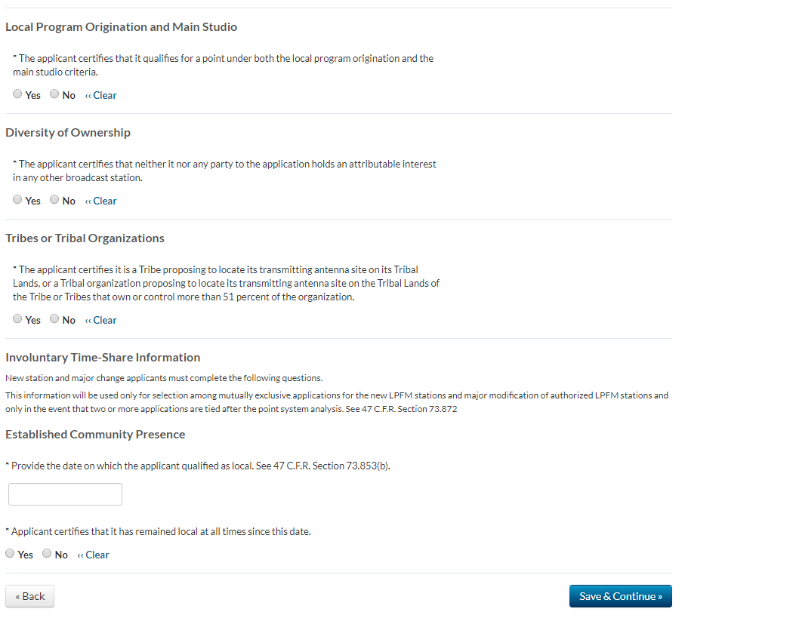

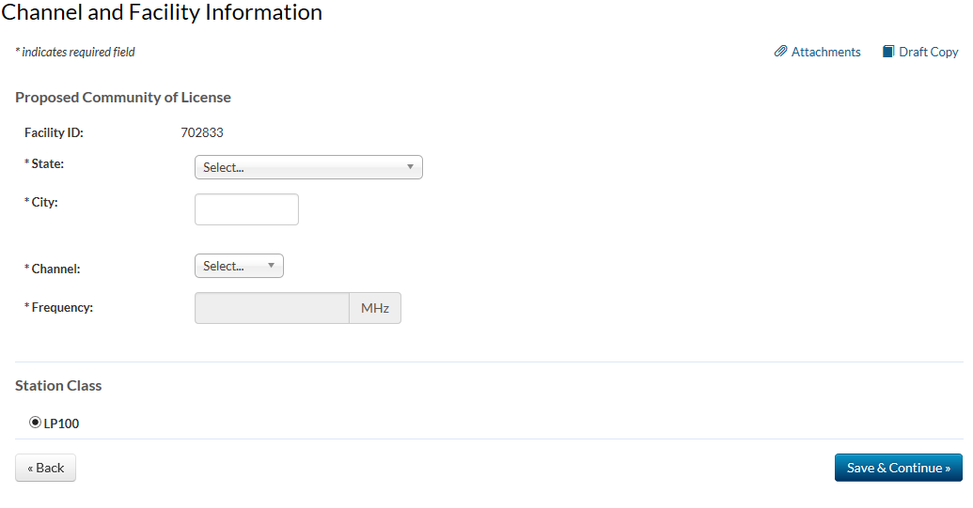

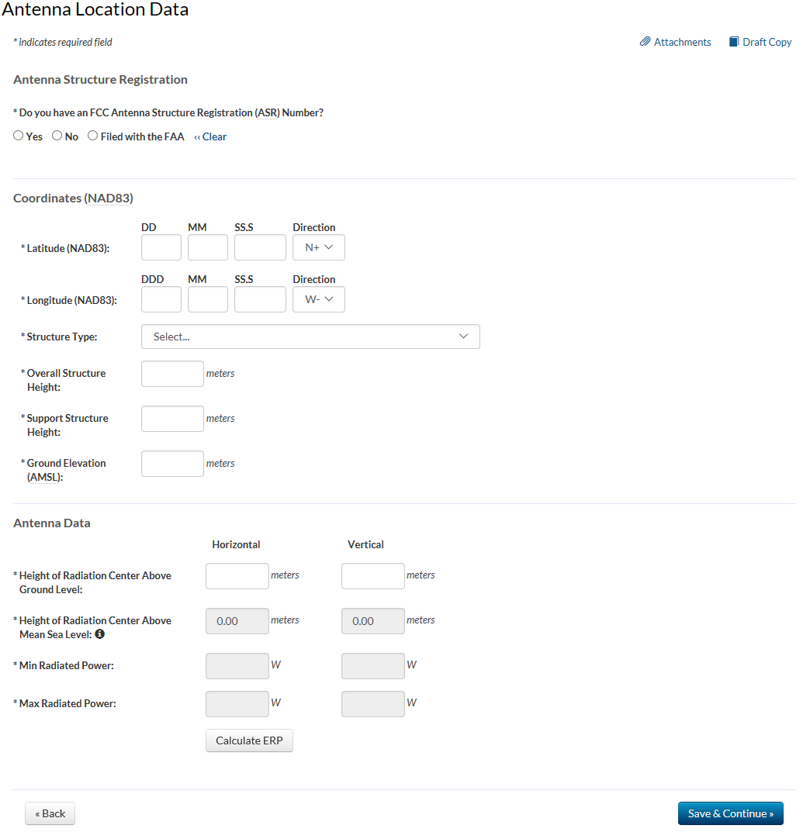
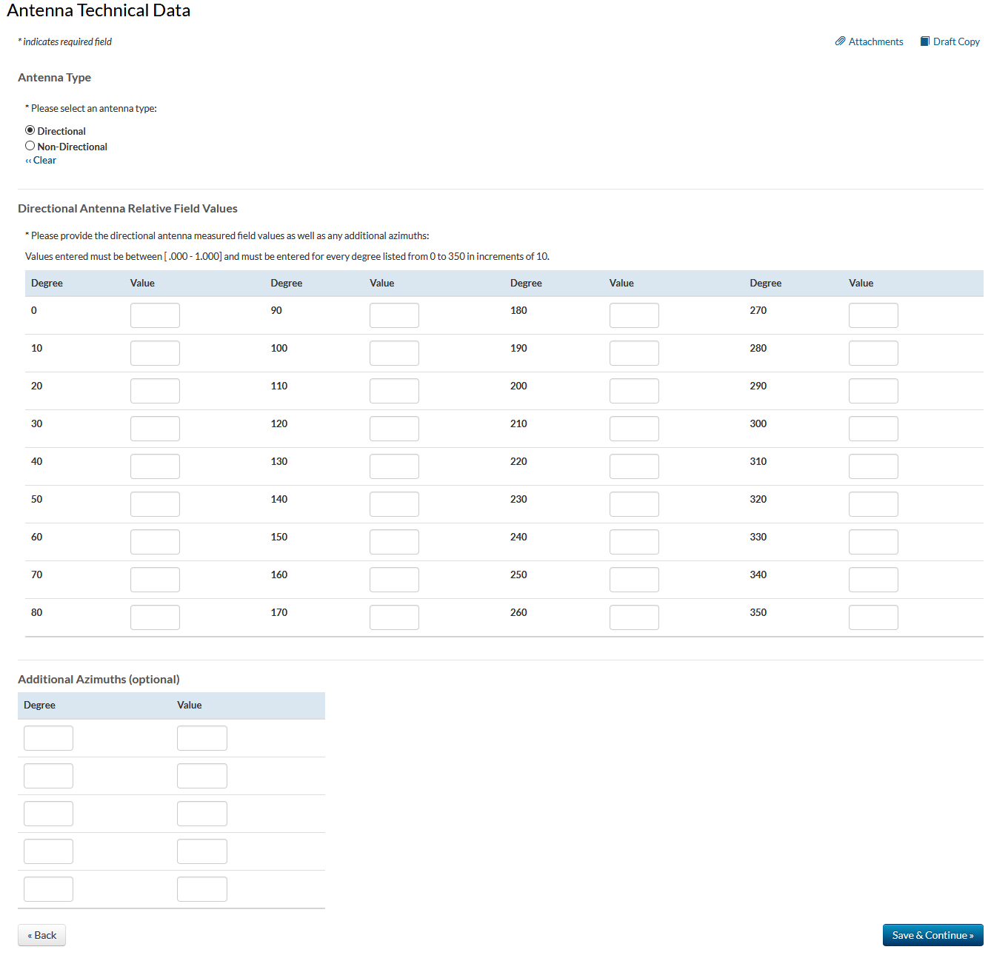
*Would a Commission grant of Authorization for this location be an action which may have a significant environmental effect? See 47 C.F.R. Section 1.1306?
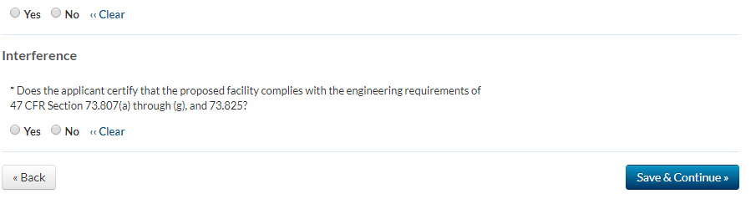
Reasonable Site Assurance
Applicant certifies that it has reasonable assurance in good faith that the site or proposed structure at the location of its transmitting antenna will be available to the applicant for the applicant’s intended purpose.
⃝ Yes ⃝ No « Clear
If reasonable assurance is not based on applicant’s ownership of the proposed site or structure, applicant certifies that it has obtained such reasonable assurance by contacting the owner or person possessing control of the site or structure.
⃝ Yes ⃝ No « Clear
Please specify the name of the person contacted, the person’s telephone number, and whether the contact is the tower owner, agent, or authorized representative.

Name

Telephone Number
Is the contact: ⃝ Tower Owner ⃝ Agent ⃝ Authorized Representative « Clear

